Communiqué: Aboriginal Leadership Group
Meeting 20: Thursday, 25 September 2025
The Aboriginal Leadership Group (ALG) convened its 20th meeting in Alice Springs on Thursday, 25 September 2025. Discussions focused on strengthening governance, reviewing progress under the Central Australia Plan (CAP), and setting strategic priorities for 2025–26.
Key Outcomes
- Governance
The ALG reviewed and discussed their 2025–26 Strategic Plan, reaffirming its commitment to co-design and community-led priorities.
- Communications Strategy
The ALG considered the Communications Strategy, which emphasises cultural safety, transparency, and visibility of community impact.
- CAP Implementation
Members received updates on CAP delivery, including investment by cluster and progress on youth and leadership programs.
- Evaluation Engagement
Inside Policy presented an update on the CAP Evaluation. No further evaluation activities are currently scheduled.
- Initiative Updates
The ALG received updates on the Strengthening Families and Communities Partnership and NT Remote Housing initiatives. Members also acknowledged the Batchelor Institute Centre of Excellence as a significant development in regional health.
The ALG reaffirmed its commitment to shared advice and continued collaboration to deliver meaningful outcomes for communities across Central Australia.
Next Meeting
The next ALG meeting is scheduled for Thursday, 13 November 2025.
Member Spotlight
We’re proud to feature one of our remote ALG members in this edition. Her voice brings vital perspective from remote Central Australia, helping shape advice that matters.
Valerie Napaljarri Martin from Yuendumu
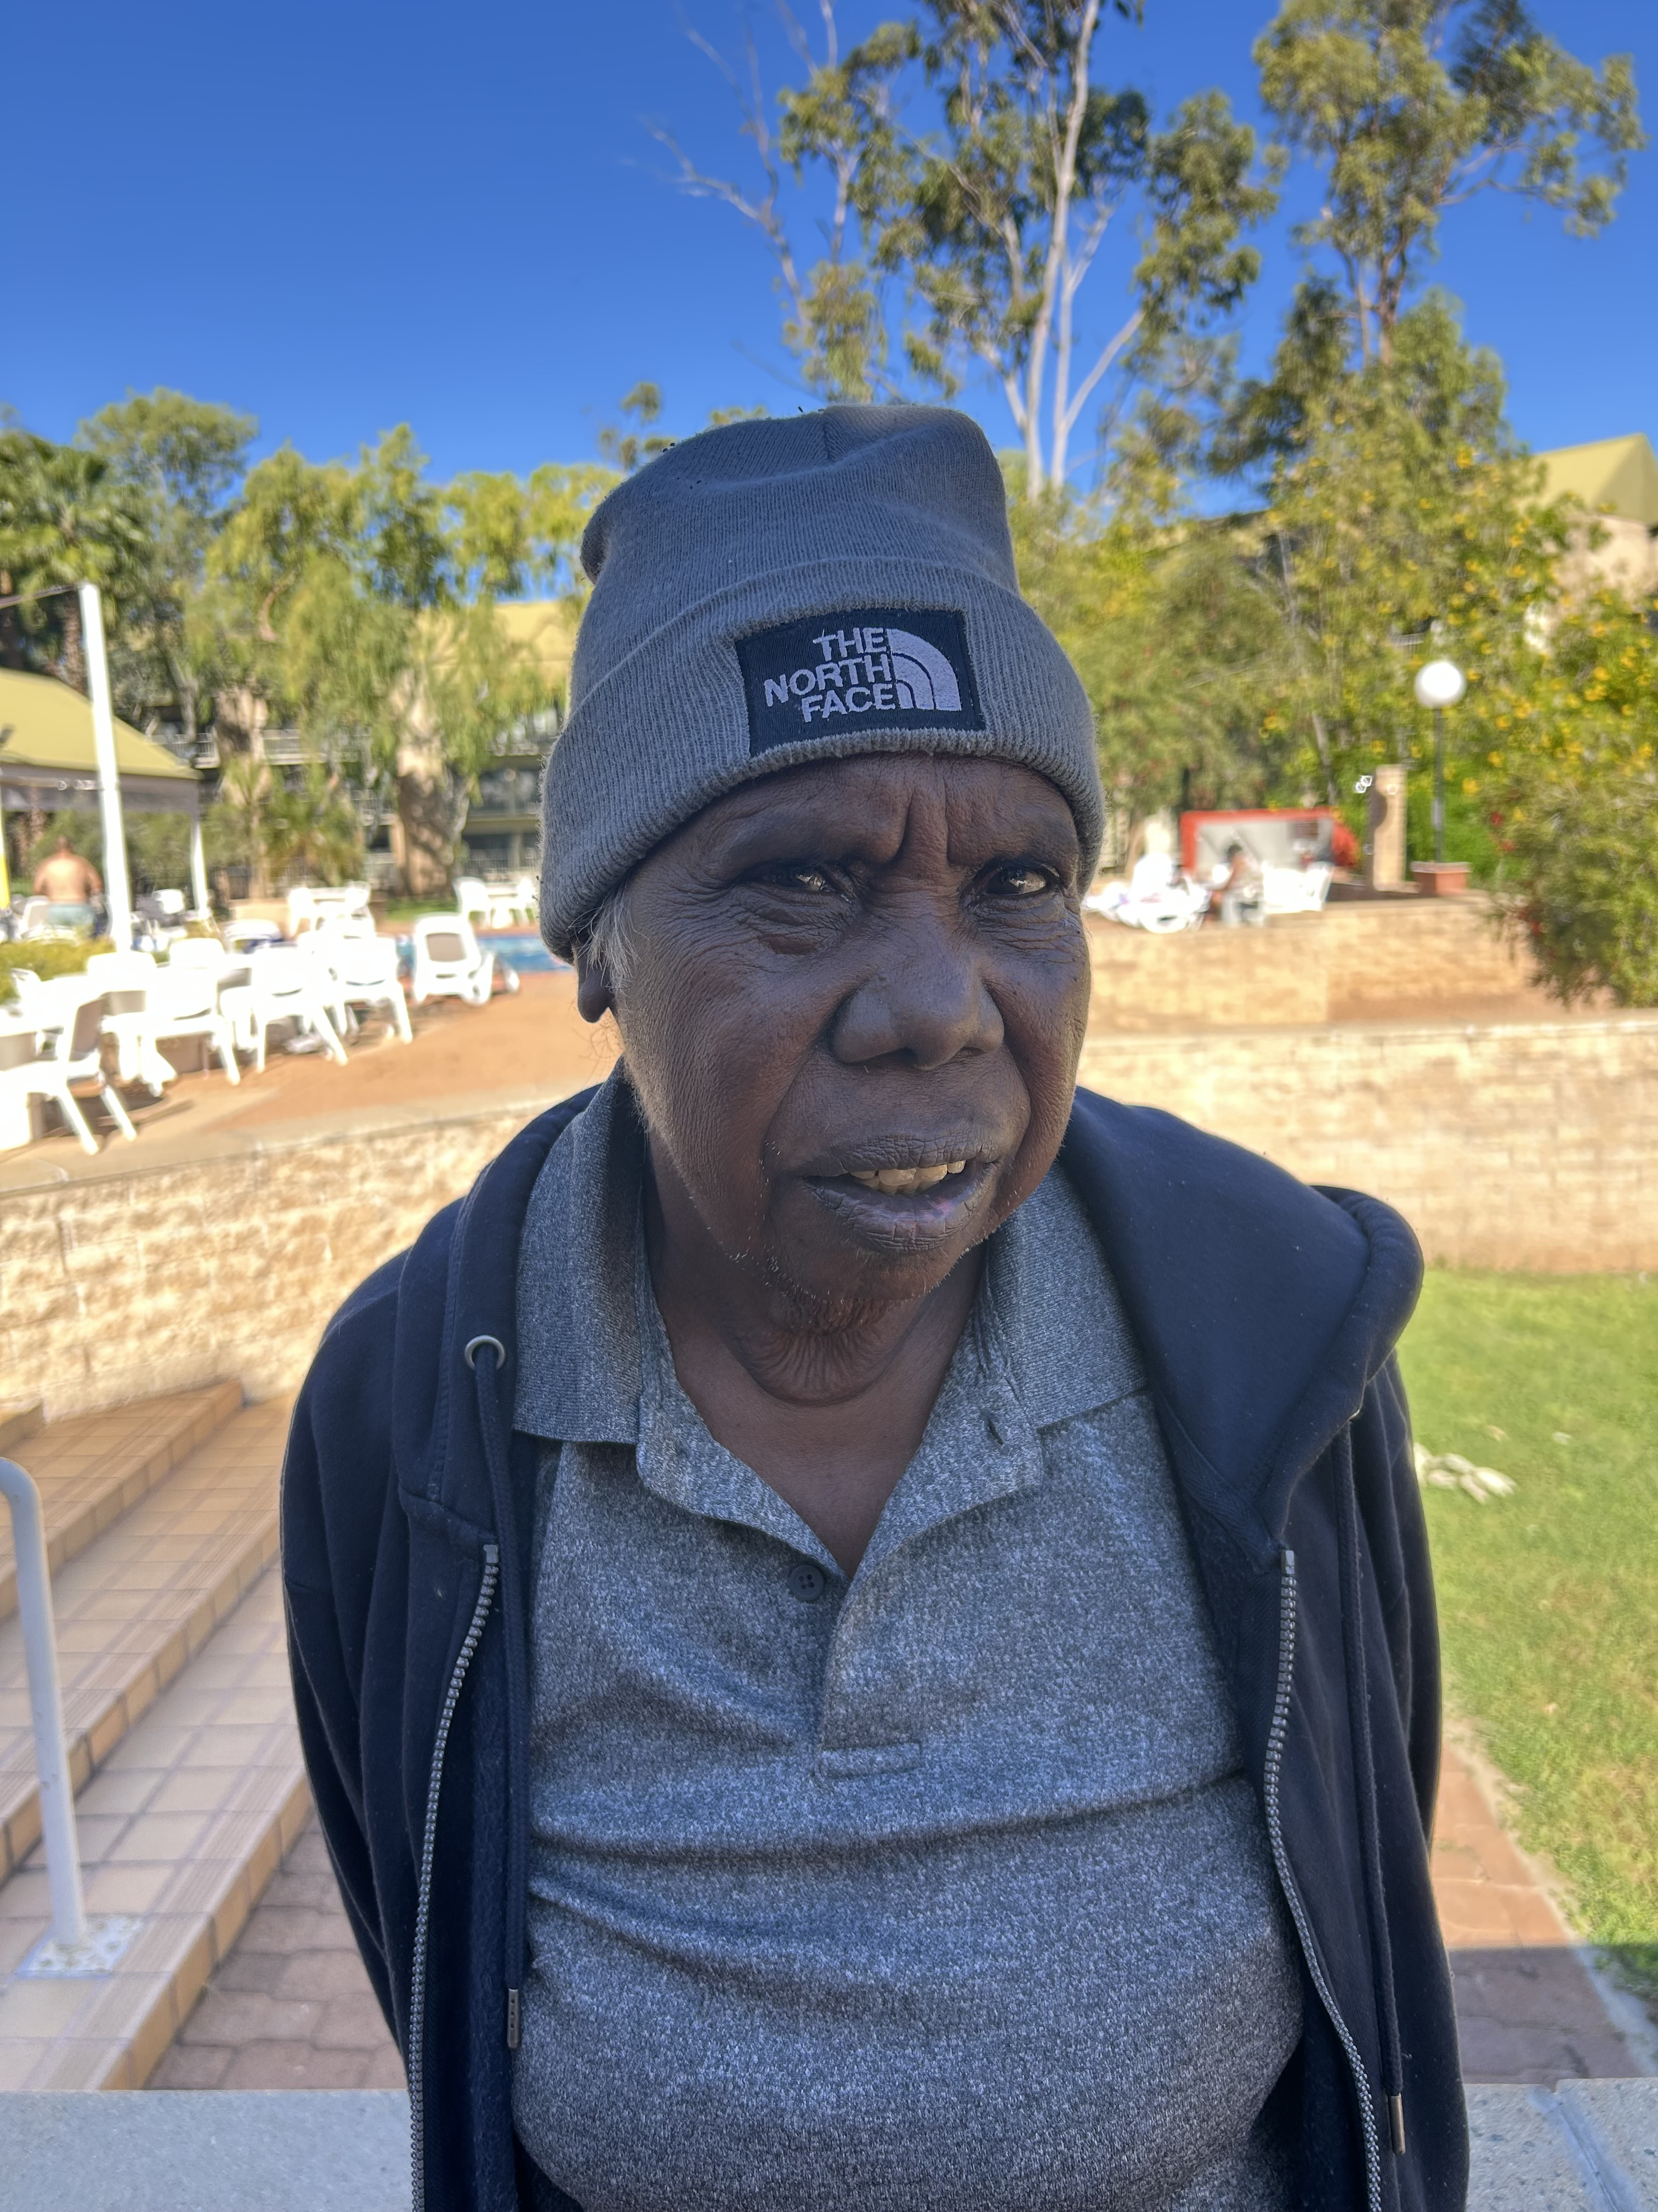
“I love being on the ALG—meeting lots of important people and having a say in guiding some of the funding advice. It feels good to be part of something that matters.”

