Communiqué: Aboriginal Leadership Group
Meeting 21: Friday, 14 November 2025
The Aboriginal Leadership Group (ALG) held its 21st meeting which focused on reviewing progress, identifying priorities, and ensuring community voices guide decisions that improve safety, wellbeing, and connectivity across Central Australia.
Key Outcomes
- CAP Implementation
Members received tailored updates on CAP delivery since the September 2025 meeting, including investment by cluster and an update on communications.
- Initiative Updates
The Group discussed and received updates on initiatives aimed at improving safety, connectivity, and community wellbeing. These included:
  - Community Safety Patroller Framework
  - First Nations Digital Connectivity
  - Summer Readiness
  - Justice Reinvestment
  - Community Infrastructure Package
  - Strengthening Families and Communities Partnership
Next Meeting
The next ALG meeting is scheduled for 18-19 February 2026.
Apmere Mwerre Visitors Park (AMVP) Expansion
The ALG acknowledged the successful opening of the AMVP expansion, operated by Aboriginal Hostels Limited, on Tuesday, 11 November 2025.
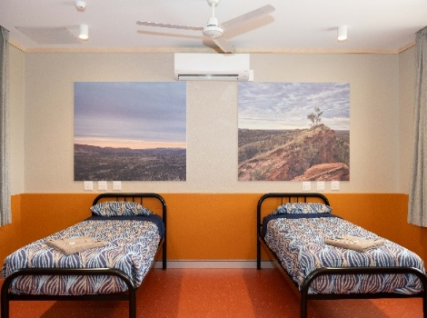
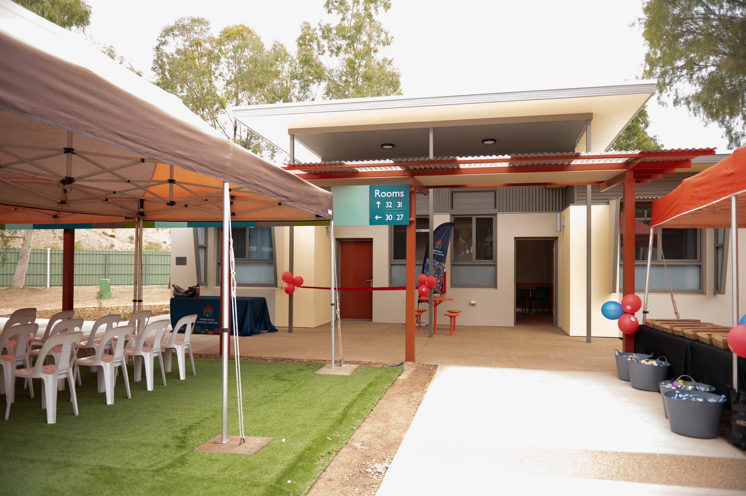
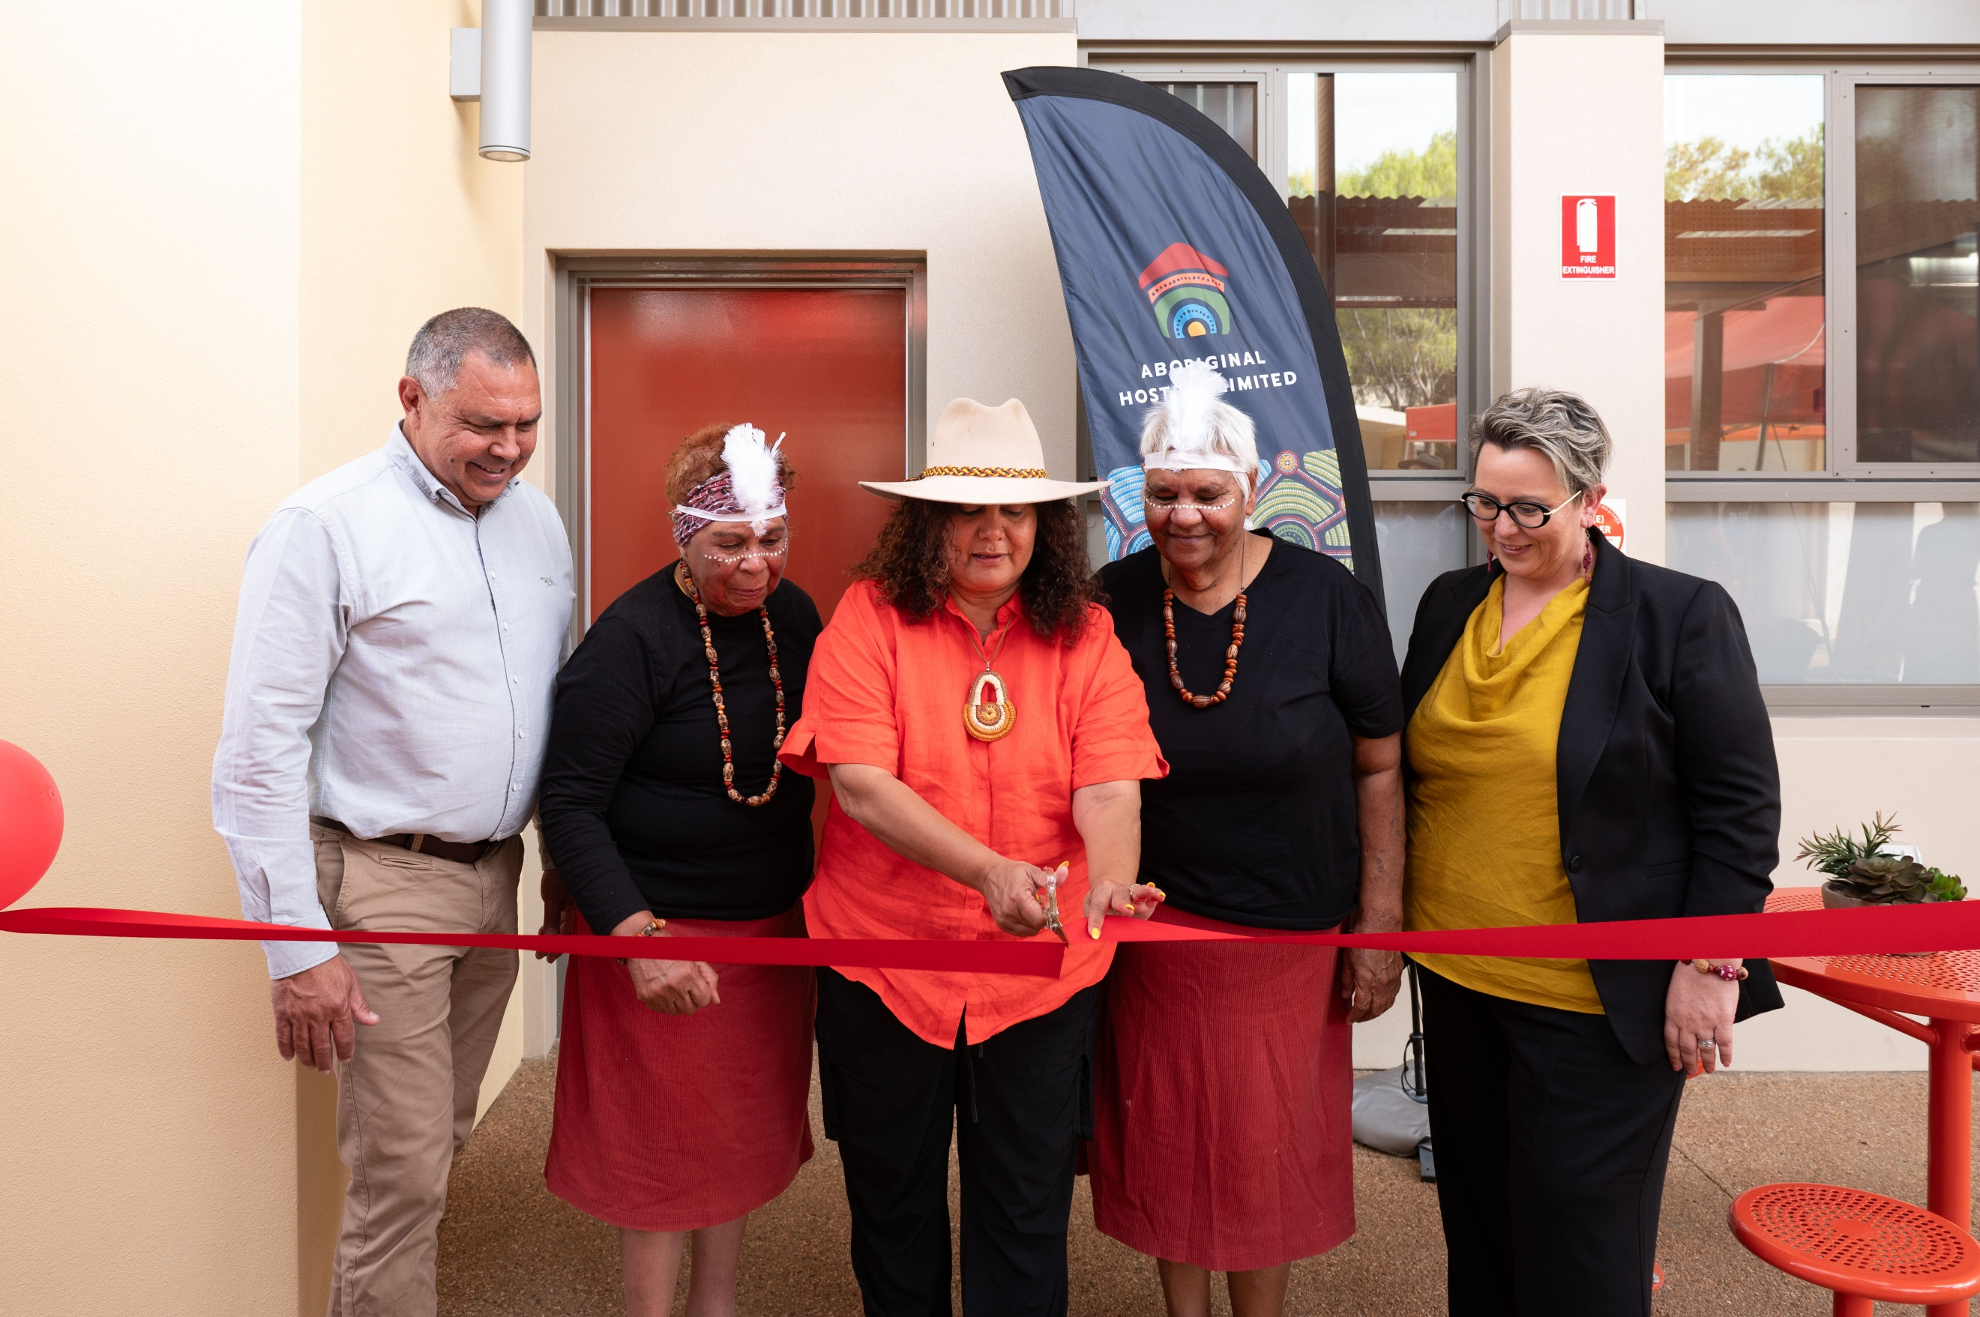
The expansion delivers 20 additional beds, providing safe and affordable accommodation for First Nations people, including women and children experiencing family and domestic violence. Members’ advice played an important role in shaping this outcome, which strengthens community accommodation and support services.
Read more: Apmere Mwerre Visitors Park expansion supporting more First Nations women and children | Ministers' media centre

