Consultation Report

National Strategy for Food Security in Remote First Nations Communities

Contents
Acknowledgement of Country 2
1 About this project 2
Who did this work? 2
Acknowledgement of Participants 3
What is this report for? 4
What is food security? 4
What does food security look like? 4
Why was this work done? 4
Discussion Paper 5
2 What happened during the project? 6
What we did 6
Who we spoke to 6
What we heard 7
Recommendations 10
What will happen next? 11
Conclusion 11

Acknowledgement of Country
We acknowledge and pay our respects to Aboriginal and Torres Strait Islander peoples as the First Peoples of Australia, whose ancestral lands, and waters we work and live on throughout Australia. We honour the wisdom of, and pay respect to, their Elders past and present, and acknowledge the cultural authority of all Aboriginal and Torres Strait Islander peoples across Australia.

About this project

Who did this work?
The National Indigenous Australians Agency (NIAA) is working with State and Territory governments and Aboriginal and Torres Strait Islander Health Peaks to design the National Strategy for Food Security in Remote First Nations Communities. The group including State and Territory governments and Aboriginal and Torres Strait Islander Health Peaks is called the Strategy Partners.
NIAA and the Strategy Partners asked Yamagigu Consulting (yamagigu) to speak to people in remote communities about food security.
This report was written by yamagigu. You can find out more about yamagigu.

Acknowledgement of Participants
Thank you to all of the Aboriginal and Torres Strait Islander people who gave us their valuable time and shared their ideas and knowledge with us.
In this work we have tried to prioritise the voices and experiences of the Aboriginal and Torres Strait Islander people. All the contributions to this project have been very valuable. They are very important to designing the Strategy to make sure everyone has access to the food they need.
We are deeply grateful for your time, effort, and commitment to this important cause.
We also thank the Strategy Partners for helping us make the consultation materials and setting up the consultations.
To maintain the privacy of participants, we have not given community names in this report.
To write this report we have summarised lots of different consultations. The results and actions we have included are general and some small details might be missing.

What is this report for?
yamagigu wrote a detailed report for NIAA and the Strategy Partners to show what we heard when we spoke to people in remote communities about food security. We have also given suggestions to the Strategy Partners to help them write the National Strategy for Food Security in Remote First Nations Communities. This is a simplified version of the detailed report which summarises the main ideas and recommendations.

What is food security?
Food security is when people can access the food they need to live full, healthy lives.

What does food security look like?
- Fresh, healthy food is available on-Country and in stores
- Communities and families understand why healthy nutrition is important
- Healthy food is affordable
- Healthy food is always available
- Everyone can get to a store or have food delivered
- Cultural knowledge of on-Country foods is passed onto future generations
- Community making decisions about food systems for themselves
- The ways or producing and transporting food are strong and flexible
- Clean and safe spaces to cook healthy meals
- Healthy bodies and minds

Why was this work done?
The Australian Government is making a plan to support food security for Aboriginal and Torres Strait Islander people in remote communities.
The plan to achieve food security is called the National Strategy for Food Security in Remote First Nations Communities.
Communities have done a lot of work in this area and have been asking for changes for many years. The government is now listening and making changes.

Discussion Paper
NIAA and Strategy Partners wrote a Discussion Paper together before the consultations began. The Discussion Paper was written to start conversations with Aboriginal and Torres Strait Islander people in remote areas, as well as with governments and businesses involved in remote food supply.
The main ideas in the Discussion Paper were grouped in these 8 areas:
- Country – Community are the experts and teachers in culture; and local and traditional foods are valued and available.
- Health – Everyone has the food needed to live healthy and active lives. Health services help people to eat the right foods for them, including people with health problems, children and old people.
- Housing – Everyone lives in homes where food can be safely stored and cooked.
- Families and communities – Everyone has access to places and equipment to make and eat healthy food.
- Stores – Fresh and healthy food is affordable and available in stores.
- Supply chains (getting food into communities) – Food and cooking and cleaning equipment can get to all communities at all times. Systems work together to cut the cost of getting food to remote communities.
- Healthy economies (jobs, partnerships & affordability) – People have enough money to afford healthy foods. Remote communities have stable jobs and income support reflects the cost of living.
- Policies, practice and governance (the way government works) – Governments and Aboriginal and Torres Strait Islander people and communities work together to make decisions. The decisions help Aboriginal and Torres Strait Islander people live long and healthy lives.
This report should be read together with the short form of the Discussion Paper.

What happened during the project?

What we did
We spoke to people in remote communities about food security. We wanted to test the information included in the Discussion Paper. We also wanted to hear new ideas and different ways the National Strategy for Food Security in Remote First Nations Communities could be put into action.

Who we spoke to
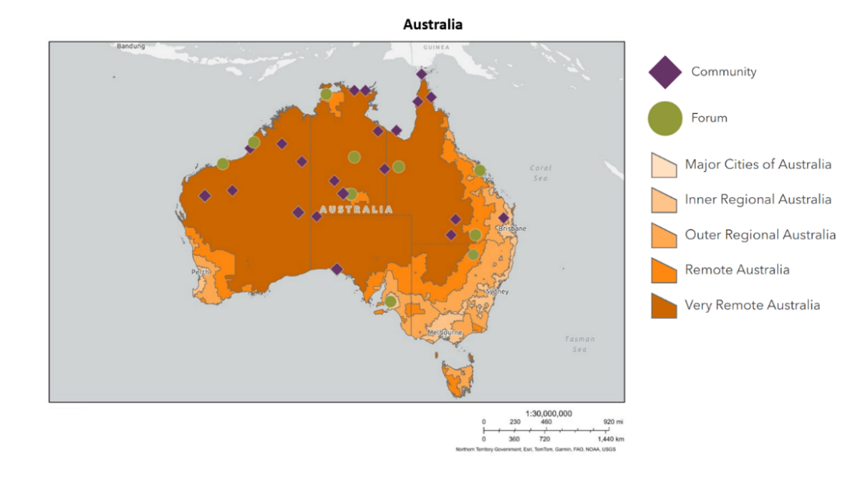
We visited communities and spoke to many people across Australia.
State | Total participants
New South Wales | 7
Northern Territory | 178
Queensland | 95
South Australia | 90
Western Australia | 134
Online workshops | 27
Online submissions | 44

What we heard
Even though we did consultations in lots of different places, we heard lots of similar ideas. The main things we heard are given below.
- Economic and Infrastructure Problems
  - Without enough money it is hard to afford healthy foods.
  - People in remote communities are keen to work. More job opportunities are needed in remote areas.
- Challenges in Community Stores
  - In some places, stores are working hard to support community to be healthy.
  - Foods in stores can be very expensive, especially healthy foods..
  - Sometimes stores don’t have enough food, or the right healthy foods.
  - It can be hard to get food into communities. This can be because transport costs are very high, roads are in bad condition or the wet season stops food being delivered.
- Health Workforce and Community Projects
  - Community members want training on cooking healthy foods and how to budget. This training could be done in schools or through job programs. The training should be available to all community members.
  - More health workers are needed to support people in remote communities to be healthy.
  - Community want support to do local projects like community gardens, fishing and farming. These projects would help people get fresh food while working.
- Traditional Practices
  - It is important to include traditional foods in plans for food security.
  - Traditional foods can include bush foods, hunting and fishing.
  - Traditional foods can help people be more healthy.
  - Traditional foods can help communities support themselves.

- Government and Decision-Making
  - Community want to see action from the government now. Community want to know what government are doing.
  - Community want to be involved in the decisions around food security.
  - Community want long term support and funding for the Strategy to make sure things are done.

The most important actions
We listened to all the ideas people had to help communities to have food security. We compared the ideas people told us with the ideas in the Discussion Paper. The ideas that the most people all came up with are considered the most important. They are copied from the Discussion Paper and shown below.

The most important actions in the Discussion Paper
Country
- Work with communities to find ways to make and grow food locally. For example: help First Nations traditional food businesses get started with loans and support; help with market gardens and other food industries like farming and fish farming.
Health
- Promote and teach healthy eating and life skills like cooking and budgeting across community.
Housing
- Make sure all houses in remote communities have electricity connected that is affordable, safe and works.
Stores
- Work with remote stores and First Nations health groups to make a national set of guidelines (Industry Code) for remote stores. Compare stores with each other and give help to stores to meet the rules.
- Help more First Nations people be more involved in running and working in remote community stores.
Supply Chains
- Make a long-term plan with governments to make roads, air, and sea transport better. This will help improve food security in remote First Nations communities.
Healthy Economies
- Make sure the Remote Area Allowance is high enough to make sure people can afford the food they need.
Policies, Practice and Governance
- Create a national group to oversee remote food security, with community controlled peak organisations as equal partners. This group will support working together and make plans to improve remote food security.
- Change Government processes to make sure policies and programs for remote food security are made and designed with First Nations people.
The other actions in the Discussion Paper are also important, but they did not come up in consultations as often.

Recommendations
We heard some ideas and actions which weren’t in the Discussion Paper. We have recommended the new ideas are included in the Strategy.

Amendments and additional actions
The new ideas and actions can be grouped into the following areas: technology and digital inclusion; housing; water and Country; tackling poverty; climate change and sustainability; and stores, supply chains and affordability.
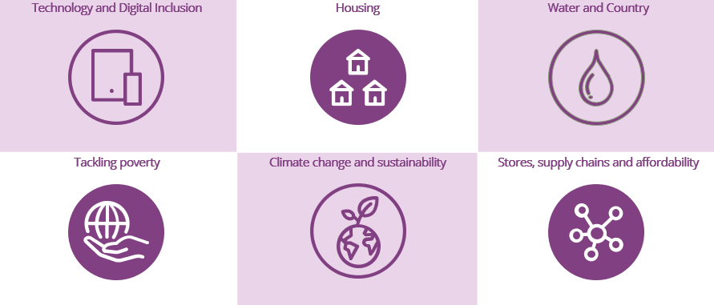

Strategy funding
Lots of people told us it is very important that funding is attached to the Strategy. We also heard that it is very important that funding can be used flexibly. For example, funding could be used to support local projects.

Education is very important
We heard lots of comments about how important education is and how it can help support food security. Participants told us it is important for the Strategy to highlight education.

What will happen next?
NIAA and Strategy Partners will keep working together. They will read this report and use it to decide how to write the Strategy. After it is written, NIAA will work with the Strategy Partners to carry out the Strategy.

Conclusion
Aboriginal and Torres Strait Islander people have done lots of work to make sure people in remote communities have food security. This project would not have been possible without the work already done. Across the country, people gave us their time and shared knowledge to help us complete this important work.
We heard about how communities are supporting and looking after each other. This work is helping to make sure everyone has access to the food they need to live long, healthy lives.
The government has listened to Aboriginal and Torres Strait Islander people and is making changes. Communities now want to see actions. Making sure everyone has the food they need is not easy, but there is a big opportunity to make changes now.


yamagigu refers to Yamagigu Consulting Pty Ltd ABN 51 165 106 712, a majority Indigenous owned company operating in a joint venture with the Australian partnership of Deloitte Touche Tohmatsu. The Australian partnership of Deloitte Touche Tohmatsu is a member of Deloitte Asia Pacific Limited and the Deloitte network. Deloitte Asia Pacific Limited is a company limited by guarantee and a member firm of Deloitte Touche Tohmatsu Limited (“DTTL”). Deloitte refers to one or more of DTTL, its global network of member firms, and their related entities (collectively, the “Deloitte organisation”). DTTL (also referred to as “Deloitte Global”) and each of its member firms and related entities are legally separate and independent entities, which cannot obligate or bind each other in respect of third parties. DTTL and each DTTL member firm and related entity is liable only for its own acts and omissions, and not those of each other. DTTL does not provide services to clients. Please see www.deloitte.com/about to learn more.
© 2024 Yamagigu Consulting Pty Ltd

Yamagigu Consulting Pty Limited prepared this report for the National Indigenous Australians Agency (NIAA) using due care and skill and drawing on community engagement. yamagigu accepts no responsibility or liability to any party other than NIAA for use of, or reliance on, its contents.

