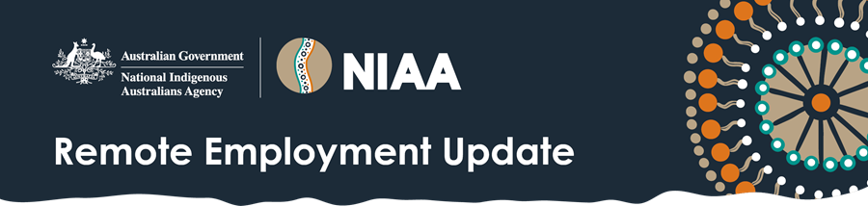

February 2026

Dear subscriber,

RJED grants now open
Grants for the third round of the Remote Jobs and Economic Development (RJED) program are now open and will close on 7 April 2026.
The Government is expanding the RJED program with a further $299 million investment over 4 years to create an additional 3,000 jobs, bringing the total to 6,000 by 2030.
Eligible employers can apply for funding to create new jobs that communities want and need in Remote Australia Employment Service (RAES) regions.
Jobs can be part-time, full-time or casual and be flexible around personal, family and community obligations.

Do you have questions about the RJED program or the Grant Opportunity Guidelines?
During the grant period, there will be public information sessions on Thursday 19 February and Tuesday 17 March about the RJED program. These sessions will cover:
- The RJED Round 3 Grant Opportunity Guidelines
- Who is eligible to apply for a grant
- The application process
- Assessment criteria
- What support is available
There will also be an opportunity to ask questions. This session will be recorded and made available on GrantConnect and the NIAA website. You can register your interest here.

Need support?
- The RJED Grant Opportunity Helpdesk will be available during the grant period from 10am -7pm AEDT.
- Contact the Helpdesk by phone: 1800 939 500 or email: RJEDHelpdesk@niaa.gov.au

Feedback on previous RJED grant rounds
Thank you to everyone who completed the RJED Grant Application Feedback Survey. The survey was open from 1 November 2025 to 1 December 2025. We will share what we heard soon on the NIAA website.

Do you have an RJED or RAES good news story that you would like to share?
We’re always looking for stories that showcase employees or job seekers and the good work that is happening in your community. If you have an idea for a story, please email: RemoteEmploymentComms@niaa.gov.au and we’ll be in touch.

Stay social and up-to-date!
Did you know that the National Indigenous Australians Agency (NIAA) now has a dedicated Facebook page where you can see stories and information celebrating Aboriginal and Torres Strait Islander peoples and cultures.

Resources available
There are a great range of resources for the RJED program available on the NIAA website

