Evaluation of the Indigenous Girls’ STEM Academy – Mid-Term Outcomes Report
0BNational Indigenous Australians Agency
Final report
November 2025


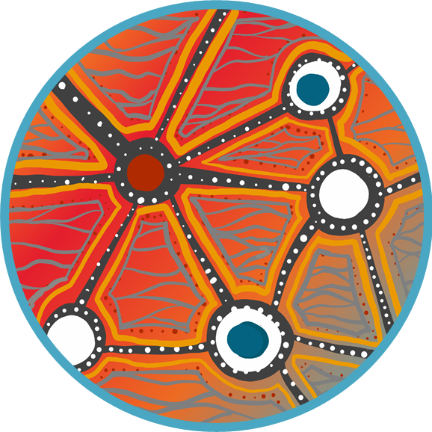
Acknowledgements
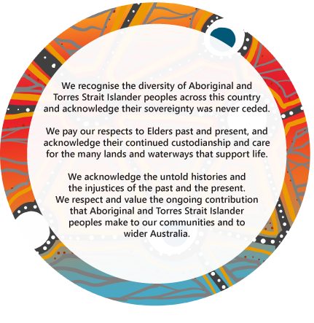
We also acknowledge the talent and artistry of Emma Walke, who designed the artwork for our acknowledgement of Aboriginal and Torres Strait Islander peoples. The design shows a story of connection to Country and people, representing the breadth of work we do with Aboriginal and Torres Strait Islander communities across Australia. The colours represent the land, and the lines in between represent the water that connects us all.

The authors would like to acknowledge the Indigenous leadership for this evaluation project that has included contributions from:
- National Indigenous Australians Agency (NIAA), specifically through its Indigenous Evaluation Committee
- Steering Committee members for both the Young Indigenous Women’s STEM Academy and the Teachers of STEM Initiative
- Indigenous service provider staff from the Commonwealth Scientific and Industrial Research Organisation (CSIRO), CareerTrackers and the Stronger Smarter Institute Limited (SSI)
- Indigenous members of the consultancy team (Julie Smith, Tammy Abbott, Holly Kovac, and previously Elizabeth Luland, Simon Jordan and Bianca Jarrett).
This evaluation was completed with the assistance of NIAA’s IGSA Team, in particular, Karen Thorne, Damian de Alwis, Jemima Walsh and Ashlen Foster-Britton. The authors would also like to thank the many key informants from CSIRO, CareerTrackers and SSI as well as all of the Indigenous Girls’ STEM Academy participants who took part in this evaluation. We thank them for their time and insights, and trust that their views are adequately represented in this document.
ARTD consultancy team
Andrew Hawkins, Paula Shaw, Natalie Martino, Julie Smith, Leah Carroll and Theebana Tharmakumar, with prior contribution by Dr Emily Yorkston, Dr Brad Astbury, Bianca Jarrett, Wendy Hodge, Elizabeth Luland, Jack Rutherford, David Watling, Simon Jordan and Dr Merrick Powell. We also acknowledge the contributions of Holly Kovac from Nama Jalu Consultants.
Ninti One consultancy team
Tammy Abbott and Anthony Rologas.

Contents
Executive summary 1
About the evaluation 2
Approach 2
Data sources and methods 2
Ethics and governance 2
Key findings – YIWSA 3
Key findings – ToSI 9
IGSA – lessons learned 16
1. Overview 19
1.1 The Indigenous Girls’ STEM Academy 19
1.2 Key Evaluation Questions 22
1.3 This report 23
2. The Young Indigenous Women’s STEM Academy 34
2.1 Overview of the initiative 34
2.2 YIWSA participant experiences 38
2.3 How well has YIWSA been implemented? [KEQs 1, 2, 3, 4] 48
2.4 To what extent is YIWSA meeting the needs of students, families, schools and communities and achieving its intended medium-term outcomes? [KEQs 5, 6] 52
2.5 Which components of YIWSA and which causal processes were most effective in generating positive change, and for whom? [KEQ 7] 67
2.6 Have there been any unintended consequences (positive or negative) associated with YIWSA with respect to the approach/actions taken? [KEQ 8] 75
2.7 Summary findings of YIWSA mid-term outcomes 79
2.8 Recommendations for the remainder of the 10-year initiative 82
3. The Teachers of STEM Initiative 85
3.1 Overview of the initiative 85
3.2 ToSI participant experiences 88
3.3 How well has ToSI been implemented? [KEQs 1, 2, 3, 4] 93
3.4 To what extent is ToSI meeting the needs of students, families, schools and communities and achieving its intended medium-term outcomes? [KEQs 5, 6] 96
3.5 Which components of ToSI and which causal processes were most effective in generating positive change, and for whom? [KEQ 7] 103
3.6 Have there been any unintended consequences (positive or negative) associated with ToSI with respect to the approach/actions taken? [KEQ 8] 109
3.7 Summary findings of ToSI mid-term outcomes 111
3.8 Recommendations for the remainder of the 10-year initiative 115
4. Discussion and conclusion 118
4.1 Lessons learned – strengths 118
4.2 Lessons learned – challenges 122
Appendix 126
Appendix 1. 127
A1.1. KEQ response summary tables 127
A1.2. Methods – strengths and limitations 135
A1.3. YIWSA program logic 139
A1.4. Program data tables and descriptives 140
A1.5. Qualitative Comparative Analysis methods 153
Connect with us 161

Abbreviations, acronyms and common terms
Academic Coordinator | YIWSA Secondary Academic Coordinator (CSIRO)
AIATSIS | Australian Institute of Aboriginal and Torres Strait Islander Studies
AIATSIS REC | Australian Institute for Aboriginal and Torres Strait Islander Studies Research Ethics Committee
Colonial load | The term refers to the expectation placed on Indigenous people to help address systemic injustices caused by colonisation, often through initiatives led by non-Indigenous Australians.
community | In this report, the term refers to Aboriginal and/or Torres Strait Islander communities.
CREST | Creativity in Research, Engineering, Science and Technology program
CRM | Customer Relationship Management (system)
CSIRO | Commonwealth Scientific and Industrial Research Organisation
EAC | Evaluation Advisory Committee
female | In this report, the term refers to people who are female and/or who identify as female, and women and girls.
IEC | Indigenous Evaluation Committee
IGSA | Indigenous Girls’ Science, Technology, Engineering and Mathematics Academy
Indigenous | In this report, the term refers to Aboriginal and/or Torres Strait Islander peoples and communities in Australia who are First Nations peoples. This term may be used when referring to a specific organisation, program or publication. In all other instances, ‘Aboriginal and/or Torres Strait Islander peoples,’ or ‘First Nations peoples,’ are used.
Indigenous Knowledge(s)/Indigenous STEM Knowledge(s) | In this report, the term ‘Indigenous (s)’ refers to the cumulative body of traditional wisdom and understanding developed by Aboriginal and/or Torres Strait Islander peoples and communities. ‘Indigenous STEM knowledge(s),’ specifically, refers to traditional knowledge systems and practices related to the fields of Science, Technology, Engineering and Mathematics.
Jardibirrijba | Three-day induction to the Mentoring and Support Pathways program for Indigenous ToSI participants, delivered by the Stronger Smarter Institute. This includes support to complete STEM teaching qualifications.
Jardi Dadarrinyi | Mentoring and Support Pathways program for Indigenous ToSI participants delivered by the Stronger Smarter Institute. This includes networking and professional development opportunities including a two-day, face-to-face component.
Jarlarla PD | An intensive, three-day professional development program for Indigenous and non-Indigenous teachers delivered by the Stronger Smarter Institute.
KEQ | Key Evaluation Question
MSP | Mentoring and Support Pathways, delivered by the Stronger Smarter Institute
NIAA | National Indigenous Australians Agency
participant | This term is used to describe YIWSA and/or ToSI participants. YIWSA participants are also referred to as ‘students’ in this report as this aligns with the terminology used by CSIRO and CareerTrackers.
PD | professional development
providers | YIWSA (CSIRO and CareerTrackers) and ToSI Teams
QCA | Qualitative Comparative Analysis
SSI | Stronger Smarter Institute Limited
STEM | Science, Technology, Engineering and Mathematics
student | YIWSA participant
Student Advisor | YIWSA Tertiary Student Advisor (CareerTrackers)
ToSI | Teachers of STEM Initiative
ToSI Team | ToSI staff collaborating to deliver the components of ToSI
YIWSA | Young Indigenous Women’s STEM Academy
YIWSA Team | CSIRO and CareerTrackers personnel collaborating to deliver the components of YIWSA

Executive summary
The Indigenous Girls’ Science, Technology, Engineering and Mathematics (STEM) Academy (IGSA) is a national $25 million investment to support high-achieving Aboriginal and/or Torres Strait Islander women and girls who aspire to study and secure jobs in STEM professions. It is being delivered over 10 years (2018–2028) and comprises two initiatives:
Young Indigenous Women’s STEM Academy (YIWSA) delivered by the YIWSA Team, a consortium between the Commonwealth Scientific and Industrial Research Organisation (CSIRO) and CareerTrackers. The $20 million initiative has high school and tertiary components.
Teachers of STEM Initiative (ToSI) delivered by the Stronger Smarter Institute (SSI), is a $5 million initiative that includes individualised Mentoring and Support Pathways (MSP) and a Professional Development (PD) program for STEM educators (Jarlarla).
Figure 1: IGSA, its initiatives and components
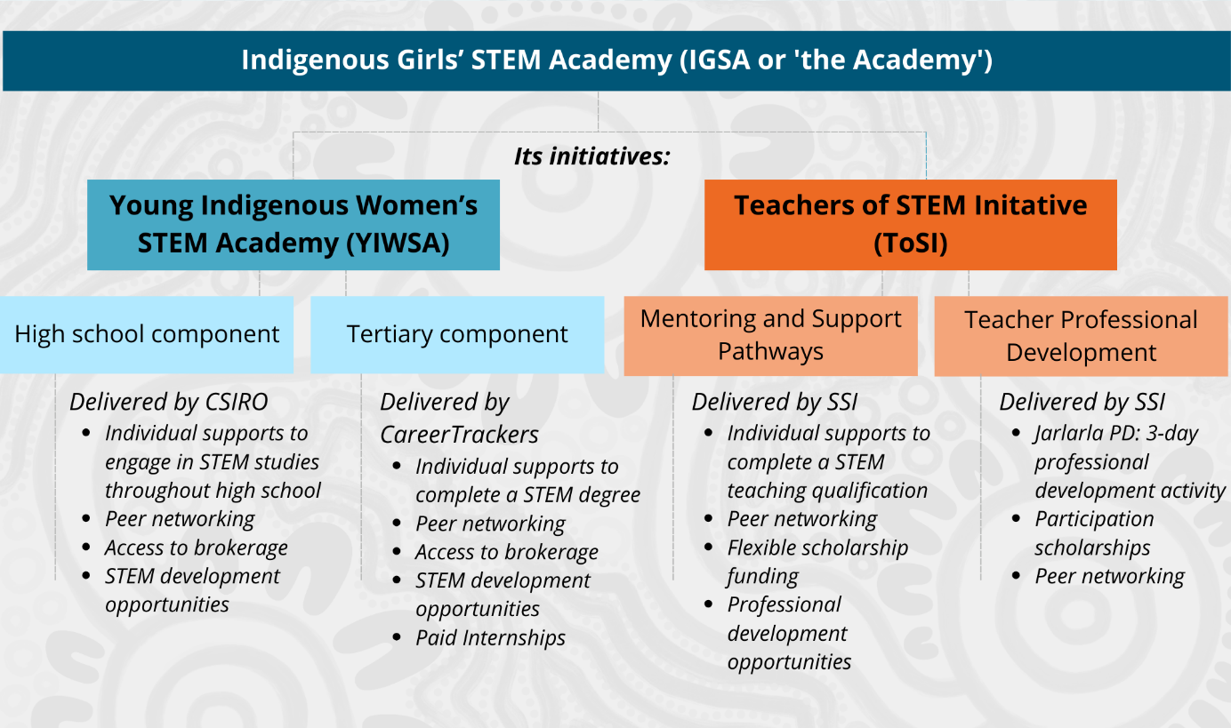

About the evaluation
National Indigenous Australians Agency (NIAA) commissioned ARTD Consultants, in partnership with Ninti One,0F to conduct a Process (Phase 1) and Mid-Term Outcomes (Phase 2) evaluation of IGSA. The findings and recommendations of this report will inform the ongoing implementation of IGSA (to 2028) and any future evaluation activities.

Approach
The Evaluation Team placed cultural responsiveness and methodological rigour at the heart of the evaluation approach, aiming to draw together a valid evidence base to support genuine improvements for the Indigenous women engaged in IGSA, as well as their families and communities.

Data sources and methods
A mix of qualitative and quantitative data sources and methods was used for this evaluation. These included consulting with YIWSA and ToSI participants through interviews, surveys and yarning circles.
In addition, YIWSA and ToSI Team members as well as a range of other stakeholders participated in interviews. Over 120 people participated in this evaluation. Administrative and financial data as well as research literature were also reviewed and analysed.
Analyses of data sets included descriptive, thematic and qualitative comparative approaches. Please refer to Section 1.3.5 for more detailed information about the evaluation methodology.
There were some limitations with regard to the availability of some administrative data and small sample sizes for some groups of interviewees.

Ethics and governance
The ethics approval process for this report involved staged submissions to the AIATSIS Research Ethics Committee (REC). Each stage received approval (Ethics ID: EO207-20210611).
Governance of the evaluation is provided by two groups: the Evaluation Advisory Committee (EAC) and the NIAA’s Indigenous Evaluation Committee (IEC).
The evaluation embeds Indigenous leadership in its design, implementation and governance, through collaboration with Indigenous Evaluation Team members (from ARTD Consultants, Nama Jalu Consulting and Ninti One), as well as with the NIAA project team, the EAC and the IEC.

Key findings – YIWSA

How well has YIWSA been implemented? [KEQs 1, 2, 3, 4]1F
Overall, YIWSA has been implemented as expected, with some variations, such as higher than planned use of virtual modalities in response to COVID-19.
The high school component has location-specific and high school grade-specific cohorts in Queensland, New South Wales, Western Australia and Tasmania/Victoria (as a single cohort), South Australia and the Northern Territory as well as the National Cohort (which mostly takes part online).
YIWSA has exceeded its mid-term recruitment target of 600 by 14 participants. As of mid-2024, 548 students have participated in the high school component. Of these, 262 transitioned, and 207 continued to be engaged with the tertiary component. Additionally, 66 participants joined the tertiary initiative while they were in university. A total of 30 participants have graduated from university, with 30 earning a STEM qualification. (For the full breakdown, see appendix Table A10 and Table A29.)
The evaluation found that the majority of participants are regularly receiving individual supports. Initiative activities such as STEM Camps, National Assemblies and tertiary internships are occurring regularly as planned (since restrictions related to the COVID-19 pandemic have been lifted).
Figure 2: YIWSA high school component – participation overview
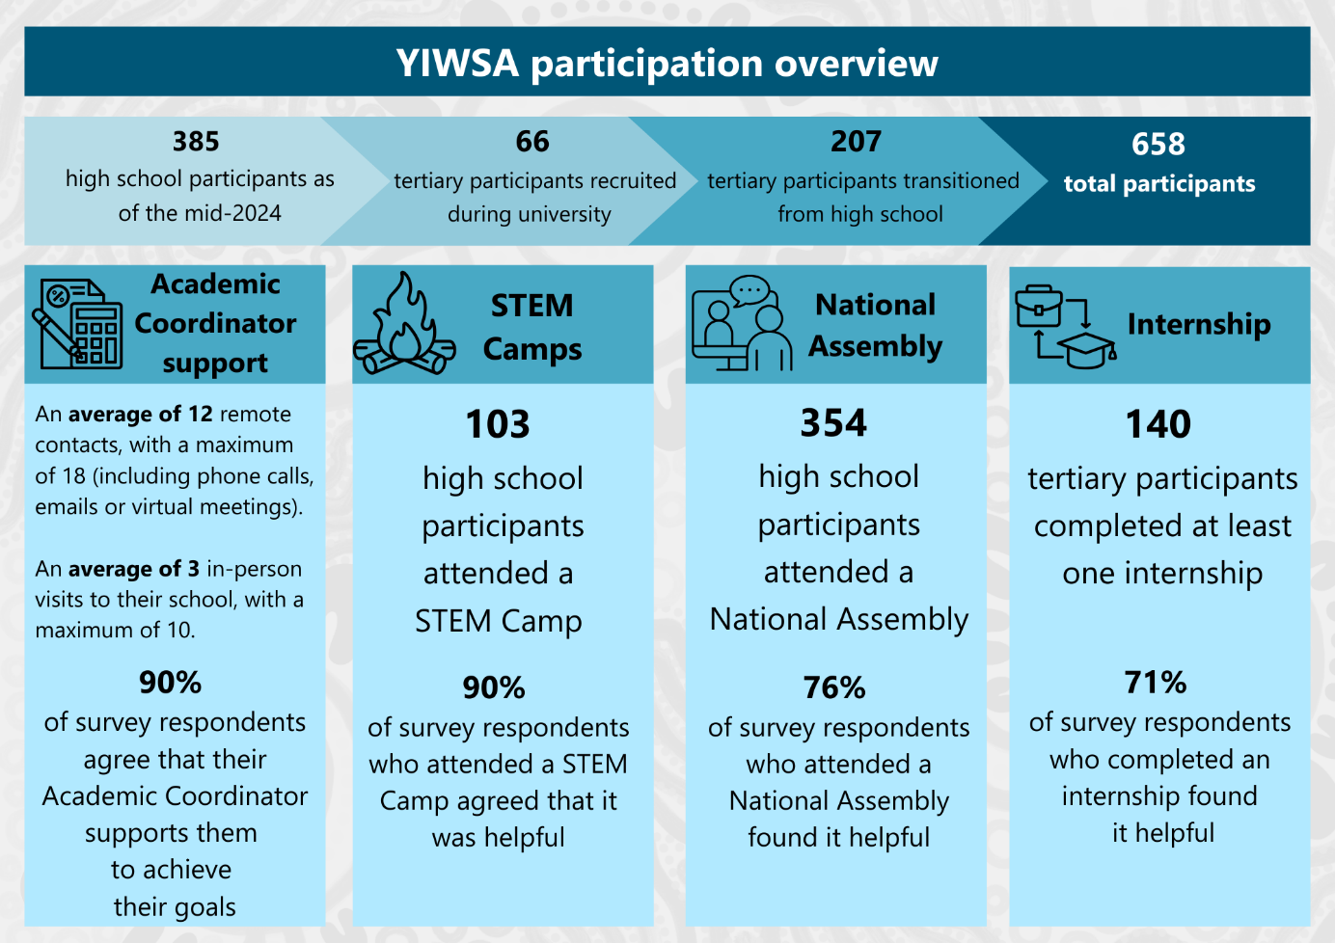
Note: High school participation data does not include data before January 2023. The contact data was averaged across all cohorts, including Years 8, 9 and 10, who have more frequent contact and Years 11 and 12, who receive less frequent contact due to high school workloads.
Source: YIWSA tertiary data CRM database – participant data: January 2018 – June 2024. YIWSA high school data collection tool – participant data: January 2023 – June 2024.

To what extent is YIWSA meeting the needs of students, families, schools and communities and achieving its intended medium-term outcomes? [KEQs 5, 6]

Overall, the evaluation has found that YIWSA is delivering well against the expected medium-term outcomes and appropriately meeting the needs of participants, their families, schools and communities.

Medium-term outcome 1: Participants achieve personal and academic goals.
Interview, survey and administrative data for YIWSA high school participants demonstrates that the majority of participants have regular one-on-one contact with their Academic Coordinator. Academic Coordinators are providing highly valued individualised support and ensure participants in their cohort are well informed about upcoming events and opportunities.
Individual support for tertiary participants is being delivered by Student Advisors. The evaluation has found that this support is of a high quality but is not consistently delivered to all tertiary participants.

Medium-term outcome 2: Participants’ wellbeing is supported.
Participant wellbeing is supported through culturally safe relationships with their Academic Coordinator or Student Advisor. These roles include facilitating access to flexible financial support (brokerage). This has allowed participants to address challenges and barriers to their participation by buying equipment, joining professional associations, taking part in PD opportunities and meeting expenses associated with commencing tertiary studies. Supporting participant wellbeing also underpins participants achieving their personal academic goals (as under Medium-term outcome 1).

Medium-term outcome 3: Participants provide support for one another and become role models/mentors.
Participants have forged strong relationships with one another through YIWSA activities. They noted that having a sense of a connected, like-minded peer group was highly motivating for them to further their studies and to achieve their STEM study or career goals. The YIWSA Team and participants share a strong ethic of reciprocal responsibility, with many participants and alumni providing role-modelling and support to other participants and beyond.

Medium-term outcome 4: Participants develop strong professional networks that support future employment.
STEM camps and tertiary internships helped provide participants with STEM learning opportunities and exposure to a broad range of STEM professions and also helped them develop peer and professional networks.
Participants credited opportunities to engage with STEM professionals with expanding their awareness of STEM professions. They said these opportunities supported them to establish a professional network and, critically, to develop their confidence to pursue STEM studies and careers.

Medium-term outcome 5: Indigenous families and communities value young women’s STEM education.
In interviews, family members of participants, YIWSA Team members and school and community stakeholders agreed that YIWSA supports families and communities to learn more about the STEM professions that are possible for their young women. This happens through the culturally safe relationship-based service delivery model whereby Academic Coordinators liaise closely with family members to ensure they’re properly informed about and consenting to the activities and opportunities available to their young women.

Medium-term outcome 6: Indigenous STEM knowledge is recognised and valued.
Interview, survey and administrative data demonstrate that Indigenous STEM knowledge is an integral part of YIWSA activities. Participants have regular opportunities to learn from Indigenous STEM professionals and to share and grow their Indigenous STEM knowledge. Participants highlighted that this aspect of the initiative was inspiring and motivating for them.

Which components of YIWSA and which causal processes were most effective in generating positive change, and for whom? [KEQ 7]
The evaluation found some causal processes of YIWSA were consistently most effective in generating positive change, including:
- participants having a strong and supportive relationship with their Academic Coordinator
- participants being aware of and participating in available opportunities.
The Qualitative Comparative Analysis (QCA) identified some factors that predict a participant will have a high level of engagement with and likely success in the initiative:
- having a strong relationship with and support from their Academic Coordinator
- having prior motivation/passion to engage in STEM and knowing what is available and participating in what they are interested in
- having strong supports outside of the initiative and knowing what is available and participating in what they are interested in.
The analysis found that those participants most likely to engage in YIWSA activities are those who have high levels of interest in STEM and who have strong supports from their families and schools in addition to the supports they receive as participants of YIWSA.

Have there been any unintended consequences (positive or negative) associated with YIWSA with respect to the approach/actions taken? [KEQ 8]
There have been some unintended consequences related to the age-grade approach to place-based cohorts in the high school component. These relate to unintentionally excluding some potential participants due to their age.
The logistical challenges of providing in-person support to students across some vast regions is also taxing on Academic Coordinators.
A related issue is managing the transition of students between the high school and tertiary components. With the age-grade cohort approach, as students mature into the tertiary component, the staffing requirements shift between providers. CSIRO and CareerTrackers are working together to refine the transition processes and ensure enough staff are available to support this; however, administrative, interview and survey data all indicate that some participants have already had negative transition experiences.
A review of YIWSA tertiary administrative data indicates that approximately one in ten tertiary participants (11%) are studying in fields unrelated to STEM, such as design and creative industries. It is to be expected that not all participants will remain engaged in STEM studies long enough to complete a tertiary STEM qualification. Both providers have a strong ethic of inclusivity, and endeavour to find ways to keep participants engaged in STEM studies. They have developed a policy which allows them to support all of the high-school YIWSA participants for 12 months post-secondary studies. Participants who are no longer pursuing STEM qualifications after that time are then exited from the program.

Recommendations for the remainder of the 10-year initiative
The evaluation has identified four recommendations for the remainder of the initiative.
With regard to maximising engagement and participation in the initiative:
- YIWSA providers should refine the practices around planning face-to-face peer learning opportunities to increase participation rates at STEM Camps and other events. This may include:
- seeking additional guidance from parents regarding any potential barriers to participation
- offering additional camp-type opportunities for participants in higher year levels (noting STEM camps have been intended for students in Year 9, early in their engagement with YIWSA)
- considering possibilities for cross-cohort, interest-focused, in-person learning opportunities.
With regard to improving the transition experience for participants moving from the high school to the tertiary component:
- YIWSA providers should refine the processes for transitioning participants from the high school to the tertiary component. This should include:
- ensuring participants can access elements of the CareerTrackers service appropriate to high school students while they are still being supported by a CSIRO Academic Coordinator – that is, having a period of overlap where students are accessing support through both CSIRO and CareerTrackers
- ensuring a warm handover for every participant moving from support from an Academic Coordinator (CSIRO-managed high school component) to support from a Student Advisor (CareerTrackers managed tertiary component), including:
- effective contact information for the participant
- background information about their STEM interests and career goals
- relevant personal information – for example, particular cultural considerations or learning needs
- consideration should be given to shifting the timing of the full transition to the tertiary component occurring mid-way through the first-year post-schooling. This would allow Academic Coordinators to offer continuity of support for participants through their final exams, and to have more information about if, and if so, what and where each participant is studying after graduating from Year 12. Further, knowing the institution that participants have enrolled in would enable CareerTrackers to allocate Student Advisors more effectively
- ensuring the resourcing balance between providers reflects the changing workload as more participants transition between providers. For example, consider whether existing YIWSA High School Team members can provide support to participants in the tertiary component.
With regard to ensuring data collection will sufficiently inform any future evaluations:
YIWSA providers should refine data collection practices to ensure that data collection is occurring consistently across the whole YIWSA Team and there are data linkage capabilities between CSIRO and CareerTrackers. Data collected should include:
- accurate information about participants’ subject choices (including at high school) and fields of study
- information on graduation (including areas of specialisation), as well as information about participants who have withdrawn from their studies
- information on participants’ employment outcomes, including fields of employment.

Considerations for the future of the initiative
The evaluation has identified two key considerations should the initiative be funded beyond 2028:
- The service provider should review the age-grade cohort approach and investigate other potential structures for any new groupings of students. This should include:
- being able to include participants across multiple grades (i.e. Year 9 through to 12) who are interested in STEM
- focusing on a smaller number of schools where there may be fewer other opportunities available for students
- ensuring the geographic reach of each cohort is realistically and sustainably able to be covered by a single Academic Coordinator.
- The service provider should investigate opportunities for participants whose interests are not STEM related to be supported by other, similar initiatives. This should include developing relationships with providers of similar initiatives and ensuring each participant is matched with the most appropriate support.

Key findings – ToSI

How well has ToSI been implemented? [KEQs 1, 2, 3, 4]2F
The original components of ToSI were implemented somewhat effectively, with the number of participants recruited nearing targets for both MSP and Jarlarla. While the early stages of implementation were substantially impacted by the COVID-19 pandemic (planned in-person events were postponed or held virtually), since early 2022, activities have been delivered largely as intended. During some periods when key positions within the ToSI Team were vacant (Mentors), some elements of service delivery were compromised.
MSP has had 89 enrolled participants, 25 of whom have subsequently withdrawn, and a further six have deferred their studies. Jarlarla PD has been delivered to a total of 82 participants. Of the MSP participants, eight have completed their teaching qualifications. An additional six participants are in final quarter of their studies. However, the highest proportion of participants – 55% – are still in the first quarter of their studies.
While at the mid-point of the initiative, the number of participants who have graduated and commenced teaching is small (n=8), this number is expected to increase over time as more participants complete their studies.
Figure 3: MSP – participation overview
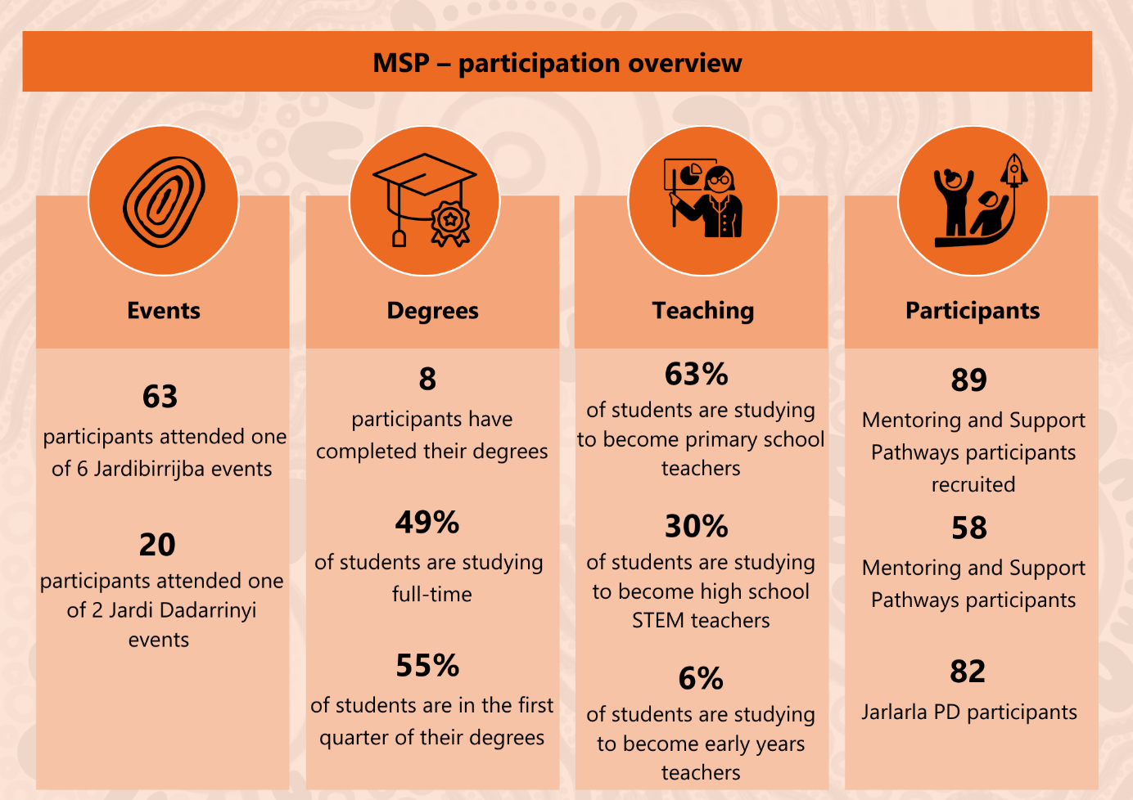
Note: MSP participant numbers are for enrolled participants as of June 2024 and excludes those who have withdrawn (n=25) or deferred (n=6). The 6% of students studying to become early years teachers are enrolled in teaching degrees that include specialist STEM subjects. To be eligible to participate, these students must complete four such subjects as part of their degree.
Source: SSI ToSI data CRM database – participant data: January 2020 – August 2024.
ToSI Team members, participants and external stakeholders agreed that the MSP component of the initiative is well designed. External stakeholders highlighted that the combination of financial support and cultural and professional mentoring, as well as the peer connection facilitated through in-person PD, is an effective holistic package that is unusual in the world of tertiary scholarships.
ToSI is being implemented both in response to and in the context of a national teacher shortage. The initiative incentivises participation through the provision of mentoring support as well as financial support. However, some of the issues that underlie the teacher shortage – such as the high expectations of teachers to manage the behaviour of and provide support to students with diverse and high needs, the high administrative and reporting load and the relatively low pay compared with other professional roles – create a challenging context for recruiting participants.

To what extent is ToSI meeting the needs of students, families, schools and communities and achieving its intended medium-term outcomes? [KEQs 5, 6]

The evaluation has found that ToSI is delivering against the intended medium-term outcomes and, in most cases, meeting the needs of its participants, their families, schools and communities.

Medium-term outcome 1: Trusted relationships are established, enabling participants to access appropriate support, feel empowered to succeed, and cultivate a strong sense of identity and shared responsibility.
ToSI is delivering culturally safe services, in relationship with participants and stakeholders.
[MSP has helped me] by allowing me the time, energy, emotional and financial support I need to complete my degree. – MSP participant (survey response)
Interview data suggests that individualised support through mentoring is effective for supporting participants to navigate their university experience. Participants appreciated that their Mentors were able to offer holistic support that recognised the broader challenges of balancing their studies with their work, family and community responsibilities.
Flexible financial support (scholarships) enables participants to undertake STEM teaching degrees, with many participants identifying that they would not be able to participate without this support. The scholarship amount is fixed but able to be used flexibly, allowing participants to utilise this money as it suits their individual needs. Some participants have used their scholarship funds to pay their tuition fees, while others have used the funds to subsidise their living costs while they complete their unpaid teaching practicum.3F
The ToSI Team has encountered some challenges in being able to recruit and retain appropriate staff to deliver the mentoring support and program coordination roles. SSI is aware that it has not always been able to provide all participants with a Mentor they can connect with on a regular or sufficiently frequent basis. While the team members have worked together to respond whenever a participant has reached out for support, including when mentoring staff have not been available, they believe that greater availability of Mentors would strengthen the initiative.
Over half (n=6) of the 14 MSP participants who were interviewed reported having had insufficient support from their Mentors or not having a Mentor. A substantial proportion of MSP participants who completed the survey did not have a strong relationship with their Mentor (19%, n=4) and did not receive regular communication from their mentor, such as monthly support sessions (25%, n=6). Others did not have a Mentor or know who their Mentor was.
For the Jarlarla PD, participation scholarships are used to allow some MSP participants who are already teachers to attend.
In-person learning opportunities are a key strength, with the ToSI Team and participants noting these provide critical opportunities for participants to develop deep and authentic relationships with one another. Participants noted that in-person networking opportunities motivated them to continue participating in MSP.
Coming to these events reignites that fire. It is likely to get burnt out with study, work and family. Coming to the meet reignites that fire – they are so valuable. – MSP participant (yarning circle contribution)

Medium-term outcome 2: Participants are accepted into STEM-specialised teacher courses, successfully transition into university life, and progress steadily through their degree coursework.
ToSI has successfully recruited 89 participants into MSP who have been accepted into STEM specialised teacher education courses. Many participants are balancing their studies with work and care-giving responsibilities and are studying part-time. Of the 89 participants recruited, 25 have withdrawn and a further six have deferred their studies. This is a high rate of withdrawal, which raises some concerns about whether ToSI will be able to reach its targets. The withdrawal rate indicates that additional support may be required to assist participants to balance their commitments and to be retained in the initiative.
Nevertheless, the majority of participants who have been recruited to the MSP are continuing their studies and eight participants have successfully graduated.

Medium-term outcome 3: Participants receive appropriate pastoral supports and culturally supportive environments at their university.
Data available to the evaluation suggests that MSP participants have varied experiences of receiving support at their university, dependent largely on the extent to which their university has an effective and well-resourced Indigenous Support Unit. The service design includes ToSI Team members working collaboratively with staff of Indigenous Support Units to better meet the needs of participants. In interviews, ToSI staff discussed how they had difficulties in developing and maintaining relationships with staff of Indigenous Support Units at universities, observing that these units were typically under resourced, and staff were very busy. The initiative’s design emphasises broad accessibility – it is not restricted by the institution where a person is studying or where they live. This means that the relationship-building and administrative workload of the initiative is high for the number of participants involved.

Medium-term outcome 4: The education community recognises the role of Indigenous Knowledges in enhancing pathways to STEM careers.
The evaluation found that ToSI is working toward this outcome through the aspects of the initiative that focus on strengthening and sharing Indigenous STEM Knowledges, including much of the in-person workshop content for Jardibirrijba and Jardi Dadarrinyi. The discussions that take place in the workshops have a strong focus on Indigenous approaches and knowledges. Participants are encouraged to recognise their existing Indigenous STEM knowledges as well as participating in on-Country learning with Traditional Owners.
Interview data confirms that these events, as well as Jarlarla PD, are helping participants link Indigenous STEM Knowledges to the Australian Curriculum and learn how to demonstrate this link in a classroom.
It has been the key to bringing Indigenous perspectives into my science classes. Before the training it was something I wanted to do but didn’t know how or feel confident with. Now I feel empowered to develop and run lessons with IK [Indigenous Knowledges] at the core. – Jarlarla participant (survey response)
Interviewees also talked about their desire to help other teachers to embed Indigenous STEM Knowledges into the curriculum.
Some Jarlarla PD participants need further support to implement their learnings. In interviews and survey responses, some Jarlarla PD participants indicated that they had struggled to implement what they had learnt at the PD. Barriers to implementation included not having the time to develop resources that incorporate their PD learnings, not having buy-in from their school leadership and not having sufficient connection to their local Indigenous communities. There is an opportunity to improve delivery of this component of the initiative by offering facilitated follow-up networking for participants to share their learnings.

Which components of ToSI and which causal processes were most effective in generating positive change, and for whom? [KEQ 7]
All data sources highlighted the importance of financial support as a key component of MSP. Of the survey respondents, 96% (n=23) rated financial support as extremely important or very important for achieving their STEM learning goals. Many participants emphasised that their tertiary studies would not be possible without the financial support offered. This was especially the case for women who were managing work and family responsibilities in addition to their studies.
The flexible approach to the scholarship funding, whereby participants are able to utilise this money as it suits their individual needs, is a key strength of the initiative. Some participants have used their funds to subsidise their living costs while they complete their unpaid teaching practicum.4F
ToSI supports participants to manage colonial load.5F The ToSI Team explicitly acknowledges the colonial load that Indigenous teachers are often asked to carry in addition to their teaching work and reflect that Indigenous teachers are often expected to take on a host of roles within their schools that are not teaching-related, and are unpaid and not recognised with time in lieu or time off class. ToSI Team members and MSP participants have described the difficulty of maintaining their own wellbeing while meeting the demands associated with wanting to support Indigenous students and their communities. To address this concern, the ToSI programming provides MSP participants with strategies to support their wellbeing and to respond to requests in ways that highlight the additional work involved.
Interview and survey data show that mentoring (when delivered as intended) is a highly effective causal process for MSP participants who utilise it for academic, work–life balance and cultural support.
Evidence from interview data suggests that MSP participants who have a range of supports in addition to that provided through the MSP, such as from family, their school or their university’s Indigenous Support Unit, are more likely to complete their teaching degree.
The evaluation was not able to interrogate the reasons for withdrawal and deferral; however, the high rate of withdrawal may suggest that additional supports or conditions were necessary to enable participants to continue in their studies.

Have there been any unintended consequences (positive or negative) associated with ToSI with respect to the approach/actions taken? [KEQ 8]
There have been unintended consequences from delivering the MSP as it has national reach and does not restrict which tertiary institutions participants can be enrolled. While intended to maximise reach and accessibility, this creates an administrative and relationship-building workload for ToSI staff that is high for the number of participants involved.

Recommendations for the remainder of the 10-year initiative
The evaluation has identified seven recommendations for the remainder of the initiative.
With regard to reaching the target number of participants:
- SSI should review the approach to recruiting the remaining target number of participants into MSP. This should include:
- identifying universities where there are strong existing relationships and where there are strong Indigenous Education Units for targeted recruitment efforts
- identifying alternative pathways (i.e. not through the Indigenous Education Unit) for finding potential eligible participants, such as working directly with staff from universities’ school or faculty of education
- drawing on existing relationships (e.g. with YIWSA) to support direct recruitment
- targeting participants who are already somewhat progressed (have completed at least one year of their course) in their education tertiary qualifications to ensure newly recruited participants can be supported to completion.
With regard to providing support for participants to the completion of their studies:
- NIAA and SSI should agree on a plan for managing appropriate support for participants who have not finished their degrees when funding ceases in 2028. This could include a process that, at a minimum, would allow access to remaining scholarship funding for individual MSP participants who are continuing with their tertiary teaching program but who have not completed their studies by the end of the program funding period.
To reduce the rates at which students withdraw or defer from MSP:
- SSI should develop an appropriate needs assessment tool for MSP participants to identify those who may need more support to complete their STEM teaching degrees. It should provide participants with higher needs with additional mentoring support and/or provide them a warm referral to other appropriate services as needed.
With regard to initiative staffing:
- SSI should ensure continuous availability of appropriate mentoring support. This should include:
- reviewing the position description and expectations of the role to ensure these are realistic (and will attract applicants) and meet the needs of participants. It may be that less experienced Mentors could be recruited and then trained and supported by other ToSI Team members
- ensuring Mentors have management and coordination support through the initiative leadership
- managing the workload of Mentors so that they can, for example, maintain monthly check-ins with participants and follow up on their support needs, and attend in-person events; it is suggested that a Mentor has no more than 30 participants to support.
- SSI should ensure ToSI leadership roles are appropriately staffed, with the full allocation of FTE positions filled.
With regard to adapting to teacher shortage issues impacting in-person PD events:
- SSI should consider options for delivering in-person PD in a way that may support more applicants to be able to attend. This may include reducing the length of the in-person component – for example, to two days, instead of three – and having pre and/or post sessions that are delivered virtually and outside of school hours.
With regard to improving outcomes for schools through the Jarlarla PD:
- SSI should provide facilitated participant networking for Jarlarla PD. This may include hosting a virtual community of practice session for alumni that occurs regularly – for example, once per term.
With regard to ensuring effective future evaluation:
- SSI should refine data collection practices to ensure data collection supports future internal review and external evaluation. Data collected should include accurate information about the frequency and type of engagement with participants – for example, on how often they are checking in with Mentors; on post-graduation employment outcomes; and on participants who have withdrawn from their studies.

Considerations for the future of the initiative
The evaluation has identified some additional considerations for the future of the initiative were it to be funded in the longer term. These are:
- The service provider taking a targeted approach to minimise ToSI Team administrative load, partnering with selected universities with strengths in delivering STEM teaching degrees.
- The service provider working with NIAA and other agencies to identify potentially productive partnerships with providers of other like initiatives, at both a national and jurisdictional level (e.g. the Queensland Remote Teacher Education Program).
- The service provider investigating opportunities to provide support to teachers in their first year of practice, potentially through assigning them an MSP alumnus ‘buddy.’

IGSA – lessons learned
The IGSA program has several key activities that represent good practice in delivering similar initiatives. These activities, highlighted below, should be considered for future service design of similar initiatives.
A unique aspect of IGSA is its focus on Indigenous women in leadership and key implementation roles. This has created culturally safe environments for participants, allowing them to engage fully and deepen their cultural knowledge and understanding. The strong Indigenous leadership has contributed to individual, family and community empowerment, fostering trusting relationships and opening doors to careers in STEM.
Most of the initiatives include mentoring or individualised support, which has been highly valued by participants. This support helps participants navigate their studies in a culturally safe manner and provides a wide range of tailored assistance, including assistance with balancing study, work and cultural obligations.
Participants are connected with various STEM learning activities, including sharing Indigenous STEM knowledges through camps, workshops, online forums, work experience and internships. These experiences have been crucial in promoting participant engagement and presenting Indigenous STEM Knowledges as an integral part of scientific learning.
The initiatives activities support the development of peer networks with in-person opportunities key in building meaningful connections, while virtual forums help maintain these networks. The activities also allow participants to develop professional networks with opportunities to work with experienced STEM professionals and educators, helping them gain knowledge and experience across STEM fields and supporting their transition into employment.
The development of confidence is crucial for empowerment, as it enables individuals to take action. The initiatives provide opportunities for participants to be recognised for their abilities, enhancing self-esteem and confidence. The IGSA initiatives emphasise giving back to the community, supporting participants in becoming leaders and role models.
Flexible financial support has been a key enabler for participation. This flexible support helps participants meet their educational and living expenses, reducing barriers to participation.

Lessons learned – challenges to consider
Clear processes for exiting participants whose interests diverge from STEM are needed, and must be managed empathetically to facilitate these participants’ transition to other supports.
Participants with multiple care-giving, work and community responsibilities require higher levels of support. Ensuring equity of opportunity through needs assessment and additional supports is essential.
In any national program, delivering equity of access for those living in more rural and remote areas is very challenging and costly. Virtual modalities help, but place-based initiatives may be more effective for very remote participants.
Recruiting and retaining appropriate staff, especially Indigenous women with STEM qualifications, is challenging.
Programs need to consider how best to maximise the impact of the outcomes they achieve. Balancing support for well-resourced participants with support for those having fewer advantages is important. Well-resourced participants can provide peer role-modelling, while supporting those with fewer resources can maximise the program’s impact.

Overview

The Indigenous Girls’ STEM Academy
The Indigenous Girls’ Science, Technology, Engineering and Mathematics (STEM) Academy (IGSA) is a national $25 million investment by the Australian Government to support high-achieving Aboriginal and/or Torres Strait Islander women and girls who aspire to study and secure jobs in STEM professions. It is being delivered over 10 years (2018–2028) and comprises two initiatives:
Young Indigenous Women’s STEM Academy (YIWSA) delivered by the YIWSA Team, a consortium between the Commonwealth Scientific and Industrial Research Organisation (CSIRO) and CareerTrackers. The initiative has high school and tertiary components.
Teachers of STEM Initiative (ToSI) delivered by the Stronger Smarter Institute (SSI), which includes individualised Mentoring and Support Pathways (MSP) and a Professional Development (PD) program for STEM educators (Jarlarla).
Figure 4: Summary of YIWSA and ToSI
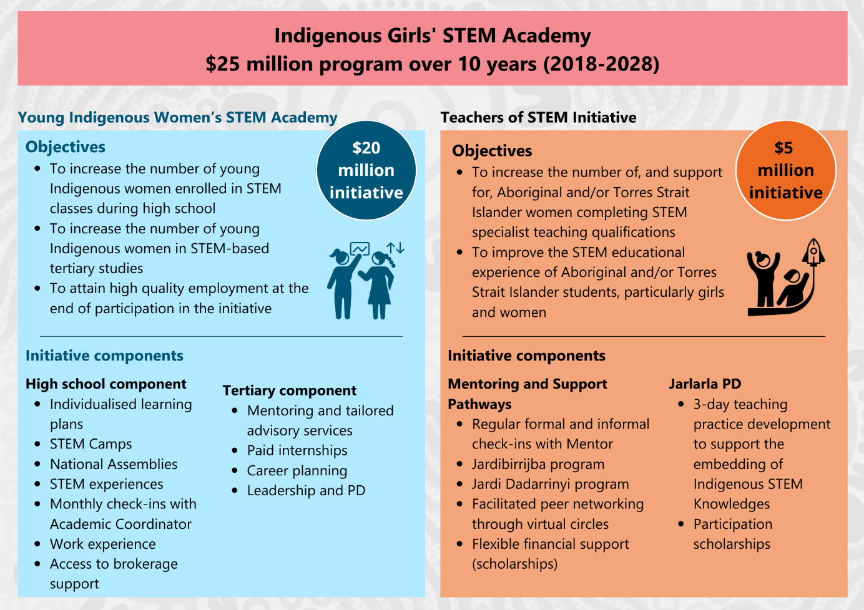

Indigenous-led program
This program differs from other STEM education programs both in terms of the target group (Indigenous women), and in the way in which it is delivered: that is, with Indigenous leadership and with culturally safe and supportive program design and delivery mechanisms.
The initiatives are being delivered by organisations with strong cultural capabilities and target the employment of Aboriginal and/or Torres Strait Islander people. Both initiatives work with high schools, tertiary education providers, local community members and STEM employers, and are supported by separate steering committees. These committees draw on the expertise of a mix of mostly female representatives from NIAA, provider organisations, Aboriginal and/or Torres Strait Islander organisations, STEM industries and academia. YIWSA was also guided by an Advisory Group in the planning and early implementation stages. This group included local community representatives who provided insights into local community organisations and activities. Once all cohorts were established, the group was disbanded at the end of 2023.
The three organisations delivering initiatives as part of IGSA share a long-term commitment to participants and communities, and to making Indigenous Knowledges more visible in STEM. Each organisation approaches these commitments differently in the initiatives they are delivering. These shared principles are reflected in a theory of change for IGSA as a whole. As shown in Figure 5, the principles inform and guide the work that is done within each initiative to activate causal processes, which contribute to achieving outcomes at multiple levels, including for students and families, teachers and schools, organisations and community, and institutions. The theory of change should be read from top to bottom:
- At the top tier are key principles that guide the work of Academy providers.
- The second tier describes core components and strategies of YIWSA and ToSI.
- The third tier articulates a range of causal processes expected to bring about the desired outcomes.
- The fourth tier is the stakeholders IGSA will impact – students and families, teachers and schools, organisations and communities, and institutions.
In summary, the theory of change identifies five shared principles that inform the YIWSA and ToSI components and strategies identified in Tier 2, including privileging Indigenous Knowledges; taking a holistic and strengths-based approach; focusing on social and emotional wellbeing; reciprocity; and long-term commitment.
YIWSA and ToSI offer culturally safe spaces for participants. They provide resources and opportunities that are anticipated to activate changes in participants’ capabilities and motivation and facilitate the setting of high expectations and formation of strong identities. The initiatives are also hoping to activate causal processes relating to individual, family and community empowerment, trusting relationships, changed mindsets and opening doors to careers in STEM.

Figure 5: Theory of change for IGSA
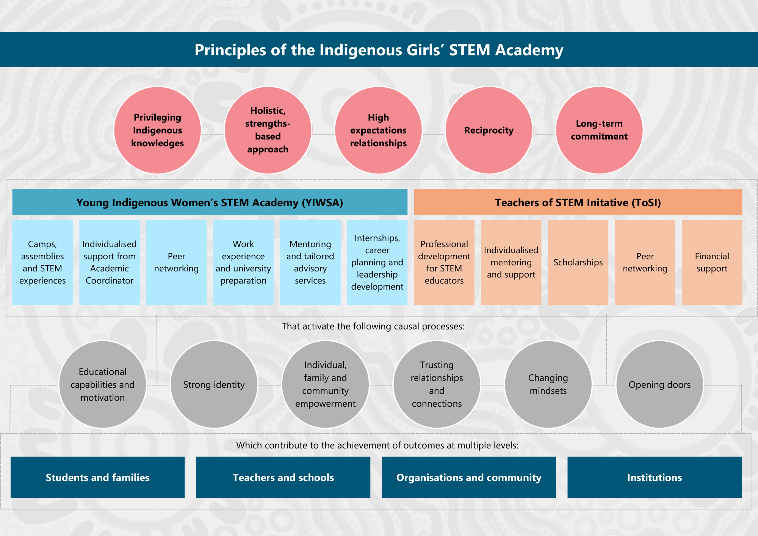

Key Evaluation Questions
This evaluation seeks to respond to a set of Key Evaluation Questions (KEQs) that have underpinned and guided the approach – see Table 1. Table A1 to Table A4 in the Appendix provide summary answers in response to these questions.
Table 1: Phases 1 and 2 – Mid-Term Outcomes Evaluation
Question number | Question
1 | How well were the original components of IGSA implemented, and were they implemented as intended? What changed during delivery and why?
2 | What specific factors are facilitating or inhibiting successful implementation?
3 | Which components of the program and its initiatives are working best for whom, under what conditions and why/how? (for example, place-based, targeting university partners)
4 | How well have resources been used to deliver IGSA?
5 | To what extent are the initiatives’ delivery mechanisms meeting the needs of students, families, schools and communities, and how can these be improved to strengthen the achievement of outcomes?
6 | How successful have the initiatives been in achieving and/or contributing to short-, medium- and longer-term outcomes anticipated in the program logic models?  In relation to YIWSA:  - What contribution has YIWSA made in supporting participants’ educational engagement and completion rates in STEM-related degrees (and VET courses as applicable)?  - What contribution has YIWSA made in supporting participants to gain employment in STEM-related careers? (Dependent on a.)  In relation to ToSI:  - What contribution has ToSI made in shifting institutional biases in schools and universities?  - What contribution has ToSI made in supporting participants to complete STEM specialised teacher courses?  - What contribution has ToSI made in supporting participants to gain employment as STEM educators and continue in these roles? (Dependent on b.)  What contribution has the initiative made in increasing participants’ and schools’ recognition of Indigenous STEM knowledges?
7 | Which components of the initiatives and which causal processes were most effective in generating positive change, and for whom?
8 | Have there been any unintended consequences (positive or negative) associated with the initiatives with respect to the approach/actions taken?
9 | To what extent do the current data collection/monitoring activities address the purpose of any future evaluation?
The report is structured to align broadly with the evaluation questions, though some sections respond to groups of questions together to avoid repetition.

This report

Overview of the evaluation
NIAA commissioned ARTD Consultants, in partnership with Ninti One,6F to conduct a Process (Phase 1) and Outcomes (Phase 2) Evaluation of IGSA.
Figure 6 shows the phases of the evaluation completed to date, including two stages within Phase 1. This Mid-Term Outcomes Report is the deliverable for Phase 2.
Figure 6: Overview of the evaluation
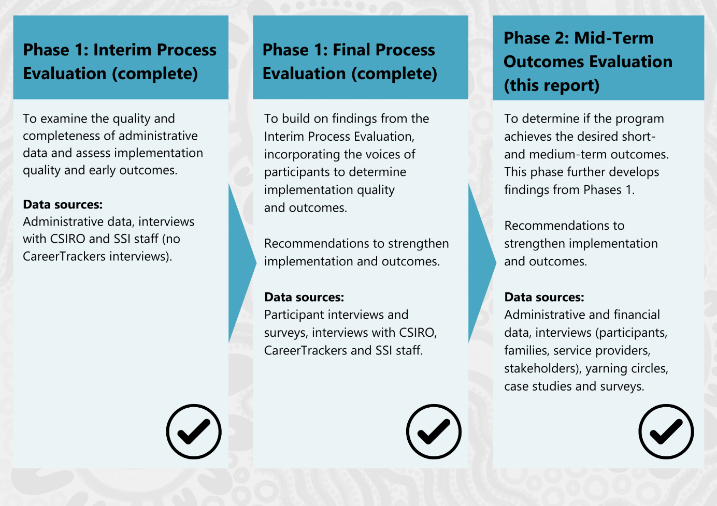

Purpose of this report
This report is the Mid-Term Outcomes Report. It aims to provide:
- updated information relating to the implementation of IGSA. It builds from information presented in the Final Process Evaluation Report, drawing on more up-to-date information regarding program participation across the initiatives and its components
- an assessment of the extent to which the each of the initiatives is achieving outcomes against its program logic and the overall IGSA theory of change. Given that IGSA is a 10-year investment with ongoing funding secured through to 2028, this report focuses on short- and medium-term outcomes.

Ethics
The Evaluation Team, ARTD and Ninti One are committed to sensitive and ethical practice. All ARTD consultants are members of the Australian Evaluation Society. The evaluation is being conducted within the Australian Institute of Aboriginal and Torres Strait Islander Studies (AIATSIS) Code of Ethics for Aboriginal and Torres Strait Islander Research, the Aboriginal Health and Medical Research Council Ethical Guidelines: Key Principles (2020, V2.0) and the Australian Evaluation Society’s Guidelines for the Ethical Conduct of Evaluations.
The Evaluation Team is dedicated to contributing to positive outcomes for Aboriginal and/or Torres Strait Islander people and communities, recognising that Indigenous Knowledges and intellectual property can often be misappropriated and exploited.
Ninti One has developed a set of guiding principles to support its approach to knowledge sharing in research and the creation of new intellectual property; these also align with the Australian Evaluation Society guidelines and support the approach for this evaluation.
The ethics approval process for this report was staged in order to ensure data collection could proceed as early as possible. The first stage was a minimal risk application (Ethics ID: EO207-20210611) that was submitted to the AIATSIS REC. This covered access to and review of program and administrative data, and interviews with staff from CSIRO, SSI and NIAA. It was approved on 26 October 2021.
A second application covering all data collection with YIWSA and ToSI participants, including parents/carers of Academy participants, was submitted to the AIATSIS REC on 25 January 2022. Approval was significantly delayed and was not received until August 2022.
The Phase 2 (Stage 3) ethics application to AIATSIS was submitted on 5 October 2022. It covered all forms of data collection with IGSA participants, including stakeholder interviews or focus groups, surveys, yarning circles and longitudinal case studies. Preliminary feedback was received from AIATSIS on 18 October 2022, and ARTD submitted the final application on 25 October 2022. Final approval was granted on 4 January 2023 (Ethics ID: EO207-20210611).
The evaluation seeks the wisdom and perspective of Aboriginal and Torres Strait Islander peoples in the following ways.
- Design: Collaboration between ARTD and Ninti One, incorporating the perspectives of Indigenous team members, the NIAA project team, the Evaluation Advisory Committee (EAC) and Indigenous Evaluation Committee (IEC), to ensure that the evaluation supports Indigenous ways of knowing; culturally resonant and safe data collection; analysis and synthesis methods; and knowledge sharing.
- Implementation: Interviewing Indigenous service providers and participants, with conversations led by ARTD and Ninti One’s Aboriginal and Torres Strait Islander team members. Quotations (without attribution to specific individuals) have been used to add depth, richness and authenticity to the analysis in this report.
- Governance: Seeking guidance from the EAC and IEC convened by NIAA, as described below, the committees provide an Aboriginal and/or Torres Strait Islander voice on issues from the Australian community, the STEM sector specifically, and the many Indigenous communities across Australia.

Evaluation governance
Governance of the evaluation is provided by two groups:
- EAC: Chaired by NIAA, the EAC comprises eight members:
- two representatives from NIAA
- two representatives from the Evaluation Team (one each from ARTD and Ninti One)
- one representative from YIWSA (nominated by CSIRO)
- one representative from ToSI (nominated by SSI)
- two independent Indigenous experts (selected by NIAA with advice from the EAC’s members).
The EAC’s purpose is set out in an agreed Terms of Reference and includes collaborating with the Evaluation Team to facilitate a robust, culturally inclusive, high-quality and influential evaluation.
- NIAA’s IEC: Chaired by an external expert, the IEC supports transparency, accountability and learning with regard to evaluation and program performance and reporting to NIAA. Its objectives are to strengthen the quality, credibility and influence of evaluations relating to policies and programs led by NIAA through the provision of independent strategic and technical advice. The IEC also provides advice on the quality and robustness of NIAA’s program performance reporting activities. Its membership comprises at least three and no more than five external members (including the Chair) and a NIAA Deputy CEO.

Methodology

Approach
Historically, research with Aboriginal people and communities has not always benefited them.7F Recognising this, the Evaluation Team placed cultural responsiveness and methodological rigour at the heart of the evaluation approach, aiming to draw together a valid evidence base to support genuine improvements for the Indigenous women engaged in IGSA, as well as their families and communities. This aligns with the AIATSIS Code of Ethics for Aboriginal and Torres Strait Islander Research.

Culturally responsive
The evaluation recognised the importance of self-determination for Aboriginal and Torres Strait Islander peoples in developing its methodology. Indigenous leadership was embedded in the evaluation design to ensure meaningful engagement and collaboration. This approach carried throughout the evaluation, with NIAA, the EAC and IEC, and the YIWSA and ToSI Steering Committees all contributing to the initial Evaluation Strategy, providing support and input throughout the evaluation’s development, and providing feedback for this report.
The Evaluation Team notes that the evaluation was also co-produced with participants and led by Indigenous researchers working within an Indigenist framework. Before data collection, written or verbal informed consent was sought from individual participants, and Indigenous Evaluation Team members provided Indigenous oversight of data analysis, synthesis and reporting. Upon completing the Mid-Term Outcomes Report, Participant Summary Reports will be produced to communicate findings directly to participants. In this way, reciprocity of information sharing is created between the evaluation and research participants.

Methodologically rigorous
The evaluation was designed to ensure the inclusion of Aboriginal and Torres Strait Islander perspectives through a strengths-based approach that followed best practices outlined in the Commonwealth Government’s Indigenous Advancement Strategy’s Evaluation Framework, including:
- A developmental and participatory evaluation approach to address the challenges of the evolving initiatives, where aspects of the design and delivery are being modified simultaneously as the initiatives are being delivered and where some activities and outcomes are still emergent.
- Realist evaluation and Contribution Analysis, which suited this evaluation because of the challenges associated with directly attributing participation to observable changes in outcomes of interest. The approaches also supported a desire to document ‘what worked’ and dig deeper to explain how, why, for whom and in what contexts.

Data sources and methods
A mix of qualitative and quantitative data sources and methods was used in this evaluation, including a survey of and interviews with YIWSA and ToSI participants, interviews with staff from the YIWSA and ToSI Teams and their stakeholders, and updated analysis of YIWSA and ToSI administrative data – see Figure 7.8F
Figure 7: Overview of evaluation methods
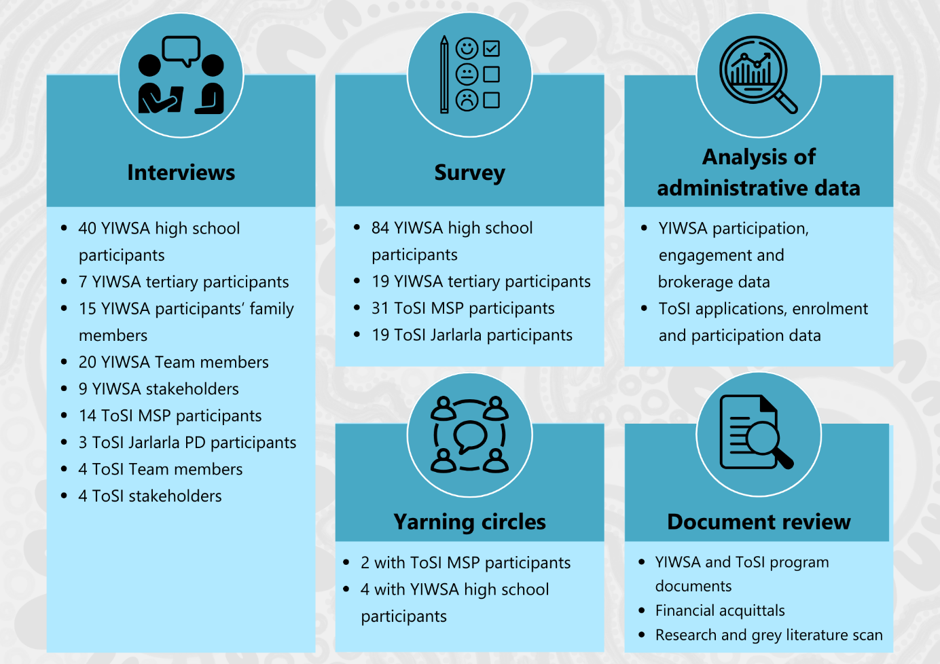

The YIWSA Annual Participant Survey was distributed to a total of 468 YIWSA participants, with a total of 103 participants substantially completing the survey. It was distributed in two ways:
- ARTD sent the survey link to high school-aged participants whose parents/carers had provided consent for their child to participate (survey sent to 120 participants, of whom 84 responded – response rate 70%).9F
- The YIWSA Team sent all participants in the tertiary component a link that allowed participants to respond anonymously to the survey (sent to 273 participants, of whom
19 completed the survey – response rate 7%).
ARTD sent the ToSI Annual Participant Survey to 155 ToSI participants. It was distributed to 112 participants in Jarlarla (of whom 19 responded – response rate 17%) and 43 participants in MSP (of whom 31 responded – response rate 72%).10F Of the MSP respondents, 21 attended Jardibirrijba and 18 attended Jardi Dadarrinyi.
The response rates are detailed in Table 2 and Table 3.
Table 2: Response rate to the Annual Participant Survey – YIWSA
 | High school students | Tertiary students | Total
Sent to | 120 | 273 | 468
Completed | 84 | 19 | 103
Response rate | 70% | 7% | 31%
Note: The YIWSA Team managed the distribution of the tertiary survey.
Source: ARTD YIWSA participant survey data.
Table 3: Response rate to the Annual Participant Survey – ToSI
 | Jarlarla PD | MSP | Total
Sent to | 112 | 43 | 155
Completed | 19 | 31 | 50
Response rate | 17% | 72% | 32%
Source: ARTD ToSI participant survey data.
Interviews were carried out with a wide range of stakeholders in this evaluation. Interviewee groups and numbers are described in Table 4.
Table 4: Interviewees
YIWSA | ToSI
Staff interviews  CSIRO – n=10  CareerTrackers – n=6 | Staff interviews  SSI – n=4
Stakeholder interviews  STEM industry/university stakeholders – n=5  School partners – n=4 | Stakeholder interviews  University stakeholder partners – n=1  SSI stakeholders (historical ToSI staff, Steering Committee members) – n=4
Participants  High school component – n=40  Tertiary component – n=7 | Participants  MSP – n=12  Jarlarla PD – n=3
Parents and family members – n=15
All interviews were conducted according to semi-structured interview guides that were approved by the AIATSIS REC. All interviews with YIWSA and ToSI participants were completed by an Indigenous member of the Evaluation Team. Interviews were done by phone or online (through Zoom, FaceTime or Teams) and, with the participants’ consent, were recorded.
Information about the demographic make-up of participant interviewees is provided in the Appendix Table A20 to Table A25.
A total of six yarning circles involving small groups of IGSA participants were held at each initiative’s in-person activities. For YIWSA these were STEM camps and for ToSI they were the Jardibirrijba and Jardi Dadarrinyi workshops with MSP participants.
The distribution and attendance of the circles was as follows.
- Four yarning circles involving a total of 34 participants were held with YIWSA participants.
- Two yarning circles involving a total of 18 participants were held with ToSI participants.
Yarning circles were facilitated by Indigenous members of the Evaluation Team according to guides approved by the AIATSIS REC.
A document review and literature scan has also formed part of the data collection activities. Documents reviewed have included program and curriculum documents; reports provided by the service providers to NIAA; and other reporting, marketing and recruitment materials provided by CSIRO, CareerTrackers and SSI. The literature scan focused on what is known about good practice in delivering similar programs to Indigenous students and was drawn from the discussion of outcomes.
Administrative data was supplied by each of the service providers. The data included basic information on the participant demographics, participation and engagements and for YIWSA, the nature and frequency of support provided to participants. See Table 5.
Table 5: Administrative data
Data source | Timing | Sample | Notes
YIWSA high school data – CSIRO | January 2023 – June 2024 | Participants – n=459 | ARTD collaborated with CSIRO to create a data collection tool that allowed Academic Coordinators to collect event and communication data. Due to a lack of confidence in the fidelity in record keeping, this report does not seek to draw on data before January 2023.
YIWSA tertiary data – CareerTrackers | January 2018 – June 2024 | Participants –n=273 | Data is drawn from the CareerTrackers McLeod database system and focuses on tertiary enrolment information (including field of study and expected graduation date) and internship participation. There is minimal demographic information (state only) and some information about participation workshops and events.
YIWSA high school brokerage data – CSIRO | April 2020 – June 2024 | Records of brokerage – n=639 | The data file contains a record for every participant, whether they requested brokerage or not. There are multiple records for participants who requested brokerage more than once.
YIWSA tertiary brokerage data – CSIRO | August 2020 – June 2024 | Records of brokerage – n=77 | The data file only contains records for participants who requested brokerage. There are multiple records for participants who requested brokerage more than once.
ToSI MSP data – SSI | January 2020 – August 2024 | Applications – n=94  Participants – n=89  University records – n=89 | ToSI data was generated from reports pulled from SSI’s CRM. Each data report was generated separately and could not be linked. The sample was missing application data for the class year 2020 (those who applied in 2019). The data capture period was meant to end in June 2024. However, the data reports were not pulled until August of 2024. Not all data reports had a date variable, so they could not be cleaned to fit the June 2024 data collection timeframe.
ToSI Jarlarla data – SSI | January 2019 – August 2024 | Applications – n=101  Enrolments – n=117 | ToSI data was generated from reports pulled from SSI’s CRM. Each data report was generated separately and cannot be linked. The sample was missing application data for the class year 2020 (applied in 2019). The data capture period was meant to end in June 2024. However, the data reports were not pulled until August of 2024. Not all data reports had a date variable, so they could not be cleaned to fit the June 2024 data collection timeframe.

Analysis
The Annual Participant Survey was analysed descriptively (counts, measures of central tendency and spread). Where sample size permitted, cross tabulations were done to provide deeper insight into response patterns. Qualitative data has also been synthesised with data collected through interviews.
Interviews and yarning circles were recorded, transcribed and analysed, by group and theme, using a grounded theory approach to thematic analysis. For participant interviews, the NVivo software package was used to support a coding frame and data analysis. The coding frame was developed collaboratively with all key Evaluation Team members. Findings from the analysis were also regularly discussed to ensure consistent interpretation.
Interview data for YIWSA participants (high school component only) has also been used to support a Qualitative Comparative Analysis (QCA)11F that focused on identifying the necessary and sufficient conditions for realising positive outcomes for participants. Although the number of ToSI participants interviewed (n=14) is sufficient to conduct a QCA, it was not conducted. This was for two reasons. Firstly, to conduct a QCA, a clearly defined and measurable outcome needs to be identified. For ToSI, there was not a clear mid-term outcome measurement for MSP participants available. Secondly, there was insufficient variation in the interviewee sample. The interview participants did not represent the full range of experience of the initiative as all were recruited via their attendance at an in-person PD event. As such, the sample does not include participants who were not actively engaged and continuing with their teaching studies.
The interview data has also been used to help develop the participant experiences sections in this report – for YIWSA, section 2.2; for ToSI, section 3.2. These sections provide an illustrative person-centred approach to understanding how each initiative is being delivered and the outcomes that are being achieved. They have been devised and guided by the Indigenous Evaluation Team members and informed by the life-world mapping methodology developed by Maggie Walter. This approach aims to disrupt the deficit narrative often present in Western approaches to Indigenous research and focuses on participant-led visual representations of experiences and relationships.12F During synthesis meetings, Indigenous team members facilitated workshops to design storytelling methods, focusing on first-person recounts of interviews presented as case stories, visual illustrations of journeys, and ripple diagrams that captured the broader impacts of participation in the initiatives.
Initiative administrative data was analysed descriptively and used to supplement the qualitative findings. The analysis approach was guided by the structure and nature of the data available for each initiative and included generating frequency tables, descriptive statistics and cross tabulations. Where possible, related data sets within an initiative were linked using unique participant IDs, and data sets were restructured to provide clearer insights about individual-level experiences. R and RStudio were used to clean, restructure and analyse administrative data.

Strengths and limitations
Each of the data sources used for this evaluation has strengths and limitations, as summarised in Table A5 in the Appendix. These should be carefully considered when interpreting the findings outlined in this Mid-Term Outcomes Report. The report includes the perspectives of the YIWSA and ToSI Teams and participants in every component of the two initiatives, as well as of external stakeholders.
The Annual Participant Survey, which was administered three times during the evaluation, ultimately included 157 responses, including from 38 respondents who responded twice or more. There were 103 unique respondents from YIWSA, which is 16% of all participants. There were 31 unique respondents from the MSP component of ToSI, which is 35% of all MSP participants. There were 19 unique respondents from the Jarlarla component of ToSI, which is 23% of all Jarlarla participants who completed the course.
The total number of interviews for YIWSA participants was 47, which represents 7% of the total number of initiative participants. Sixteen interviews were conducted with ToSI participants, representing 18% of that cohort.
There were differences in the administrative data available for YIWSA (high school and tertiary components) and ToSI, with different limitations.

Regarding YIWSA (high school component) data:
- CSIRO, in discussion with the Evaluation Team, established that there were inconsistencies in how internal data collection systems were used.
- To address this, the Evaluation Team collaborated with the YIWSA High School Team to develop a data collection tool to record initiative data relevant to the evaluation.
- Although implementation started in 2018, the Evaluation Team has chosen to analyse only the data collected by the evaluation’s data collection tool, which covers the period from January 2023 to June 2024. This was because earlier data collection had not included reliable recording of key data items required for analyses undertaken for this evaluation.
Regarding YIWSA (tertiary component) data:
- Extracts from the CareerTrackers CRM were provided to the evaluation for analysis. At the time of the evaluation, the CareerTrackers Team was moving from manual data keeping to more consistently using the CRM system, resulting in several entry fields being missing as that information was not recorded during the manual process.
- Additionally, both the CSIRO and CareerTrackers Teams use different CRM systems, and the unique person-level identifier is not carried between systems. As a result, the number of participants transitioning between the high school and tertiary component could not be analysed in the data.
Regarding ToSI data:
- Extracts from SSI’s CRM were provided to the evaluation for analysis.
- These de-identified data extracts did not include unique person-level identifiers, and as a result could not be linked or restructured to examine person-level metrics.
- The sample of MSP participants the evaluation was able to engage in interviews does not include any participants who had withdrawn from the initiative. The findings related to the reasons for withdrawal from the initiative are limited due to this key data source (participant experiences) being missing from our analysis. Findings related to reasons for withdrawal have been largely informed by interviews with ToSI Team members.
The strengths and limitations of each method are explained further in the Appendix. The additional data available to the evaluation is consistent with the findings in the Final Process Evaluation Report. The Evaluation Team is confident the findings provide a sound evidence base for decision making.

The Young Indigenous Women’s STEM Academy

Overview of the initiative
The program logic presented in Figure 813F outlines how YIWSA seeks to support young Indigenous women to pursue further studies and careers in STEM as well as describing the initiative’s short-, medium- and longer-term goals.
YIWSA comprises a high school component, delivered by CSIRO, and a tertiary component, delivered by CareerTrackers.
While both of the components contribute to all of the outcomes, there are differences in the way each component is delivered that are intended to reflect age- and stage-appropriate supports.

Figure 8: YIWSA program logic
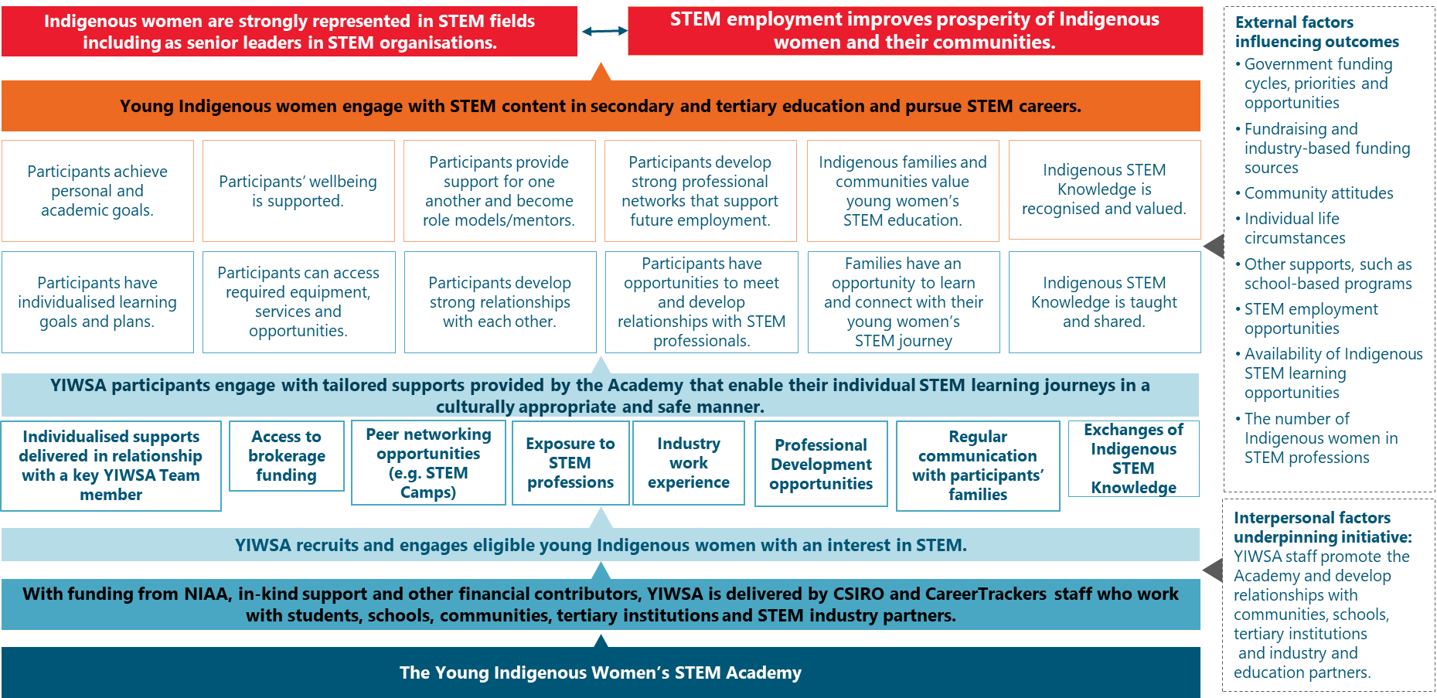
Note: The full YIWSA program logic is available in the Appendix, Figure A1.

Figure 9: Overview of YIWSA
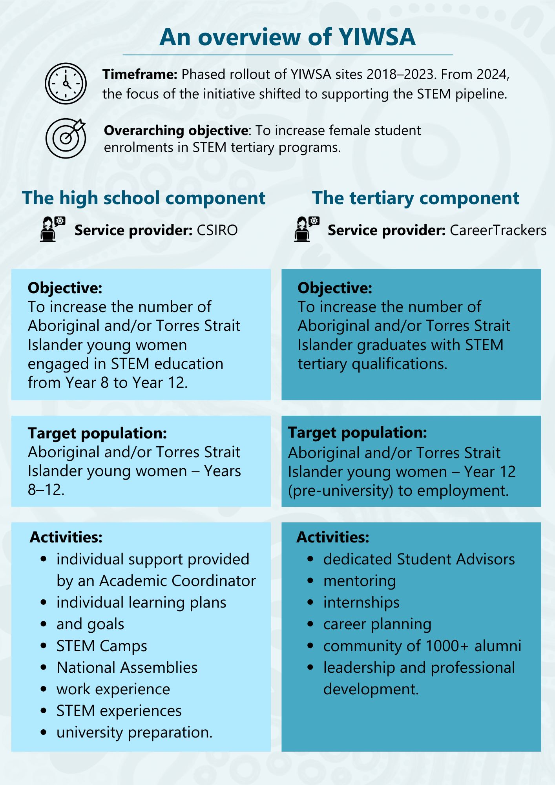

As shown in Figure 9, the high school component includes individual support from an Academic Coordinator – this includes in-person visits once per term at participants’ schools; email and phone contact; as well as liaison with parents and carers to ensure they understand what is being offered and consent to their young women being part of YIWSA activities.
The Academic Coordinator connects participants and their families with information about upcoming events and opportunities that are offered as part of YIWSA, such as camps and National Assemblies, as well as externally provided STEM learning opportunities; for example, university-based STEM camps, presentations or lectures, STEM activities and competitions.
Each Academic Coordinator works with a cohort of up to 40 students within a distinct, sometimes vast, geographic region. The cohort is defined by its geographic location as well as the school year level of participants. For example, in 2024 the SA cohort are all in Year 10, because they all commenced in 2022, when participants were in Year 8.
Cohorts are intended to be recruited when potential participants are in Year 8, so that by the time they are in Year 9, they have completed all application processes, can begin having in-person visits at school from their Academic Coordinator and can prepare for a camp with all cohort members, which is intended to occur when participants are in Year 9.
In addition to an in-person STEM camp, participants connect through regular online National Assemblies, to which all YIWSA participants are invited. These are an opportunity to hear from STEM professionals (wherever possible, these professionals are Indigenous women) about their work across diverse STEM fields.
A key component of engaging with Indigenous female STEM professionals at National Assemblies and STEM Camps is for the STEM professional to share not only their STEM journey but also the challenges they faced and how they overcame these. Sharing of these experiences is intended to build participants’ resilience and confidence that they can tackle challenges and to help prepare them for a STEM career.
Academic Coordinators work with students to understand their interests and goals and provide appropriate opportunities to explore them further. YIWSA provides flexible brokerage support to enable participants to access supports and resources they require to be able to pursue their study goals. For example, brokerage may be used to support a young woman to purchase a computer or other piece of needed equipment, or to subsidise the cost of tutoring, or in some circumstances to pay for travel and other costs of participation in STEM learning opportunities, such as university-based STEM camps.
The tertiary component also includes one-on-one support. In this component the support is provided by a Student Advisor from CareerTrackers. Student Advisors make regular contact with participants and support them to:
- connect with the Indigenous Support Unit at their tertiary institution
- find and connect with a STEM industry mentor in their field of interest
- connect with paid internship opportunities throughout their studies
- develop skills for job interviews
- participate in CareerTrackers networking events
- be informed about STEM PD opportunities more broadly, including study tours, presentations, conferences and so on
- become role models, with opportunities to present lectures, workshops and so on.
The YIWSA Team works together to ensure it shares information across both the tertiary and high school components so participants can be made aware of any relevant opportunities.
The team encourages participants to contribute back to the initiative through presenting at STEM camps, being part of the YIWSA Steering Committee and presenting about their experiences with YIWSA at other events.
The team also leverages existing relationships CSIRO and CareerTrackers have built with STEM industry employers and STEM education providers to ensure participants can access a wide range of opportunities and also contribute to in-community events such as delivering activities at science fairs.
In addition to the funding received through NIAA, YIWSA receives in-kind support and sponsorship to deliver its activities.

YIWSA participant experiences
This section seeks to describe and illustrate YIWSA from the perspective of the participant.

Putting the participant at the centre
Figure 10, a ripple diagram, illustrates the intended individual- to systems-level impacts of the initiative, including impacts for families, communities, schools and institutions. These impacts are informed by the YIWSA program logic and supporting program documentation.
Figure 10: Ripple diagram of YIWSA participant experience
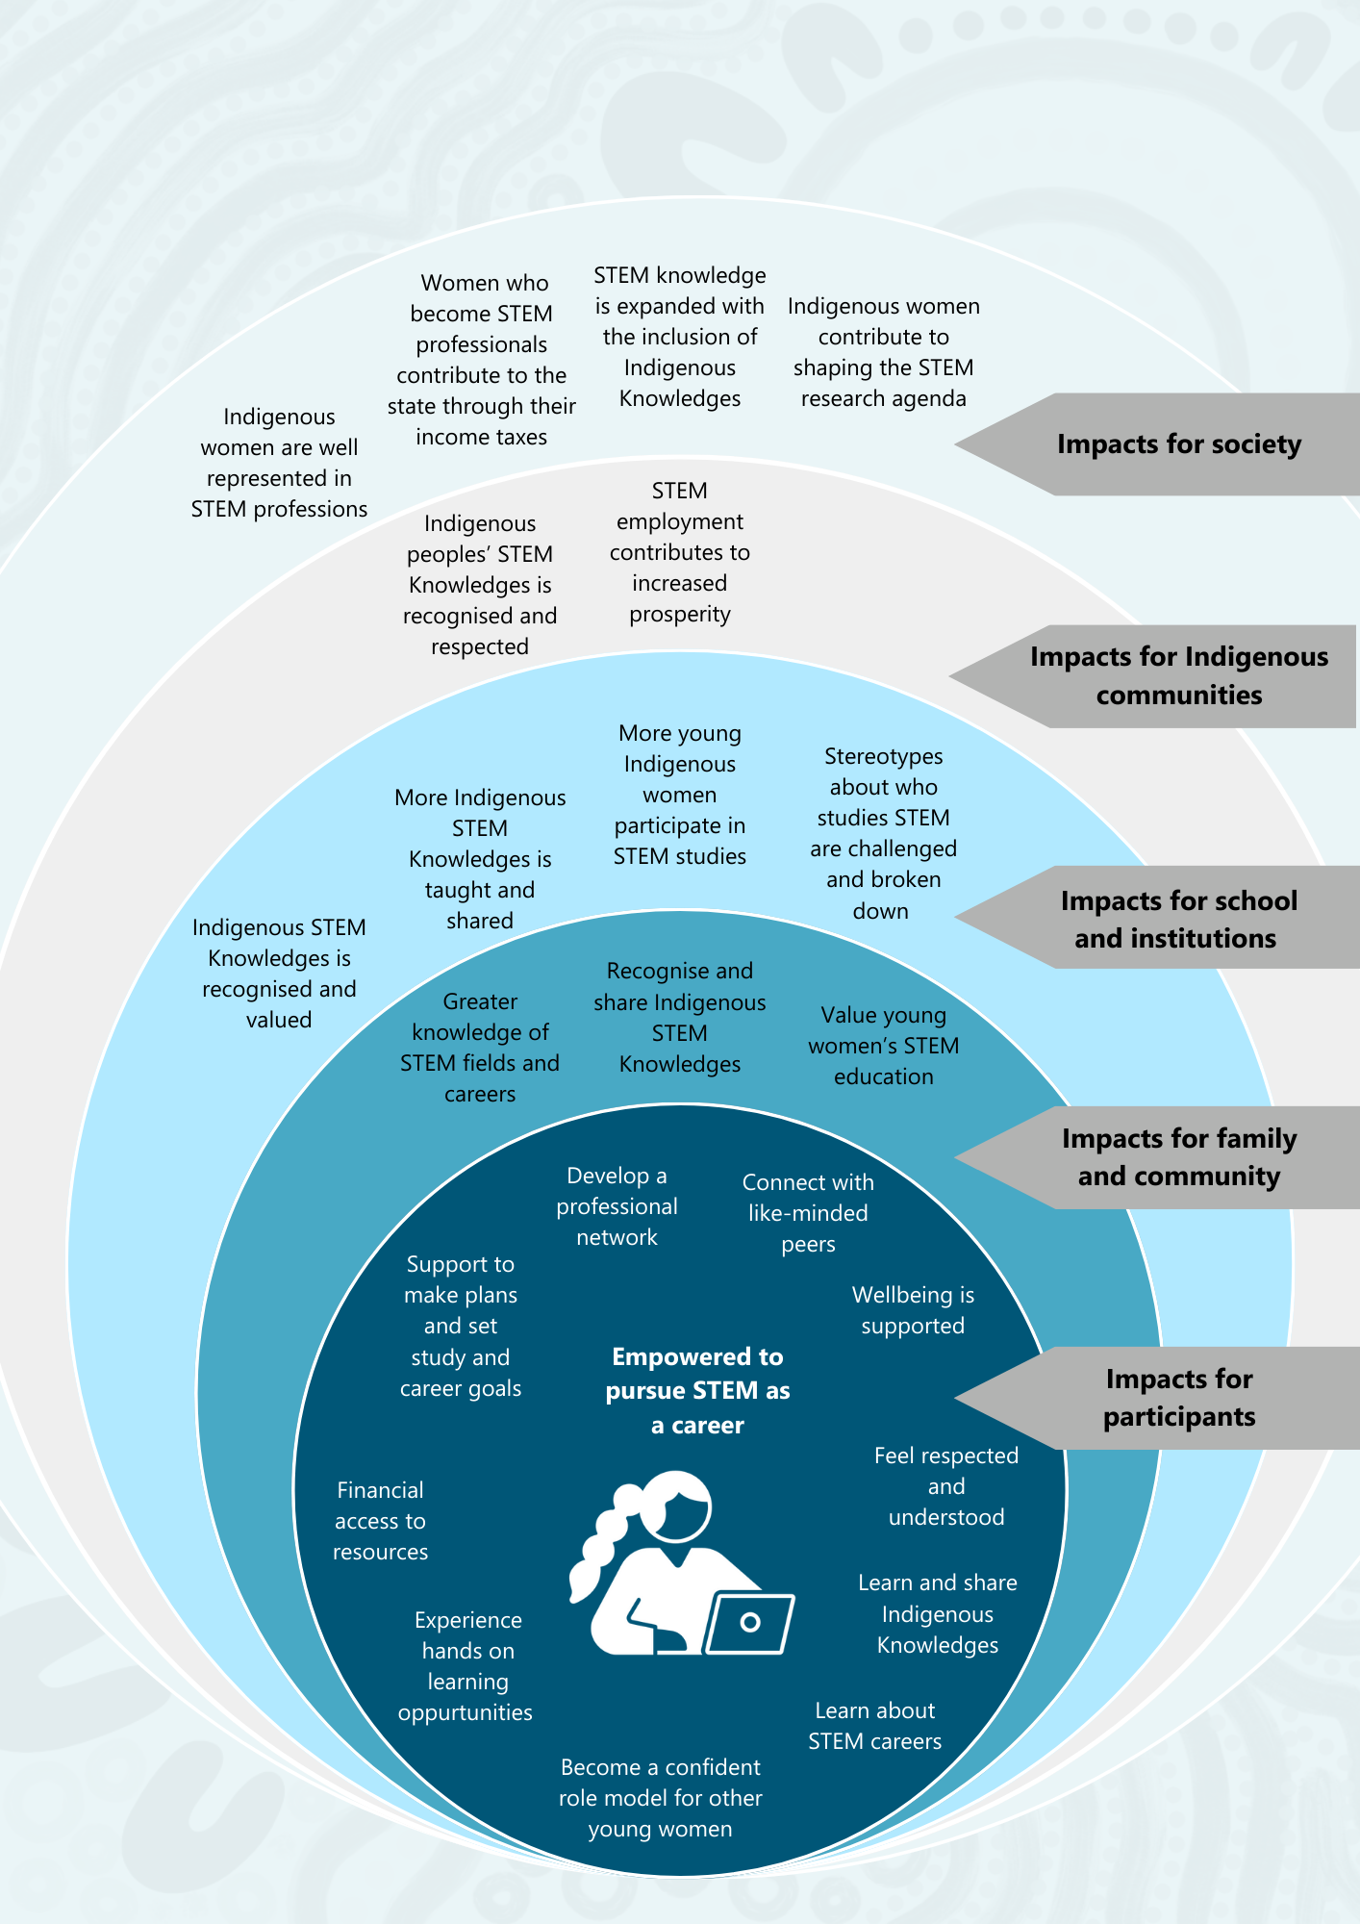

Case stories
These case stories of participants are recounted in the voices of the Indigenous researchers of the Evaluation Team who interviewed them: Aunty Julie Smith and Tammy Abbott.

High school participants
In this section, the stories are told by Aunty Julie Smith, a proud Kalkadoon and Kamilaroi woman, who has had extensive experience as an educator and a researcher and of serving on the Murri Court. As part of the Evaluation Team, she interviewed many YIWSA high school participants. On the following pages, she recalls some of those interviews, outlining what she learnt about the young women’s experiences. The stories are real stories of YIWSA participants, but pseudonyms have been used to protect their identities.
Ava’s story
Ava ,15, is from a regional town in NSW. During our interview, she told me about her passion for STEM, particularly health, and that she dreams of one day working as a doctor in remote communities. She told me she wanted to help people who are in trouble, who are out rural and who need that help. Her passion made her an ideal candidate for the Young Indigenous Women‘s STEM Academy. She told me how her teachers recognised her love for biology and handed her a flyer about the Academy. She went home to research the Academy on the CSIRO website, saying: ‘Reading all the stories about the amazing things that other Indigenous women have achieved inspired me to join the Academy. It showed me that my dreams of being a doctor were achievable, and the Academy could give me the confidence to pursue those dreams.’
When I asked her about the application process, Ava said it was straightforward. The only part she found difficult was writing about herself, but her mum was very supportive and helped her decide what to say. She received great feedback on her application from her Academic Coordinator who said it was exceptional. Ava told me that she found the application process a great learning experience.
Ava also had a really great relationship with her Academic Coordinator. She told me how they had a strong line of communication, with visits to her school once a term and the ability to text or call her when she had a question. She also told me about a time when her Academic Coordinator helped her find a maths tutor when she was struggling in class, which helped her improve her grades.
Like many other students I spoke with, Ava loved the STEM camp she attended. She told me that the camp was an opportunity to explore different STEM careers that she had never considered before. For example, she went to a shark expo, where she learnt about shark anatomy, and she is now considering marine science as a career. She also really enjoyed meeting more of the other participants and making some good friends.

Ava and I also discussed the connection between Indigenous Knowledges and STEM, which she learnt about through YIWSA. She explained that they explored traditions like weaving and fish traps at the camps. She told me: ‘It’s not something we delve into deeply at school, and learning more about ancient knowledges has opened my eyes to all the Indigenous people who have been doing this for thousands of years without recognition.’
As our conversation ended, Ava told me about her plans to continue studying STEM subjects like biochemistry and maths at school next year and at university. She told me that before YIWSA, this all felt a bit unobtainable, but now she feels it is achievable. Ava spoke so enthusiastically about YIWSA and what had really helped, such as her mum’s support in completing her application, a strong relationship with her Academic Coordinator, and the opportunity to attend STEM camps and make connections between Indigenous Knowledges and STEM, which was just not available to her at school.
It seems like YIWSA has really inspired Ava and helped ensure she can pursue her STEM learning and career aspirations. It’s likely made a big difference to her education experience and her confidence.

Figure 11: Ava’s journey – YIWSA high school component
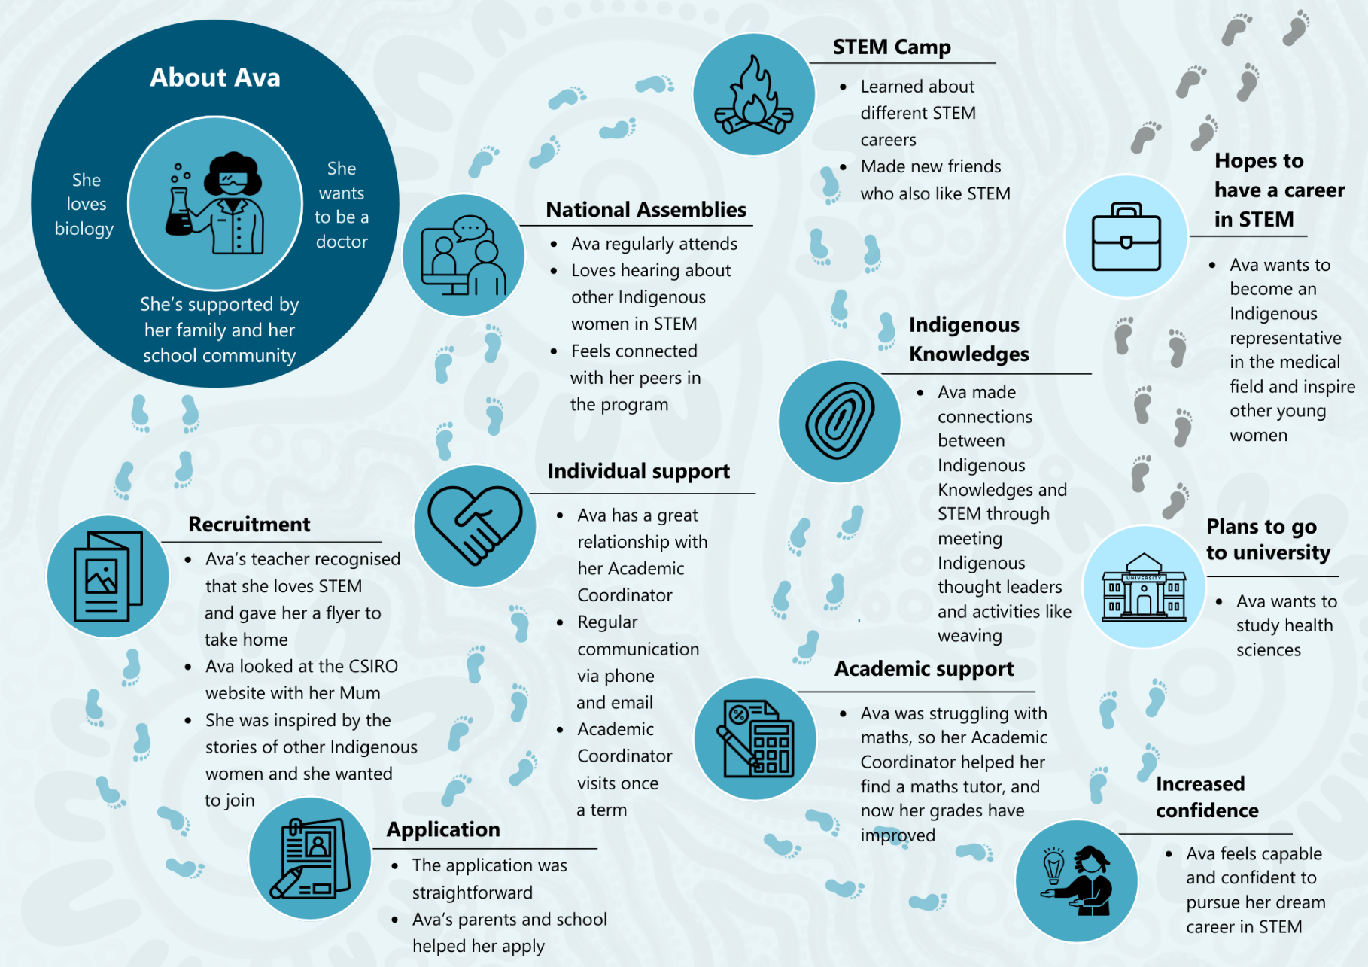

Claire’s story
Reflecting on the stories of young women who had great experiences in YIWSA like Ava, an important lesson emerged from my conversations with some participants who struggled to engage fully with the initiative. My interview with Claire highlighted some challenges participants might encounter.
Claire is living and studying in a capital city. Like many other young women, she was motivated to join the Academy by her deep passion for STEM. She enthusiastically shared with me her love for chemistry and physics, telling me, ‘I enjoy chemistry and looking at components that make up the world around us, and I just take a lot of joy in that. And physics, I’ve always been interested in astronomy, so it’s kind of a way for me to delve deeper into that interest as well.’ Her excitement extended to potential career paths in STEM. Claire mentioned considering roles like astrophysicist or chemical engineer, though she wasn’t entirely certain about her specific direction yet.
When I asked about her initial motivation to join YIWSA, Claire said she was drawn by the opportunities and resources, particularly the chance to ‘meet up with other Indigenous women who also were a part of STEM and kind of learn from them as well.’
Despite her enthusiasm, Claire reflected on the barriers she faced, mainly balancing the Academy with school and family commitments. She admitted to struggling at school and having numerous family responsibilities, which limited her ability to commit to YIWSA activities fully. Claire shared with me that she struggled to fully engage with the Academy and couldn’t join STEM camps or assemblies due to conflicts with family events or her other extracurricular activities.
When I enquired about support systems, Claire noted that she couldn’t contact her Academic Coordinator for help navigating these challenges. Having changed Academic Coordinators after the first year and never having met her new Academic Coordinator in person, she didn’t feel she had a strong enough relationship to reach out and ask for extra support.
Claire did mention receiving emails about YIWSA activities but expressed a desire for more communication. She confided feeling isolated from other participants, especially since no one else from her school was involved. ‘I felt a bit isolated from the other young women in the program and like I wasn’t really a part of it all,’ she told me.
Despite these setbacks, Claire maintained her belief in the initiative’s potential. Her story highlighted to me some challenges that young women who are passionate about STEM face when trying to engage with the programs, such as other family and school responsibilities, and the importance of the relationship with the Academic Coordinator to the young woman’s experience.

Tertiary participants
In these sections stories are told by Tammy Abbott, a proud Arrernte and Luritja Pintipi woman from Alice Springs who has worked as an Aboriginal Community Researcher and Community and Stakeholder Engagement Officer for over a decade. As part of the evaluation, she conducted a number of interviews with participants in the tertiary component of YIWSA. On the following pages, she recounts some of those interviews, outlining what she heard and learnt about the young women’s experiences.
Belinda’s story
I interviewed Belinda, who had joined YIWSA during the final year of her Bachelor of Engineering and Maths degree. She told me all about how she had always had a passion for physics and maths and even dreamt of becoming Australia’s first woman in space one day. When she finished Year 12 in her small regional town, she felt that going to university was the natural next step for her.
Belinda first heard about YIWSA in the second to last year of her degree when the CareerTrackers staff contacted her directly and encouraged her to join. She recounted to me all the support she had received as part of the initiative, including opportunities to attend STEM events in her interest area and network with people who may one day be her co-workers.
She also noted how important her Student Advisor was to her progress in YIWSA. They would have support sessions once a month, and she always felt she was in a culturally safe environment.
YIWSA was even supportive of Belinda when she encountered challenges at university. For example, when she failed a class, her Student Advisor assisted her in reviewing her approach to learning and setting goals and helped her connect with her university’s Indigenous Support Unit to find a tutor. She noted that the extra assistance helped her improve her grades, and she is now about to graduate.
Belinda told me that perhaps the most important thing she received was assistance to get into the internships that her degree requires. To secure those internships, she needed to have a great CV and cover letter and be able to navigate the interview process. YIWSA offered her support that included writing a CV, practising for interviews, even down to how dress the part. She nailed those interviews and landed two internships in her last year of university. As a result of one of those internships, Belinda has now been offered a job at one of her dream companies.
Towards the end of the interview, Belinda reflected on how important community was to her on her journey, which was a major reason she wanted to give back. She is now mentoring girls participating in the YIWSA high school component, and she feels like being a part of YIWSA and hearing the stories of other women have inspired her to share her story of what it is like to be a woman in a male-dominated industry.

As I reflected on my conversation with Belinda, it became clear to me how important YIWSA was to a young woman in achieving her dream job, with the support and guidance from educators and other peers along her journey. This motivates her to pass on this support to other young ladies to come.

Figure 12: Belinda’s journey – YIWSA tertiary component
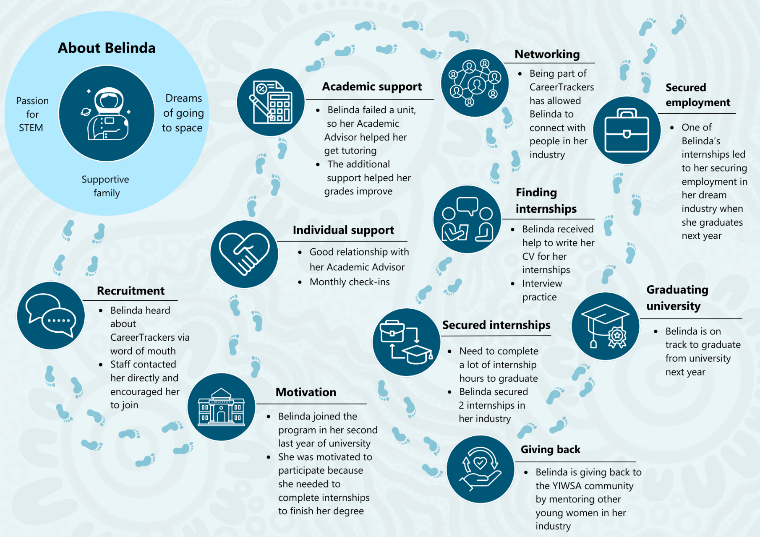

Dakota’s story
Dakota connected with YIWSA at the start of her university journey. Her Student Advisor helped her to secure an internship. Dakota said this was particularly helpful because she is naturally quite shy, and it is difficult for her to pursue opportunities. She also said it was a big help that the internships were paid. Her degree requires a lot of work placements, and when these aren’t paid, it can be difficult to manage doing these at the same time as working a paid job. She also enjoyed other opportunities in her first year, such as connecting with others through seminars. She said listening to the stories and achievements of others was inspiring.
Throughout our conversation, it was clear to me that Dakota valued the support she received in her first year of university. However, as she moved into her second year, she lost contact with her Student Advisor. This lack of follow-up support has been a significant challenge for her, leading to a feeling of disconnection from the initiative.
While she spoke about the support of the university’s Indigenous Support Unit and her family, she also expressed that she would like to reconnect with YIWSA for additional support to help cope with the pressure and stress she experiences at university. She also noted that she would like YIWSA to help connect her with other YIWSA participants at her university, so they can feel part of a community together there. Dakota has felt a lack of cultural safety at university, recounting that, in lectures, she would question what she was being taught from an Aboriginal perspective and be dismissed by other students, which was very disheartening. She felt that connecting with other Indigenous women who have similar experiences would be helpful.
As I reflect on the conversation I had with Dakota, it really highlights that a supportive community is a fundamental aspect of the initiative that young women like Dakota are seeking, particularly while at university. The stress of assessments, the financial challenges of finding internships, and a lack of cultural safety are significant hurdles. Dakota’s experience underscores the importance of support, and continuity of support in overcoming these challenges.

How well has YIWSA been implemented? [KEQs 1, 2, 3, 4]
Overall, YIWSA has been implemented as expected, with some variations, such as higher than planned use of virtual modalities in response to challenges arising from the COVID-19 pandemic.
At its mid-point, YIWSA is being delivered across Australia to more participants than originally envisaged. Figure 13 provides an overview.
Figure 13: YIWSA implementation overview
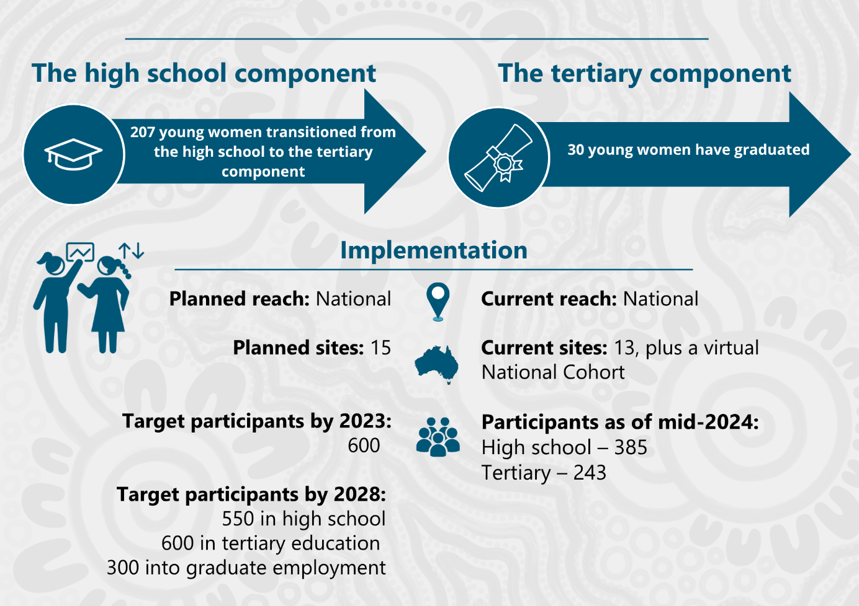

High school component
The high school component has location-specific and high school grade-specific cohorts in Queensland, Western Australia and Tasmania/Victoria (as a single cohort), South Australia and the Northern Territory as well as the National Cohort (which mostly takes part online). As shown in Table 6, the place-based cohorts have approximately 30 to 40 participants each. Despite best efforts and numerous strategies, the YIWSA Team was unable to recruit any more young women for the Greater Western Sydney Cohort and Newcastle and Central Coast Cohorts. These smaller cohorts are each staffed by a part-time Academic Coordinator.
Recruitment for all but the National Cohort is targeted by geographic area and year level, with each year focusing on a region and year group. Since 2019, there has been a National Cohort to ensure a continuous flow of young women transitioning into the tertiary component.
In total, 459 students participated in the high school component of whom 62 (14%) are in Year 9, 104 (23%) are in Year 10, 120 (26%) are in Year 11 and 99 (20%) are in Year 12.14F Table 7 shows graduated cohorts. At the end of 2023, 74 students graduated from high school.
Table 6: YIWSA high school participants – active cohorts
Active cohorts | Year level in 2024 | Number of participants | Percentage of total participants
National Cohort Year 12 | Year 12 | 35 | 8%
WA | Year 12 | 34 | 7%
Greater Western Sydney | Year 12 | 17 | 4%
Newcastle and Central Coast | Year 12 | 13 | 3%
Brisbane West | Year 11 | 33 | 7%
Central West NSW and ACT | Year 11 | 33 | 7%
National Cohort Year 11 | Year 11 | 30 | 7%
NT | Year 11 | 24 | 5%
SA | Year 10 | 42 | 9%
Brisbane North | Year 10 | 40 | 9%
Tasmania and Victoria | Year 10 | 22 | 5%
NSW | Year 9 | 33 | 7%
Queensland | Year 9 | 29 | 6%
Total active participants |  | 385 | 84%

Table 7: YIWSA high school participants – graduated cohorts
Graduated cohorts | Year level in 2024 | Number of participants | Percentage of total participants
Far North Queensland | Graduated 2023 | 35 | 8%
North Queensland | Graduated 2023 | 35 | 8%
National Cohort Graduated | Graduated 2023 | 4 | 1%
Total graduated participants |  | 74 | 16%
Total participants |  | 459 | 100%
Notes: The Far North Queensland and North Queensland cohorts graduated from high school at the end of 2023. Percentages do not total 100% due to rounding.
Source: YIWSA high school data collection tool – participant data: January 2023 – June 2024.

Tertiary component
Between January 2019 and June 2024:
- 273 participants were engaged with the tertiary component of YIWSA
- 129 (47%) came from Queensland, followed by 57 (21%) from New South Wales and 27 (10%) from Victoria (see Figure 14 and Appendix, Table A6).
Figure 14: Tertiary YIWSA participants by state
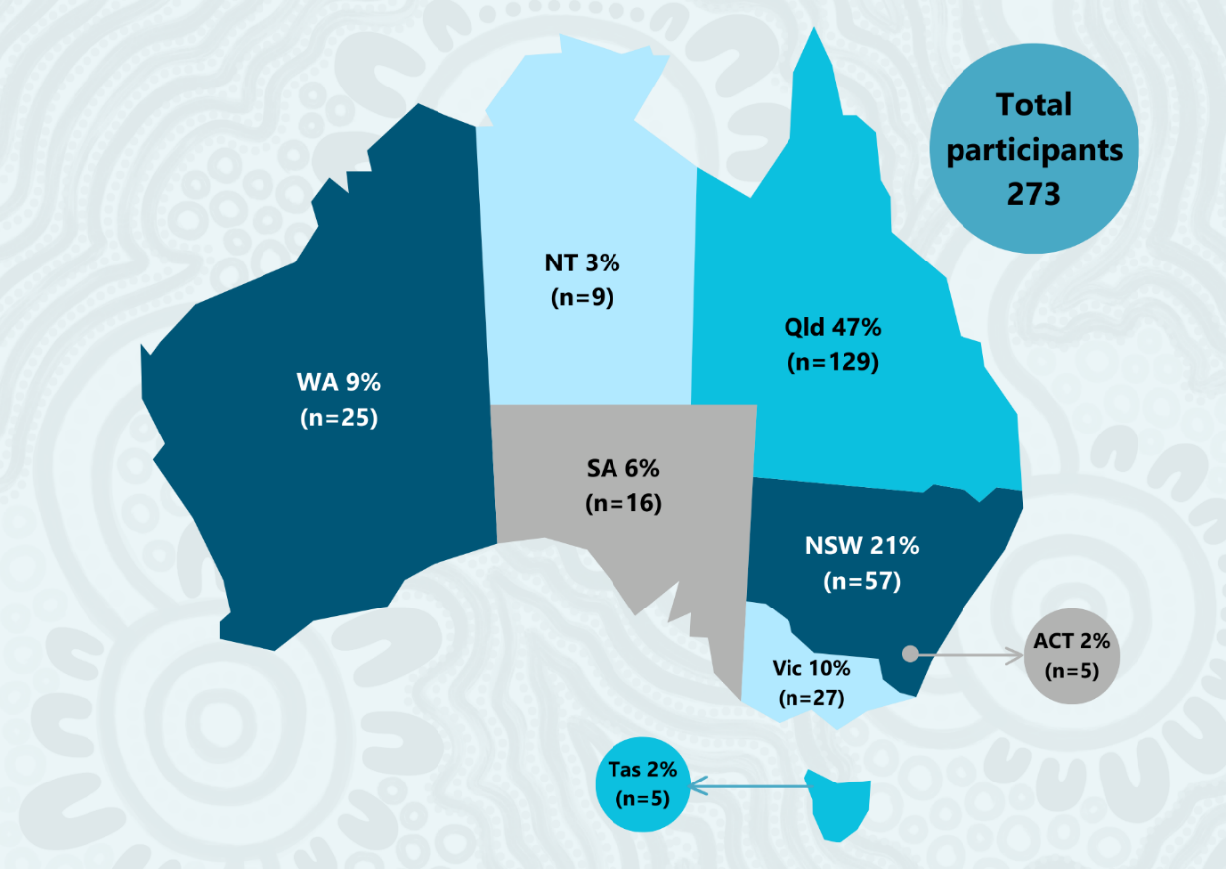
Source: YIWSA tertiary data CRM database – participant data: January 2018 – June 2024.
There are several pathways for students to connect into the tertiary component of the initiative. As shown in Table 8, the majority of students 207 (76%) entered the tertiary component through the high school component, followed by 48 (18%) who registered on the CareerTrackers website. Other registration pathways include Community Partners (2%), the Work Shadow Program (2%) and referrals from other participants (1%).
Table 8: YIWSA tertiary participants by how they entered the initiative
Registration pathway | Number | Percentage
YIWSA high school component | 207 | 76
Website registration | 48 | 18
Community Partners | 5 | 2
Work Shadow Program | 5 | 2
Participant referral | 3 | 1
Other | 5 | 2
Total | 273 | 100
Note: 118 records that had no registration pathway recorded in the data set were added to the ‘YIWSA high school component’ pathway on advice from CareerTrackers staff.
Source: YIWSA tertiary data CRM database – participant data: January 2018 – June 2024.

Total recruitment
Figure 15 illustrates the planned trajectory of combined high school and tertiary enrolments throughout the initiative’s lifetime. Originally, the initiative aimed to peak at 600 enrolments in 2023. Recruitment activities were affected by the COVID-19 pandemic between 2020 and 2022. Despite these challenges, the initiative has a total of 614 participants as of June 2024, exceeding its recruitment goals. See Table A10 in the Appendix.
Figure 15: Planned total number of YIWSA enrolments
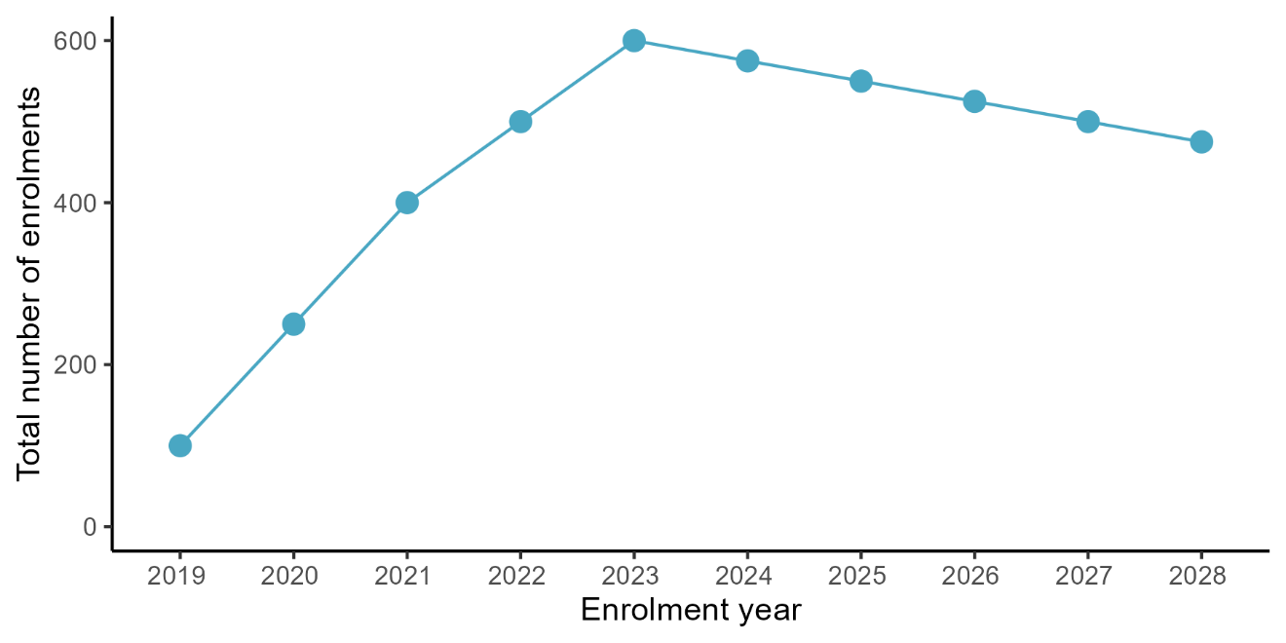
Source: CSIRO IAS Funding Agreement – IGSA Project Schedule (YIWSA).

To what extent is YIWSA meeting the needs of students, families, schools and communities and achieving its intended medium-term outcomes? [KEQs 5, 6]
This section is organised under the medium-term outcomes identified in the program logic model for YIWSA (Figure 8).

Medium-term outcome 1: Participants achieve personal and academic goals.
Across YIWSA, the key mechanism for supporting participants is the Academic Coordinator for high school participants, and the Student Advisor for tertiary participants. These staff members develop a trusting relationship with participants to enable them to:
- communicate their needs and reach out when they need additional supports
- know about upcoming events and opportunities
- develop their goals and plans for their future studies and careers.

High school component – Academic Coordinators
In the high school component of YIWSA, Academic Coordinators use a range of approaches to connect with students and families. These include:
- in-person visits with students at their schools
- phone, video-call and email contact
- e-newsletters and update emails.
During Years 8, 9 and 10, Academic Coordinators aim to have eight in-person contacts with participants per year, including both in-person visits at the participant's school and during STEM Camps. In recognition of the increasing level of schoolwork associated with Years 11 and 12, the frequency of in-person contact reduces to 6 until the participant transitions to the tertiary initiative mid-way through Year 12.
The purpose of in-person visits with Academic Coordinators is to provide individualised support to participants. However, in instances where the participants are unable to meet in person – for example, because of family responsibilities, being sick, or urgent school responsibilities – a virtual meeting is offered to provide the same individualised support in a flexible format that meets the participants' needs.
Academic Coordinators also organise to speak with or meet parents and carers, and believe this is important for them to build trust. This in turn helps parents to be supportive of their young women’s participation in YIWSA. Because they are working with school-aged young women, parental or carer consent is required for all of the initiative activities. As such, parents and carers need to be aware and informed and understand the purpose of activities in order to provide their consent. Academic Coordinators play a key role in facilitating consent processes and report that developing a trusting relationship with parents and carers is critical to ensuring participants can engage in activities.
My daughter’s Academic Coordinator is always there to try and see what she can do to help support her. She’s very adamant that she’s always there if we need anything, and she’s been amazing through the whole process. – Parent of YIWSA participant, high school component (interview data)

Tertiary component – Student Advisors
Within the tertiary component, the support provided by Student Advisors is less structured and there is a greater expectation that participants will take responsibility for checking in with their Student Advisor themselves. Student Advisors and participants interviewed noted that although there were expectations about monthly contact, there was much variability in the frequency of contact. The level of engagement also varied depending on the particular stage a student was at in their participation. For example, contact may be more frequent when participants first join the initiative, are working towards securing an internship or during an internship. At these times, contact might occur weekly or more.
It ebbs and flows. If I’m really needing support and it’s coming up to doing my internship, then probably I’d meet [with my Student Advisor] once a week, every week for about a month. If I’m having a hard time at school, I’ll reach out. But in general, it’s probably once a month in-person and then just texts, or calls, or emails whenever needed. – YIWSA participant, tertiary component (interview data)
The YIWSA Tertiary Team reflected that the transition process from the high school to the tertiary component was still being refined and acknowledged that this has resulted in some students not being able to be contacted effectively. This is explored further in section 2.6.2.
The evaluation data indicates that overall, YIWSA is providing high-quality individualised support via the work of the Academic Coordinators (high school component) and Student Advisors (tertiary component).
Survey data shows that the majority of participants agreed that they were well supported by their Academic Coordinator or Student Advisor, including feeling that their Academic Coordinator or Student Advisor understands their needs and goals, checks in regularly, helps them feel safe and comfortable to discuss their concerns, and supports them to achieve their goals – see Figure 16.
Figure 16: Survey respondent feedback on Academic Coordinators/Student Advisors
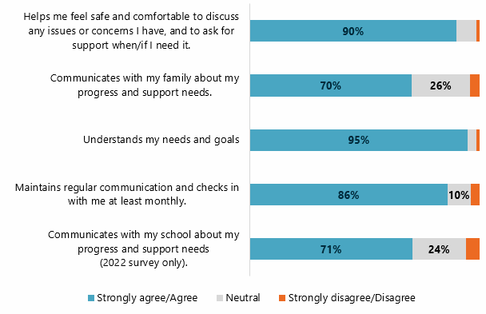
Notes: Graph contains high school student respondent data. Total respondents for each row: 1 (n=79), 2 (n=74), 3 (n=77), 4 (n=78), 5 (n=17). Row 5 only contains data from the 2022 survey. Labels for <10% are not shown. Source: The 2022, 2023 and 2024 YIWSA Participant Survey.
Most survey respondents feel they have a supportive relationship with their Academic Coordinator, with 71 (90%) agreeing that their Academic Coordinator helps them feel safe and comfortable to discuss any issues or concerns and that they can ask for support when/if they need it.
Open text responses also positively reflected on participants’ relationships with their Academic Coordinator, with 34 out of 38 respondents stating their Academic Coordinator was very supportive and kind.
I love that I can have conversations with my Academic Coordinator. It makes me feel valued when they ask how I am going, how school’s going and how work’s going. – YIWSA participant, high school component (survey response)
Some respondents mentioned they felt valued and listened to, others appreciated shared experiences with their Academic Coordinator, and a few highlighted that opportunities and guidance provided by Academic Coordinators are allowing them to pursue their STEM career goals.
She has been great with us girls – always patient with us and always supporting us with decisions we make. She gives us the opportunities we wouldn’t be able to get with just being at school. – YIWSA participant, high school component (survey response)
-------------------------------------------------------------------------------------------------------
I like that my Coordinator is from NT and understands my way of life. She also has shown me that there are lots of careers that are STEM related. – YIWSA participant, high school component (survey response)
Just one respondent said they had no support from or contact with their Academic Coordinator.
YIWSA participants interviewed appreciated and preferred face-to-face meetings with their Academic Coordinators. They also believed more in-person opportunities would be valuable.

Learning plans and goal setting/tailored opportunities
Academic Coordinators recognised the individual goals of their participants and provided support accordingly. They searched for work experience and internship opportunities that aligned with the participants’ individual goals.
Just under half of survey respondents (19 out of 40) had learning goals or a learning plan that they created with their Academic Coordinator, and some credited these with giving them direction for their future studies and helping them improve in subjects with which they were struggling. Some noted that their plans also included personal goals such as buying a car, becoming more confident and excelling in sport.
Survey respondents agreed that Academic Coordinators understood their individual needs and goals (n=73, 95%) and supported respondents to achieve them (n=70, 90%).
She has been very helpful to me in leading me along the paths I need to take to become an engineer. – YIWSA participant, high school component (survey response)
-------------------------------------------------------------------------------------------------------
My STEM Coordinator [Academic Coordinator] helped me organise my work experience which was very helpful. – YIWSA participant, high school component (survey response)

Advocacy
Academic Coordinators advocated for the individual needs of participants in their schools, internships and work placements. For example, a parent of a YIWSA participant reflected that the Academic Coordinator advocated for the needs of her child at her school, which facilitated extra learning support for her child.
Having the STEM Academy has been helpful because she [daughter] has dyslexia, and them [YIWSA and Academic Coordinator] knowing that she’s got dyslexia as well, they help out where they can. I mean, they really need that learning support in school. So having that extra advocate pushing and things like that, when the schools identify that, ‘hang on, this Murri one, black one, she’s part of this STEM Academy,’ well, they’re like, ‘okay, well we better take extra, extra care.’ – Parent of YIWSA participant, high school component (interview data)

Medium-term outcome 2: Participants’ wellbeing is supported.
Providing each participant with an Academic Coordinator or Student Advisor with whom they can develop a direct relationship helps connect students with additional supports as these are needed. Additional supports can be provided on an as-needed basis through flexible brokerage funding.
Sally’s story
Sally15F shared that she felt anxious about advanced maths. She felt she was falling behind and had tried tutoring before without much success. Her Academic Coordinator connected her with a different tutoring service, and organised access to brokerage support to pay for this. Sally has been having tutoring weekly, which has built her confidence and empowered her to see that she can go to university to be a mechatronic engineer.
Twelve (33%) of the YIWSA high school students interviewed reported that they had been supported through YIWSA to receive tutoring. Administrative data shows there were 479 brokerage requests between 2020 and 2024 – see Figure 17.
This data indicates that the brokerage funding is being used as intended and is facilitating students’ participation and engagement in studies and activities that may otherwise be out of reach. The proportion of students who are accessing the brokerage funding (223 of a total 459) is about half. Accessing brokerage is an indicator that, without YIWSA, these participants would have faced barriers to continuing to pursue STEM studies.
Figure 17: YIWSA high school component brokerage data
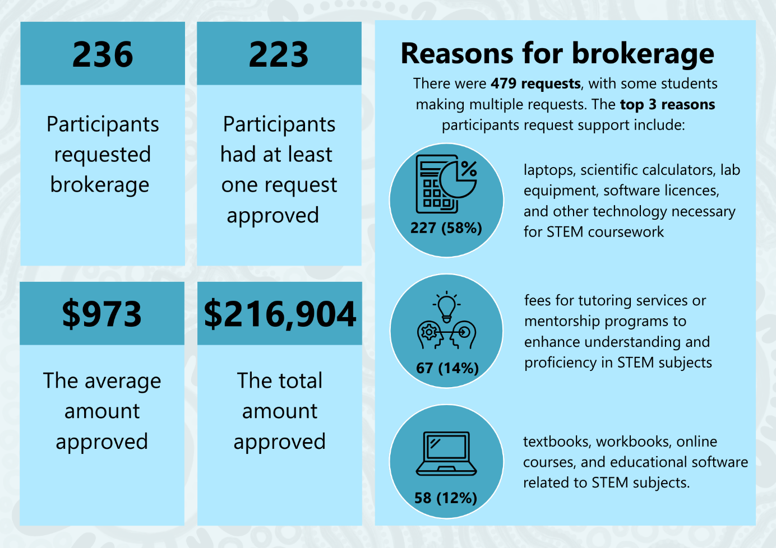
Source: YIWSA high school brokerage data collection tool – participant data: April 2020 – June 2024.
The majority of YIWSA high school survey respondents (72%, n=52) rated financial support as highly important.
Administrative brokerage data for the tertiary component shows that 44 participants have made brokerage requests between 2020 and 2024, ranging from $85 to nearly $5,000 – see Figure 18.
Figure 18: YIWSA tertiary component brokerage data
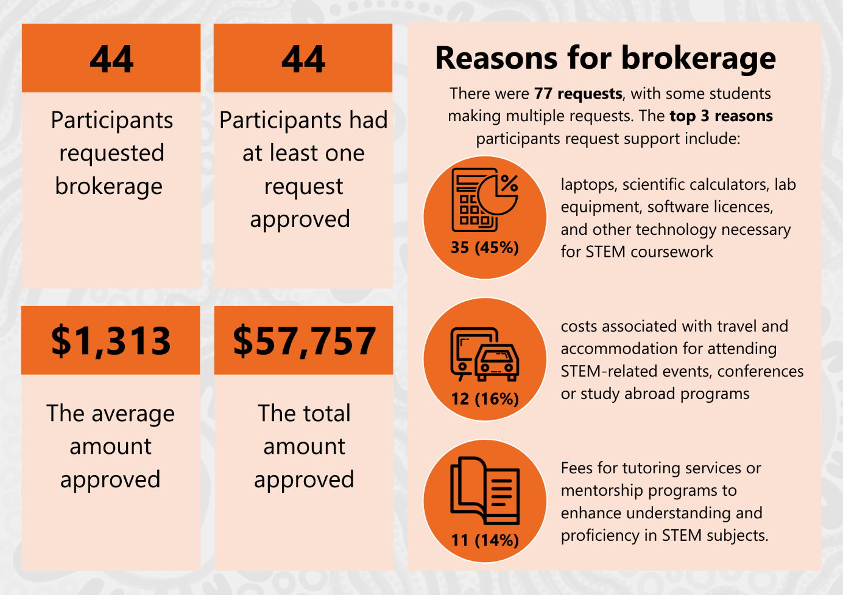
Source: YIWSA tertiary brokerage data collection tool – participant data: August 2020 – June 2024.
Student Advisors working in the tertiary component of the initiative indicated that the ability to utilise brokerage flexibly had been particularly useful for some students during their transition to university – particularly with securing housing where beginning at university had required young women to move from their homes in regional areas.
Amber’s story
Amber16F was excited to begin her course at the University of Queensland based at the Brisbane campus, but moving out of home for the first time and away from her home in Townsville, she was struggling to find suitable and affordable accommodation. Even though she had been able to organise a job for herself in Brisbane, she did not have any substantial savings and didn’t know how she could raise the bond required for a rental property.

Amber talked to her Student Advisor, saying she thought she’d have to go back to Townsville and defer her studies, but her Student Advisor was able to help her apply for brokerage.
She was able to use brokerage funds to secure a rental property without going into debt and to commence her studies as planned.
Further detailed breakdown of brokerage data is provided in Tables A11 to A16 in the Appendix.

Medium-term outcome 3: Participants provide support for one another and become role models/mentors.
Nineteen YIWSA participants who were interviewed explicitly reflected that an important outcome was that they had created strong, supportive relationships with like-minded peers. They highlighted that the initiative has allowed them to connect with like-minded girls in a culturally safe space.
For both participants and their parents, having a peer group with similar interests was noted to be of high importance.
She likes that there is a big group of people interested in STEM, and they are there to support you. – Parent of YIWSA participant, high school component (interview data)
YIWSA includes several mechanisms for peer networking to occur, including:
- STEM camps
- online forums such as National Assemblies
- participation in local events such as science fairs.

YIWSA STEM camps
Camps were seen as an important opportunity for YIWSA participants to demonstrate and extend their capabilities in a supportive environment.
Between January 2023 and June 2024, a total of six YIWSA STEM camps were held, and a total of 103 participants attended. The two largest camps had 29 attendees each, and the smallest camp had eight attendees. Attendance ranged between 41% and 73% of the cohort. See Table A7 in the Appendix.
Across the survey and interview data sets, STEM Camps are clearly identified as key opportunities for students to build relationships with their peers and with YIWSA Team members, engage in STEM learning and strengthen their engagement with the initiative.
While some camps were well attended by the intended cohort (for example, 73% of the Brisbane cohort attended their camp in 2023), other camps had low participation rates (e.g. just 41% of the Victoria and Tasmania cohort attended their camp). YIWSA Team interview data provides insight into the reasons why some participants are not able to attend YIWSA STEM Camps. These are most often related to participants having existing prior commitments to family, community and to other extracurricular activities. STEM Camps are typically held during school holiday periods to minimise interruptions to schooling. Overall, participation rates for STEM camps indicate that a substantial proportion of YIWSA participants are not taking up the opportunity to participate and there may be opportunities to strengthen participation.

University-based STEM Camps
In addition to providing information and attending the YIWSA STEM camps, Academic Coordinators inform participants about similar opportunities that are external to the initiative. Mostly these are university-based camps intended for high school students and are, for the most part, not specifically for Indigenous young women. The YIWSA High School Team shares information about these opportunities with participants, usually through group email communications. However, where they are aware of an opportunity that aligns with a particular participant’s interests, they will reach out to the participant individually.
I saw it [the external camp] on a newsletter, and I was like, I should definitely apply for this … It’s a health and science camp for Year 11 and 12. We did a lot of Indigenous activities. I got to hear about things from doctors, surgeons, dentists and physiotherapists. – YIWSA participant, high school component (interview data)
In 2023, 30 participants applied for and attended an external STEM camp. A further 16 applied but did not attend. In 2024 (to June 30), 25 participants applied for and attended an external STEM camp. A further five applied but didn’t attend. Further detail can be found in the Appendix, Tables A8 and A9.

Strong peer networks
There is strong research evidence to suggest that peer networking opportunities are a valuable component of programs designed to support high academic achievement for Indigenous students. In particular, research demonstrates that placing Indigenous students with similar academic abilities together reduces pressures to mask giftedness for the sake of following cultural norms and gaining acceptance by peers.17F In addition, the research literature highlights that bringing together groups of like-minded Indigenous students provides opportunities for them to form connections and to help affirm their Indigenous selves.18F
Survey data shows that high school students were very positive about STEM camps. Most of the high school student respondents who attended a camp (n=38) found these either extremely helpful or helpful, with 33% of respondents (n=25) not having participated in the camps and 5% of respondents (n=4) not finding this initiative component helpful.
Of the 20 high school students who responded to the question about initiative improvements, eight suggested holding more camps and longer camps so that participants can spend more time together face-to-face.
Being able to go on camps and listen to the National Assemblies has been incredibly helpful with assisting me with what I want to do when I leave school! – YIWSA participant, high school component (survey response)
-------------------------------------------------------------------------------------------------------
I do wish there was more funding for the STEM camps as I found these to be some of the most beneficial parts of the YIWSA in my experience. – YIWSA participant, high school component (survey response)
Participants reflect feeling like their connection to other participants was strong – feeling like ‘sisters,’ and ‘close mates.’
The other people in the Academy are my friends and they are also always willing to help me out. – YIWSA participant, high school component (interview data)

Medium-term outcome 4: Participants develop strong professional networks that support future employment.
YIWSA provides opportunities for its participants to meet and connect with STEM professionals, including Indigenous women who are STEM professionals. This happens as part of camps, through National Assemblies and at a range of other community events. In addition, YIWSA hosts workshops and guest lectures from YIWSA alumni and other STEM professionals.19F
This Academy has been amazing for me and has provided me with many great opportunities throughout the years to meet some amazing STEM professionals and people. – YIWSA participant, high school component (survey response)
Industry stakeholders interviewed reflected that the YIWSA Team (Academic Coordinators) had worked alongside them to facilitate opportunities for them to present to groups of students (at their camps) as well as for YIWSA participants to facilitate activities at community events.

National Assemblies
National Assemblies are conducted online and are available to all YIWSA participants. The National Assemblies have guest presenters – two Indigenous female STEM professionals at each National Assembly. Each of the four National Assemblies for the year focuses on one of the ‘letters’ of STEM. It is expected that all participants will join all National Assemblies where they do not have other commitments, such as family, study, work or extracurricular activities. The YIWSA Team tries to ensure that the times for National Assemblies are not always the same and to consider the various time zones from which participants will join.
In 2023, a total of 235 participants attended National Assemblies and as of June, a total of 119 attended in 2024. Table A17 in the Appendix shows that each term, approximately 15% of participants attend a National Assembly.

Industry work experience opportunities
Part of the high school component of YIWSA is connecting students with relevant STEM work experience opportunities. For the most part, however, work experience for this group was provided through their schools. Academic Coordinators noted that some schools were able to provide excellent opportunities, while others had very limited opportunities for students. Where this was the case, Academic Coordinators utilised their own networks and the broader CSIRO networks to support students to access more relevant and suitable work experience opportunities.
Of participants interviewed, a small number (n=4) reflected on having been supported by their Academic Coordinator to connect with work experience opportunities. Participants noted that their Academic Coordinator was able to connect them with opportunities in their fields of interest.
For example, a student aspiring to study medicine was supported by her Academic Coordinator to identify related work experience opportunities.
Lilly’s story
When Lilly20F first joined YIWSA she was very motivated to study medicine as a career. Her Academic Coordinator talked to her about the different ways YIWSA could support her to achieve her goals. She was able to introduce Lilly to a young Indigenous woman paediatric neuroscientist studying brain cancer. Lilly has had the opportunity to meet this STEM professional a few times and they’re now organising a work placement for Lilly at the research facility.
Administrative data provided by the YIWSA Team shows that between January 2023 and June 2024, 18 participants were supported through the initiative to complete a work experience placement. See Table A18 in the Appendix for more detail.

Internships
For the tertiary YIWSA participants, industry-relevant work experience is intended to be provided through paid internship opportunities. Student Advisors endeavour to match students’ study interests and career aspirations with internship opportunities with their partner employers. Students can pursue internship opportunities from the summer period preceding their first university semester and after that, during semester break periods.
CareerTrackers administrative data, which was used to create Figure 19, shows that between 2018 and 2024:
- 140 participants completed an internship
- 65 of these participants completed four or more internships.
Figure 19: Number of internships completed
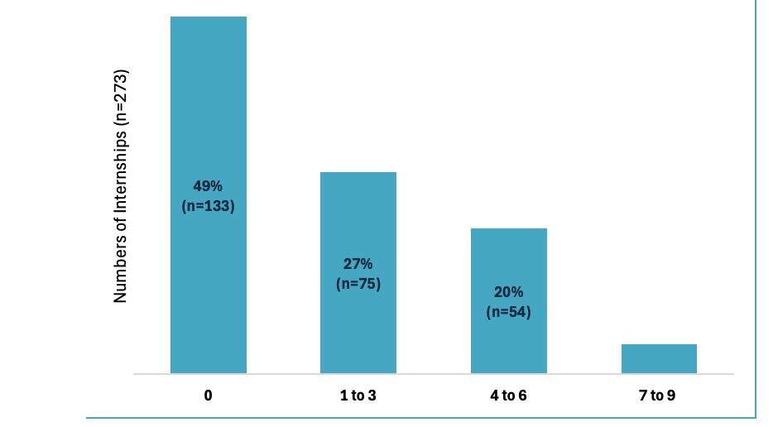
Notes: Labels <10% not shown.
Source: YIWSA tertiary data CRM database – participant data: January 2018 – June 2024.
It is notable, however, that of the tertiary students participating in YIWSA, nearly half (133 of 273) had yet to participate in an internship. While no administrative data is available on why a participant has not undertaken an internship, this may be explained partly by the participants’ year of study. Since 6% (n=11) of participants began their degree in 2024 and 16% (n=29) started in 2023, they may not have had the opportunity to undertake an internship. See Table A30 in the Appendix for more detail on university start dates. YIWSA Tertiary Team members advise that some participants choose not to participate in internships due to:
- existing work commitments
- limited opportunities to return home except during the semester breaks (which is when internships take place)
- their degree already having substantial practical/work experience components (particularly notable for those studying in medicine, nursing and allied health degrees).
This trend was also reflected in survey data, which showed that 50% of tertiary respondents had not experienced this aspect of the initiative at the time of the survey.
Of the tertiary survey respondents who participated in work placements, five (71%) found work placements extremely helpful/very helpful. Around two-thirds of tertiary respondents (n=11) did not participate in work placement.
I think that that [internship opportunity] was one of the most important things that kind of drew me to it. And they said to me that they would have grants and have funding and have work opportunities where I’d be able to learn from other Aboriginal people about agriculture, food science. So, I think that that just sounded the best to me, to be in food science is already so niche and so small, but to actually be able to engage with First Nations food scientists and companies, that’s amazing. – YIWSA participant, tertiary component (interview data)
Interviewees and survey respondents also valued the opportunities to hear from alumni and other Indigenous STEM professionals, who provided both their Indigenous STEM knowledge and examples of successful Indigenous women working in STEM careers, which many participants described as being inspirational and motivating.
As a corollary, participants saw the possibility of serving as role models for other young Indigenous women and girls as an important component of their participation in YIWSA.

Developing confidence
The research literature indicates that the single most significant positive impact of excellence programs for Indigenous students is that students improve confidence in themselves and their academic abilities21F.22F Some research indicates that when students are recognised for their achievements in school and placed in a space where their abilities are further nurtured, they learn better, and their self-esteem is enhanced.23F The findings of this evaluation support this, with data from interviews confirming participants have increased confidence.

Interviewees talked about several factors that they felt helped them become more confident, including:
- gaining exposure to industry
- having STEM professionals as mentors
- having a strong sense of belonging to a community of peers
- having access to hands-on practical activities and work experience.
I had access to my mentor, and we became friends, really. They were supportive and encouraging. Being in biomedical science organisations, it’s definitely not a space that’s been safe for people like me, I guess, forever. So, I had a lot of anxiety going into it. [My mentor] supported me to overcome that anxiety. I had a presentation that I was supposed to do, and I called my mentor, and I said, ‘I don’t know if I can drive in.’ I was like, ‘I’m so scared to do my presentation.’ And they helped talk me through it, and I had ended up driving in, and I felt terrible doing the presentation, but I did it and I was so proud after. And I just needed someone that could encourage me that knew about the space. – YIWSA participant, tertiary component (interview data)

Medium-term outcome 5: Indigenous families and communities value young women’s STEM education.
So far, it’s just been such a beautiful community and has really helped [my child] to connect with her culture and with everybody, her peers, the aunties; everyone has just been so good in helping her to just feel, yeah, connected. – Parent of YIWSA participant, high school component (interview data)
Parent and participant interviewees reflected that the initiative has been useful in building and providing community connections for participants, but also for families and communities to become more engaged in their young woman’s STEM learning journey.
Participant interviewees shared that a key motivating factor for them to participate in YIWSA was their desire to learn and share Indigenous STEM Knowledges and understand how these Knowledges can be incorporated into STEM careers. Survey respondents and interviewees highlighted the importance of the program being specifically for Indigenous young women, because of the cultural safety of working together with other Indigenous young women and with predominantly Indigenous staff.
[At the camps] there is a cultural safety that comes about from being an Aboriginal and Torres Strait Islander targeted program … and when they come together in that camp setting, being young women with a similar focus like ‘we’re all here, and we’ve been selected for this program, I’m gonna show up.’ – YIWSA participant, high school component (survey response)
The evaluation has found that developing a network of peers has supported participants to develop their sense of themselves, including their Indigenous cultural identity.
Eleven YIWSA participants who were interviewed reflected that they were motivated to join the initiative to connect to role models and peers in a similar position. Two interviewees from regional locations noted they did not have Indigenous peers at their school and valued the opportunity to meet other Indigenous girls and make friends from other places. In interviews, participants indicated they felt they learn from one another and value being able to talk about their university experience, Country and language.

Parents interviewed as part of the evaluation also reflected that YIWSA, and the Academic Coordinators in particular, had supported them to expand their knowledge and awareness of possible STEM careers. External stakeholders noted also that YIWSA participants were involved in community events and facilitated activities that helped build community knowledge and awareness of STEM and STEM careers.
Academic Coordinators consistently reflected that where they were able to build trust-based relationships with parents and other family members, this increased their willingness to allow and support their young women to participate in a wider range of STEM learning opportunities, including camps.

Medium-term outcome 6: Indigenous STEM Knowledge is recognised and valued.
In alignment with findings under Medium-term outcome 6, the evaluation finds Indigenous STEM Knowledge is recognised and valued in YIWSA. Interview, survey and administrative data demonstrate that Indigenous STEM Knowledge is an integral part of YIWSA activities. As discussed in the sections above, participants have regular opportunities to learn from Indigenous STEM professionals and to share and grow their Indigenous STEM Knowledge. Participants highlighted that this aspect of the initiative was inspiring and motivating for them.

Which components of YIWSA and which causal processes were most effective in generating positive change, and for whom? [KEQ 7]
The evaluation has found that YIWSA is delivering several causal processes that are effective for generating positive change. As discussed in section 2.3, YIWSA is:
- delivering high-quality, individualised support, including developing learning plans and setting goals, advocating for participants to ensure their needs are met, and ensuring participants are aware of and supported to take part in activities relevant to their interests
- facilitating the establishment of strong peer networks within and across participant cohorts through in-person and virtual learning experiences
- supporting families to be involved in their young women’s STEM learning journeys by providing both information and material support as necessary
- growing the confidence of YIWSA participants through YIWSA Team and peer support as well as through exposure to STEM learning opportunities and STEM professional experiences
- integrating Indigenous STEM Knowledges into YIWSA in-person and virtual learning experiences
- supporting young Indigenous women to develop their own professional networks through work experience and internship opportunities.
As shown in Figure 20, the initiative components that most respondents found most helpful are:
- ‘Support from my Academic Coordinator’ (71% – n=55 Extremely helpful/Helpful) – high school only
- ‘Talks and lectures from STEM professionals’ (57% – n=56 Extremely helpful/Helpful) – all
- ‘Talks and lectures from Academy alumni’ (52% – n=51 Extremely helpful/Helpful) – all
- ‘Mentoring (tertiary only)’ (100% – n=9 Extremely helpful/Helpful for those who experienced it; 50% did not experience mentoring).
Survey data indicates that high school student respondents mostly found National Assemblies either extremely helpful or helpful (49%). Twelve per cent of respondents reported that they had not participated in a National Assembly and 12% of respondents did not find them helpful.
Around two-thirds of those who attended talks and lectures from STEM professionals (n=56) and Academy alumni (n=51) found them extremely or very helpful. More than 80% of survey respondents indicated they had attended talks and lectures hosted by YIWSA.
Figure 20: YIWSA initiative components and respondent participation
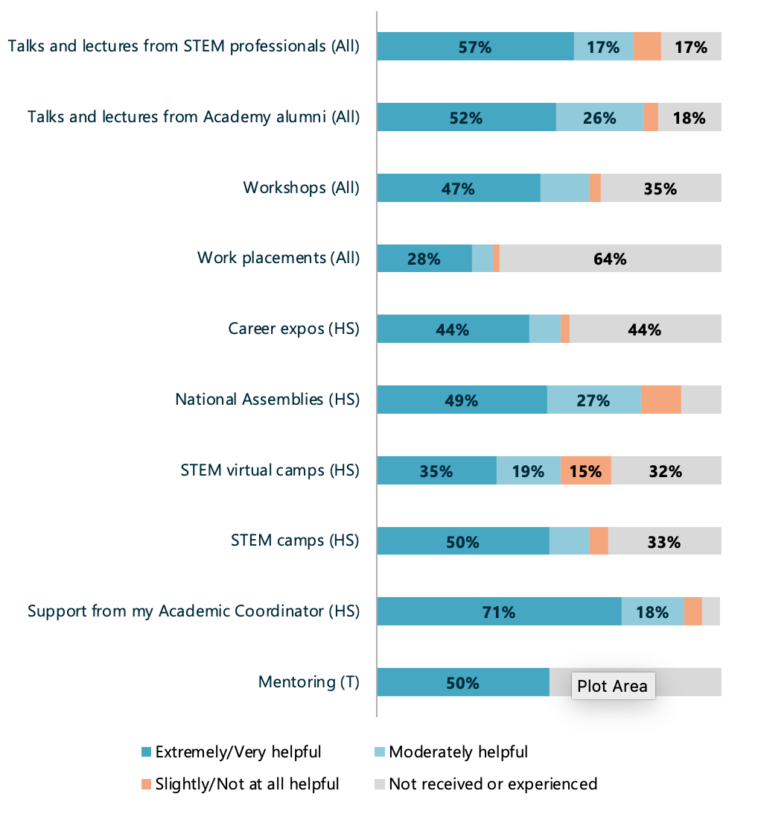
Notes: Program components in rows 5 to 9 were aimed at high school students (HS) and in row 10, at tertiary students (T). Total respondents for each row: 1 (n=98), 2 (n=98), 3 (n=97), 4 (n=98), 5 (n=77), 6 (n=77), 7 (n=75), 8 (n=76), 9 (n=77), 10 (n=18). Labels for <15% are not shown.
Source: The 2022, 2023 and 2024 YIWSA Participant Survey.

Qualitative Comparative Analysis
To gain further insight from the data gathered through interviews, the Evaluation Team undertook a Qualitative Comparative Analysis (QCA).24F The technique tests whether there are certain factors, or sets of factors, that are likely to lead to positive outcomes. The QCA uses only interview data from participants because this data set was sufficiently nuanced and detailed to enable this kind of analysis.
In QCA, different factors or ‘conditions’ that appear to be related to outcomes are systematically compared across multiple cases. This helps to identify which factors or conditions are most strongly correlated to achieving a particular outcome. For QCA to be effectively applied, there need to be examples in the data set of individuals who have achieved a defined outcome, as well as examples of individuals who have not.
For this evaluation, the methodology applied was:
- defining appropriate positive outcome(s), based on the program logic
- determining conditions that appear to be related to the outcome being achieved or not (based on the thematic analysis of the interview data)
- creating a data set that relates only to the identified conditions and outcomes
- analysing necessary conditions
- analysing sufficient conditions
- presenting results
- interpreting results.
This is a Mid-term Outcomes Evaluation. As such, there are few participants who have ‘completed’ the initiative. That is, those participants who have completed the initiative did not commence it until they were already engaged in tertiary education – they have not progressed through the entire initiative. This means that it is not practical to use an endpoint outcome (for example, completing a tertiary STEM qualification) as the definition of a positive outcome for this analysis. Rather, intermediate outcomes need to be used.
In consultation with NIAA and CSIRO, the Evaluation Team defined a positive outcome for YIWSA as: Highly engaged in YIWSA activities.

The analysis draws heavily from the thematic analysis of interviews with participants to determine a set of conditions that seem to affect the extent to which students are engaged with the initiative:
- prior motivation/passion for STEM
- participation in a YIWSA STEM camp
- strong relationship with/support from Academic Coordinator
- strong supports outside of initiative (school, workplace, university, institution)
- substantial other responsibilities (family, extracurricular, work, community)
- knew what was on offer and could participate in what they were interested in
- location – metro or regional.
Interview data for all of the YIWSA interviewees (n=40 high school participants)25F was closely examined to determine whether the interviewees met these conditions, and if relevant, to what extent. The data was then coded accordingly. Table A5 in the Appendix provides details about the methods used.
The analysis of the data identified four necessary conditions – those that are consistently seen in highly engaged participants, but sometimes also in less engaged participants:
- participating in a STEM camp and having a strong relationship with and support from their Academic Coordinator
- participating in a STEM camp and knowing what is available and participating in what they are interested in
- participating in a STEM camp and being in a regional location
- knowing what is available and participating in what they are interested in and being in a regional location.
Where these are present, it is probable that the participant will be engaged in the initiative.

Figure 21: Necessary conditions
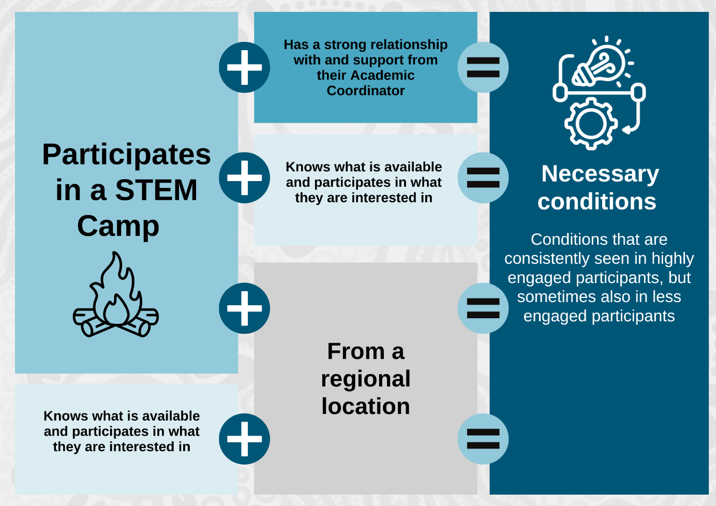

The analysis of sufficient conditions – conditions that highly engaged participants meet, but less engaged participants never do – are:
- having a strong relationship with and support from their Academic Coordinator
- having prior motivation/passion for STEM and knowing what is available and participating in what they are interested in
- having strong supports outside of the initiative and knowing what is available and participating in what they are interested in.
Where these are present, it is highly likely (but not certain) that the participant will be engaged in the initiative.
Figure 22: Sufficient conditions
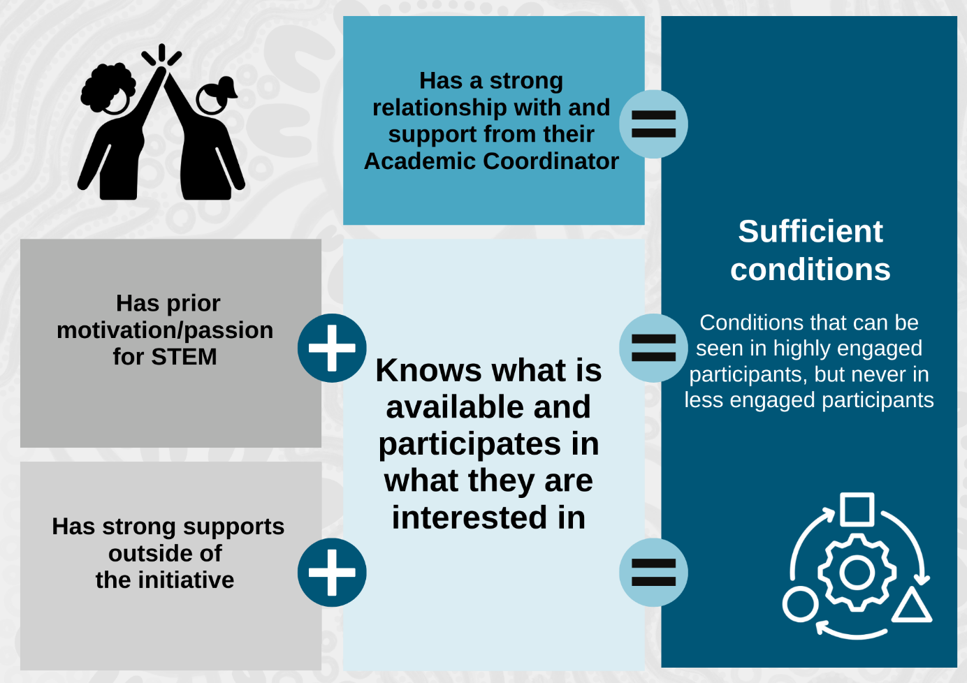
The QCA strengthens findings from the thematic analysis, particularly the importance of the individualised support being delivered by Academic Coordinators. As illustrated in Figure 22, a strong relationship between the participant and their Academic Coordinator is, in and of itself, sufficient to predict that a participant will be highly engaged in the initiative. In other words, a strong relationship with their Academic Coordinator was always seen in highly engaged participants but never among participants who were considered not to be engaged. As highlighted in interview data, this was expected because where there is a strong relationship, participants are more able to capitalise on opportunities and are encouraged to participate.
Additionally, the QCA showed that participants knowing what is available and participating in their interests was a sufficient condition for high levels of engagement when combined with strong support outside of the initiative (for example, through their school, family or both) or having prior motivation/passion for STEM (see Figure 22). It is important to note that strong support and passion for STEM are both conditions over which the initiative has little influence.
The other external factor of being from a regional location was a necessary condition when combined with participating in STEM Camps or participating in other activities of interest. Location was included as a condition in the QCA analysis as a mechanism to investigate whether participants from regional locations were any less likely to achieve positive outcomes than participants from metro locations, where typically access to facilities, opportunities and resources is better. While the QCA suggests that being from a regional area does not hinder engagement, the interview sample skewed towards regional areas (see Appendix, Table A25),26F meaning the evaluation cannot draw any meaningful conclusion about location beyond the fact that being from a regional area does not appear to be a barrier.
Participation in a STEM Camp was seen as also a necessary condition for engagement when combined with the internal factors of participating interests and strong relationships with the Academic Coordinator.
As illustrated in Figure 23, factors over which the initiative has greater control (shown in blue), such as participants’ relationship with their Academic Coordinator, participating in their interests and attending a STEM Camp, are those most likely to result in high levels of participant engagement. This finding highlights the importance of these elements in the design of the initiative. External factors (in grey), such as other support from family, school or community and a strong existing passion for STEM, are also predictive of high levels of engagement. However, these are factors external to the initiative’s design. The findings of the QCA and thematic analysis highlight the importance of ensuring the relationship between participants and their Academic Coordinator is strong and of maximising participation in STEM camps and other STEM learning activities wherever possible.
Figure 23: Synthesis of QCA and thematic analysis
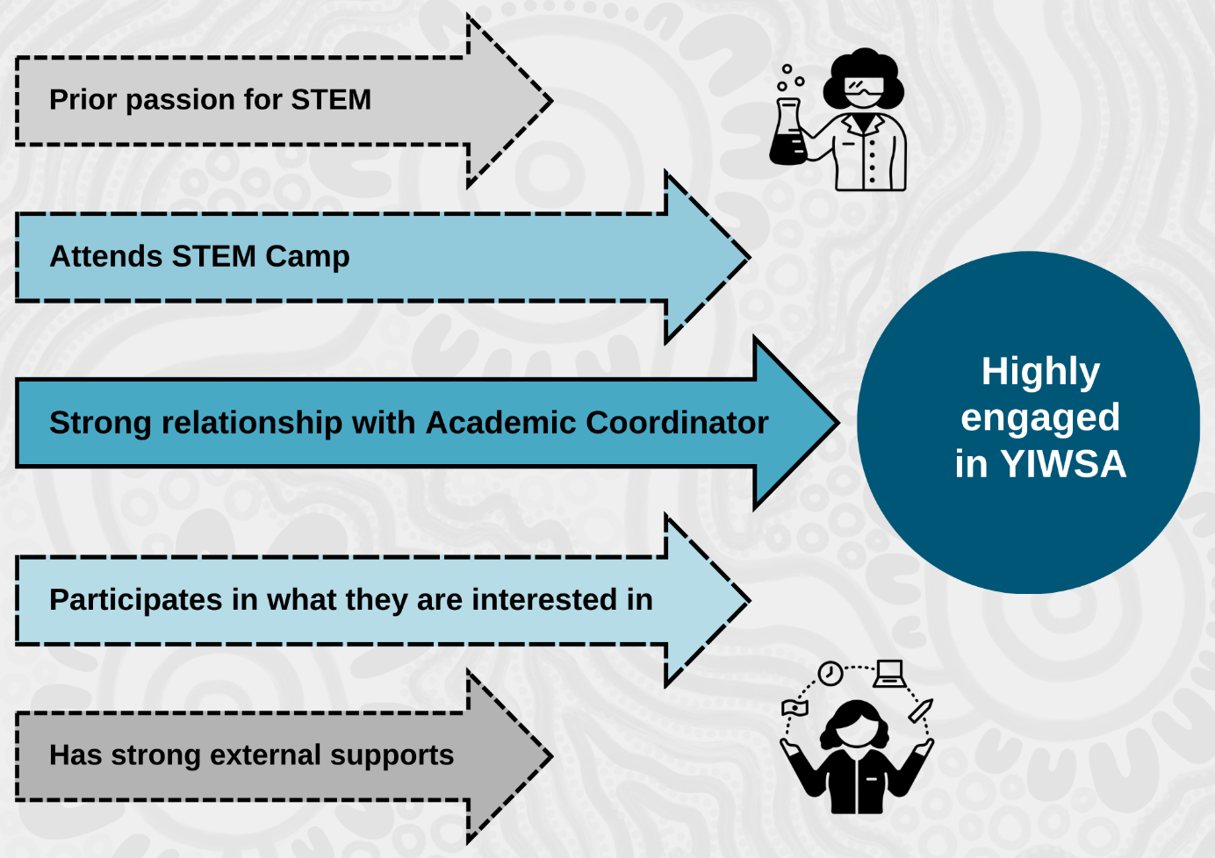

Have there been any unintended consequences (positive or negative) associated with YIWSA with respect to the approach/actions taken? [KEQ 8]

Managing national reach and accessibility
Maintaining communications and connection between Academic Coordinators and the students in their cohorts represents a substantial challenge for YIWSA. As an initiative with an ambitious national reach, certain decisions have had to be made to enable a geographically dispersed group to access the initiative. While the cohorts are ‘place-based,’ the reach of each cohort is, nevertheless, still vast. Some particularly extreme examples include the cohorts that extend to include the whole of WA, or SA. In interviews, YIWSA staff spoke about the extensive planning and logistics involved in coordinating regular in-person visits27F with the students they support. This has a negative impact on Academic Coordinators’ ability to have face-to-face contact with participants in their cohort.
Rather than limit access by geography, the cohorts limit participation based on school year group. This has meant that some students who would otherwise be ideal candidates for the initiative have effectively been excluded from participation. YIWSA has attempted to provide opportunities for these students to participate through the introduction of National Cohorts that are accessible once a student (who can be based anywhere) reaches Year 11. While this measure goes some way to addressing the issue, it is sometimes a far-off proposition for a student who may only be in Year 9. The National Cohort participants must be enrolled in STEM subjects for their senior years in high school. It is likely that members of this cohort are either very highly motivated or have existing strong supports that have enabled them to be studying STEM subjects at a senior level. They are likely to be highly successful as YIWSA participants but are perhaps more likely than some other potential participants to have succeeded without the support of YIWSA. The QCA finding that having strong supports outside the initiative and prior motivation and passion for STEM are sufficient to predict success in YIWSA supports this.
The cohort approach within the high school component provides for a commonality of experience for participants and strong relationships with Academic Coordinators where personnel stay in their role over extended periods. Some YIWSA High School Team members reflected that supporting a cohort that is distributed over a vast geographical area contributed to work stress. No data on staff turnover was available to the evaluation to support this perception.
The cohort design also means that as students move through the initiative, there is a substantial shift in where resourcing is required. As more students graduate from high school, less resourcing is required for this component, and more is required for the tertiary component. The plan for managing this is still in development but should be prioritised for finalisation before the next major transition of participants in the middle of 2025.

Managing the transition from high school to tertiary component
As an initiative designed with a 10-year lifespan in mind, the recruitment of participants has been staged to ensure that as many of the participants as possible can benefit from the full support – that is, from Year 8 through to completion of a STEM degree. To enable this, the planned approach to recruitment follows the pattern shown in Figure 24.
Figure 24: The scheduled intake and exit of participants
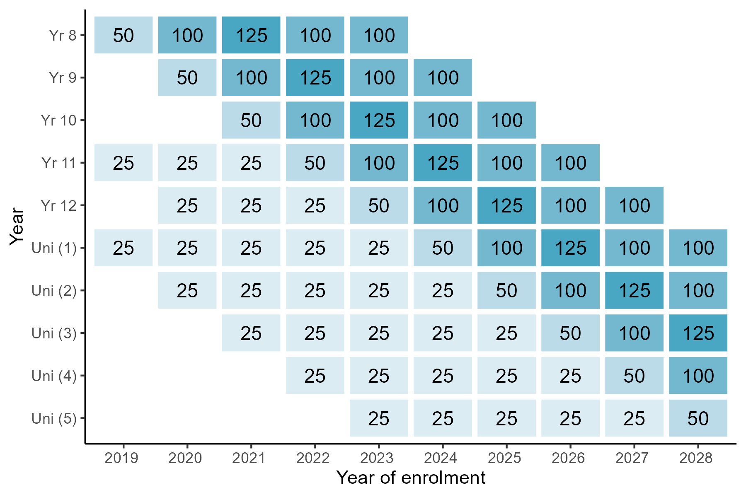
Source: CSIRO IAS Funding Agreement – IGSA Project Schedule (YIWSA).
During the first year of YIWSA, the two components of the initiative undertook their own recruitment, with the high school component focusing on a small number of cohorts in Years 8 and 11, and the tertiary component recruiting students who were already enrolled in STEM degrees at tertiary institutions where the YIWSA Tertiary Team had Student Advisors in place. Some of the tertiary participants were students who may have already applied to CareerTrackers, but because they were pursuing STEM degrees, they were able to be directed into YIWSA. In other cases, recruitment efforts focused on promoting YIWSA though Indigenous Support Units at tertiary institutions.
The first planned transition to the tertiary component for a small number of participants who had completed Year 12 occurred in 2020, with additional transitions of small numbers of participants happening in 2021 and 2022. As shown in Table A10 in the Appendix, a total of 89 participants transitioned between 2018 and 2022. The first transition of a cohort that began as a Year 8 cohort occurred in 2023, with 74 participants making the transition. 2024 saw the most transitions, with 99 participants moving into the tertiary component. In total, 262 participants have transitioned out of the high school component.
As seen in Table 8, as of mid-2024, the YIWSA Tertiary Team had engaged 207 of the participants who made the transition. Staff noted they had not been able to reach the remaining 55 participants, reporting several challenges including outdated contact information for participants.
The transition process is continuing to be refined, and as noted above, some issues have become apparent. The ways of working with participants differ distinctly between the two components. While a whole high school cohort will graduate at the same time, moving that cohort from one Academic Coordinator to one Student Advisor is not necessarily feasible. While the Academic Coordinators work with a group within a specific geographic region and in a specific year level, the Tertiary Team typically employ Student Advisors to work with students across multiple year levels in a wide range of fields, who are studying at the same institution (though this is not always the case). This enables Student Advisors to build very strong relationships with the Indigenous Support Unit at that university and connect with potential participants. Typically, Student Advisors connect with students when they have already been accepted into a course of study at a specific university.
At the time of writing, YIWSA participants are scheduled to transition from Academic Coordinators to Student Advisors mid-way through Year 12. While the intention with this timing was to enable participants to plan for and participate in an internship at the end of Year 12, both Academic Coordinators and Student Advisors had concerns with the transition point. For Academic Coordinators, some felt that they were being asked to step back their support right as students were facing exam periods and big decisions about their futures – that is, at a time when they may need the support of a known and trusted person. Likewise, Student Advisors noted that it was very difficult to engage with students at this juncture as they were very much occupied with the requirements of completing their high school education. Several Student Advisors also noted that most students were looking forward to taking a break over the summer between school ending and tertiary studies commencing.
The YIWSA Tertiary Team members advise that the proportion of students transitioning into the tertiary component who complete internships during this pre-university summer session is very small. This indicates that the timing of the transition may be unhelpful and should be reviewed. The evaluation sets out some considerations in the recommendations provided in section 2.8.
Up until recently, the number of YIWSA participants graduating from high school has been relatively small, with only one or two cohorts graduating at a time. The Tertiary Team has utilised a key YIWSA staff member to provide interim (and ad hoc continuing) support for students in the early stages of the transition. More recently, other senior Student Advisors have taken up this role with particular graduating cohorts as the load has become less manageable for one person. These senior Student Advisors report, however, that they have received limited information about or for students to whom they are supposed to be offering support. One Student Advisor spoke of receiving a list with contact information that sometimes consisted only of an email address that was connected to the student’s school. Both Academic Coordinators and Student Advisors were concerned at the lack of a warm handover between the two components, with Academic Coordinators being told to cease providing support and Student Advisors being asked to provide it based on minimal and sometimes insufficient information.
While the YIWSA Team is working on improving its transition process, the data shows that many students have not received the continuity of support the initiative intends to deliver.
Out of the 12 tertiary survey respondents who gave open text responses, seven had little to no support from or contact with their Student Advisors. Two of these respondents stated that since moving from the high school component to the tertiary component, little to no contact had been made.
Since moving to the tertiary component, no contact has been made. Otherwise, my Coordinator previously was wonderful. – YIWSA participant, both components (survey response)
-------------------------------------------------------------------------------------------------------
Since finishing high school I’ve had little to no contact from YIWSA. The [Student Advisor] doesn’t contact myself or my family. I’ve only had my previous Coordinator contact to get updated contact details. I’ve received no financial support or guidance since I’ve started studying at JCU [James Cook University] Townsville this year for a career in Biomedical Sciences. I feel that YIWSA has tossed myself and other participants I know who are at Uni aside. My family are also disappointed in the non-existence of support for me. I have dyslexia and support for a person such as myself is something [that is] always welcome. But most of all, every YIWSA participant deserves a fair and equal opportunity in this program. – YIWSA participant, both components (survey response)
Only a few respondents (25%, n=4) agreed that their Student Advisor maintains regular communication and checks in at least monthly. Of those who added their thoughts on their experiences with their Student Advisor (n=12), over half (n=7) stated that they had no support or contact with their Student Advisor, with two respondents noting that they hadn’t been contacted after transitioning to the tertiary component.
This data highlights the challenges with managing the transition from the high school component.
In the initial stages, the resource investment required from the Tertiary Team to provide Student Advisor support was relatively small and could be managed with a single YIWSA Academic Coordinator role and using CareerTrackers’ existing staffing allocation. During the initial stages, students were selected for participation who neatly fit within the parameters of the CareerTrackers business-as-usual model. They were already studying STEM degrees at universities where CareerTrackers had existing relationships with Indigenous Support Units. They were also studying in fields in which CareerTrackers had existing industry employer relationships, which largely meant that finding internship placements for YIWSA students was straightforward. Combined with the substantial increase in the number of students transitioning to the tertiary program, additional factors have made the role of supporting students more complex. For example, students are enrolled in a range of tertiary institutions including those where CareerTrackers does not have an existing presence or relationship. This includes VET providers, which previously were beyond the scope of CareerTrackers’ work.
Interviews with the YIWSA Tertiary Team staff also indicate that turnover of Student Advisors is high. Student Advisors are often recruited from the CareerTrackers pool of alumni and as such, are new graduates for whom the position is a jumping board for work in other fields. CareerTrackers has a strong ethic of supporting its staff to take up these kinds of opportunities, but this contributes to high turnover of staff, creating issues with providing sufficient and continuously available support for YIWSA participants.

Providing alternative pathways
While the YIWSA Team has a formal policy that participants who are no longer pursuing STEM studies should be provided with a final six months of support to be exited from the initiative, survey, administrative and interview data indicate that there is a proportion of students who are participating in the initiative whose interests are primarily not related to STEM. Twenty-three per cent of survey respondents in Years 8–10 indicated that they did not intend to continue with STEM subjects into their senior years of schooling. Twenty-one per cent of tertiary YIWSA students are studying fields that would sit outside most definitions of STEM – see Table A26 and Table A27 in Appendix 1.

Summary findings of YIWSA mid-term outcomes

YIWSA is providing individualised support in relationship with a key YIWSA Team member, which is supporting participants to achieve their personal and academic goals
Interview, survey and administrative data for YIWSA high school participants demonstrates that the majority of participants have regular one-on-one contact with their Academic Coordinator, which is highly valued because Academic Coordinators recognised the individual goals of their participants and provided support accordingly. Providing each participant with an Academic Coordinator or Student Advisor with whom they can develop a direct relationship supports them to connect with other activities and additional supports as these are needed.

YIWSA is supporting the development of strong peer networks
YIWSA participants highly valued the relationships they were able to forge with one another. Participants noted that having a sense of a connected, like-minded peer group was highly motivating for them to further their studies and to achieve their STEM study or career goals. Peer networks were developed most strongly through participation in STEM camps as well as other in-person and virtual activities where participants have the opportunity to connect with one another.

YIWSA is supporting strong cultural connections for participants and their families
YIWSA supports strong cultural connections for participants and their families through:
- culturally safe mechanisms for delivering YIWSA – that is, in relationship with a known and trusted personal contact (Academic Coordinator or Student Advisor)
- the high proportion of Indigenous staff in the YIWSA Team
- the emphasis on prioritising Indigenous speakers and presenters at YIWSA events and activities
- Indigenous STEM and other traditional Knowledges being embedded in the learning activities YIWSA delivers.
In addition, YIWSA facilitates the development of strong peer networks among participants, which supports strong cultural communal identity.

YIWSA is expanding participants’ knowledge and experience of STEM and developing their confidence
YIWSA is providing participants with a range of opportunities to engage with STEM professionals, through National Assemblies, mentoring, at STEM camps and through work experience opportunities including paid internships. Participants believed these opportunities have been very valuable for expanding their awareness of STEM professions, establishing a professional network and, critically, to developing their confidence to pursue STEM studies and careers.

Success in YIWSA is predictable for some participants
The QCA identified some factors that predict a participant will have a high level of engagement and likely success in the initiative:
- having a strong relationship with and support from their Academic Coordinator
- having prior motivation/passion for STEM and knowing what is available and participating in what they are interested in
- having strong supports outside of the initiative and knowing what is available and participating in what they are interested in.

Delivering an initiative with national reach is challenging
The YIWSA Team’s recruitment approach has been successfully implemented. YIWSA has exceeded targets for participation and engaged participants nation-wide. Nevertheless, some aspects of the approach make it unlikely to be sustainable should YIWSA be implemented into the future. In interviews, Academic Coordinators indicated that delivering support over a vast geographic area was logistically very difficult.

The transition between high school and tertiary components is complex to manage
A related issue is the transition of students between the high school and tertiary components. With the age-grade cohort approach, as students mature into the tertiary component, the staffing requirements shift between providers. The YIWSA High School and Tertiary Teams are working together to refine the transition processes and ensure the appropriate staffing allocations are available to support this; however, administrative, interview and survey data all indicate that some participants have already had negative transition experiences.

Not all YIWSA participants wish to pursue STEM studies and careers
An additional challenge relates to supporting participants whose interests and studies are in non-STEM fields. A review of YIWSA tertiary administrative data indicates that approximately one in 10 (11%) tertiary participants are studying in fields that are not STEM, or related to STEM. It is to be expected that not all participants will remain engaged in STEM studies long enough to complete a tertiary STEM qualification. Both providers have a strong ethic of inclusivity, and endeavour to find ways to keep participants engaged in STEM studies.
They have developed a policy which allows them to support all of the high-school YIWSA participants for 12 months post-secondary studies. Participants who are no longer pursuing STEM qualifications after that time are then exited from the program. Ensuring that students who are exited from the program can be connected with other forms of support through alternative programs is an area for further development.

Recommendations for the remainder of the 10-year initiative
The evaluation has identified four recommendations for the remainder of the initiative.
With regard to maximising engagement and participation in the initiative:
- YIWSA providers should refine the practices around planning face-to-face peer learning opportunities to increase participation rates at STEM Camps and other events. This may include:
- seeking additional guidance from parents regarding any potential barriers to participation
- offering additional camp-type opportunities for participants in higher year levels (noting STEM camps have been intended for students in Year 9, early in their engagement with YIWSA)
- considering possibilities for cross-cohort, interest-focused, in-person learning opportunities.
With regard to improving the transition experience for participants moving from the high school to the tertiary component:
- YIWSA providers should refine the processes for transitioning participants from the high school to the tertiary component. This should include:
- ensuring participants can access elements of the CareerTrackers service appropriate to high-school students while they are still being supported by a CSIRO Academic Coordinator – that is, having a period of overlap, where students are accessing support through both CSIRO and CareerTrackers
- ensuring a warm handover for every participant moving from support from an Academic Coordinator (CSIRO-managed high school component) to support from a Student Advisor (CareerTrackers managed tertiary component), including:
- effective contact information for the participant
- background information about their STEM interests and career goals
- relevant personal information – for example, particular cultural considerations or learning needs
- consideration should also be given to shifting the timing of the full transition to the tertiary component, which currently occurs mid-way through Year 12. Potentially this could occur mid-way through the first-year post-schooling. This would allow Academic Coordinators to offer continuity of support for participants through their final exams, and to find out whether each participant is studying after graduating from Year 12, and if so, what and where it would allow for participants who are not pursuing STEM careers to exit the initiative before they transition to the tertiary component. Further, knowing the institution that continuing participants have enrolled in would allow CareerTrackers to allocate Student Advisors more effectively
- ensuring the resourcing balance between providers reflects the changing workload as more participants transition between providers. For example, consider whether existing YIWSA High School Team members can provide support to participants in the tertiary component.
With regard to ensuring support is being provided to students who are pursuing STEM studies:
- YIWSA providers should ensure existing policy is implemented to exit students who are not pursuing STEM studies from the initiative. Consideration should be given to:
- exploring other support opportunities that may be available to students being exited and, wherever possible, providing a warm referral or handover into this support initiative
- offering places in the initiative to new students who may have expressed interest but sit outside current eligibility criteria due to their age, or who may be commencing STEM degrees at university, to replace exited participants.
With regard to ensuring data collection will sufficiently inform any future evaluations:
- YIWSA providers should refine data collection practices to ensure that data collection is occurring consistently across the whole YIWSA Team and there are data linkage capabilities between CSIRO and CareerTrackers. Data collected should include:
- accurate information about participants’ subject choices (including at high school) and fields of study
- information on graduation (including areas of specialisation), as well as information about participants who have withdrawn from their studies
- information on participants’ employment outcomes, including fields of employment.

Considerations for the future of the initiative
The evaluation has identified two key considerations should the initiative be funded beyond 2028:
- Review the age-grade cohort approach and investigate other potential structures for any new groupings of students. This should include:
- being able to include participants across multiple grades (i.e. Year 9 through to 12) who are interested in STEM
- focusing on a smaller number of schools where there may be fewer other opportunities available for students
- ensuring the geographic reach of each cohort is realistically and sustainably able to be covered by a single Academic Coordinator.
- Investigate opportunities for participants whose interests are not STEM related to be supported by other, similar initiatives. This should include developing relationships with providers of similar initiatives and ensuring each participant is matched with the most appropriate support.

The Teachers of STEM Initiative

Overview of the initiative
As described in Figure 25, ToSI is delivered by SSI and consists of two components. These are:
- Mentoring and Support Pathways (MSP) – provides support to Indigenous women to obtain qualifications to become teachers of STEM subjects in schools. MSP includes:
- mentoring from an SSI Mentor who can provide participants with advice and support, including academic support
- flexible scholarship funding, which can be used to pay tuition fees or meet other costs, such as supporting living costs during unpaid practicums that form part of an education student’s coursework
- Jardibirrijba – a three-day in-person orientation professional learning activity that explores Indigenous STEM Knowledges and how these can inform and be embedded in teaching practice
- Jardi Dadarrinyi – two-day in-person professional learning activities intended to support participants as they make the transition to becoming practicing teachers
- networking opportunities – through in-person activities, MSP participants develop rapport and connection with one another and are encouraged and supported to establish a peer network of support, facilitated through a private Facebook group. In addition, SSI facilitates ‘virtual circles’ once per school term that all MSP participants are expected to attend.
- Jarlarla PD – a two-day, in-person PD activity available to teachers of STEM (including men and women, Indigenous and non-Indigenous). Jarlarla PD provides on-Country, practical activities to support teachers to:
- incorporate Indigenous Knowledges in STEM into their lessons
- develop culturally responsive curriculum resources
- discuss and develop strategies to authentically engage community as partners in STEM learning and teaching.
Figure 26 shows the ToSI program logic. This was developed in collaboration with the ToSI Team, NIAA and ARTD and provides an overview of the initiative’s intended inputs, outputs and outcomes.
Some MSP participants, experienced teachers who are gaining STEM-specific qualifications, will participate in Jarlarla PD in place of Jardi Dadarrinyi as a more suitable activity.
The ToSI funding arrangements provide for 100 funded positions in the Jarlarla PD. The funded positions have been provided to educators working in schools, in STEM fields. This has included some MSP participants.
Figure 25: Overview of ToSI
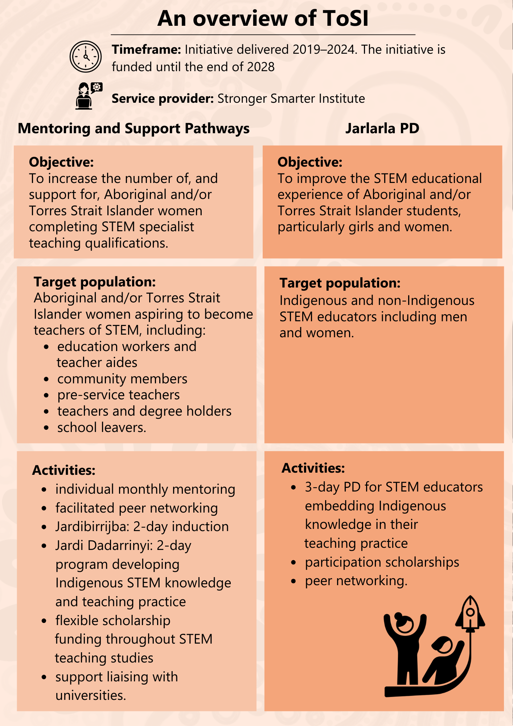

Figure 26: ToSI program logic
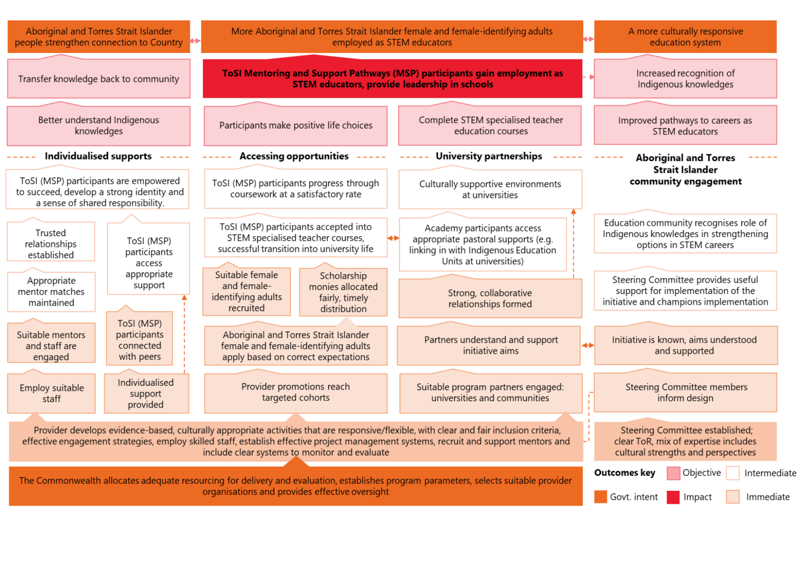

ToSI participant experiences

Putting the participant at the centre
Figure 27, a ripple diagram, illustrates the intended individual- to systems-level impacts of the initiative, including impacts for families, communities, schools and institutions. These impacts are informed by the ToSI program logic and supporting program documentation.
Figure 27: Ripple diagram of ToSI participant experience
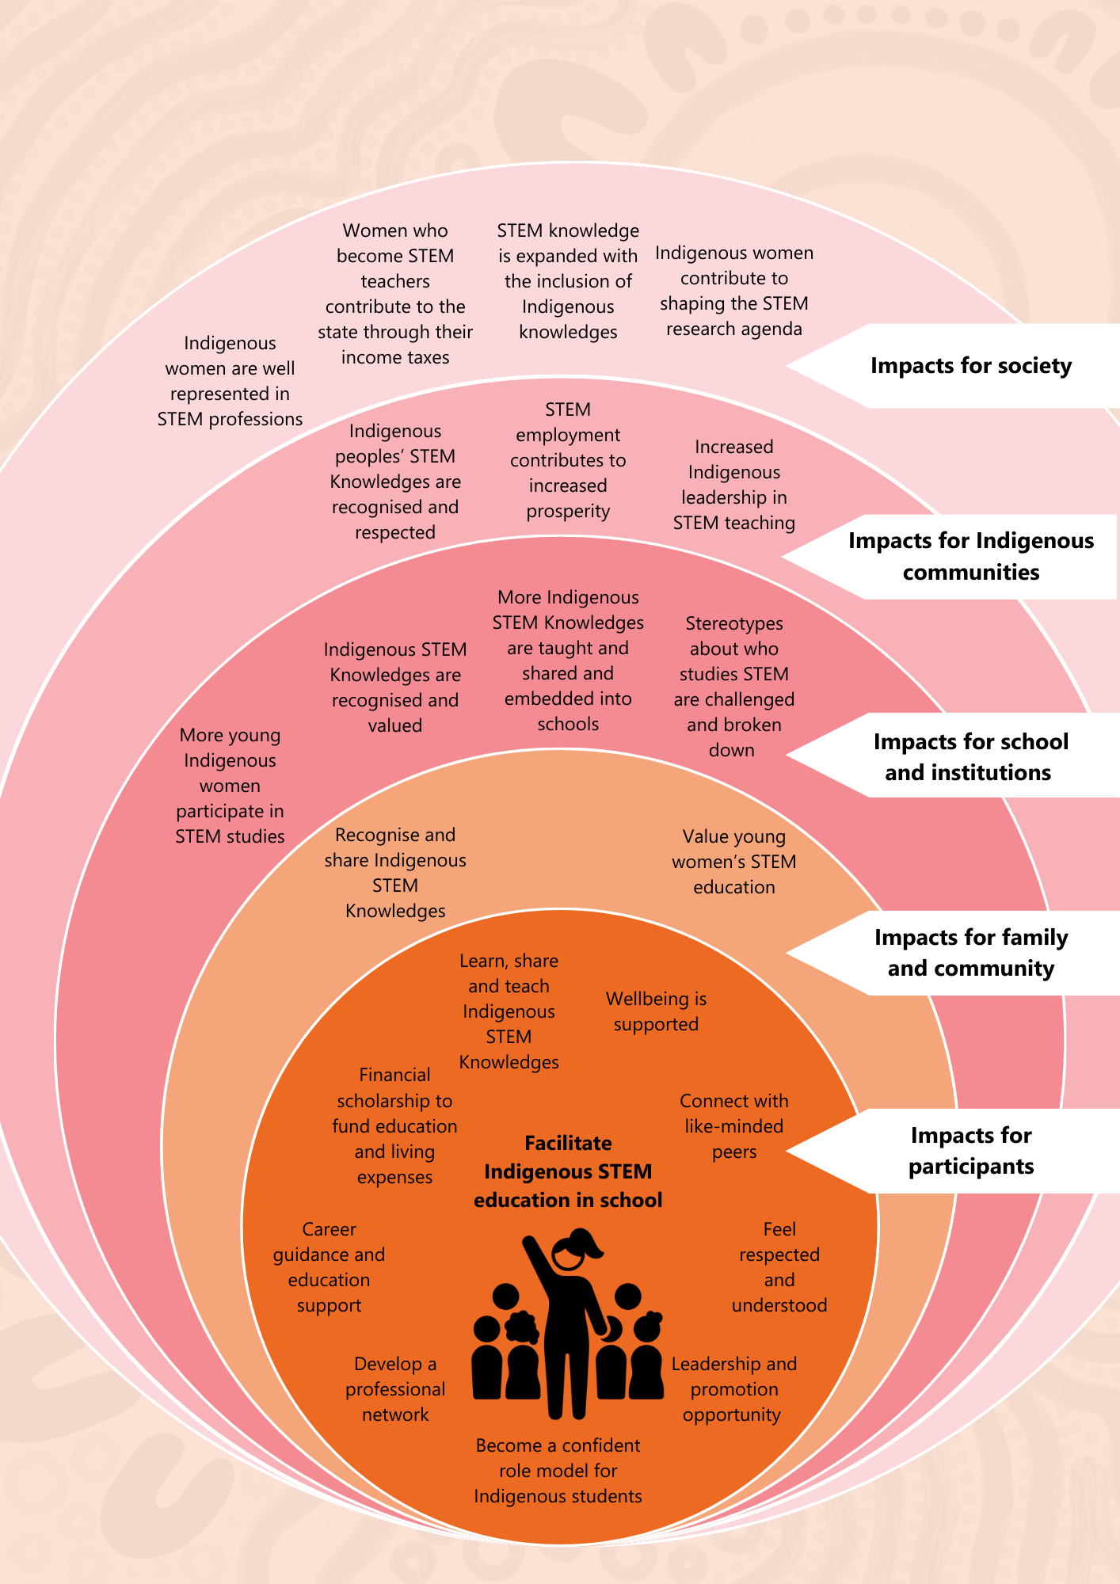

Case stories
These case stories of participants are recounted in the voices of the Indigenous researchers in the Evaluation Team who interviewed them: Aunty Julie Smith and Tammy Abbott.
MSP participants
In this section, the stories are told by Aunty Julie Smith, a proud Kalkadoon and Kamilaroi woman, who has had extensive experience as an educator, a researcher and serving on the Murri Court. As part of the evaluation, she interviewed several MSP participants. On the following pages, she recalls some of her interviews, outlining what she learnt about the women’s experiences. The stories are real stories of MSP participants, but pseudonyms have been used to protect their identities.
Ella’s story
I had an insightful interview with Ella, who works as an Aboriginal Education Officer (AEO). She started the role right after high school. A co-worker who was a teacher at her school recognised her passion and encouraged her to explore ToSI. Before that, she hadn’t considered going to university, but the idea of becoming a teacher and offering even more support to her students than she already does appealed to her. Ella shared with me that she sees herself as a support person, helping her students with their skill development and overall wellbeing. Becoming a teacher is a way to expand that support even further.
Ella is a busy woman. In addition to working full-time, she’s also a single mum with two kids who keep her on her toes. Despite her hectic schedule, she’s determined to earn her degree and make her children proud. She mentioned how fortunate she feels to have a supportive family around her to help with childcare, which allows her to balance work, family and study.
When Ella first enrolled in her course, she found that the university wasn’t accommodating of her family and work commitments and nearly dropped out. However, her ToSI scholarship motivated her to push through. SSI was incredibly supportive when she decided to transfer to a new university and she is now completing a Bachelor of Mathematics and plans to continue with a Master of Teaching, specialising in maths.
Ella has completed both Jardi B and D. These programs have been instrumental in connecting her with other women in similar situations, making her feel like she’s part of a community. She and the women she met through the program keep in touch, often sharing resources. Ella mentioned how important these gatherings have been, especially when she felt overwhelmed. They made her feel less alone, knowing other women had the same goals and challenges. The support Ella has received from ToSI has been invaluable. First, the financial support with textbooks and units has been a huge help. She’s also connected with a Mentor through ToSI, who has been a great help. They have just connected but already talking about how her Mentor can provide support, from proofreading assessments to planning her semester and general check-ins.

As an Aboriginal woman, Ella has been able to integrate cultural connections into how she teaches subjects like maths. She reflected on how much she learnt growing up connected to nature and wants to bring that into her teaching. For example, one of her students loves fishing, so she plans to create maths problems based on fishing to make learning more relatable and engaging. She said, ‘Especially with STEM subjects if I can relate it to their interests or culture or to our area, I’ll do it. Whatever it takes to motivate these kids to learn, I’ll do it.’
Ella particularly appreciates the support she’s received through ToSI, not only academically but as an Aboriginal woman as well. She observed that many of the staff at her school are non-Indigenous, and she believes that the education system needs more Aboriginal female role models to inspire the kids. Today, Ella feels stronger and more capable at university and as a mother and a support person for her students. She told me, ‘I feel like this program has made me a better person – culturally, academically, and in every way.’
It was wonderful to hear how positively Ella’s journey with ToSI has impacted her. With the support of ToSI, she returned to university while working and raising her family. She’s moving toward becoming a passionate and dedicated teacher who will go the extra mile to support her students. As we wrapped up our conversation, Ella shared how her involvement in ToSI is already having a ripple effect in her community as she has inspired one of her work mates to go back to university to become a teacher. While he isn’t eligible for MSP, seeing Ella juggle university, work and family while progressing toward her degree has motivated him to pursue his educational goals.

Figure 28: Ella’s journey – MSP participant

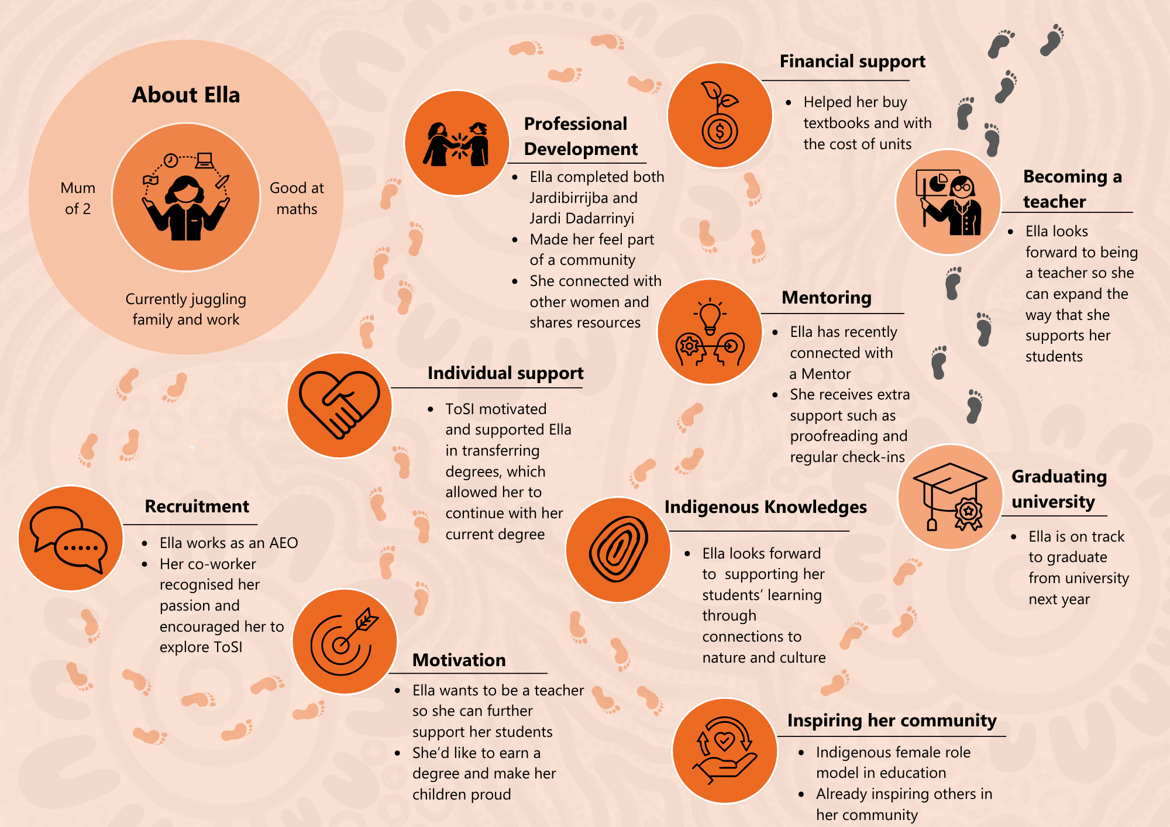

Fiona’s story
Over the course of the interviews I conducted with ToSI participants, it was wonderful to hear stories like Ella’s, who was having a fantastic experience with ToSI. It was also interesting to compare these stories with those of participants who encountered challenges engaging with the initiative. For example, Fiona’s story highlights why some women might face difficulties staying engaged.
Fiona first heard about ToSI during a PD day at her school and then explored it further on the SSI website, where she learnt about the support she could receive to become a teacher and decided to apply. She had already been working as a Community Education Counsellor for a few years and saw ToSI as an opportunity to upskill and develop. Additionally, learning more about practical ways to embed First Nations perspectives in the education system was a major motivation for her to participate. Reflecting on her family’s own experience with the education system, she noted that she is one of the few who has attended university, highlighting that the status quo is not working: ‘We have been living under a system of Western learning for all our lives … I think this needs to change.’
Fiona was accepted into both ToSI and her preferred university, and a couple of years ago, she began pursuing her Bachelor of Education, focusing on Mathematics and Sciences. She told me that she has always excelled these subjects because she has a logical brain, but when she was in high school, she did not see First Nations perspectives included in these subjects. This is something she would like to do when she is teaching these subjects.
Fiona started university feeling highly motivated and was earning distinctions in all her classes. In her first year, she attended Jardibirrijba, which inspired her to return to Country to learn more about her Ancestors and how they used natural resources. She shared: ‘We went for a walk on-Country, and that was awesome … exactly the kind of experience I need to take back to my school and say, “Hey, let’s go for a walk through this bush here and see what resources we find.”’ Additionally, during Jardibirrijba, she met many other women in similar positions with comparable goals, and she left feeling connected to a supportive community.
However, by the time Fiona was more than halfway through her degree, she noted feeling disconnected from ToSI. She observed that staff turnover was quite high, having gone through three Mentors in two years, and she spent a significant amount of time without a Mentor. Fiona mentioned that she thought she would have completed Jardi Dadarrinyi by now but didn’t know why she hadn’t, and she’d lost touch with the women she met at Jardibirrijba, leaving her feeling isolated without the community support. She told me she struggled to balance her responsibilities with her family, work and university, which ultimately resulted in her losing motivation and deferring her studies.

After a break, Fiona decided to return to university and has recently been connected with a new Mentor. Although it was still early days at the time of our interview, she hoped her Mentor would provide her with additional guidance and help her to better manage her time and responsibilities, enabling her to complete her degree. Fiona shared that she believes the initiative is incredibly important and has increased her confidence, but it needs more stability and clearer communication.
My interview with Fiona made it clear that while ToSI offers invaluable support and opportunities for the women included, some are facing challenges around remaining engaged.

How well has ToSI been implemented? [KEQs 1, 2, 3, 4]
The original components of ToSI were implemented somewhat effectively, with the number of participants nearing targets for both MSP and Jarlarla. While the early stages of implementation were substantially impacted by the COVID-19 pandemic (planned in-person events were postponed or held virtually), since early 2022, activities have been delivered largely as intended. During some periods when key positions within the ToSI Team were vacant (Mentors), some elements of service delivery were compromised.
ToSI is being implemented both in response to and in the context of a national teacher shortage. The initiative incentivises participation through the provision of mentoring support as well as financial support. However, some of the issues that underlie the teacher shortage – such as the high expectations of teachers to manage the behaviour of and provide support to students with diverse and high needs, the high administrative and reporting load and the relatively low pay compared with other professional roles – create a challenging context for recruiting participants.

MSP recruitment and retention
ToSI Team members report that the most effective mechanism for recruitment to MSP and Jarlarla PD is through word of mouth. The team has been able to leverage the other work of SSI in delivering programs in schools and in communities – for example, a senior teacher or principal attends the SSI leadership PD program and hears about ToSI (MSP), then mentions it to staff, including Indigenous Education Workers.
This is consistent with findings from interviews and yarning circle data, that indicate many MSP participants hear about the initiative through word of mouth.
As evidenced in the applications data in Table A32 in the Appendix, these approaches have been reasonably effective, having attracted a total of 94 applicants up to the end of June 2024.
Between January 2021 and June 2024, there were 94 applications to the MSP component of ToSI – see Table A32. Application numbers peaked in 2023, and applicant numbers dropped significantly (n=7) in Semester 1 of 2024. This may reflect the timing of changes in MSP leadership roles within SSI and the prioritisation of delivering in-person PD opportunities over recruitment activities. At the time of writing, ToSI Team members were actively engaged in renewed recruitment efforts.
Figure 29: MSP application data by start year
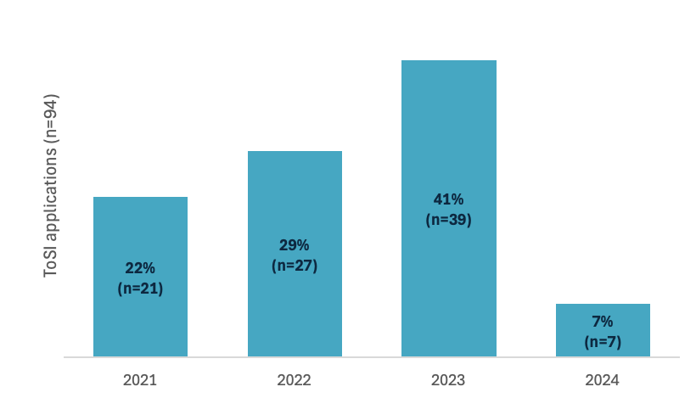
Notes: Application data for 2019 (year starting 2020) was unavailable. Percentages do not total 100% due to rounding.
Source: SSI ToSI data CRM database – applications data: January 2020 – August 2024.
Of the 89 participants who commenced, 25 have subsequently withdrawn, and a further six have deferred their studies (see Table A38 in the Appendix). This brings the number of participants at the time of writing to just 58. This is a high rate for withdrawals and deferrals that the ToSI Team advises is related to the high proportion of participants who are managing multiple demands while attempting to undertake their studies. Many participants are parents or have other caring responsibilities and many are also working full-time. Data regarding people’s personal circumstances was not available to the evaluation.
As noted in section 1.3.7, the evaluation was not able to interview any participants who had withdrawn from the initiative. As such, insights into why there were high rates of withdrawals are only those provided by the ToSI Team. The evaluation was unable to explore whether there were any elements of the initiative design or implementation that have had an impact on the rate of withdrawals.
The high rates of withdrawals means that the ToSI Team will need to continue to recruit participants in order to be able to reach the target number of participants (n=99). The ToSI Team members advise they are seeking to recruit students who are already somewhat progressed in their studies to ensure they’re able to continue to support them through to the completion of their teaching qualification.
MSP has had 89 enrolled participants, 25 of whom have subsequently withdrawn and six who have deferred, while Jarlarla PD has been delivered to a total of 82 participants (the target is 100). Of the MSP participants, eight have completed their teaching qualifications. An additional six participants are in final quarter of their studies. However, the highest proportion of participants – 55% – are still in the first quarter of their studies.
Given that most participants are enrolled part-time, this raises some concerns that not all participants will have completed their courses before the initiative funding ceases in 2028. This creates a risk that the initiative will not meet its targets and that there will be a number of participants mid-way through their degree who may expect or need ongoing support. Figure 29 above also shows that applications for the MSP dropped significantly between 2023 and 2024. Further recruitment is necessary and urgent if ToSI is to meet its targets. However, additional recruitment will require consideration around the management of participants who have not finished their degree when funding ceases in 2028.
While at this mid-point of the initiative, the number of participants who have graduated and commenced teaching is small (n=8), this number is expected to increase over time as more participants complete their studies.
Figure 30: ToSI implementation overview – MSP component
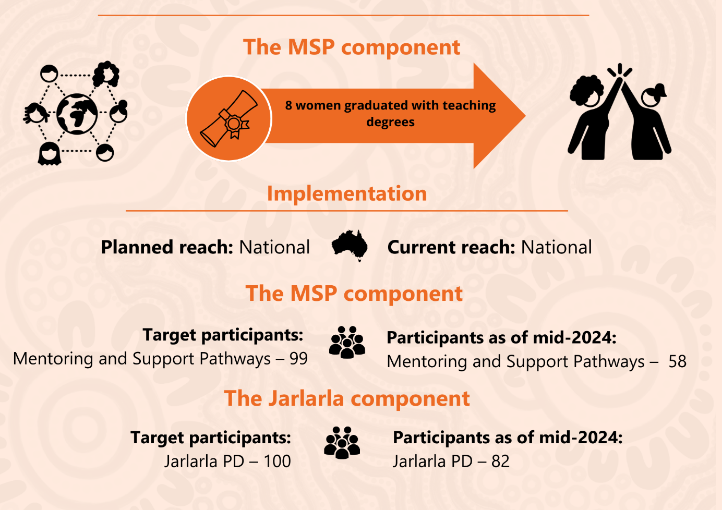
While Jarlarla PD was originally conceived as a distinct and separate activity from MSP, there are a number of MSP participants who are already highly experienced teachers for whom this initiative is considered more suitable than the Jardi Dadarrinyi PD event, which is focused on preparing participants for beginning teaching. As such, some MSP participants will also participate in Jarlarla.
The ToSI Team wants to ensure that its MSP participants can access Jarlarla PD at no cost. The ToSI funding arrangements provide for 100 funded positions in the Jarlarla PD. To date, the funded positions have been provided either to MSP participants (who are studying higher degrees and who are already practicing teachers), or as part of an offer open to all STEM teachers. The ToSI Team advises that participation for MSP participants is prioritised.

To what extent is ToSI meeting the needs of students, families, schools and communities and achieving its intended medium-term outcomes? [KEQs 5, 6]
This section is organised under the medium-term outcomes identified in the program logic model for ToSI (Figure 26).

Medium-term outcome 1: Trusted relationships are established, enabling participants to access appropriate support, feel empowered to succeed, and cultivate a strong sense of identity and shared responsibility.

SSI as a service provider
The Stronger, Smarter Institute – we are a relational organisation, and our core business is around relationships and high expectation relationships. So, if anyone knows how to be patient and work hard, it’s us. – ToSI Team staff member (interview data)
SSI is a not-for-profit organisation with a strong values base. It gives a high priority to relationships and providing a culturally safe learning environment for participants across all its programs. SSI has many employees (the majority of whom are Indigenous) who have chosen to work in the organisation because they strongly believe in its work. SSI believes that finding the right person for its roles is very important.
SSI is highly respected and very well regarded in the Indigenous Education sector. It has well developed frameworks and processes for delivering PD, particularly in leadership. SSI is well placed to deliver ToSI and has an effective national reach, as well as a place-based Communities Team that provides a range of supports for the specific target communities it works with – for example, Mornington Island.

Strong initiative design
ToSI Team members, participants and external stakeholders agreed that the MSP component of the initiative is well designed. External stakeholders highlighted that the combination of financial support and cultural and professional mentoring, as well as the peer connection facilitated through in-person PD, is an effective holistic package that is unusual in the world of tertiary scholarships.
Open text responses from the survey suggest that the holistic initiative design has had a positive impact on participants. Fifteen respondents commented that the holistic nature of the support and the support networks that are part of the initiative – including emotional and culturally understanding support, and help and advice on time management and balancing their workload – were invaluable. Five people answered that this support allowed them to focus on their studies and enabled them to get through their tertiary education, and others stated that they wouldn’t be where they were without the support provided.
[MSP has helped me] by allowing me the time, energy, emotional and financial support I need to complete my degree. – MSP participant (survey response)
-------------------------------------------------------------------------------------------------------
Keeping me emotionally stable and financially supported takes the stress when my plate is too full. – MSP participant (survey response)
-------------------------------------------------------------------------------------------------------
I feel as though I have the most wonderful support network. They are important to me as I work full-time, I have a family and my husband works away. I need to be organised and have the support of my village. – MSP participant (survey response)

Flexible financial support (scholarships) enables participation in STEM teaching degrees, with many participants identifying that they would not be able to participate without this support. The funding is flexible, allowing participants to utilise this money as it suits their individual needs. Some participants have used their funds to subsidise their living costs while they complete their unpaid teaching practicum.28F
Interview data suggests that individualised support through mentoring is effective for supporting participants to navigate their university experience. Participants appreciated that their Mentors were able to offer holistic support that recognised the broader challenges of balancing their studies with their work, family and community responsibilities, including cultural responsibilities.
The ToSI Team has encountered some challenges in being able to recruit and retain appropriate staff to deliver the mentoring support and program coordination roles. They have sought to recruit Mentors who are highly skilled and experienced Indigenous women but report that such women are often already very fully occupied with work, family and community roles.
SSI is aware that it has not always been able to provide all participants with a Mentor they can connect with on a regular or sufficiently frequent basis. While the team members have worked together to respond whenever a participant has reached out for support, including when mentoring staff have not been available, they believe that greater availability of Mentors would strengthen the initiative.
Nearly half (n=6) of the 13 MSP participants who were interviewed reported having had insufficient support from their Mentors, or not having a Mentor. A substantial proportion of MSP participants who completed the survey did not have a strong relationship with their Mentor (19%, n=4) and did not receive regular communication from their Mentor, such as monthly check-ins (25%, n=6). Others did not have a mentor or know who their Mentor was.
In-person learning opportunities are a key strength, with the ToSI Team and participants noting these provide critical opportunities for participants to develop deep and authentic relationships with one another in a culturally safe environment. Participants noted that in-person networking opportunities motivated them to continue participating in MSP and stay enrolled in their STEM teaching degree.

Providing individualised support through mentoring – MSP
Interview data suggests that where individualised support is being delivered through mentoring, this is very highly valued and effective.
Now that I have a Mentor the program is tailored to my needs, when I didn’t, the program wasn’t. – MSP participant (interview data)
Interviewees and yarning circle participants noted that mentoring support was very useful for supporting them to navigate their university experience.
Only one person in my family other than myself has studied. So, it is nice to have someone I can talk it through with. This is where I benefit from my Mentor. – MSP participant (interview data)
In addition, participants appreciated that their mentors were able to offer holistic support that recognised the broader challenges they were facing, including managing cultural obligations.
Work–life study balance is difficult. My Mentor is helping me develop a strategy to manage this. – MSP participant (yarning circle contribution)
Survey respondents in contact with their Mentors were mostly satisfied with the support they received. Most respondents agreed that their Mentor helps them feel safe and comfortable to discuss any issues or concerns (90%, n=19), and that they can ask for support when/if they need it (86%, n=18). See Figure 31.
Figure 31: MSP participants’ satisfaction with support received
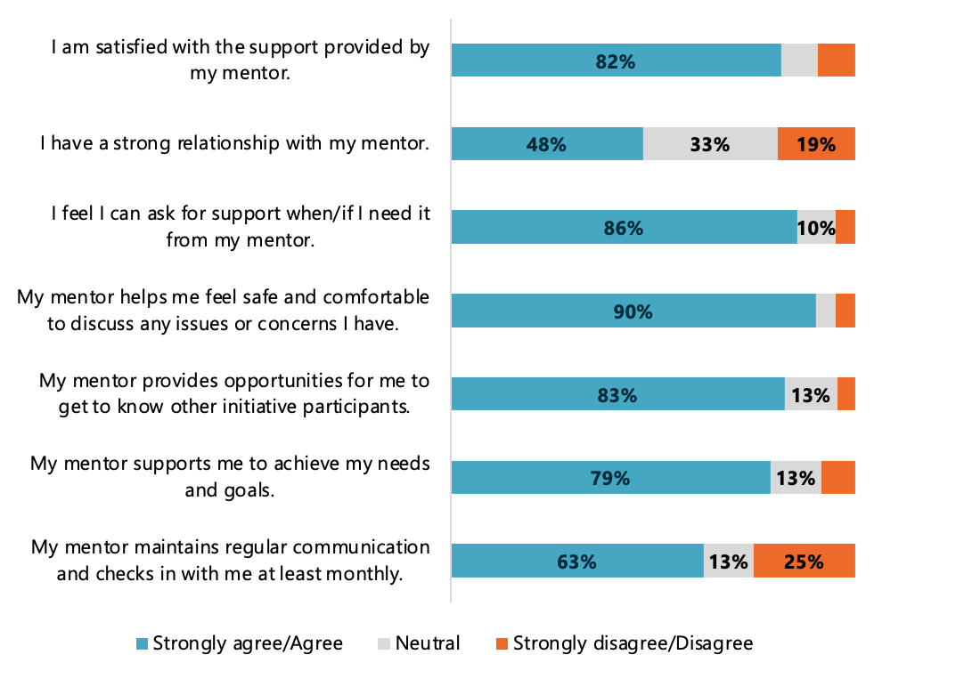
Notes: Total respondents for each row: 1 (n=22), 2 (n=21), 3 (n=21), 4 (n=21), 5 (n=23), 6 (n=24), 7 (n=24). Labels for <10% are not shown.
Source: 2023-24 ToSI Participant Survey.
Open text responses mostly support that respondents are satisfied with the Mentors they are in contact with. Several respondents thought their mentors were extremely supportive, helpful and useful, appreciating check-ins, subject matter expertise and the personal connection. Two respondents, although not in regular contact, knew that support from their Mentor was there if they needed it. However, evidence from interviews demonstrates that accessing a Mentor is a significant challenge for some participants.
My Mentor has been amazing, they have been able to support me recently with a deeply troubling personal issue. – MSP participant (survey response)
-------------------------------------------------------------------------------------------------------
My new Mentor that I received this year has been very supportive and helpful to assisting me with my degree … [B]ringing women together to share our experiences, knowledges and journeys has been very powerful and given me lots of inspiration to continue on with my studies. – MSP participant (survey response)
-------------------------------------------------------------------------------------------------------
My Mentor keeps me accountable for my goals and [checks in] which is really good. – MSP participant (survey response)

Medium-term outcome 2: Participants are accepted into STEM-specialised teacher courses, successfully transition into university life, and progress steadily through their degree coursework.
ToSI has recruited a total of 89 participants into MSP who have been accepted into STEM specialised teacher education courses. Many participants are balancing their studies with work and care-giving responsibilities and are studying part-time. Of the 89 participants recruited, 25 have withdrawn and a further six have deferred their studies, indicating that maintaining this balance of commitments is very challenging and impacts on participants’ retention in a STEM teaching degree. This high rate of withdrawal represents a substantial risk that the initiative will not meet its participation targets.
As described above, where mentoring has been received, this has been very useful in supporting participants to balance work, family, community and study commitments. However, the inconsistency with which mentoring has been able to be delivered increases the risk that students may not be sufficiently well supported to be able to progress steadily through their degree coursework.

Medium-term outcome 3: Participants receive appropriate pastoral supports and culturally supportive environments at their university.
Part of the MSP model includes ensuring students are connected with the Indigenous Education Units at the institution where they are studying. The ToSI Team reflected that working with universities’ Indigenous Education Units is difficult and variable. Research literature supports that these units are largely under resourced and face substantial challenges meeting the demand for service.29F Some students report they are well supported through the units and others struggle to get much support. Many units are overstretched, and students often haven’t been able to build trusting relationships with staff, so don’t seek help when they’re really struggling.
Where SSI staff have had direct connections to and relationships with the units, they have had greater success in working collaboratively to support MSP participants. While the ToSI Team notes that the relationship-based collaboration is highly successful, it also observes that high turnover both within the team and of unit staff can mean the collaboration is fleeting.

Medium-term outcome 4: The education community recognises the role of Indigenous Knowledges in enhancing pathways to STEM careers.
ToSI is providing MSP participants with learning focused on strengthening and sharing Indigenous STEM Knowledges, including much of the in-person workshop content for Jardibirrijba and Jardi Dadarrinyi.
SSI has given us lots of frameworks and shows us how things link-in with Indigenous knowledge and how we can take that into the classroom. That has been valuable to me. – MSP participant (yarning circle contribution)
Observations made during field work at Jardibirrijba and Jardi Dadarrinyi sessions included the centrality of Indigenous approaches and knowledges in the discussions and program content. Participants were encouraged to recognise their existing Indigenous STEM Knowledges and had opportunities for on-Country learning with Traditional Owners.
Interview data confirms that these events are helping participants learn how to link Indigenous Knowledges to the Australian Curriculum, and how to demonstrate this link in a classroom. One interviewee gave an example of taking students onto Country to speak about Indigenous Knowledges in STEM, including identifying patterns in how weather and light direction change.
Interviewees also talked about their desire to help other teachers to embed Indigenous Knowledges into the curriculum.
Jarlarla participants likewise highlighted the benefit of the PD event in supporting their capacity to embed Indigenous STEM Knowledges into their teaching practice.
It has been the key to bringing Indigenous perspectives into my science classes. Before the training it was something I wanted to do but didn’t know how or feel confident with. Now I feel empowered to develop and run lessons with IK [Indigenous Knowledges] at the core. – Jarlarla participant (survey response)
Survey respondents provided very positive feedback about the PD event and its outcomes.
Making connections between the curriculum, STEM and Indigenous Knowledges. I have taught using skills gained from ToSI and all students are 100% engaged! All students, First Nations included, are intrigued by Indigenous Knowledges to ensure sustainability. – Jarlarla participant (survey response)
-------------------------------------------------------------------------------------------------------
Excellent PD on-Country provided me with Indigenous Knowledges on the environment, different plants and their uses for medicine etc. Best PD I have been on! – Jarlarla participant (survey response)
For Indigenous participants, the PD event also supported them to feel more confident to share their knowledge with colleagues.
I have made connections with other colleagues in different areas. I have been able to share my experiences and assist colleagues to incorporate Indigenous perspectives into their teaching and planning. – Jarlarla participant (survey response)
-------------------------------------------------------------------------------------------------------
It’s given me confidence in sharing my knowledge with my colleagues. – Jarlarla participant (survey response)

Implementing learnings – Jarlarla PD
In interviews and survey responses, some Jarlarla PD participants indicated they had struggled to implement what they had learnt at the PD.
Several survey respondents (n=4) indicated that between their teaching work, and home, education and other commitments, finding time to develop resources to incorporate their PD experience into their teaching was difficult.
It has been difficult to develop and implement things on top of all the regular teaching/leadership role I currently have. With dedicated time I feel like I could develop things and then lead other teachers to follow suit. – Jarlarla PD participant (survey response)
Jarlarla participant interviewees identified the need for more collaboration between their school and SSI. They explained that embedding Indigenous Knowledges into their school requires support from school leadership, and that this was not always forthcoming.
In surveys and interviews, participants identified that a barrier to the successful implementation of their PD learnings was a lack of connection to their local Indigenous communities. Participants didn’t know whom to connect with to help implement their learnings in their home communities. They indicated that they don’t feel confident to support Indigenous Knowledge sharing in schools.
I felt worried that it wasn’t my culture of knowledge to pass on, and that was a barrier for me. – Non-Indigenous Jarlarla participant (interview data)
-------------------------------------------------------------------------------------------------------
It is difficult to access elders back in school to come and be involved in curriculum activities. Having the local Indigenous Knowledge and connections would be great. – Jarlarla participant (survey response)
Participants felt the PD did not equip them with a network with which to share knowledge about Indigenous perspectives. This resulted in participants feeling ill equipped to share cultural knowledge in teaching. Participants noted that the PD program focused primarily on Queensland connections, and did not have a structure that facilitated such connections across jurisdictions.
I think there should be a revisit of those who have attended the program, to share where they are at now. – Jarlarla participant (survey response)

Which components of ToSI and which causal processes were most effective in generating positive change, and for whom? [KEQ 7]

Providing individualised support through mentoring – MSP
As described in section 3.4.1, data from surveys and interviews suggest that where individualised support is being delivered through mentoring, this is very highly valued and effective. The data strongly indicates that mentoring is one of the key causal processes most effective in generating positive change.
Mentoring, when delivered effectively, provides participants with a relationship with a trusted person from whom they can seek help and advice on a wide range of issues that impact on their university studies. These issues can include navigating university administrative processes, work and family commitments and colonial load. Mentors can also provide guidance on academic assignments.

In-person learning and networking opportunities
There are several elements of the MSP design that are intended to support the development of a peer network for participants. These include e-newsletters and virtual circles as well as support delivered through their Mentor such as regular informal check-ins and individualised goal setting. The most highly valued elements for developing and supporting a peer network, however, were the in-person Jardibirrijba and Jardi Dadarrinyi events. See Figure 32.
Figure 32: MSP participant perceptions of learning and networking opportunities
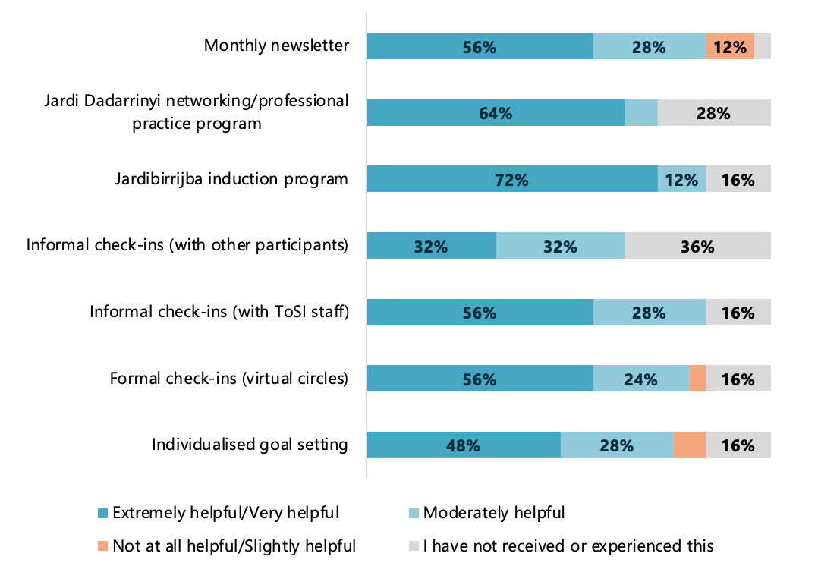
Notes: Only the informal check-ins and individual goal setting are part of mentoring. Total respondents for each row is n=25. Labels for <10% are not shown.
Source: 2023-24 ToSI Participant Survey.
The ToSI Team highlighted its appreciation for and strong belief in the effectiveness of the established frameworks and processes of the SSI in-person PD programs. The team believes that the approach taken in these programs allows participants to develop deep and authentic relationships with one another, and that this provides a strong foundation for participants to connect with each other using other forums – for example, connecting through virtual circles or using their Facebook page.
The face-to-face opportunities really brings out confidence in people. It reignites people’s passion when they come together in group. In STEM, students can sometimes get bogged down in their uni degree and forget why they’re doing things. When they come together, they reignite their passion – and remember why you are doing things. – ToSI Team member (interview data)
-------------------------------------------------------------------------------------------------------
Coming in as teacher and as an Aboriginal woman, I can see how much this helps people. ToSI is a great way to spend funds. – ToSI Team member (interview data)
-------------------------------------------------------------------------------------------------------
People participating in Jardi b and d become very close. They feel like a little family and want to stay connected. They like to create their own thing (Facebook or WhatsApp group) on the side. – ToSI Team member (interview data)
During yarning circles, which were held at two of the PD programs, participants noted the importance of being able to meet one another and develop relationships with other people going through a similar experience.
This workshop has given me nine more support networks. We [other women] are all on the same journey. We can touch base and share and support one another in our studies. – MSP participant (yarning circle contribution)
-------------------------------------------------------------------------------------------------------
I don’t have a lot of support besides this program to be a female Indigenous educator. It is great to hear about other Indigenous teacher’s experiences. – MSP participant (yarning circle contribution)
In particular, participants noted that in-person networking opportunities (Jardibirrijba and Jardi Dadarrinyi) motivated them to continue participating.
I found these programs really helpful. I was burnt out at uni, and was thinking, do I want to drop out? But coming here to this program is rejuvenating; it is knowing that you’re not alone and knowing that there are other people that feel the same way. – MSP participant (yarning circle contribution)
-------------------------------------------------------------------------------------------------------
Coming to these events reignites that fire. It is likely to get burnt out with study, work and family. Coming to the meet reignites that fire – they are so valuable. – MSP participant (yarning circle contribution)
Their sentiments were supported by participant perspectives captured in survey responses. Most survey respondents found in-person learning and networking very helpful, with 72% (n=18) finding the Jardibirrijba induction program extremely helpful/very helpful and 64% (n=16) finding the Jardi Dadarrinyi networking/professional practice program extremely helpful/very helpful. Open text responses echoed this sentiment, with a few survey respondents stating that their favourite parts of the initiative were Jardibirrijba and Jardi Dadarrinyi.
The Jardibirrijba induction program was an inspiring experience which set me on a positive path at the beginning of my degree. – MSP participant (survey response)
-------------------------------------------------------------------------------------------------------
I found the Jardi Dadarrinyi program to be immensely valuable and a very positive experience. – MSP participant (survey response)

Jarlarla PD
Survey data shows that participating in the PD was largely a very positive experience, with 94% of respondents agreeing or strongly agreeing that the program was interesting and 82% agreeing or strongly agreeing that it helped them achieve their STEM teaching goals to incorporate Indigenous Knowledges into their teaching. See Figure 33.
Figure 33: Participants’ perceptions of Jarlarla PD
w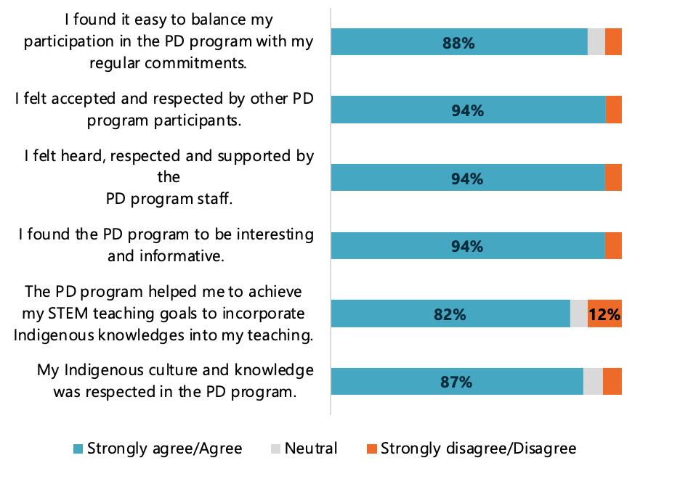
Notes: Total respondents for each row: 1 (n=17), 2 (n=18), 3 (n=17), 4 (n=17), 5 (n=17), 6 (n=17), 7 (n=15). Labels for <10% are not shown.
Source: 2023-24 ToSI Participant Survey.
In open text responses, participants generally expressed that the three-day program was one of their best experiences. Eleven survey respondents appreciated the supportive team and useful guidance, six enjoyed connecting to Indigenous Knowledge systems and obtaining a greater understanding of Indigenous perspectives, and three appreciated the local connections and experience on-Country.

Flexible financial support (scholarships)
All data sources highlighted the importance of financial support as a key component of MSP. Of survey respondents, 96% (n=23) rated financial support extremely important or very important for achieving their STEM learning goals. Many participants emphasised that their participation in a STEM teaching degree would not be possible without the financial support provided.
I have three kids and two mortgages. If it weren’t for the financial support, I wouldn’t have been able to come back to do my Masters. – MSP participant (yarning circle contribution)
-------------------------------------------------------------------------------------------------------
I don’t know if I would have enrolled in university if it wasn’t for the [financial] support that ToSI offered. – MSP participant (interview data)
The flexible approach to the scholarship funding, whereby participants are able to utilise this money as suits their individual needs, is a key strength of the initiative. Some participants have used their funds to subsidise their living costs while they complete their unpaid teaching practicum.30F
All MSP survey respondents (n=24) found the financial support at least moderately important. Out of 23 open text responses relating to supports, eight respondents stated that having financial support that addressed their needs, like funding placements or providing funds to support themselves and their family, enabled them to participate in their STEM teaching degree without financial stress.
They provided financial support to allow me to get through my placements which are unpaid and [so] that I can focus on my STEM units. – MSP participant (survey response)
-------------------------------------------------------------------------------------------------------
Having a mortgage, two young children and completing unpaid practicum, the financial support is one of the biggest supports – it’s meant that I have been able to not worry about money while completing them. – MSP participant (survey response)
-------------------------------------------------------------------------------------------------------
The support means everything, and the financial support helps ease the burdens of study and the costs involved. – MSP participant (survey response)
-------------------------------------------------------------------------------------------------------
Having the financial support really helps me, especially if I need to travel to intensives because I might not have the leave with work or can’t afford it. It also helps to buy my textbooks. – MSP participant (interview data)
-------------------------------------------------------------------------------------------------------
There is no way I would be getting my teaching qualifications without the support of the SSI program. Financially, I couldn’t do it. – MSP participant (interview data)
-------------------------------------------------------------------------------------------------------
Financially the program is supportive when I do uni. My supervisor at my previous school wouldn’t support me so I would have to take two days off for university. The financial support was there to replace this. – MSP participant (interview data)
Interview and survey data show that mentoring (when delivered as intended) is a highly effective causal process for MSP participants who utilise the support for academic, work–life balance and cultural support.
Evidence from interview data suggests that MSP participants who have a range of supports in addition to those provided through the MSP, such as from family, their school or their university’s Indigenous Education Unit, are more likely to complete their teaching degree.

Strengthening and sharing Indigenous STEM Knowledges
As discussed in section 3.4.4, participants highly valued the aspects of the initiative that focused on strengthening and sharing Indigenous STEM Knowledges, including much of the in-person workshop content for Jardibirrijba and Jardi Dadarrinyi. Jarlarla participants also highlighted the benefit of the PD event in supporting their capacity to embed Indigenous STEM Knowledges into their teaching practice.
ToSI staff interviewed were keen to emphasise strengthening and sharing Indigenous STEM Knowledges as an explicit and substantial focus for much of the in-person PD programs as well as in discussions at virtual circles. As described in section 3.4.4, interview and survey participants believed this was a key strength of the initiative.

Supporting participants to manage colonial load – MSP
In its approach to delivering ToSI and in the content of the in-person workshops, the ToSI Team explicitly acknowledges the colonial load that Indigenous teachers are often asked to carry in addition to their teaching work. The ToSI Team reflected that Indigenous teachers are often expected to take on a host of roles within their schools that are not teaching-related and are unpaid and not recognised with time in lieu or time off class. This can include liaising with parents and families of Indigenous students across the school (not just in their own classes), organising the school’s NAIDOC week celebrations, leading the school’s RAP and being the go-to person for any teacher wanting to organise cultural experiences for their class. Because most Indigenous teachers see the importance of this kind of work, they are generally reluctant to say no to doing it, but ultimately, it contributes to their workload being unsustainable and to teachers leaving the profession.

Cultural load31F is a huge thing. The cultural load of having to coordinate the whole of NAIDOC when you’re only paid as a teacher … you have to deal with the Murri politics … and then being called to come and explain something in the classroom … I wasn’t at my best. – MSP participant (interview data)
ToSI Team members and MSP participants have described the difficulty of balancing their own wellbeing and the demands associated with wanting to support Indigenous students and their communities. ToSI Team members are very aware that the rate of trained Indigenous teachers leaving the profession in the first years of practice is even higher than the rate for all teachers and they believe that a contributing factor is that Indigenous teachers are often expected to take on additional roles such as liaising with community and parents of Indigenous students, organising cultural events and supporting the cultural capacity development of non-Indigenous staff at the school. The ToSI Team intentionally address this in their programming and provide MSP participants with strategies to support their wellbeing and to respond to requests in ways that highlight the additional work involved.

Have there been any unintended consequences (positive or negative) associated with ToSI with respect to the approach/actions taken? [KEQ 8]

Managing the workload associated with maintaining relationships with universities – MSP
In interviews, ToSI staff discussed how they had difficulties in developing and maintaining relationships with staff of Indigenous Education Units at universities, observing that these units seemed typically under resourced and that staff were very busy.32F They also reflected that these units often had high staff turnover rates, meaning that progress made could quickly be lost. Recent research has also identified issues for Indigenous Education Units being significantly under resourced and difficulties in retaining staff due to burnout.33F ToSI staff noted that they were reluctant to ask staff in these units to do anything more than distribute emails or flyers.

National reach
A related challenge is delivering national reach. The MSP design emphasises broad accessibility – it is not restricted by the institution where a person is studying or where they live. This means that the ToSI Team members are often brokering relationships with staff at universities with which they have no or minimal connection. They must also negotiate the university’s administrative systems for managing the distribution of scholarships or financial support. Each institution will also have specific requirements for a degree or particular course of study that the ToSI Team must learn about. This means that the administrative workload of the initiative is high for the number of participants involved.
Open text responses from the survey about barriers to participation suggested that the initiative’s national reach presented several challenges for participants. Four respondents answered that distance and lack of nearby networks was a challenge to participation, and that they felt isolated. A respondent from WA felt that resources were not evenly distributed among states and asked for more support for non-eastern states, including adjusting the times of virtual meetings to accommodate time zone differences. She also suggested having a Mentor based in WA.
[Challenges have included] supporting those outside of Queensland or New South Wales with their journey, as I feel that the resources are very eastern-centric. – MSP participant (survey response)
-------------------------------------------------------------------------------------------------------
Potentially having a Mentor in Western Australia to assist with time differences [would help]. Having the virtual circles later in the day so it doesn’t impact schoolwork hours [would also help]. – MSP participant (survey response)

Summary findings of ToSI mid-term outcomes

MSP has a strong service model
ToSI Team members, participants and external stakeholders agreed that the MSP component of the initiative is well designed. External stakeholders highlighted that the combination of financial support and cultural and professional mentoring, as well as the peer connection facilitated through in-person PD, is an effective holistic package that is unusual in the world of tertiary scholarships.

MSP participants appreciate individualised support
Interview data suggests that where participants receive individualised support through mentoring, they highly value this and find it effective. Interviewees and yarning circle participants noted that mentoring support was very useful for supporting them to navigate their university experience. In addition, participants appreciated that their Mentors were able to offer holistic support that recognised the broader challenges of balancing their studies with their work, family and community responsibilities. Most survey respondents agreed that their Mentor helps them feel safe and comfortable to discuss any issues or concerns (90%, n=19) and that they can ask for support when/if they need it (86%, n=18).
However, it is important to note that mentoring has not been delivered consistently, as SSI has struggled to recruit and retain Mentors over the course of the initiative to date.

ToSI in-person learning opportunities are a key strength
The ToSI Team highlighted its appreciation for and strong belief in the effectiveness of the established frameworks and processes of the SSI PD in-person programs. Team members believe that the approach allows participants to develop deep and authentic relationships with one another. In yarning circles and interviews, participants noted the importance of being able to meet one another and develop relationships with others going through a similar experience. They noted that in-person networking opportunities motivated them to continue participating in MSP and their STEM teaching degree.

Flexible financial support enables participation in STEM teaching degrees
All data sources highlighted the importance of financial support as a key component of MSP. Of the survey respondents, 96% (n=23) rated financial support extremely important or very important for achieving their STEM learning goals. Many participants emphasised that their participation in their STEM teaching degree would not be possible without the financial support offered. This was especially the case for women who were managing work and family responsibilities in addition to their studies.
The flexible approach to the scholarship funding, whereby participants are able to utilise this money as suits their individual needs, is a key strength of the initiative. Some participants have used their funds to subsidise their living costs while they complete their unpaid teaching practicum.34F

ToSI is strengthening and expanding participants’ Indigenous STEM Knowledges
Participants highly valued the aspects of the initiative that focused on strengthening and sharing Indigenous STEM Knowledges, including much of the in-person workshop content for Jardibirrijba and Jardi Dadarrinyi. The discussions that take place in the workshops also have a strong focus on Indigenous approaches and Knowledges. Participants are encouraged to recognise their existing Indigenous STEM Knowledges as well as participating in on-Country learning with Traditional Owners.
Interview data confirms that these events, as well as Jarlarla PD, are helping participants link Indigenous Knowledges to the Australian Curriculum, and how to demonstrate this link in a classroom. One interviewee gave an example of taking students onto Country to speak about Indigenous Knowledges in STEM, including identifying patterns in how weather and light direction change.
Interviewees also talked about their desire to help other teachers to embed Indigenous Knowledges into the curriculum.

ToSI supports participants to manage colonial load
In its approach to delivering ToSI and in the content of the in-person workshops, the ToSI Team explicitly acknowledges the colonial load that Indigenous teachers are often asked to carry in addition to their teaching work. The ToSI Team reflected that Indigenous teachers are often expected to take on a host of roles within their schools that are not teaching-related, and are unpaid and not recognised with time in lieu or time off class.
ToSI Team members and MSP participants have described the difficulty of balancing their own wellbeing and the demands associated with wanting to support Indigenous students and their communities. The ToSI programming provides MSP participants with strategies to support their wellbeing and to respond to requests in ways that highlight the additional work involved.

Rates of withdrawal from MSP are high
While ToSI has been reasonably successful at recruiting participants into the MSP, the rate at which participants have withdrawn or deferred from their studies is high, with 31 of 89 participants not actively engaged with the initiative at the time of writing. The administrative data available to the evaluation does not provide any clear insights into the reasons why individuals may be withdrawing; however, interview data from ToSI Team members as well as participants indicates that participants may not continue with their study plans primarily due to other commitments such as family caring responsibilities or difficulty managing their studies on top of their other commitments.
As noted elsewhere in the report, the evaluation was unable to interview participants who had withdrawn, and as such insights into any elements of initiative design or implementation that may have contributed to withdrawals from the initiative are absent from this analysis.
The rates of withdrawal and deferral raise risks that targets for MSP participation may not be able to be reached. The ToSI Team has indicated its intention to renew efforts to recruit new participants, targeting students who are already somewhat progressed in their teaching qualifications. As noted in section 3.3, teacher shortages create a challenging context for delivering ToSI.
MSP, like many other government initiatives before it, was designed to address the low supply of First Nations teachers in the education sector. The low demand for initial teacher education remains a challenge. While participants highly value the fact that MSP offers flexible funding through a scholarship payment, costs associated with completing a teaching qualification can nevertheless represent a substantial barrier to participation.
The evaluation found that the teacher shortage issue was also having an impact on the capacity of some participants to take part in PD activities. Some participants noted that their participation depended on their school being able to find replacement staff. Some noted that their schools did not support their participation because of this issue. ToSI Team members noted that they had needed to advocate on behalf of participants to support their attendance.

Maintaining relationships with universities is difficult
In interviews, ToSI staff discussed how they had difficulties in developing and maintaining relationships with staff of Indigenous Education Units at universities, noting that these units were typically under resourced and staff were very busy. They also reflected that these units often had high staff turnover rates, meaning that progress made could quickly be lost. There perceptions are supported by current literature.35F The program design emphasises broad accessibility – it is not restricted by the institution where a person is studying or where they live. This means the ToSI Team members are often brokering relationships with staff at universities where they have no or minimal connection. This leads to a high administrative workload for the number of participants involved.

Staffing issues have affected service delivery
The ToSI Team has encountered some challenges in being able to recruit and retain appropriate staff to deliver the mentoring support and program coordination roles. SSI is aware that it has not always been able to provide all participants with a Mentor they can connect with on an a regular or sufficiently frequent basis. While the team members have worked together to respond whenever a participant has reached out for support, including when mentoring staff have not been available, they believe that greater availability of Mentors would strengthen the initiative.
Nearly half (n=6) of the 13 MSP participants who were interviewed reported having had insufficient support from their Mentors or not having a Mentor. A substantial proportion of MSP participants who completed the survey did not have a strong relationship with their Mentor (19%, n=4) and did not receive regular communication from their Mentor, such as monthly check-ins (25%, n=6). Others did not have a Mentor or know who their Mentor was or had changed Mentors.
The data available to the evaluation does not enable any correlation to be drawn between a lack of mentoring support and rates of withdrawal from the MSP. Nevertheless, the evaluation suggests that strengthened mentoring support would facilitate the delivery of timely access to support, which may reduce the rates at which students choose to withdraw.

Some Jarlarla PD participants need further support to implement their learnings
In interviews and survey responses, some Jarlarla PD participants indicated that they had struggled to implement what they had learnt at the PD. Several survey respondents (n=4) indicated that between their teaching work, and home, education and other commitments, finding time to develop resources to incorporate their PD experience was difficult.
Jarlarla participant interviewees identified the need for more collaboration between their school and SSI. They explained that embedding Indigenous Knowledges into their school requires support from school leadership, and that this was not always forthcoming.
In surveys and interviews, participants identified that a barrier to the successful implementation of their PD learnings was a lack of connection to their local Indigenous communities. Participants didn’t know whom to connect with to help implement their learnings in their home communities. Participants felt the PD did not equip them with a network with which to share Knowledge about Indigenous perspectives. This resulted in participants feeling ill equipped to share cultural Knowledge in teaching.

Recommendations for the remainder of the 10-year initiative
The evaluation has identified seven recommendations for the remainder of the initiative.
With regard to reaching the target number of participants:
- SSI should review the approach to recruiting the remaining target number of participants into MSP. This should include:
- identifying universities where there are strong existing relationships and where there are strong Indigenous Education Units for targeted recruitment efforts
- identifying alternative pathways (i.e. not through the Indigenous Education Unit) for finding potential eligible participants, such as working directly with staff from universities’ schools of education
- drawing on existing relationships (e.g. with YIWSA) to support direct recruitment
- targeting participants who are already somewhat progressed (have completed at least one year of their course) in their education tertiary qualifications to ensure newly recruited participants can be supported to completion.
With regard to providing support for participants to the completion of their studies:
- NIAA and SSI should agree on a plan for managing appropriate support for participants who have not finished their degrees when funding ceases in 2028. This could include a process that, at a minimum, would allow access to remaining scholarship funding for individual MSP participants who are continuing with their tertiary teaching program but who have not completed their studies by the end of the program funding period.
To reduce the rates at which students withdraw or defer from MSP:
- SSI should develop an appropriate needs assessment tool for MSP participants to identify those who may need more support to complete their STEM teaching degrees. It should provide participants with higher needs with additional mentoring support and/or provide them a warm referral to other appropriate services as needed.
With regard to initiative staffing:
- SSI should ensure continuous availability of appropriate mentoring support. This should include:
- reviewing the position description and expectations of the role to ensure these are realistic (and will attract applicants) and meet the needs of participants. It may be that less experienced Mentors could be recruited and then trained and supported by other ToSI Team members
- ensuring Mentors have management and coordination support through the initiative leadership
- managing the workload of Mentors so that they can, for example, maintain monthly check-ins with participants and follow up on their support needs, and attend in-person events; it is suggested that a Mentor has no more than 30 participants to support.
- SSI should ensure ToSI leadership roles are appropriately staffed, with the full allocation of FTE positions filled.
With regard to adapting to teacher shortage issues impacting in-person PD events:
- SSI should consider options for delivering in-person PD in a way that may support more applicants to be able to attend. This may include reducing the length of the in-person component – for example, to two days, instead of three – and having pre and/or post sessions that are delivered virtually and outside of school hours.
With regard to improving outcomes for schools through the Jarlarla PD:
- SSI should provide facilitated participant networking for Jarlarla PD. This may include hosting a virtual community of practice session for alumni that occurs regularly – for example, once per term.
With regard to ensuring effective future evaluation:
- SSI should refine data collection practices to ensure data collection supports future internal review and external evaluation. Data collected should include accurate information about the frequency and type of engagement with participants – for example, on how often they are checking in with Mentors; on post-graduation employment outcomes; and on participants who have withdrawn from their studies.

Considerations for the future of the initiative
The evaluation has identified some additional considerations for the future of the initiative were it to be funded in the longer term. These are:
- The service provider taking a targeted approach to minimise ToSI Team administrative load, partnering with selected universities with strengths in delivering STEM teaching degrees.
- The service provider working with NIAA and other agencies to identify potentially productive partnerships with providers of other like initiatives, at both a national and jurisdictional level (e.g. the Queensland Remote Teacher Education Program).
- The service provider investigating opportunities to provide support to teachers in their first year of practice, potentially through assigning them an MSP alumnus ‘buddy.’

Discussion and conclusion
This section draws together some of the key findings from across the whole of the IGSA program that have potential to be applied in other contexts or settings. It provides a discussion of lessons learned and both strengths and challenges that need to be considered in implementing this type of program. It highlights activities and approaches that the data has consistently shown to be successful. These approaches can be seen to represent good practice in the delivery of programs of this type and should be considered for inclusion in service design for any similar initiatives.

Lessons learned – strengths
This section highlights activities and approaches that the data collected for this evaluation has consistently shown to be successful. These approaches can be seen to represent good practice in the delivery of programs of this type and should be considered for inclusion in service design for any similar initiatives.

Indigenous leadership and implementation
As outlined in Section one, a key point of difference when comparing IGSA with other programs with similar objectives is the focus on Indigenous women both in leadership positions and in key implementation roles: the initiatives that make up IGSA, YIWSA and ToSI, are being delivered for and largely by Indigenous women. This has meant participants experience culturally safe environments for learning and engaging.
Qualitative data from interviews highlights the extent to which the cultural safety of the initiatives supports participants to feel comfortable to participate fully. Many participants also emphasised that they were highly motivated by the opportunity to deepen their cultural Knowledge and understanding, including Indigenous STEM Knowledges through ongoing connection with the Indigenous YIWSA and ToSI Team members.
The strong Indigenous leadership of IGSA contributes to individual, family and community empowerment, trusting relationships, changed mindsets and opening doors to careers in STEM.

Mentoring and individualised support
Most elements of each initiative have included an individualised or mentoring support component (excluding the ToSI Jarlarla PD activity). Overwhelmingly, participants have reported that when this has been well delivered, it has been very highly valued and appears to strongly correlate with engagement and participation in other parts of the initiative.
The mentoring components have provided an opportunity for participants to develop a strong, trust-based relationship with a supportive Indigenous woman who primarily helps them navigate their way through the challenges of their studies in a culturally safe manner. In addition, the mentoring model being delivered through these initiatives is holistic, allowing participants to access a wide range of supports tailored to their individual needs. This has included support with managing and balancing study and work obligations, cultural obligations, extracurricular activities and family needs. It has also included support with managing colonial load.
For parents and caregivers of YIWSA participants, the individualised support provided through the Academic Coordinators has also provided an important mechanism for developing trust in the initiative and knowledge about STEM careers and possibilities for their young women.

STEM learning experiences
Through IGSA, participants are connected with opportunities to engage in a range of STEM learning activities. This happens as part of camps, workshops and online forums as well as though work experience and internship opportunities and being connected to professional associations. As demonstrated in the QCA for YIWSA, STEM camps were consistently shown to be necessary conditions to promote participant engagement. As outlined in the interviews, one of the key reasons that participants found the camps so valuable was the exposure to STEM learning experiences, emphasising the importance of STEM camp attendance.

Sharing Indigenous STEM Knowledges
Participants in both YIWSA and ToSI have opportunities to learn more about Indigenous STEM Knowledges. They participate in on-Country learning experiences, as well as being supported to recognise and share their existing Indigenous STEM Knowledges with others in in person and virtual forums. The explicit focus on Indigenous STEM Knowledges in these initiatives encourages participants to further explore Indigenous ways of knowing, helping both to further promote Indigenous Knowledges as a scientific practice and to sustain and grow them more broadly.

Peer networking opportunities
Across each of the initiatives, a key strength appears to be activities that have sought to support participants to develop networks with one another. There is strong evidence in the research literature for the idea that having a connected peer network who have shared spirations and who may be experiencing similar challenges is highly supportive of engagement and retention in education programs.36F
Each of the initiatives includes explicit mechanisms to facilitate the development of peer networks, such as camps, workshops, virtual circles and regular online forums. Across all initiatives, participants recognised that opportunities to meet with each other in person were crucial in the development of relationships with their peers. Virtual forums were considered a useful mechanism for maintaining networks, but in-person opportunities for meeting, working and learning together were consistently identified as the key mechanism for initiating meaningful connections with other participants.
These activities (including, but not limited to STEM Camps, Jardibirrijba, Jardi Dardirrinyi and Jarlarla PD) play an important role in achieving outcomes and participation should continue to be highly encouraged and supported. The QCA for YIWSA shows that participation in these activities is closely correlated with higher engagement with the initiative. Interview data for ToSI participants also strongly suggests that the in-person learning opportunities are important mechanisms for deepening engagement with the initiative.

Facilitating the development of professional networks
Through participation in these initiatives, Indigenous women have opportunities to meet with experienced STEM professionals and educators. For YIWSA participants this happens as part of STEM Camp experiences, through National Assemblies and through mentoring groups and internships as part of the tertiary component. These opportunities mean that by the time participants are graduating from their degrees, they have knowledge and experience across several fields of STEM and have some points of connection to help support them into employment.
While this is a less explicit part of ToSI, MSP participants are able to develop their professional networks through connections through SSI’s alumni as well as the schools where they complete their practicums. In addition, the Jarlarla PD brings together groups of passionate STEM educators.

Developing confidence to support empowerment
The development of confidence is very important to realising the intended outcome of this program as identified in its theory of change (see Figure 5): to empower individuals, families and communities. This is because confidence underpins empowerment. When individuals have skills and knowledge, and have a clear intention, this, combined with confidence, enables them to take action – or to be empowered to do so.37F Data from the survey and interviews across both initiatives indicates that participating in these initiatives has supported Indigenous women to develop their confidence. For participants in these initiatives, this is an outcome of value beyond their studies and irrespective of whether they pursue a career in STEM. As described in the research literature, these initiatives are providing opportunities for participants to be recognised for their abilities and have those abilities nurtured, which enhances self-esteem.38F
Within the peer networks in each initiative, there are opportunities for participants to present information to one another at both in-person and virtual events. The opportunities are key in supporting participants to develop their confidence. The initiatives also seek out opportunities for participants to lead events at schools and in the community, which further develops their confidence.

Ethic of reciprocity
Related to empowerment, particularly beyond the individual and extending into families and communities, is the ethic of reciprocity that is evident across IGSA’s initiatives. Giving back to the community is an important value of both initiative teams and was also evident in interview and survey data from participants. Moreover, YIWSA and ToSI aim to support the participants in becoming leaders and role models within the initiatives and their communities.
YIWSA explicitly seeks out additional opportunities for participants to be involved in running activities (for example, at community science fairs) and to participate as a peer mentor for younger participants at local events. YIWSA alumni are invited to become role models for others by giving presentations, offering work experience opportunities or being part of the YIWSA Steering Committee.
For many ToSI participants, the ethic of reciprocity was a strong motivating factor. These participants believe that by becoming a teacher, they will be able to invest their work lives into their communities’ young people both by being a role model as a STEM professional and by providing young people with the skills and knowledge they will need to pursue their own careers.

Flexible financial support
Each of the initiatives includes a service element that allows for participants to access financial support – via brokerage funding for YIWSA, and via scholarship funding for ToSI.
Accessing financial support for participants of YIWSA is needs-based, which allows funding to be used as best supports participants to be able to continue their education journey. Flexible brokerage funding has allowed service providers to buy in equipment and services as needed, reducing barriers to participation.
The flexible scholarship funding provided for MSP participants also represents a key mechanism for facilitating participation. The qualitative interview data as well as survey data consistently showed that participants believed that the financial support was a key enabler for their participation in a STEM teaching degree. While the funding amount is set based on an estimate of teaching degree tuition fees, the ability for participants to use the funding how best met their own needs was highly valued. Paying the tuition fees was a priority for some. For others, being able to use the funding to help them meet costs of living, particularly when their degree requirements meant they were unable to do their usual paid work, was critical and a key enabler of their participation.

Lessons learned – challenges
This section provides discussion of some of the challenges that need to be considered in the design and implementation of programs like the IGSA.

Managing participation for those whose interests are out of scope
For both YIWSA and ToSI, there have been challenges associated with offering support to participants whose interests and areas of study have, over time, moved away from those that would normally be considered STEM.
As an explicitly STEM-focused program, it is important that the initiatives are delivering outcomes that are within scope – that is producing STEM graduates and STEM teachers. Nevertheless, it is to be expected that not all participants will ultimately choose to pursue STEM or STEM teaching careers. Developing clear processes for exiting participants whose interests are no longer within scope is important. However, this needs to be managed empathetically and effectively so that participants who are no longer suitable for support through IGSA are facilitated to transition to other more suitable supports.

Supporting participants with complex responsibilities to remain engaged
Programs that focus support for Indigenous women need to recognise that this cohort is disproportionately bearing the load for caring for children, elders and other family members with other needs. They are also disproportionately more likely to be doing work in and for their community in voluntary roles.
For both initiatives under IGSA, there are some participants who are managing multiple care-giving, work, community and extracurricular responsibilities. There are also some participants who may have additional learning needs or who may live in more isolated areas where facilities, resources and other opportunities are few.
The results of the QCA and from the thematic analysis of participant interview data indicate, however, that it is the students who have strong additional supports (through their school or their family) who are most consistently successfully engaged in the initiatives. For high school students this may look like attending a very well-resourced school and living at home with parents who are employed professionals. Students without these supports external to the initiative likely require higher levels of support to attain and maintain the same levels of engagement. While students who do not have these advantages are nevertheless also often highly engaged, the findings provide some impetus for ensuring a degree of needs assessment is incorporated into the individual support planning processes and that prioritising additional appropriate supports for students with higher needs should occur wherever possible. This would go some way towards ensuring equity of opportunity among participants.
While participant withdrawal is an issue into which the evaluation has little insight, interviews with program staff indicate that participants with substantial additional responsibilities may be more likely to withdraw from this kind of initiative. Future evaluations need to consider mechanisms for connecting with participants who have withdrawn to better understand why this has occurred.

Delivering a program with national reach
In Australia, any program intended to have national reach is highly ambitious. The vast geography of, and dispersal of small populations outside of major urban centres in this country mean delivering equity of access for those living in more rural and remote areas is very challenging and costly. While virtual modalities for participation go some way to responding to these challenges, these modalities are reliant on the required technology being accessible and functional. Nor do virtual modalities respond to the contextual disparities for potential participants. For example, there may be disparities in terms of the resources available at school (skilled and experienced teachers, technology and reliable connectivity), the existence of a peer group with similar aspirations, as well as the availability of other community resources such as healthcare and childcare facilities, which may impact how much time a person can devote to a program.
It is noteworthy that both IGSA initiatives have managed to engage participants from across all states and territories, including regional, rural and even some remote areas. The YIWSA high school component has intentionally developed cohorts that cover substantial geographic areas that include regional hubs as well as rural and remote areas. The QCA clearly demonstrates that this approach has been successful, with participants from regional areas being highly engaged in the initiative. While the approach is labour and time intensive, it appears to have been successful in broadening the reach of the initiative into more regional areas than might otherwise have been possible.
Service providers have noted that costs for bringing groups of participants together for in-person opportunities can be very high when participants are highly geographically dispersed or travelling from regional areas. This is an important consideration when considering the level of resourcing required to facilitate these kinds of programs.
While both initiatives offer opportunities for those in remote areas through virtual modalities, the number of participants from these areas is small.44F Participants whose home communities are very remote are generally only able to participate if they are residing in more urban areas for their schooling. Facilitating access for those in remote areas remains a challenge for IGSA. Given the likelihood that participants based in remote areas will have higher support needs due to having fewer supportive resources available in their home location, it is likely that a small number of place-based initiatives would be more effective for engaging participants from remote locations.

Maintaining program staffing
The service providers have sought, wherever possible, to employ Indigenous women with STEM and/or teaching qualifications to deliver these initiatives, as this is in keeping with the ethos and intention of IGSA.
Recruiting and retaining staff has proved challenging because highly educated Indigenous women are in high demand across many employment sectors. Initiatives with national reach can create significant demands on staff, including substantial travel commitments and, in some instances, working across time zones. These demands also limit the number of Indigenous women who may be able to undertake these roles if they’re also caring for children or other family members.

Maximising impact and outcomes
While not explicitly an ‘excellence program,’ there are nevertheless elements of IGSA’s design (in particular, the YIWSA initiative) that target high-achieving students. It is important, however, to recognise that concepts of excellence are culturally bound. Ensuring that Indigenous conceptions of excellence are included is crucial to consider in recruitment processes and in the design of supports offered.
For programs like this, recruiting participants who are already well supported and high achieving maximises the chances that the goal of seeing participants through to completion of a tertiary STEM qualification will be reached. Nevertheless, such an initiative may have greater impact where it supports a participant with fewer resources and supports, who may be first-in-family, to the reach the same outcome.
Ensuring there is a positive peer culture with which to identify requires that a critical mass of highly engaged and highly motivated participants is maintained. This may necessitate having a balance of participants who are well resourced (and more readily able to role-model passion for the subject matter, high expectations of their own achievement, and confidence in their own abilities), with participants who may be less well-resourced for whom the overall impact may be substantially more significant.

Resourcing of Indigenous Education Units at tertiary institutions
Both initiatives have components that aim to support students through their tertiary studies. For YIWSA, this is the component managed by CareerTrackers, for ToSI, this is the MSP.
Interview data from staff of IGSA initiatives indicates that Indigenous Education Units at universities are key points for connecting with and finding support for Indigenous students. They also reflect that this has been challenging due to the high demand for service from IEUs. Reflections of staff are consistent with the research literature, which shows that these units are most often under resourced and overstretched.45F Given this context, initiatives like IGSA need to ensure they are alleviating, not adding to the burden on IEUs. Where practical, reaching out to specific schools and faculties within tertiary institutions (e.g. Education Faculties, Mathematics and Engineering etc.) may provide alternative avenues for connecting with participants and for increasing awareness of the initiatives.

Appendix

  - KEQ response summary tables
Table A1: KEQ YIWSA response summary Table Phase 1 – Process Evaluation
Question number | Question | Summary response
1 | How well were the original components of IGSA implemented, and were they implemented as intended? What changed during delivery and why? | The original components of YIWSA were implemented effectively, with the number of participants exceeding targets and the vast majority of participants engaging regularly with one-on-one support and a range of YIWSA activities. While the early stages of implementation were substantially impacted by the COVID-19 pandemic (planned in-person camps and other events were postponed or held virtually), since early 2022, activities have been delivered as intended. Some activities (for example, Creativity in Research, Engineering, Science and Technology) are being delivered differently than originally planned to better suit the delivery context.
2 | What specific factors are facilitating or inhibiting successful implementation? | Evaluation data suggests that the following factors are facilitating successful implementation; however, some of them also have drawbacks:  - Strong communications within the YIWSA Team, which supports Academic Coordinators and Student Advisors to be well informed about upcoming events and opportunities and have access to support and resources for their roles.  - The place-based approach to cohorts has been successful, though it has been challenging where the ‘place’ is geographically vast (for example, WA is a single cohort).  - The age-grade approach to cohorts has had benefits in that participants within each cohort are at the same stage in their learning journey; however, this has also created some barriers to participation (for example, students in a school who would be ideal candidates for YIWSA are not able to participate because they are not in the specified grade) and consequences for longer-term staffing as Academic Coordinators’ roles expire once their cohorts transition into the tertiary component. The age-grade approach has also meant that a shift in resourcing is required as each cohort transitions.
3 | Which components of the program and its initiatives are working best for whom, under what conditions and why/how? (for example, place-based, targeting university partners) | Analysis of data suggests that the components of YIWSA that are working best are:  - Providing participants with one-on-one support from Academic Coordinators and Student Advisors. Participants highly valued relationships with these staff, and these relationships were a keystone for their engagement in YIWSA activities.  - STEM camps and tertiary internships. These were highly valued because they provided participants with STEM learning opportunities and exposure to a broad range of STEM professions but also helped them develop peer and professional networks.  - Access to flexible financial support – that is, brokerage. This has allowed participants to address challenges and barriers to their participation by buying equipment, joining professional associations, taking part in PD opportunities and meeting expenses associated with commencing tertiary studies.  Analysis further suggests that the initiative is working best for participants:  - who are highly motivated and passionate about STEM  - who have a range of supports available to them  - who are able to engage with in-person learning opportunities.  In-person learning opportunities were particularly valuable for participants located outside of metro locations. The strength of the tailored individualised support provided by Academic Coordinators and Student Advisors is strongly associated with participant engagement.
4 | How well have resources been used to deliver YIWSA? | Available data suggests that the YIWSA service providers have, to date, used resources effectively to deliver the initiative, recruiting and supporting more than the target number of participants. Evidence shows that the majority of participants have been engaged in a range of planned activities and provided with individualised support to meet their personal and academic goals.
Table A2: KEQ YIWSA response summary table Phase 2 – Outcomes Evaluation
Question number | Question | Summary response
5 | To what extent are the initiatives’ delivery mechanisms meeting the needs of students, families, schools and communities, and how can these be improved to strengthen the achievement of outcomes? | Evaluation data indicates that the initiatives’ delivery mechanisms are meeting the needs of the majority of participants, their families, schools and communities.  As an initiative with national reach, working towards equity of access has meant that some of the high school cohorts cover geographically vast areas, which makes maintaining the level of in-person contact logistically challenging. Nevertheless, in-person visits at schools ensure that participation has a minimal impact on participants’ schedules and ensures a regular opportunity to liaise with key personnel at schools. Parents/carers of high school participants value the role of the Academic Coordinator in keeping them informed about opportunities and in being a key contact for any concerns they may have for their young women.
6 | How successful have the initiatives been in achieving and/or contributing to short-, medium- and longer-term outcomes anticipated in the program logic models?  - What contribution has YIWSA made in supporting participants’ educational engagement and completion rates in STEM-related degrees (and VET courses as applicable)?  - What contribution has YIWSA made in supporting participants to gain employment in STEM-related careers? (Dependent on a.) | There is strong evidence across a range of sources that the initiatives are contributing to the short-, medium- and longer-term outcomes set out in the program logic models. Evidence indicates that most participants are well supported, are developing strong peer and professional networks and are growing in confidence. Participants are gaining knowledge and experience of STEM fields and careers; they also have an increased awareness of Indigenous STEM Knowledges and share these more often.  Administrative data suggests that the majority of students who graduate from the high school component go on to study in STEM fields in their tertiary studies.  To date, 30 participants have graduated with STEM qualifications.  While administrative data does not capture employment outcomes, interview data suggests that YIWSA STEM degree graduates are transitioning to employment.
7 | Which components of the initiatives and which causal processes were most effective in generating positive change, and for whom? | The Qualitative Comparative Analysis of interview data (n=40 – high school participants only) suggests that the most effective causal processes for high engagement in the initiative included:  - a strong relationship with a YIWSA Team member (Academic Coordinator)  - knowing what is available (usually this is also facilitated by a strong relationship with the Academic Coordinator) and participating in what’s offered  - participating in a STEM camp (particularly for those in non-metro locations).  These causal processes are most effective for participants who have:  - prior motivation and interest in STEM  - strong school, family or other supports.
8 | Have there been any unintended consequences (positive or negative) associated with the initiatives with respect to the approach/actions taken? | There have been some unintended consequences related to the age-grade approach to place-based cohorts in the high school component. These relate to unintentionally excluding some potential participants due to their age. The approach also has implications for longer-term staffing as Academic Coordinators do not have a specific role once their cohort graduates from high school.  In addition, the approach also means that the staffing balance across the two components needs to shift substantially as more cohorts graduate into the tertiary component. This is creating some challenges for the initiatives.
9 | To what extent do the current data collection/monitoring activities address the purpose of future evaluations? | Data collection and monitoring activities will provide for many of the purposes of future evaluations. However, data collection within the high school component has been inconsistently practiced across the YIWSA Team. The team is aware of this issue and is implementing measures to improve team-wide compliance with data collection expectations.  Data collection tools for future evaluations could better capture areas of study (for both the high school and tertiary components), graduation data and employment data.

Table A3: KEQ ToSI response summary table Phase 1 – Process Evaluation
Question number | Question | Summary response
1 | How well were the original components of IGSA implemented, and were they implemented as intended? What changed during delivery and why? | The original components of ToSI were implemented somewhat effectively, with the number of participants nearing targets for both MSP and Jarlarla. While the early stages of implementation were substantially impacted by the COVID-19 pandemic (planned in-person camps and other events were postponed or held virtually), since early 2022, activities have been being delivered as intended. The originally planned internship and work experience opportunities are no longer a part of the initiative as many participants, who were working, could not take time off from their roles, especially in addition to needing leave to complete teaching practicums.
2 | What specific factors are facilitating or inhibiting successful implementation? | Evaluation data suggests that the following factors are facilitating and impeding successful implementation:  - The provision of flexible financial support. Access to such support, provided through scholarships, has allowed participants to address barriers to their participation. It has allowed them to pay university course fees or meet expenses associated with completing a teacher education degree, including subsidising living costs during teaching practicums.  - Issues relating to teacher shortages. These have proved a barrier for some participants, who have not been released for PD because of the lack of available relief teachers.  - The COVID-19 pandemic. This inhibited implementation in the early stages, leading to delays and then a pivot in delivery mode to online. While this was well managed, participants have reflected their strong preference for in-person PD events.  - Staffing difficulties have also inhibited the extent to which effective mentoring support has been able to be offered to MSP participants.
3 | Which components of the program and its initiatives are working best for whom, under what conditions and why/how? (for example, place-based, targeting university partners) | Analysis of data suggests that the components of ToSI that are working best are the in-person PD; opportunities for peer networking; and developing knowledge and understanding of Indigenous STEM Knowledges and how these can be included within the Australian Curriculum.  Flexible financial support appears to be enabling the participation of many participants for whom tertiary study would otherwise not be possible. Participants highly valued in-person PD opportunities. Individualised support provided by a Mentor has been very highly valued by the MSP participants who have received this; however, this support has not been consistently available.  The ToSI Team and external stakeholders noted that where universities have well resourced and effective Indigenous Education Units, MSP participants do not require the same level of support from the ToSI Team that those at other institutions sometimes need.  Participants consistently noted that having opportunities to come together in person and to maintain their connections through virtual circles greatly supports their ongoing engagement and motivation.
4 | How well have resources been used to deliver ToSI? | SSI has faced some challenges in recruiting and retaining appropriate ToSI Team staff, which has impacted how resources have been used to deliver ToSI.
Table A4: KEQ ToSI response summary table Phase 2 – Outcomes Evaluation
Question number | Question | Summary response
5 | To what extent are the initiatives’ delivery mechanisms meeting the needs of students, families, schools and communities, and how can these be improved to strengthen the achievement of outcomes? | Evaluation data indicates that the initiatives’ delivery mechanisms are meeting the needs of the majority of participants. However, some of the delivery mechanisms –notably, providing mentoring – have been negatively impacted by a lack of staff for these roles.  As an initiative with national reach, working towards equity of access has meant that the ToSI Team is liaising with many different universities, resulting in team members having a substantial administrative load. Revising the scope of MSP’s delivery – for example, focusing on a smaller number of target universities that have a strong record for supporting Indigenous teaching students – may support more efficient delivery.
6 | How successful have the initiatives been in achieving and/or contributing to short-, medium- and longer-term outcomes anticipated in the program logic models?  - What contribution has ToSI made in shifting institutional biases in schools and universities?  - What contribution has ToSI made in supporting participants to complete STEM specialised teacher courses?  - What contribution has ToSI made in supporting participants to gain employment as STEM educators and continue in these roles? (Dependent on b.)  - What contribution has the initiative made in increasing participants’ and schools’ recognition of Indigenous STEM Knowledges? | ToSI is successfully supporting some Indigenous women to earn their teaching qualifications through MSP, with 89 recruited participants (58 of whom are continuing), including eight graduates. Participants in both MSP and Jarlarla PD report being inspired and empowered to embed Indigenous STEM Knowledges in their lessons.  MSP participants report that without the initiative, especially the scholarship funding, they would be unlikely to have enrolled or be continuing with their studies.  Longer-term outcomes with regard to graduation rates and employment for MSP participants will not be able to be measured until the initiative funding ends.
7 | Which components of the initiatives and which causal processes were most effective in generating positive change, and for whom? | The MSP scholarship funding and in-person PD opportunities that facilitated ongoing peer networking were identified as being most effective in generating positive change.
8 | Have there been any unintended consequences (positive or negative) associated with the initiatives with respect to the approach/actions taken? | The national and unrestricted approach to recruitment, while highly inclusive, has resulted in a substantial administrative workload for the ToSI Team.
9 | To what extent do the current data collection/monitoring activities address the purpose of an impact evaluation? | The data collection activities will need to be reviewed to ensure that more information is available to enable an effective impact evaluation. This includes information about the nature and intensity of the support being offered and about employment outcomes.

  - Methods – strengths and limitations
Table A5: Strengths and limitations of data sources used in the Mid-term Outcomes Evaluation
Data source | Strengths | Limitations
Annual Participant Survey | The sample size is sufficient to enable a range of analyses. | ToSI participants, who receive a range of other surveys from SSI as part of ToSI, were not included in the survey for the Final Process Evaluation. As such, there have been fewer opportunities to include ToSI participant voices directly in the evaluation. Nevertheless, the total number of ToSI respondents (n=50) provides a reasonable sample and complements the data captured through interviews and yarning circles and in the administrative data provided by SSI. The sample size is reasonable for descriptive statistical analysis, which has been undertaken in this evaluation. The response rate in earlier rounds of data collection (for example, in 2022) was low, so change over time analyses have been limited.
Interviews with YIWSA and ToSI participants | The sample size was substantially stronger than for the Final Process Evaluation (n=63).  The number of interviews for both initiatives is sufficient to be able to conduct thematic analysis and identify illustrative case stories. There are a sufficient number of YIWSA interviews to be able to be used for a Qualitative Comparative Analysis. | Unfortunately, the number of and variation within the ToSI interviewee sample is not sufficient to be used for a Qualitative Comparative Analysis. When there are very small numbers of respondents, the particular circumstances of individuals can mean that any extrapolation may be misleading.  It is likely that the participants who agreed to participate in an interview are highly engaged with the program and therefore, the sample may have a bias towards more positive sentiments. The evaluation findings with regard to participants who have withdrawn is also limited by the absence of this group from our interviewee sample.
Yarning circles | Yarning circles provided an opportunity for Indigenous members of the Evaluation Team to develop rapport with participants directly. As these occurred at YIWSA and ToSI in-person activities, they provided an opportunity for Evaluation Team members to better understand the practices and processes involved in these activities.  The circles provided a culturally safe space for participants to contribute their perspectives to the evaluation in a group setting.  The circles were also a highly effective mechanism for recruiting participants for individual interviews. | The number of yarning circles was lower than originally intended. Four yarning circles were held at YIWSA STEM camps and two were held at ToSI Jardibirrijba (n=1) and Jardi Dadarrinyi (n=1). It was decided to hold the circles at existing YIWSA and ToSI events, and this did reduce the burden associated with participating. However, it also meant that the circles could only occur at these times and when planned events were cancelled, so were the circles.
Administrative data | The administrative data from all providers contained a range of useful information on:  - participant demographics  - applications  - participant status in initiatives  - self-reflections.  The Evaluation Team worked with service providers to ensure that the data received could be used to help better understand the ways in which participants engaged. For CSIRO, this involved developing a data collection tool specifically for the evaluation. This has improved visibility into the frequency and type of engagements participants have had in the high school component of the initiative.  Administrative data offered useful supplementary information to qualitative data. | In discussions with CSIRO, it was established that the internal data collection systems for the YIWSA high school component had been used inconsistently. The Evaluation Team collaborated with the YIWSA High School Team to develop a data collection tool that could collect a range of data points of interest to the evaluation. In order to ensure that the data collected was reasonably accurate, the Evaluation Team decided to focus on data from 1 January 2023. This means that the data does not capture engagement information about participants for the entire duration of the initiative.  In a discussion with CareerTrackers, it was confirmed that if they could not contact a transitioning high school participant, their data would not have been entered into their CRM system. As a result, 55 records are missing and have been considered ‘unsuccessful’ transitions.  ToSI data was provided as reports generated from SSI’s CRM. Each de-identified data report was generated separately and could not be linked.  As is common with data input into a CRM over a long period of time, there are some missing values. A missing value represents a variable that was not input into the database during the data entry process. This can occur for several reasons, including information that was unknown or missed at the point of data entry. Where missing data exists, it is not possible to create a complete picture of all participants.
Financial reporting data | Sufficient data was available to enable a range of financial assessments. | As financial reporting data was not available for the 2023–2024 financial year, metrics are reported covering the financial years 2018–2023. Additionally, as some outcome metrics were only available as aggregated totals, year-on-year analysis is not presented for either initiative. However, analysis of available year-on-year data shows that any trends observed are attributable to the cost implications of setting up a multi-year program (which makes earlier year performance lower), as well as the impacts of the COVID-19 pandemic on program capacity, the broader education system and communities.

  - YIWSA program logic
Figure A1: Full YIWSA Program Logic (CSIRO in collaboration with CareerTrackers)
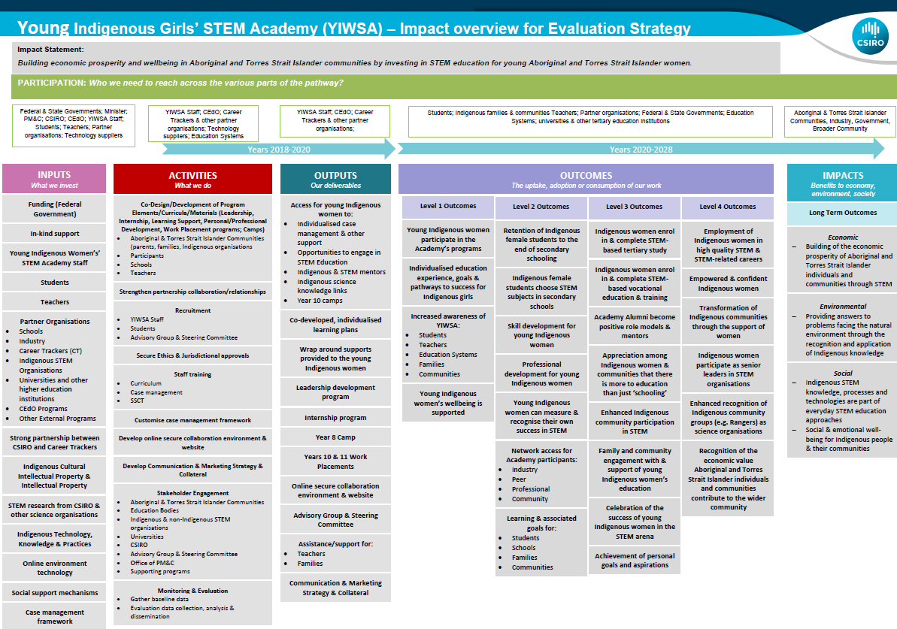

  - Program data tables and descriptives
- YIWSA
Table A6: Tertiary participants by state
State | Number | Percentage
Queensland | 129 | 47
NSW | 57 | 21
Victoria | 27 | 10
WA | 25 | 9
SA | 16 | 6
NT | 9 | 3
ACT | 5 | 2
Tasmania | 5 | 2
Total | 273 | 100
Source: YIWSA tertiary data CRM database – participant data: January 2018 – June 2024.
Table A7: 2023 and 2024 YIWSA STEM camp attendance as percentage of cohort
STEM camp | Number of attendees | Size of cohort | Attendance as percentage of cohort
2023 Greater Western Sydney and Central Coast Camp | 8 | 17 | 47
2023 WA Camp | 19 | 34 | 56
2023 Tasmania and Victoria Camp | 9 | 22 | 41
2023 Brisbane North Camp | 29 | 40 | 73
2023 SA Camp | 29 | 42 | 69
2024 Tasmania and Victoria Camp | 9 | 22 | 41
Total | 103 | N/A | N/A
Source: YIWSA high school data collection tool – participant data: January 2023 – June 2024.

Table A8: High school external STEM camp attendance – 2023
2023 | Number | Percentage
Applied – attended | 30 | 12
Applied – did not attend | 16 | 6
Did not apply | 207 | 82
Total | 253 | 100
Missing | 206
Note: Data was not provided for 206 participant records.
Source: YIWSA high school data collection tool – participant data: January 2023 – June 2024.
Table A9: High school external STEM camp attendance – 2024
2024 | Number | Percentage
Applied – attended | 25 | 9
Applied – did not attend | 5 | 2
Did not apply | 257 | 90
Total | 287 | 101
Missing | 172
Notes: Percentages do not total 100% due to rounding. Data was not provided for 172 participant records.
Source: YIWSA high school data collection tool – participant data: January 2023 – June 2024.
Table A10: Total YIWSA recruitment and transition
 | Number
Transitioned participants between 2018–2022 | 89
Transitioned participants in 2023 | 74
Transitioned participants in 2024 | 99
Active high school participants as of mid-2024 | 286
Total participants recruited in high school | 548
Total participants transitioned to the tertiary component | 262
Transitions where the participant continued with YIWSA | 207
Transitions where the participant did not continue with YIWSA | 55
Participants recruited during tertiary studies | 66
Total active tertiary participants (does not include 55 participants who did not continue with YIWSA) | 273
Total number of participants recruited across YIWSA | 614
Notes: Because of inconsistent data collection, high school participant records were not available for the period between 2018-2022. However, the IGSA Process Evaluation Report noted that 89 participants had transitioned during this period.
Source: YIWSA high school data collection tool – participant data: January 2023 – June 2024. YIWSA tertiary data CRM database – participant data: January 2018 – June 2024.
Table A11: Overview of high school brokerage support
Brokerage requested and approved | Amounts
Number of brokerage requests | 479
Amount of brokerage requested | $241,292
Amount of brokerage approved | $216,904
Source: YIWSA high school brokerage data collection tool – participant data: April 2020 – June 2024.
Table A12: High school brokerage amounts requested and approved by participant
 | Brokerage requested by participant | Brokerage approved by participant
Number | 236 | 223
Average | $1,022 | $973
Minimum | $8 | $8
Maximum | $4,030 | $4,030
Source: YIWSA high school brokerage data collection tool – participant data: April 2020 – June 2024.
Table A13: High school brokerage requests by category
Category of support | Number | Percentage
Laptops, scientific calculators, lab equipment, software licenses and other technology necessary for STEM coursework | 277 | 58
Fees for tutoring services or mentorship programs to enhance understanding and proficiency in STEM subjects | 67 | 14
Textbooks, workbooks, online courses and educational software related to STEM subjects | 58 | 12
Registration fees for attending STEM conferences, seminars, workshops or training sessions | 10 | 2
Expenses related to tuition for STEM courses or workshops not covered by scholarships or grants | 9 | 2
Supplies and materials for conducting experiments, research projects or science fair presentations | 8 | 2
Costs associated with travel and accommodation for attending STEM-related events, conferences or study abroad programs | 5 | 1
Fees for standardised tests or certification exams related to STEM fields | 2 | <1
Memberships to STEM-related professional organisations or societies | 1 | <1
Unknown | 41 | 9
Total | 478 | 102
Missing | 160
Notes: Request amounts that did not have a category selected have been attributed as ‘unknown.’ Percentages do not total 100% due to rounding. Data was not provided for 160 participant records.
Source: YIWSA high school brokerage data collection tool – participant data: April 2020 – June 2024.
Table A14: Overview of tertiary brokerage support
Brokerage requested and approved | Amounts
Number of brokerage requests | 77
Amount of brokerage requested | $65,590
Amount of brokerage approved | $57,757
Source: YIWSA tertiary brokerage data collection tool – participant data: August 2020 – June 2024.
Table A15: Tertiary brokerage amounts requested and approved by participant
 | Brokerage requested by participant | Brokerage approved by participant
Number | 44 | 44
Average | $1,491 | $1,313
Minimum | $85 | $85
Maximum | $4,936 | $3,979
Source: YIWSA tertiary brokerage data collection tool – participant data: August 2020 – June 2024.

Table A16: Tertiary brokerage requests by category
Category of support | Number | Percentage
Laptops, scientific calculators, lab equipment, software licenses and other technology necessary for STEM coursework | 35 | 45
Costs associated with travel and accommodation for attending STEM-related events, conferences or study abroad programs | 12 | 16
Textbooks, workbooks, online courses and educational software related to STEM subjects | 11 | 14
Supplies and materials for conducting experiments, research projects or science fair presentations | 3 | 4
Expenses related to tuition for STEM courses or workshops not covered by scholarships or grants | 1 | 1
Specialised software programs, coding tools or apps used for STEM projects or coursework | 1 | 1
Unknown | 14 | 18
Total | 77 | 99
Note: Percentages do not total 100% due to rounding.
Source: YIWSA tertiary brokerage data collection tool – participant data: August 2020 – June 2024.
Table A17: National Assembly attendance
 | 2023 | 2023 | 2024 | 2024
 | Number | Attendance as a percentage of active participants | Number | Attendance as a percentage of active participants
Term 1 attendance | 77 | 17 | 54 | 14
Term 2 attendance | 34 | 7 | 65 | 17
Term 3 attendance | 56 | 12 | N/A | N/A
Term 4 attendance | 68 | 15 | N/A | N/A
Total number of attendees | 235 | 51 | 119 | 31
Total active participants | 459 | 100 | 385 | 100
Note: Attendance figures may include participants who attended one or more events.
Source: YIWSA high school data collection tool – participant data: January 2023 – June 2024.

Table A18: 2023 and 2024 work experience attendance by cohort
Cohort | 2023 | 2023 | 2024 | 2024
 | Number | Percentage | Number | Percentage
Brisbane North | 0 | 0 | 2 | 33
Brisbane West | 1 | 7 | 0 | 0
Central West NSW and ACT | 8 | 67 | 0 | 0
Greater Western Sydney | 0 | 0 | 0 | 0
National 2024 | 0 | 0 | 0 | 0
Newcastle and Central Coast | 0 | 0 | 0 | 0
NT | 3 | 25 | 0 | 0
SA | 0 | 0 | 2 | 33
Tasmania and Victoria | 0 | 0 | 1 | 17
WA | 0 | 0 | 1 | 17
Total | 12 | 100 | 6 | 100
Source: YIWSA high school data collection tool – participant data: January 2023 – June 2024.
Table A19: Tertiary internships
Number of internships | Number | Percentage
0 | 133 | 49
1 to 3 | 75 | 27
4 to 6 | 54 | 20
7 to 9 | 11 | 4
Total | 273 | 100
Source: YIWSA tertiary data CRM database – participant data: January 2018 – June 2024.
Table A20: High school interviewee demographics – interview year
Interview year | Number | Percentage
2023 | 15 | 38
2024 | 25 | 63
Total | 40 | 100

Table A21: High school interviewee demographics – year level
Interview year level | Number | Percentage
9 | 7 | 18
10 | 11 | 28
11 | 9 | 23
12 | 12 | 30
First year of tertiary studies | 1 | 3
Unknown | 0 | 0
Total | 40 | 102
Note: Percentages do not total 100% due to rounding.
Table A22: High school interviewee demographics – commencing year
Commencing year | Number | Percentage
2019 | 2 | 5
2020 | 4 | 10
2021 | 5 | 13
2022 | 6 | 15
2023 | 18 | 45
Unknown | 5 | 13
Total | 40 | 101
Note: Percentages do not total 100% due to rounding.
Table A23: High school interviewee demographics – commencing year level
Commencing year level | Number | Percentage
8 | 13 | 33
9 | 11 | 28
10 | 8 | 20
11 | 2 | 5
12 | 1 | 3
Unknown | 5 | 13
Total | 40 | 102
Note: Percentages do not total 100% due to rounding.
Table A24: High school interviewee demographics – state
State | Number | Percentage
NSW | 9 | 23
WA | 6 | 15
Queensland | 11 | 28
NT | 3 | 8
Victoria | 6 | 15
Tasmania | 2 | 5
ACT | 1 | 3
Unknown | 2 | 5
Total | 40 | 102
Note: Percentages do not total 100% due to rounding.
Table A25: High school interviewee demographics – rural/regional/metro
Regional/rural/metro | Number | Percentage
Regional | 16 | 40
Rural | 2 | 5
Metro | 9 | 23
Unknown | 13 | 33
Total | 40 | 101
Note: Percentages do not total 100% due to rounding.
Source: ARTD participant interview data. Regional, rural and metro was determined by the Australian Government’s Health Workforce Locator.46F

Table A26: CareerTrackers classifications
Classification | Definition
STEM | STEM refers to the integrated disciplines of science, technology, engineering, and mathematics. These fields focus on knowledge generation, problem-solving, and innovation, playing a crucial role in the development of technology, infrastructure, and addressing global challenges. STEM is central to Australia’s economic growth and societal progress.
STEM Adjacent | STEM-adjacent fields encompass areas that are related to STEM but not entirely within the core disciplines. These fields often require a combination of STEM knowledge and other interdisciplinary approaches. Examples might include fields like data science, geospatial technologies, health informatics, and environmental management, which rely heavily on STEM skills without being solely defined by them.
STEM Informed | STEM-informed fields integrate elements of STEM knowledge into their work without being primarily based in STEM disciplines. These areas use STEM principles to inform decision-making, strategies, or policies. In Australia, fields such as public policy, economics, and even the arts may rely on STEM-informed approaches to leverage data analytics, technology, and scientific research to improve outcomes.
Non-STEM | Non-STEM fields are academic or professional domains that do not focus on science, technology, engineering, or mathematics. These disciplines include the humanities, social sciences, arts, and other areas that emphasise creativity, theory, and qualitative analysis.
Source: Correspondence with CSIRO and CareerTrackers.
Table A27: University degree by CareerTrackers classifications
Degree type | Number | Percentage
STEM | 181 | 66
STEM Informed/Adjacent | 37 | 14
Non-STEM | 31 | 11
Unknown | 24 | 9
 | 273 | 100
Source: YIWSA tertiary data CRM database – participant data: January 2018 – June 2024.

Table A28: CareerTrackers classifications for degrees
Classification | Examples of areas of study
STEM | Science, Nursing, Engineering, Information Technology, Medicine, Physiotherapy, Actuarial Studies, Architecture, Biotechnology, Commerce, Pharmacy, Psychology, Indigenous Pre-Science, Urban Planning, Veterinary Medicine, Electrical
STEM Informed/Adjacent | Social Work, Arts, Business, Design, Economics, Criminology, Law, Education (Science/Mathematics), Occupational Therapy, Speech Pathology, Archaeology, Design
Non-STEM | Game Art, Design, Animation, Education (General), Creative Industries, Visual Communication, Applied Design
Source: Correspondence with CareerTrackers.
Table A29: Alumni by CareerTrackers classifications
Degree type | Number | Percentage
STEM alumni | 27 | 90
STEM Informed/Adjacent alumni | 3 | 10
Total | 30 | 100
Source: YIWSA tertiary data CRM database – participant data: January 2018 – June 2024.

Table A30: University start date
Semester | Number | Percentage
Semester 1 2017 | 4 | 2
Semester 1 2018 | 7 | 4
Semester 1 2019 | 18 | 10
Semester 2 2019 | 6 | 3
Semester 1 2020 | 29 | 16
Semester 2 2020 | 1 | 1
Semester 1 2021 | 40 | 22
Semester 2 2021 | 4 | 2
Semester 1 2022 | 30 | 16
Semester 2 2022 | 6 | 3
Semester 1 2023 | 27 | 15
Semester 2 2023 | 2 | 1
Semester 1 2024 | 11 | 6
Total | 185 | 101
Missing | 88
Note: Percentages do not total 100% due to rounding.
Source: YIWSA tertiary data CRM database – participant data: January 2018 – June 2024.
Table A31: High school participants contacts per relevant month
Descriptive statistics | Remote contacts | In-person contacts
459 records
Mean | 12 | 3
Median | 12 | 2
Standard Deviation | 6 | 3
Minimum Value | 0 | 0
Maximum Value | 18 | 10
Source: YIWSA high school data collection tool – participant data: January 2023 – June 2024.
- ToSI
Table A32: MSP application data by start year
Year | Number | Percentage
2021 | 21 | 22
2022 | 27 | 29
2023 | 39 | 41
2024 | 7 | 7
Total | 94 | 99
Notes: Application data for 2019 (year starting 2020) is missing. Percentages do not total 100% due to rounding.
Source: SSI ToSI data CRM database – participant data: January 2020 – August 2024.
Table A33: MSP applications by previous education
 | Number | Percentage
I am currently studying for a teaching degree | 33 | 35
I don’t have a degree | 33 | 35
I have a teaching degree | 16 | 17
I have a degree other than a teaching degree | 6 | 6
I am currently studying for a degree other than a teaching degree | 5 | 5
Total | 93 | 98
Missing | 1
Notes: Application data for 2020 (year starting 2021) is missing. Percentages do not total 100% due to rounding.
Source: SSI ToSI data CRM database – applications data: January 2020 – August 2024.

Table A34: MSP university record by year level focus
Year level focus | Number | Percentage
Early years | 5 | 6
Primary | 50 | 63
High school | 24 | 30
Total | 79 | 99
Missing | 10
Note: Percentages do not total 100% due to rounding.
Source: SSI ToSI data CRM database – participant data: January 2020 – August 2024.
Table A35: MSP enrolment record by start year
Start year | Number | Percentage
2020 | 17 | 19
2021 | 20 | 22
2022 | 19 | 21
2023 | 25 | 28
2024 | 8 | 9
Total | 89 | 99
Note: Percentages do not total 100% due to rounding.
Source: SSI ToSI data CRM database – participant data: January 2020 – August 2024.
Table A36: MSP enrolment record by progression
Status | Number | Percentage
Completed | 8 | 9
First quarter | 49 | 55
Second quarter | 14 | 16
Third quarter | 11 | 12
Fourth quarter | 6 | 7
Total | 89 | 99
Note: Percentages do not total 100% due to rounding.
Source: SSI ToSI data CRM database – participant data: January 2020 – August 2024.

Table A37: MSP university record by study load
Study load | Number | Percentage
Full-time | 47 | 53
Part-time | 41 | 47
Total | 88 | 100
Missing | 1
Source: SSI ToSI data CRM database – participant data: January 2020 – August 2024.
Table A38: MSP university record by enrolment status
Study load | Number | Percentage
Bridging | 1 | 1
Completed | 8 | 10
Deferred | 6 | 7
Enrolled | 45 | 51
Transfer | 3 | 3
Withdrawn | 25 | 28
Total | 88 | 100
Missing | 1
Source: SSI ToSI data CRM database – participant data: January 2020 – August 2024.
  - Qualitative Comparative Analysis methods
The Qualitative Comparative Analysis (QCA) technique tests whether there are certain factors, or sets of factors, that are likely to lead to positive outcomes. The QCA uses only interview data from participants because this data set was sufficiently nuanced and detailed to enable this kind of analysis.
QCA blends qualitative and quantitative approaches to help understand what factors or ‘conditions’ appear to be important in seeing positive outcomes for participants.
In QCA, different conditions that appear to be related to outcomes are systematically compared across multiple cases. This helps to identify which conditions are most strongly correlated to achieving a particular outcome.

QCA uses an analysis framework based on Boolean algebra and a branch of mathematics called set-theory. For this evaluation, the methodology applied was:
- defining appropriate positive outcome(s) and conditions
- determining appropriate conditions
- calibrating data
- creating a raw data matrix
- analysing necessary conditions
- analysing sufficient conditions
- presenting results
- interpreting results.
- Defining positive outcomes
QCAs involve identifying factors that contribute to positive outcomes from any particular intervention. A first step in conducting a QCA is, therefore, defining what is understood to be a positive outcome.
This is a Mid-term Outcomes Evaluation. As such, there are few participants who have ‘completed’ the initiative. That is, those participants who have completed the initiative did not commence it until they were already engaged in tertiary education: they have not progressed through the entire initiative. This means that it is not practical to use an endpoint outcome (for example, completing a tertiary STEM qualification) as the definition of a positive outcome for this analysis. Rather, intermediate outcomes that align with the program logic need to be used.
In consultation with NIAA and CSIRO, the Evaluation Team defined a positive outcome for YIWSA as: Highly engaged in YIWSA activities. Note that this is the outcome for the initiative as a whole; it is not the same as a positive outcome for an individual participant.
The analysis draws heavily from the thematic analysis of interviews with participants to determine a set of conditions that seem to affect the extent to which students are engaged with the initiative:
- prior motivation/passion for STEM
- participation in a YIWSA STEM camp
- strong relationship with/support from Academic Coordinator
- strong supports outside of initiative (school, workplace, university, institution)
- substantial other responsibilities (family, extracurricular, work, community)
- knew what was on offer and could participate in what they were interested in
- location – metro or regional.
Interview data for all of the YIWSA interviewees (n=40 high school participants)47F was closely examined to determine whether they met these conditions, and if relevant, to what extent. Where possible, these conditions were coded as either present or absent. For example, it is possible to say whether or not a person has attended a camp or utilised brokerage. For other attributes, this was substantially less clear. For example, a participant might have a part-time job, but would this be considered having substantial other responsibilities? To address this, a four-point scale against which to measure each condition was developed – see Table A42.
Table A39: Rating scores attribution for each condition
Category | Score | Definition
C1: Prior motivation/passion for STEM | 0 – None | The interviewee said she was not interested in STEM or STEM-related careers.
 | 0.33 – A little | The interviewee said that she had little prior interest in general STEM or STEM-related careers.
 | 0.67 – Some | The interviewee said she had a prior interest in STEM and/or spoke about an interest in specific STEM subjects.
 | 1 – Substantial | The interviewee said that she was very passionate about STEM before the initiative and/or spoke about having a specific interest in STEM subjects or careers.
C2: Participation in YIWSA STEM camp | 0 – No | The interviewee said she has not attended a camp.
 | 1 – Yes | The interviewee said she has attended one or more camps.
 | NA – not in high school (not eligible) | N/A
C3: Strong relationship with/ support from Academic Coordinator | 0 – None | The interviewee said she did not know her Academic Coordinator and did not receive any support.
 | 0.33 – A little | The interviewee said she had limited contact with her Academic Coordinator and noted she wanted a lot more support.
 | 0.67 – Some | The interviewee said she had frequent contact with her Academic Coordinator but noted she wanted some more support.
 | 1 – Substantial | The interviewee said she had a strong ongoing relationship with her Academic Coordinator and received all the support she wanted.
C4: Strong supports outside of initiative (family, community, work, university) | 0 – None | The interviewee did not mention external supports or noted not having external supports.
 | 0.33 – A little | The interviewee said she had a little external support from one place (for example, only family support).
 | 0.67 – Some | The interviewee said she had some external support from one or more places (for example, support from both family and school).
 | 1 – Substantial | The interviewee spoke of her strong support network that included multiple avenues of support.
C5: Substantial other responsibilities (family, extracurricular, work, community) | 0 – None | The interviewee said her only responsibility was school or university.
 | 0.33 – A little | The interviewee said she had one other responsibility besides school or university (for example, only extracurricular activities).
 | 0.67 – Some | The interviewee said she had more than one additional responsibility besides school or university (for example, extracurricular activities and a part-time job).
 | 1 – Substantial | The interviewee said she had substantial additional responsibility beside school or university such as full-time work and/or as a primary carer.
C6: Knew what was on offer and could participate in what they were interested in | 0 – None | The interviewee said she was not aware of any initiative opportunities and didn’t participate in any events.
 | 0.33 – A little | The interviewee said she was aware of initiative opportunities and/or participated in one.
 | 0.67 – Some | The interviewee said she was aware of initiative opportunities and/or participated in one or more but mentioned she would like to participate in more.
 | 1 – Substantial | The interviewee said she was aware of initiative opportunities and/or participated in more than one and noted feeling she had opportunities to participate in what interested her.
C7: Location | 0 – Metro | N/A
 | 1 – Regional | N/A
 | N/A – not known | N/A
O1: Highly engaged with the initiative | 0 – No | The interviewee scored either ‘none’ or ‘a little’ across all categories and/or explicitly stated she did not feel part of/engaged with the initiative.
 | 1 – Yes | The interviewee scored either ‘some’ or ‘lots’ across all categories and/or expressed a positive sentiment about her level of engagement in the initiative.
Once the data set was developed (that is, each interviewee’s information had been coded against each condition), the mathematical analysis was carried out. This established the significance of the relationship between each condition, other conditions and the desired outcome. By doing this, it was possible to identify both necessary and sufficient conditions for the outcome to be realised. The difference between these types of conditions is explained below.
The difference between necessary and sufficient conditions
Necessary conditions are always present when ‘positive outcomes’ occur but are also sometimes present when ‘less positive outcomes’ occur. This means that a ‘successful outcome’ cannot occur without the necessary condition being present. However, a less positive outcome can still occur, even if the necessary condition is present.
Sufficient conditions are present where positive outcomes occur but are never present where less positive outcomes occur. This means that it is possible to reasonably predict the type of outcome (positive or less positive) that will occur when this condition is present.
- Necessary conditions
The analysis of necessity examines all possible combinations of causal conditions to assess which condition (or combination of conditions) are present when girls are highly engaged in the initiative. To identify which of the many potential causal conditions are considered most necessary, three measures are used:
- Consistency: How often this causal condition is present when a positive outcome is observed. Scores closer to one indicate that this condition is consistently seen in positive outcomes.
- Relevance of necessity: How relevant or trivial the causal condition is. A condition is considered trivial if it is very common and seen almost all the time regardless of outcome. Scores closer to one indicate that this condition is highly relevant.
- Raw coverage: How often a positive outcome is observed when a casual condition is present. Scores closer to one indicate that this condition is highly relevant.
Using the recommended consistency threshold of 0.9, analysis of the data identified four necessary conditions – those that are consistently seen in highly engaged participants, but sometimes also in less engaged participants:
- participating in a STEM camp and having a strong relationship with and support from their Academic Coordinator
- participating in a STEM camp and knowing what is available and participating in what they are interested in
- participating in a STEM camp and being in a regional location
- knowing what is available and participating in what they are interested in and being in a regional location.
The raw coverage scores show that 83 to 86% of the time (depending on the condition), where these causal configurations were seen in girls, the girls were highly engaged in the initiative. However, the modest relevance of necessity scores suggest that these necessary conditions were relatively common across the cohort regardless of engagement outcome. See Figure A2.
Figure A2: Causal configurations necessary for high engagement with the initiative
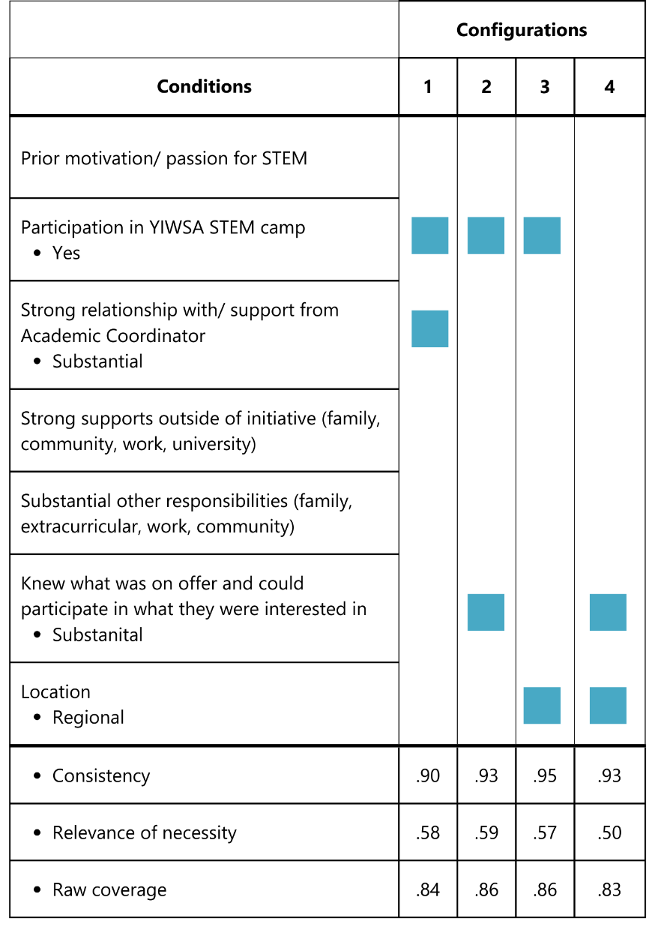
- Sufficient conditions
As with the analysis of necessary conditions, there are three measures to determine which of the many potential conditions or combinations of conditions are considered sufficient to explain the outcome observed:
- Consistency: The same as in the analysis of necessity – how often a positive outcome occurs when this condition is present.
- Proportional Reduction in Inconsistency (PRI): The degree to which a condition is associated exclusively with positive outcomes (that is, when this condition is present, there is never a negative outcome).
- Raw coverage: How much of the positive outcome is explained by each condition. A condition is more important for a positive outcome the more it covers.
Using the recommended consistency threshold of 0.9, the analysis identified the following sufficient conditions – those that can be seen in highly engaged participants, but never in less engaged ones:
- having a strong relationship with and support from their Academic Coordinator
- having prior motivation/passion for STEM and knowing what is available and participating in what they are interested in
- having strong supports outside of the initiative and knowing what is available and participating in what they are interested in.
Where these are present, it is highly likely that the participant will have a positive outcome.
The raw coverage scores indicate that these causal configurations explained whether a girl would be highly engaged with the initiative 72 to 80% of the time, depending on the condition. The high PRI scores indicate that there are few contradictions, and when these conditions and sets of conditions are present, participants are highly engaged in the initiative. See Figure A3.
Figure A3: Causal configurations sufficient to explain high engagement with the initiative
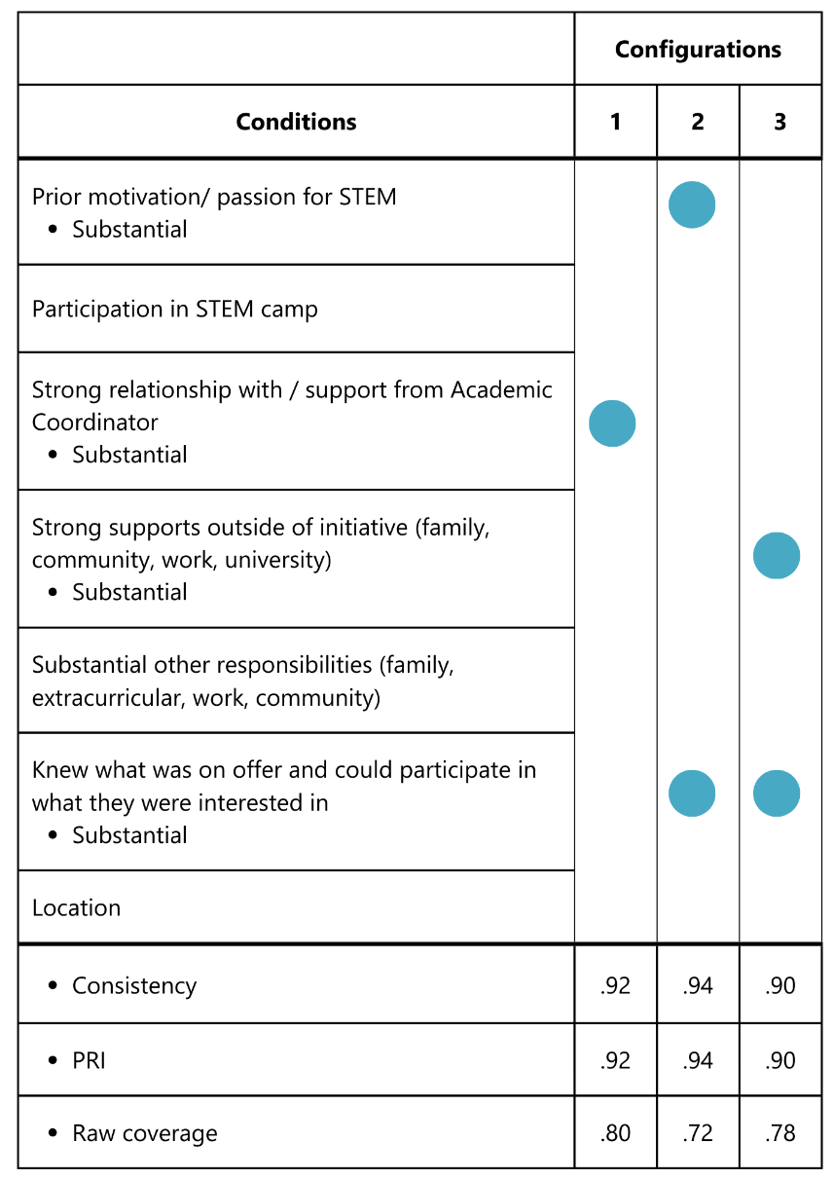

Connect with us
artd.com.au | (02) 9373 9900


The Evaluation team acknowledges the contributions of all stakeholders who supported the development of the IGSA Mid-term Outcomes Evaluation Report. We thank CSIRO and CareerTrackers for their review of policies, collaboration and provision of additional YIWSA program data in response to the IGSA Evaluation Management Response by NIAA. Following a review of additional program data presented by CSIRO and CareerTrackers, the Evaluation findings in relation to the proportion of women supported by the program who were studying non-STEM courses were independently reviewed by ARTD. The report reflects a complete analysis and recommendations based on the additional YIWSA data and was finalised on 21 November 2025.
Ninti One’s role in the project is informing the design of data collection instruments and providing Indigenous researchers to assist with participant data collection and analysis. Holly Kovac, an Indigenous member of the original ARTD Evaluation Team, has continued to work on this project through her new employer, Nama Jalu Consultants.
The first four KEQs have been grouped together as these all relate to implementation of the initiative. A full list of the KEQs is available in section 1.2.
The first four KEQs have been grouped together as these all relate to implementation of the initiative. A full list of the KEQs is available in section 1.2.
A Commonwealth Prac Payment was introduced in the 2024–2025 budget, which will mean teaching students will be eligible for some financial support during their practicum placements. This may reduce the need for MSP participants to use their scholarship fees for this purpose.
A Commonwealth Prac Payment was introduced in the 2024–2025 budget, which will mean teaching students will be eligible for some financial support during their practicum placements. This may reduce the need for MSP participants to use their scholarship fees for this purpose.
The term ‘colonial load’ refers to the expectation placed on Indigenous people to help address systemic injustices caused by colonisation, often through initiatives led by non-Indigenous Australians.
Ninti One’s role in the project is informing the design of data collection instruments and providing Indigenous researchers to assist with participant data collection and analysis.
Walter, M. (2022). Exploring and researching the Indigenous life course. Life Course Centre Working Paper Series, 2022-22. Institute for Social Science Research, The University of Queensland.
In the Interim Process Evaluation, the Evaluation Team interviewed NIAA staff, service providers (CSIRO and SSI, but not CareerTrackers), reviewed key documents and analysed the routinely collected program and administrative data. Please refer to the Interim Process Evaluation Report for a description of the methods and data sources used.
Parent/carer information and consent forms were distributed, signed and received ahead of any contact with school-aged participants being made.
There were eight ToSI participants who were on the survey distribution list for both Jarlarla PD and MSP. This is because some MSP participants who are qualified teachers undertaking post-graduate courses are offered Jarlarla in place of Jardi Dadarrinyi.
The QCA analysis was conducted using the R statistical software and the QCA package.
Walter, M., & Suina, M. (2018). Indigenous data, Indigenous methodologies and Indigenous data sovereignty. International Journal of Social Research Methodology, 22(3), 233–243.
The program logic presented here is a simplified version created in collaboration with the YIWSA Team, NIAA and ARTD. The full version is available in the Appendix, Figure A1.
The administrative data set available from CSIRO draws from a data collection tool collaboratively designed with ARTD. Because of inconsistent data collection practices within the YIWSA High School Team, the data from earlier years of the initiative is incomplete and inaccurate.
The proportion of Queensland participants is higher than that of other states and territories due to two of the three graduating cohorts were from Queensland (n = 70).
Participant name has been changed to protect their identity, and any identifying information has been excluded or adapted to ensure confidentiality.
Participant name has been changed to protect their identity, and any identifying information has been excluded or adapted to ensure confidentiality.
Wardman, J. (2018). Supporting the affective needs of gifted learners. In Education and Psychology. Routledge.
Raciti, M., Carter, J., & Gilbey, K. (2017). The ‘University Place’: How and Why Place Influences Engagement and Retention of Aboriginal and Torres Strait Islander University Students: Final Report. S. a. E. Department of Education.
Noting that child safety considerations mean restrictions are in place to minimise any risk for YIWSA high school participants.
Participant name has been changed to protect their identity, and any identifying information has been excluded or adapted to ensure confidentiality.
Barney, K. (2022). Building a Stronger Evidence Base to Support Effective Outreach Strategies for Aboriginal and Torres Strait Islander Students. Curtin University National Centre for Student Equity in Higher Education.
Collins, J. (2001). The Education of Gifted Children. WR Senate Employment, Small Business and Education References Committee.
The QCA analysis was conducted using the R statistical software and the QCA package.
Data from the seven tertiary participants who were interviewed was coded, but this data was excluded from analysis due to the requirements for coding consistency. (Tertiary participants were not eligible to participate in STEM Camps.)
Both participants from areas noted as ‘regional’ and ‘rural’ were considered ‘regional’ for the QCA, due to the need for a binary.
In-person visits with students are conducted at the student’s school. This means that the visit needs to be organised through the school and coordinated with school timetables, events and available meeting spaces. Coordinators try to organise visits to multiple schools in different, sometimes distant locations over a series of days to reduce the number of separate long-distance trips they need to make.
As outlined by CareerTrackers’ classifications, STEM-related fields are those that are either adjacent to or informed by the disciplines of science, technology, engineering, and mathematics (see Table A26 for more details).
A Commonwealth Prac Payment was introduced in the 2024–2025 budget, which will mean teaching students will be eligible for some financial support during their practicum placements. This may reduce the need for MSP participants to use their scholarship fees for this purpose.
Trudgett, M. (2009). Build it and they will come: Building the capacity of Indigenous units in universities to provide better support for Indigenous Australian postgraduate students. The Australian Journal of Indigenous Education, 38, 9–18.
A Commonwealth Prac Payment was introduced in the 2024–2025 federal budget, which will mean teaching students will be eligible for some financial support during their practicum placements. This may reduce the need for MSP participants to use their scholarship fees for this purpose.
Elsewhere in this document, ‘cultural load’ is referred to as ‘colonial load.’
While this needs to be understood as the perception of ToSI Team members relayed during interviews, it is corroborated by the Evaluation Team’s own difficulties seeking to engage these units in stakeholder interviews.
Western Sydney University Indigenous Professoriate Group. (2024). Submission to the Accord Interim Report. www.education.gov.au/system/files/2023-09/AUA_inter_tranche7_165%20Western%20Sydney%20University%20Indigenous%20Professoriate%20Group.pdf; Buckskin, P., Tranthim-Fryer, M., Holt, L., Gili, J., Heath, J., Smith, D., Larkin, S., Ireland, S., MacGibbon, L., Robertson, K., Small, T., Butler, K., Chatfield, T., Anderson, P., & Ma Rhea, Z. (2018). NATSIHEC Accelerating Indigenous Higher Education Consultation Paper. National Aboriginal and Torres Strait Islander Higher Education Consortium, Australia. NATSIHEC Accelerating Indigenous Higher Education Consultation Paper | QUT ePrints
A Commonwealth Prac Payment was introduced in the 2024–2025 budget, which will mean teaching students will be eligible for some financial support during their practicum placements. This may reduce the need for MSP participants to use their scholarship fees for this purpose.
Western Sydney University Indigenous Professoriate Group. (2024). Submission to the Accord Interim Report. www.education.gov.au/system/files/2023-09/AUA_inter_tranche7_165%20Western%20Sydney%20University%20Indigenous%20Professoriate%20Group.pdf
Collins, R. (2001). The education of gifted children. Submission to the Inquiry into the Education of Gifted and Talented Children; Raciti, M., Carter, J., & Gilbey, K. (2017). The ‘University Place’: How and Why Place Influences Engagement and Retention of Aboriginal and Torres Strait Islander University Students: Final Report. S. a. E. Department of Education.
Norman, M., & Hyland, T. (2003). The role of confidence in lifelong learning. Educational Studies, 29, 261–272. 10.1080/03055690303275
Collins, J. (2001). The Education of Gifted Children. WR Senate Employment, Small Business and Education References Committee.
The evaluation recognises that some participants may pursue dual degrees, which may combine science with, for example, law, communications, or business degrees. While these students may ultimately pursue careers that are not strictly STEM careers, their studies would still be considered in-scope for the IGSA.
The evaluation does not have quantitative data on remoteness of location for ToSI participants and has drawn on interview data from ToSI team members for this information. CSIRO data indicates that approximately 6% of participants have a home address that is in a remote or very remote area using the ABS data map. Interview data with YIWSA team members suggests that the majority of these students are based in remote service hubs (e.g. Alice Springs, Mount Isa, Kunnanurra), with a very small number from very remote locations (e.g. Tiwi Islands) who are able to participate because they attend boarding schools in urban centres).
Shay, M., Miller, J., Hameed, S., & Armour, D. (2024). Indigenous voices: Reimagining Indigenous education through a discourse of excellence. The Australian Educational Researcher.
Western Sydney University Indigenous Professoriate Group. (2024). Submission to the Accord Interim Report.
Department of Health and Aged Care. (n.d.). Health Workforce Locator. www.health.gov.au/resources/apps-and-tools/health-workforce-locator/app?language=en
Data from the seven tertiary participants who were interviewed was coded, but this data was excluded from analysis due to the requirements for coding consistency. (Tertiary participants were not eligible to participate in STEM camps.)

