

Department of the Prime Minister & Cabinet
Social Return on Investment analysis of the Birriliburu and Matuwa Kurrara Kurrara Indigenous Protected Areas

FULL REPORT

February 2016

About Social Ventures Australia
Social Ventures Australia (SVA) works with innovative partners to invest in social change. We help to create better outcomes for disadvantaged Australians by bringing the best of business to the for-purpose sector, and by working with partners to strategically invest capital and expertise. SVA Impact Investing introduces new capital and innovative financial models to help solve entrenched problems. SVA Consulting partners with non-profits, philanthropists, corporations and governments to strengthen their capabilities and capacity to address pressing social problems.

List of Abbreviations
BHA Bush Heritage Australia
CDEP Community Development Employment Projects
CDNTS Central Desert Native Title Services
CSR Canning Stock Route
DPaW Department of Parks and Wildlife (WA)
DoE Department of the Environment (Commonwealth)
IAS Indigenous Advancement Strategy
ILC Indigenous Land Corporation
IPA Indigenous Protected Area
IUCN International Union for Conservation of Nature
MKK Matuwa Kurrara Kurrara
MNR Mungarlu Ngurrarankatja Rirraunkatja (Aboriginal Corporation)
NGO Non-Government Organisation
NRS National Reserve System
PBC Prescribed Body Corporate
PM&C Department of the Prime Minister & Cabinet
SROI Social Return on Investment
SVA Social Ventures Australia
TEK Traditional Ecological Knowledge
TMP Tarlka Matuwa Piarku (Aboriginal Corporation)
WA Western Australia
WoC Working on Country

Table of Contents
About Social Ventures Australia 1
List of Abbreviations 2
Executive Summary 4
1 Introduction 8
1.1 Project objective 8
1.2 Project scope 8
1.3 Report structure 8
2 Context 10
2.1 Indigenous Protected Areas 10
2.2 About the Birriliburu and MKK IPAs 11
2.3 Investment (inputs) 15
3 Methodology for this project 17
3.1 Understanding change 17
3.2 Measuring change 19
3.3 Valuing change 20
3.4 SROI ratio 21
4 Impact of the Birriliburu and MKK IPAs 22
4.1 Understanding the change 22
4.2 Stakeholder outcomes 28
4.3 Measuring the change 42
4.4 Valuing the change 46
4.5 Calculating the SROI 48
5 Conclusion 54
6 Appendices 58

Executive Summary
Insights
- The Indigenous Protected Areas (IPA) programme has demonstrated successes across a broad range of outcome areas, effectively overcoming barriers to addressing Indigenous disadvantage and engaging Indigenous Australians in meaningful employment to achieve large scale conservation outcomes, thus aligning the interests of Indigenous Australians and the broader community
- The Birriliburu & Matuwa Kurrara Kurrara (MKK) IPAs have provided an opportunity for Martu people to reconnect with and actively manage their traditional country
- The two IPAs have proved a useful tool with which to leverage third party investment, through a joint management arrangement with the Western Australia (WA) Government, project specific funding from environmental NGOs and mutually beneficial partnerships with the private sector
- Increased and diversified investment from a range of funding sources would meet the high demand for Ranger jobs and could deliver a more expansive programme of works, which would, in turn, increase the social, economic and cultural outcomes for Martu Rangers and Community Members.
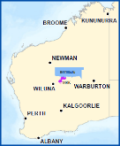
About the Birriliburu & Matuwa Kurrara Kurrara IPAs
The Birriliburu and MKK IPAs are located in central WA, north east of Wiluna. The land belongs to the Martu people, who were among the last of Australia’s Indigenous people to make contact with Europeans. Many living Martu recall their experience of first contact, occurring as late as the 1960’s. Whilst Martu culture and connection to country remains strong, many Martu now live in towns and communities on the edge of the desert, rather than on their country.
The Birriliburu IPA (depicted in blue on the map to the right) consists of 6.6 million hectares and was declared in April 2013. The MKK IPA (depicted in purple), covers 596,754 hectares south of Birriliburu and consists of two former pastoral properties, Lorna Glen (Matuwa) and Earaheedy (Kurrara Kurrara). It was declared in July 2015.
Figure E.1 – Map of Western Australia, depicting the Birriliburu (blue) and MKK (purple) IPAs
The IPAs establish plans of management for country, identifying works that Martu have prioritised through the consultation process. Those works include burning country, managing feral animals, protecting threatened species and managing tourist visitation to important Martu sights.
Impact of the Birriliburu & Matuwa Kurrara Kurrara IPAs
This Social Return on Investment (SROI) analysis demonstrates that the Birriliburu and MKK IPAs have generated significant social, economic, cultural and environmental outcomes for Martu Rangers, Community members, Government and other stakeholders. The achievement of these outcomes is strongly dependent on the engagement of Martu on country; the more time Martu spend working on country, the greater the value created by the Birriliburu and MKK IPAs.
“We want jobs and money for Martu; people to look after country.”
‘What Martu want for country’, Birriliburu IPA, Plan for Country, 2012

The three most significant outcomes for Rangers and Community members relate to better caring for country, preserving culture and language and leveraging the IPAs for additional funding and economic opportunities. The Birriliburu IPA is characterised by a strong custodial responsibility to look after country and provides for the transfer of traditional knowledge between generations. The MKK IPA provides for the development of Rangers’ natural resource management and work readiness skills through a joint management arrangement with the WA Department of Parks and Wildlife (DPaW).
The WA and Australian Governments have experienced a range of outcomes, including more skilled Indigenous people and improved engagement with community. NGO and Research partners have also benefited from deeper relationships with community and being better able to meet their core objectives.
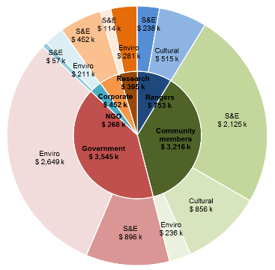
Financial proxies have been used to approximate the value of these outcomes. The social, economic, cultural and environmental value associated with these outcomes was estimated to be $8.8m for the five financial years between 2011 and 2015 inclusive.
Social Return on Investment
The Birriliburu & MKK IPAs delivered an SROI ratio of 2.3:1 based on the investment in operations between FY11-15.
That is, for every $1 invested, approximately $2.3 of social, economic, cultural and environmental value has been created for stakeholders.

S&E: Social & Economic Outcomes
Cultural: Cultural Outcomes
Enviro: Environmental Outcomes

Figure E.2 – Value of social, economic, cultural and environmental outcomes created by stakeholder group, FY11-15
During this period, $3.8m was invested in the programmes, with most (74%) coming from Government and the remainder from NGO and Corporate partners.
Stakeholder | Total
Government  Includes IPA funding (64%), DPaW fee for service work (14%) & Wiluna Healthy Country (11%) | $2,806,681
NGO Partners  Includes investment from Rangelands NRM (91%) | $535,530
Corporate partners  Includes investment from Northern Star and Newmont (75%) and Telstra (25%) | $472,155
Total | $3,814,365
Table E.1 – Investment FY11-15

In the spotlight: Lena Long, Ranger
Lena Long was born at Well 7 on the Canning Stock Route. Lena tells of how her mother gave birth, then spent the following day on horseback, carrying Lena into the pastoral station at which she worked.
Lena has been one of the most consistent Ranger employees on the Birriliburu and MKK IPAs. She has enjoyed reconnecting with country and passing on her knowledge to younger generations. She sees a huge opportunity to effect greater change with increased investment in the IPAs.
At a meeting with representatives of DPaW at the Lorna Glen research station on the MKK IPA, Lena explained how Martu and the Department staff can continue to strengthen their working relationship and learn from each other.
"We want to work with the scientists. Even if it's just one or two Martu. Learning from the scientists. And we can teach them Martu names and looking for tracks."
DPaW Regional Manager, Ian Kealley, agrees.
"I don't think our staff could ever read the country and track a cat cross country the way Martu can."

About this project
The Department of the Prime Minister & Cabinet (PM&C) commissioned SVA Consulting to understand, measure or estimate and value the changes resulting from the investment in the Birriliburu & MKK IPAs. This analysis is part of a broader project that considers five IPAs across Australia, also including Girringun in Queensland, Minyumai in New South Wales and Warddeken in the Northern Territory. The SROI methodology was used to complete each of these analyses.
The Birriliburu and MKK analysis involved 34 consultations with stakeholders of the two IPAs, including nine Community members, seven Rangers (overlapping with representatives from two Indigenous corporations), six representatives of local, WA and Australian Government, four NGO partners, two Corporate partners and two Research partners.
Recommendations
Recommendations derived from this analysis have been provided to the Birriliburu and MKK management team.
Consolidated Report
A corresponding report has also been developed by SVA Consulting titled, Consolidated report on Indigenous Protected Areas following Social Return on Investment analyses, which includes key insights from this analysis alongside the analyses of three other IPAs. That report is available on the PM&C website.

1 Introduction

1.1 Project objective
PM&C commissioned SVA Consulting to understand, measure or estimate and value the changes resulting from the investment in the Birriliburu and MKK IPAs in WA (together forming one analysis). This analysis is part of a project that analyses five IPAs across Australia including Girringun in Queensland, Minyumai in New South Wales and Warddeken in the Northern Territory. The SROI methodology was used to complete this analysis. The analysis will enable PM&C to understand the social, economic, cultural and environmental outcomes created by the Birriliburu and MKK IPAs for stakeholders and inform the future policy direction of the IPA programme.
Social Return on Investment
SROI is an internationally recognised methodology used to understand, measure or estimate and value the impact of a program or organisation. It is a form of cost-benefit analysis that examines the social, economic, cultural and environmental outcomes created and the costs of creating them. The Social Value principles are defined in the methodological attachment to this report.

1.2 Project scope
The scope of the current analysis represents a SROI of the Birriliburu and MKK IPAs for a five year period between July 2010 and June 2015. This period is the time from the beginning of the consultation period to establish the IPAs to the end of the 2015 financial year.
There are two forms of SROI analysis outlined in the SROI Guide, a forecast SROI and an evaluative SROI. A forecast SROI makes a prediction about what will happen and is informed by stakeholder consultation and other research. An evaluative SROI looks back to assess the value created as a result of an investment. This analysis is most similar to an evaluative SROI, in that it forms a judgment on the value created by the Birriliburu and MKK IPAs over time. However, due to the limited data available for comparison, this analysis has been less rigorous than an evaluative SROI. This SROI looks back in time and takes account of the available evidence from past performance and, where appropriate, from project social values. In line with Social Value principles, it is informed by stakeholder consultation.
The analysis involved consultations with 34 stakeholders of the Birriliburu and MKK IPAs including nine Community members, seven Rangers (overlapping with representatives from two Indigenous corporations), four Government, three NGO partners, two Corporate partners and three Research partners. A review of the Birriliburu and MKK IPA projects’ financial and payroll data was also undertaken. The methodology for this analysis and interview guides are set out in the Methodological Attachment to this report.

1.3 Report structure
The structure of the report is set out below.
- Section 1 (this section) introduces the analysis
- Section 2 provides the context of the Birriliburu and MKK IPAs
- Section 3 includes information about the methodology for this project
- Section 4 describes the impact of the Birriliburu and MKK IPAs
- Section 5 synthesises the findings and draws insights from the analysis
- Section 6 contains details of the Appendices

2 Context

2.1 Indigenous Protected Areas
An IPA is an area of Indigenous owned or managed land or sea country that is formed when traditional owners voluntarily enter into an agreement with the Australian Government to manage their land for conservation with government support. The IPA programme was developed in the mid 1990’s and supports Indigenous landowners to use land and sea management as a framework for employment and natural and cultural heritage conservation outcomes.
Goals of the IPA programme
- Support Indigenous land owners to develop, declare and manage Indigenous Protected Areas on their lands as part of Australia's National Reserve System
- Support Indigenous interests to develop cooperative management arrangements with Government agencies managing protected areas
- Support the integration of Indigenous ecological and cultural knowledge with contemporary protected area management practices.
There are five key steps involved in establishing and maintaining an IPA:
- Community and stakeholder consultation
- Developing a Plan of Management
- IPA Declaration
- Implementing the Plan of Management
- Monitoring, evaluation, reporting and improvement.
An IPA can be declared after a consultation period has occurred and a Plan of Management has been developed. During the consultation period, Indigenous communities are supported by the Australian Government to consult with their communities and other stakeholders about whether an IPA is suitable for them. A Plan of Management is then developed which sets out how country, its cultural values and threats to these values will be managed.
Once recognised by the Australian Government, IPAs form part of the NRS that seeks to protect Australia’s biodiversity for the benefit of all Australians in line with international guidelines. As at November 2015, there were 72 dedicated IPAs across almost 65 million hectares accounting for more than 43% of the total area of the NRS.
The IPA programme is managed by the Environment Branch of the Indigenous Employment and Recognition Division within the Indigenous Affairs Group of the Department of the Prime Minister and Cabinet. Funding is provided through the Natural Heritage Trust under the National Landcare Programme which is administered by DoE, with $73.08 million allocated from 2013-14 through to 2017-18.
There are four key features of an IPA:
- An open-ended consultation period in which Indigenous traditional owners can decide whether to proceed to IPA declaration or not, depending on their intentions for managing their country
- Commitments made by Indigenous communities outlined in a Management Plan to manage their land and sea within the IPA are voluntary, rather than by statutory agreement with the Australian Government
- Partnerships with various Government agencies, NGOs, corporates, research institutions and others are often formed to support capacity building and undertake joint activities within the IPA
- IPAs can occur over sea country as well as on multi-tenure land including national park, local government reserves, private land and native title returned lands, under co-management arrangements

2.2 About the Birriliburu and MKK IPAs
Martu people
The Birriliburu and MKK IPAs are adjoining IPAs in central WA. The land within the Birriliburu and MKK IPAs belongs to native title holders who self-identify as Martu. Martu are connected through shared country as well as through a common language, Martu Wangka (Martu talk), which is a recent amalgamation of several dialects such as Kartuujarra, Putijarra and Mandiljarra, that were spoken in discrete parts of the Martu lands.
Martu are among the last of Australia’s Indigenous people to make contact with Europeans, with many coming into pastoral stations and missions from a completely traditional desert life as late as the 1950’s and 1960’s. Many living Martu recall their experience of first contact with European civilisation.
Whilst Martu culture and connection to country remains strong, many Martu live in towns and communities on the edge of the desert, rather than on the country to which they are deeply connected. The challenges they face integrating traditional life with a modern existence are significant.
Historical context of Birriliburu
The Birriliburu IPA was declared in April 2013 to be managed under the International Union for Conservation of Nature (IUCN) Categories III and VI. The IPA consists of 6.6 million hectares of desert country, straddling three biogeographic regions – the Little Sandy Desert, the Gibson Desert and the Gascoyne. It extends from Katjarra (Carnarvon Range) in the west to the Gibson Desert in the east, and from Mungarlu in the north to a series of pastoral stations in the south.
Birriliburu native title holders and their predecessors lived on Birriliburu country for thousands of years until first contact with white people. When white people came they established the Canning Stock Route (CSR) and set up stations to the west and south of the Birriliburu IPA. The traditional owners moved out of the desert into remote towns and communities including Wiluna, Jigalong and Warburton where food and water was easier to access. Today, most Martu still live in these towns and other communities proximate to the Birriliburu IPA.
Historical context of MKK
The MKK IPA was declared in July 2015. The majority of the area within the IPA is managed under IUCN Category V, with parts of the IPA managed under Categories III and IV. The MKK IPA consists of 596,754 hectares of desert country south of the Birriliburu IPA, on the southern edge of the Little Sandy Desert. It includes some of the most valuable parcels of land on the Martu estate, as well as an abundance of major Jukurrpa (dreaming) sites and Jukurrpa tjina (dreaming tracks).
Many Martu were employed on the former pastoral properties of Lorna Glen (Matuwa) and Earaheedy (Kurrara Kurrara) from the 1970s until the 1990s and the land remained a corridor for Martu moving between settlements, pastoral stations and desert country. On the basis of this continuing connection, a native title claim was lodged over the properties in 1998.
With the decline of the pastoral industry, the leases were surrendered to the WA Government in 2000 and 2001 respectively. Under the management of DPaW (formerly the Department of Conservation and Land Management), the properties evolved into a premier arid zone research station. A co-management relationship between the Department and the Martu native title claimants began to evolve after a Memorandum of Understanding (MoU) was signed in 2004. With the recent determination of native title and declaration of the MKK IPA, Martu and DPaW are now exploring a deeper co-management relationship over the land.
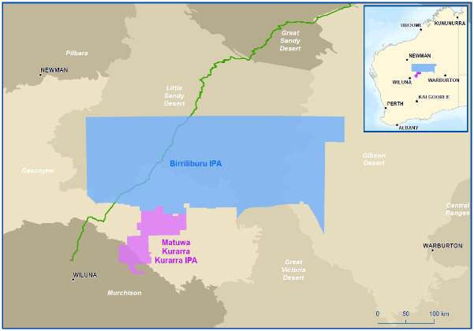
Figure 2.1 – Map of Birriliburu and MKK IPAs with reference to the Canning Stock Route and Western Australia (inset)
Wiluna township
The township of Wiluna is about 500km directly north of Kalgoorlie and a 1000km drive from Perth. It has a transient population of around 300 residents, roughly two thirds of whom are Martu. Local industry includes pastoral and mining operations, the latter of which is the major employer in the region. Within a 50km radius of Wiluna there are two working mines and a further three prospective mines in various stages of development. The township includes a school, health service, training provider, a general store, a pub, local Shire offices and a nearby airport.
A 2013 Attitudinal survey of 98 Martu living in and around Wiluna – conducted by Martu – established that there are low levels of work participation amongst Martu living in Wiluna. Respondents identified inadequate engagement of the Martu community by local employers, resulting in a low capacity to respond to work, training and enterprise opportunities amongst Martu.
Working on the IPAs
Wiluna is the base from which most Martu access both the Birriliburu and MKK IPAs. The most readily accessible work zone on the Birriliburu IPA is Katjarra, which is a five hour drive from Wiluna. There are two dirt roads connecting Wiluna to the MKK IPA, with the Lorna Glen homestead situated 170kms from Wiluna. These roads also link Wiluna to mine sites and pastoral stations.
Indigenous rangers look after country within the Birriliburu and MKK IPAs, using a small sum of grant funding received from the Australian Government through the IPA programme. Central Desert Native Title Services (CDNTS) manages the IPA contracts on behalf of Martu. No funding is received through the Australian Government’s Working on Country (WoC) programme.
CDNTS has been successful in leveraging the two IPAs to attract additional funds in support of land management activities. On the Birriliburu IPA, major partners have included Rangelands NRM (Rangelands, an NGO partner), and Telstra (a Corporate partner). On the MKK IPA, due to the history of co-management, a fee for service relationship has been established whereby DPaW engages Martu Rangers to work alongside and support DPaW staff in their activities on the research station.
A third, important workzone is situated between the MKK IPA and Wiluna on the Jundee gold mine. Rangers undertake rehabilitation, recycling and flora and fauna survey work in partnership with Northern Star Resources (formerly with Newmont Mining Corporation, the owner of Jundee until July 2014) (hereafter, Northern Star and Newmont).
The three work zones – Birriliburu, MKK and Jundee – offer different opportunities for Martu Rangers, providing a progression from a cultural space (Birriliburu), to one of joint management with Government (MKK), through to a commercial operation (Jundee). Martu have a different cultural and historical relationship with the country comprising each work zone and the nature of Ranger work undertaken reflects that. The differing, but complimentary nature of these work zones is represented in figure 2.1.

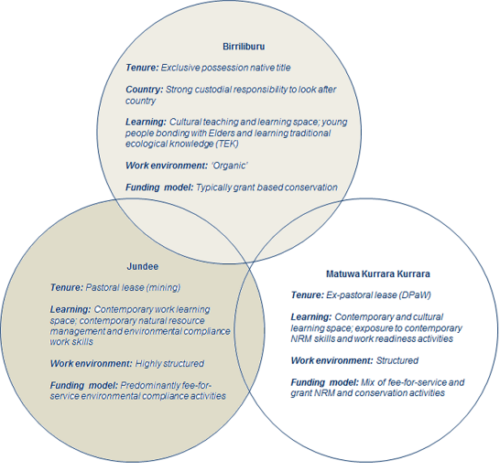
Figure 2.2 – Birriliburu, MKK and Jundee work zones, Central Desert Native Title Services
As the Jundee site is outside the IPAs, work carried out on that site is beyond the scope of this analysis. However, the value of the partnerships with Northern Star and Newmont have been considered and incorporated separately.
During the five year period of investment covered by this analysis 95 Indigenous people (64% men and 36% women), mostly Martu, worked on the Birriliburu and MKK IPAs. Figures 2.2 and 2.3 below provide further data in relation to the number of Rangers employed and the number of hours worked on the Birriliburu and MKK IPAs.
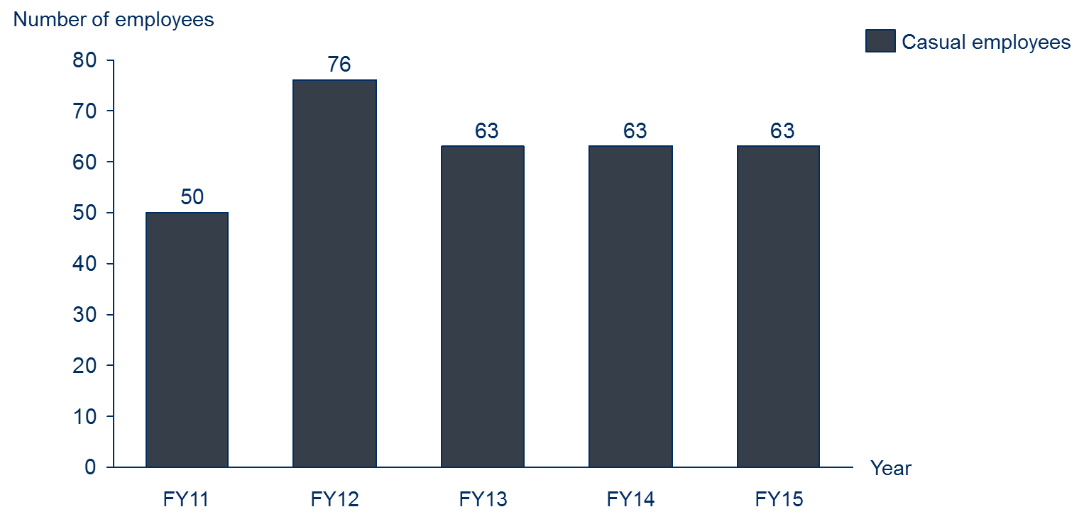
Figure 2.3 – Number of Birriliburu and MKK Indigenous Rangers (referred to as Rangers throughout this report), FY11-15
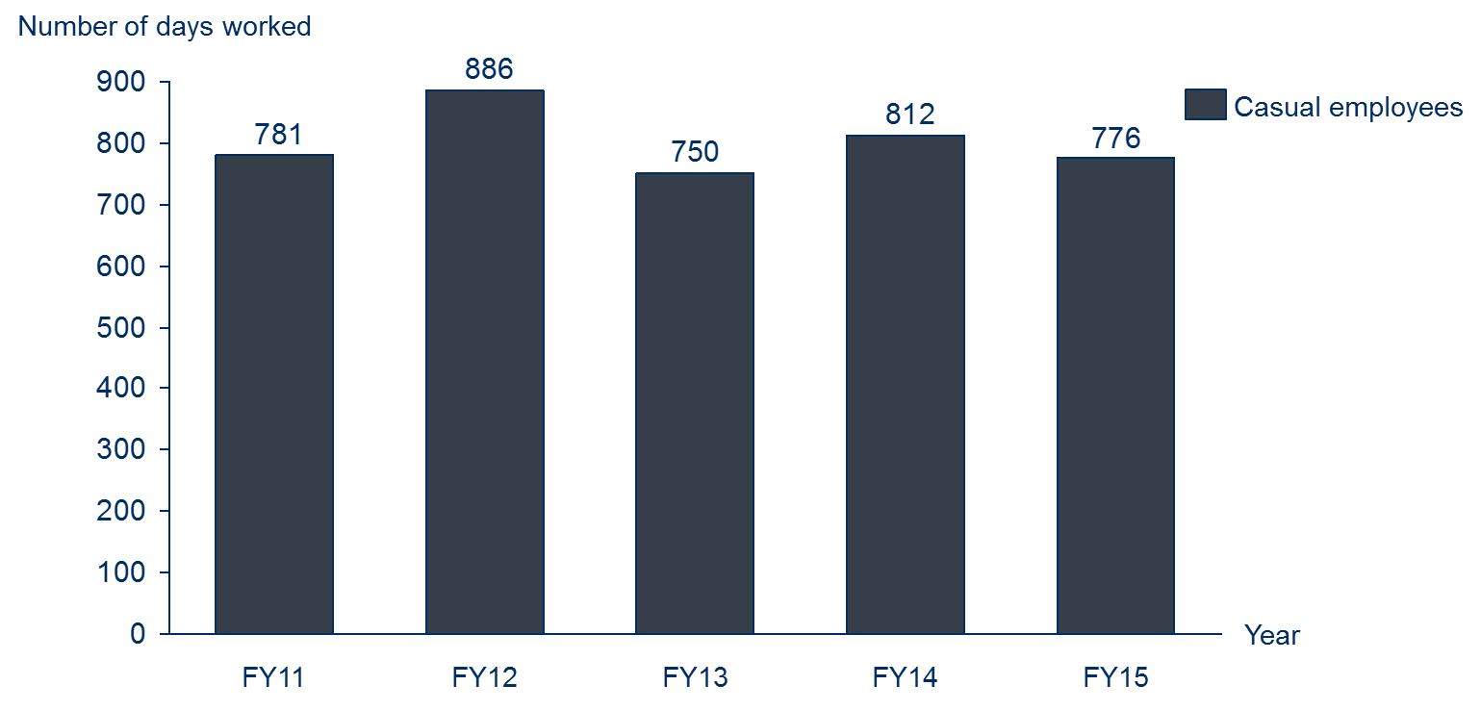
Figure 2.4 – Number of days worked by Birriliburu and MKK Indigenous Rangers, FY11-15

2.3 Investment (inputs)
The investment included in an SROI analysis is a valuation of all the inputs required to achieve the outcomes that will be described, measured or estimated and valued. For the purpose of this SROI analysis, the investment includes the value of financial (cash) investment over the five year period between FY11 and FY15. No in-kind (non-cash) investments were found to be material. Total investment over the five years was approximately $3.8 million.
Investment Summary
Table 2.2 and Figure 2.4 include a summary of the investment for the Birriliburu and MKK IPAs.
Stakeholder | Total | Notes
Government | $2,806,681 | Includes IPA funding (64%), fee for service work for DPaW (14%) and Wiluna Healthy Country (11%)
NGO Partners | $535,530 | Includes investment from Rangelands NRM WA (91%)
Corporate partners | $472,155 | Includes investment from Northern Star and Newmont (75%) and Telstra (25%)
Total | $3,814,365
Table 2.2 – Investment by stakeholder group, FY11-FY15

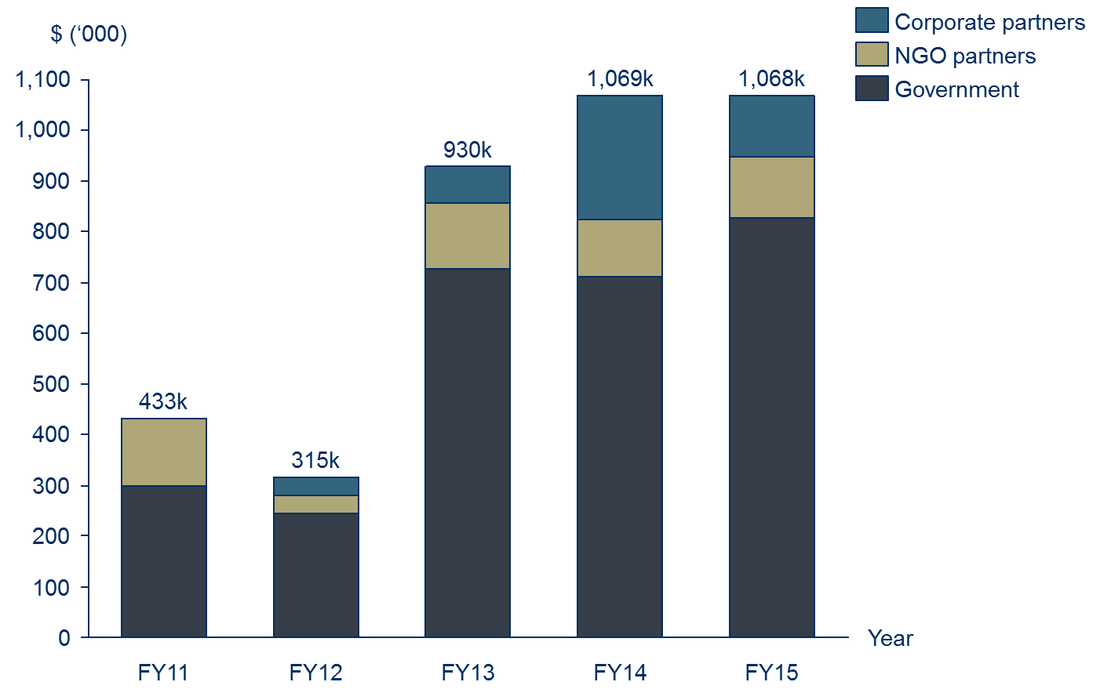
Figure 2.5 – Investment by stakeholder group, FY11-15

3 Methodology for this project

3.1 Understanding change
An SROI analysis requires that the key changes are described, measured or estimated and valued. It requires a balance between developing a hypothesis that can be tested on the one hand, and hearing the stories which emerge from stakeholder consultation on the other. SVA facilitated a theory of change workshop with PM&C to develop the theory of change for the IPA programme overall in order to define the key changes. The information from the workshop informed the focus of the research approach to ensure relevant data was collected from all key stakeholders.
About theory of change
A theory of change tells the story of change that takes place as a result of the activities of the organisation or programme. It specifies:
- The issue that the organisation or programme is seeking to address
- The key participants in the activities of the organisation or the programme
- The activities that organisation or programmes deliver
- The inputs required to generate the outcomes
- The outcomes of activities that occur through the organisation or programme, for various stakeholders
- The overall impact of these outcomes.

The theory of change developed during the workshop was subsequently refined to incorporate findings from the research and stakeholder consultations and tailored to ensure it adequately reflected the situation within the Birriliburu and MKK IPAs.
Defining stakeholder groups
Stakeholders are defined as people or organisations that experience change, whether positive or negative, or those who want to see change, as a result of the activity. For stakeholders to be included in an SROI, they must be considered material to the analysis. Materiality is a concept that is borrowed from accounting, whereby information is classified as material if it has the potential to affect the readers’ or stakeholders’ decisions about the programme or activity. According to the SROI Guide, a piece of information is material if leaving it out of the SROI would misrepresent the organisation’s activities.
A preliminary list of stakeholders was developed by the management team of the Birriliburu and MKK IPAs, which was used as a basis for stakeholder consultation. Stakeholder consultations were later completed to test the materiality of changes experienced by those stakeholders.
Based on this analysis, it was determined that there were seven material stakeholder groups that experience outcomes as a result of the Birriliburu and MKK IPAs:
- Rangers
- Community members, including Indigenous traditional owners
- Government, including the Australian and WA Governments (but not local government)
- Indigenous corporation partners
- NGO partners
- Corporate partners
- Research partners.
Stakeholder consultations
Stakeholders were consulted to identify and understand the relative importance of changes (or outcomes); consider how to measure or estimate change; and consider how to value the outcomes. The consultation approach completed for this analysis involved a two-phased approach:
- Phase 1: SVA and PM&C completed in-person consultations, predominately with Indigenous stakeholders, while on country within the Birriliburu and MKK IPAs in mid-September 2015
- Phase 2: SVA and PM&C completed phone consultations, predominately with non-Indigenous stakeholders, after returning from country in late September 2015. These consultations involved additional stakeholders identified by the management team of the Birriliburu and MKK IPAs and Indigenous stakeholders on country during phase 1. These stakeholders were consulted to determine whether the Birriliburu and MKK IPA projects had generated material changes for them, and to define the nature of those changes.
An outline of completed stakeholder consultations is included in Table 3.1 below.
Stakeholder group | Participation in consultations | Estimated total number of stakeholders
Rangers | 7 | 95
Community members | 9 | ~200
Government | 6 | N/A
Indigenous corporation partners | 2 | 2
NGO partners | 4 | 4
Corporate partners | 2 | 3
Research partners | 2 | 3
Total | 30 engaged through consultation | ~370
Table 3.1 – Summary of stakeholder consultations
The management team of the Birriliburu and MKK IPAs were involved in the verification of results at three main points:
- Stakeholder consultations – through feedback on the theory of change;
- The measurement and valuation phase – through feedback on the measurement or estimation approach and the calculation of the value of outcomes; and
- The reporting phase – through feedback on the draft report.
Research and analysis
To complement the stakeholder consultations, desktop research and analysis was completed using the Birriliburu and MKK IPA projects’ data as well as secondary research relating to land management and previous evaluations of aspects of the IPA and WoC programmes. Key data sources used to supplement the stakeholder consultations and project specific data are outlined in Table 3.2 below.
Data source | Use in the SROI analysis
Matuwa and Murrara Kurrara Indigenous Protected Area Country Management Plan 2015 to 2020, 2015 | To inform section 2 of this report
Dermot Smyth, Indigenous Protected Areas and ICCAs: Commonalities, Contrasts and Confusions, 2015 | Background information
Dermot Smyth, Caring for Country: An Indigenous Propitious Niche in 21st Century Australia, 2014 | To inform Ranger and Community member outcomes
PM&C, Working on Country and Indigenous Protected Areas programmes, 2013-14 | To inform section 2 of this report
Birriliburu Indigenous Protected Area Plan for Country, 2012 | To inform section 2 of this report
Urbis, Assessment of the social outcomes of the Working on Country program, 2012 | Background information
The Allen Consulting Group, Assessment of the economic and employment outcomes of the Working on Country program, 2011 | Background information
Garnett and Sithole, Healthy Country, Healthy People: Sustainable Northern Landscapes and the Nexus with Indigenous Health, 2007 | To inform Ranger and Community member outcomes
Putnis, Josif and Woodward, Healthy Country, Healthy People: Supporting Indigenous Engagement in the Sustainable Management of Northern Territory Land and Seas, 2007 | To inform Ranger and Community member outcomes
Table 3.2 – Data sources used to supplement consultation

3.2 Measuring change
The stakeholder outcomes included in the SROI represent the most significant consequences that are experienced by stakeholders as a result of the Birriliburu and MKK IPAs up to July 2015. The measures are estimates inferred through stakeholder consultation and quantitative data. Wherever possible we have estimated the extent to which the outcomes have occurred through the use of quantitative data previously collected by the IPA or by other sources. The measures have also been deeply informed by stakeholder consultation. Throughout the data collection process, attention was paid to all possible consequences that arise as a result of the Birriliburu and MKK IPAs: intended and unintended; positive and negative.
Defining the material outcomes for stakeholder groups is complex. When defining the material outcomes for each stakeholder group, an SROI practitioner must ensure that each outcome is unique or it would be considered double counting. This is difficult as the outcomes for each stakeholder group are necessarily related because they describe all of the changes experienced by the stakeholder. Outcomes also happen at different times throughout the period being analysed with different levels of intensity.
These various factors were considered when identifying appropriate measures or estimates and indicators for a particular outcome or set of outcomes created through the Birriliburu and MKK IPAs.

3.3 Valuing change
Financial proxies
Financial proxies are used to value an outcome. This is particularly important in SROI as it relates to the principle of valuing what matters. This means that there is a need to value outcomes even if there isn’t an existing market value.
There are a number of techniques used to identify financial proxies and value outcomes. Importantly, within an SROI, the financial proxy reflects the value that the stakeholder experiencing the change places on the outcome. This could be obtained directly through stakeholder consultation, or indirectly through research. The financial proxies approximate the value of the outcome from the stakeholder’s point of view. Techniques for valuing outcomes are included in the Methodological Attachment to this report.
SROI (Valuation) filters
To present an accurate view of the value created through the Birriliburu and MKK IPAs, SROI (Valuation) filters have been applied to different financial proxies. This is in accordance with the Social Value principle to not over-claim. Different techniques were used to identify the most appropriate filter for each of the outcomes, including SROI filter assumption categories, also included in the Methodological Attachment to this report.
Consideration of the different SROI filters for this analysis is as follows:
- Deadweight: Deadweight is an estimation of the value that would have been created if the activities from the programme did not happen. To estimate deadweight for the current analysis, stakeholder consultations and desktop research were completed to understand the context and nature of outcomes
- Attribution: Attribution estimates how much change was as a result of other stakeholders or activities, which were not included in the investment. An understanding of the contribution of others to each outcome was determined through stakeholder consultations and research
- Displacement: Displacement is an assessment of how much of the activity displaced other outcomes. Stakeholder consultations and desktop research were completed to identify if any of the outcomes displaced other activities
- Duration and drop-off: Duration refers to how long an outcome lasts for. The duration and drop- off are linked to whether the stakeholder is likely to benefit from the activities over a defined period.
Valuing the outcomes
The total adjusted value is the value calculated for each outcome, which takes into account the following components:
- Quantity: the number of stakeholders who will experience an outcome
- Financial proxy: value of the outcome
- SROI filters: accounting for whether the outcome would have happened anyway (deadweight), who else will contribute to the change (attribution), whether the outcome will displace other activities or outcomes (displacement), how long the outcome will last for (duration) and how it changes over time (drop off).

3.4 SROI ratio
The SROI ratio is a comparison of the value of the benefits to the value of investment. It is expressed in numerical terms e.g. 3:1, which means that for every dollar invested, $3 of value is returned.
It is important that the SROI calculations are tested by understanding how the judgements made throughout the analysis affect the final result. The judgements that are most likely to influence the SROI ratio were identified, and a sensitivity analysis was conducted to see how sensitive the ratio was to changes in these judgements. To decide which judgements to test, two key questions were considered:
Considerations for interpreting the ratio
- The SROI ratio represents the additional value created, based on the Social Value principles. This is the unique value that is created by a program or organisation for a specific period
- SROI ratios should not be compared between organisations without having a clear understanding of each organisation’s mission, strategy, theory of change, geographic location and stage of development. A judgement about investment decisions can only be made when using comparable data
- How much evidence is there to justify our judgement? The less evidence available, the more important it is to test
- How much does it affect the final result? The greater the impact, the more important it is to test.

4 Impact of the Birriliburu and MKK IPAs

4.1 Understanding the change
Theory of change
A theory of change was initially drafted for the Birriliburu and MKK IPAs via a workshop completed with 12 PM&C staff. The theory of change developed during the workshop was extensively tested and subsequently refined to incorporate evidence collected through stakeholder consultations and specific feedback from stakeholders. At least one stakeholder from each stakeholder group provided feedback during the testing of the theory of change. The refined theory of change is included in Figure 4.1.
The theory of change tells the story of change for the Birriliburu and MKK IPAs. It consists of four pages:
- Issues, Stakeholders, Activities and Inputs
- Outputs, outcomes and impact for Community members and Rangers
- Outputs, outcomes and impact for Government
- Outputs, outcomes and impact for other stakeholders – Indigenous corporation partners, NGO partners, Corporate partners and Research partners
The first page outlines the issue that the Birriliburu and MKK IPAs seek to address, the stakeholders involved, the activities that take place and the inputs (investments) into the programme. Only those stakeholders that appear in bold experience outcomes that are measured or estimated in the analysis.
The next three pages consist of outputs (i.e. the immediate consequences of activities), outcomes and impact for stakeholders identified in bold. The outcomes represented on these pages should be interpreted from left to right, and consist of short, medium and long term outcomes. There are three types of outcomes represented:
- Material outcomes
- Intermediate outcomes
- Other outcomes
Material outcomes are outcomes that have been measured or estimated and valued as part of the SROI analysis. These outcomes are considered “material” because they are relevant and significant changes that stakeholders experienced due to the Birriliburu and MKK IPAs during the period of investment being analysed. Decisions around materiality were informed by stakeholder consultation.
Intermediate outcomes are outcomes that have been achieved as a result of the Birriliburu and MKK IPs, however their value is subsumed by later outcomes that carry a higher value. For this reason, intermediate outcomes are not measured or valued in the analysis as it would be considered double counting.
Other outcomes are those outcomes that have not yet been achieved, and are aspirational outcomes based on the logic of what should occur given other outcomes have been achieved.
The theory of change emphasises the interrelationship between social, economic, cultural and environmental outcomes. This is aligned with how stakeholders perceived the change they experienced through the programme. For instance, Martu have a cultural obligation to care for country through traditional burning practices, but that same activity can lead to positive environmental outcomes, including less dangerous fires and less ferals. For Martu, these outcomes are intrinsically connected.
Key points to draw out of the representation of the Theory of Change are:
- The outcomes generated by the Birriliburu and MKK IPAs are widespread across the social, economic, cultural and economic domains
- Over the last five years, the Birriliburu and MKK IPAs have pushed well beyond outputs to generate extensive short and medium term outcomes, and some long term outcomes
- Many of the outcomes for different stakeholders are interrelated. For example, Rangers acquiring new skills manifests as an outcome for Rangers (“Increased skills through training and experience”) and Government (“Rangers are skilled and trained”); in addition, numerous environmental outcomes are shared across Community members and Government (such as “More burning using cultural practices”)
- In all cases, stakeholders are striving for two interrelated impacts: healthier people and healthier country.
Potential negative or unintended outcomes were tested throughout stakeholder consultation. For example, some Rangers identified that ranger work took them away from their family, because of the vast distances between community and the IPAs. On balance, it was determined that there were no material negative outcomes associated with the Birriliburu and MKK IPA projects. Ongoing, significant challenges are evident, particularly for Community members and Rangers (such as alcohol addiction) however the Birriliburu and MKK IPAs were not seen as contributing negatively to these issues.

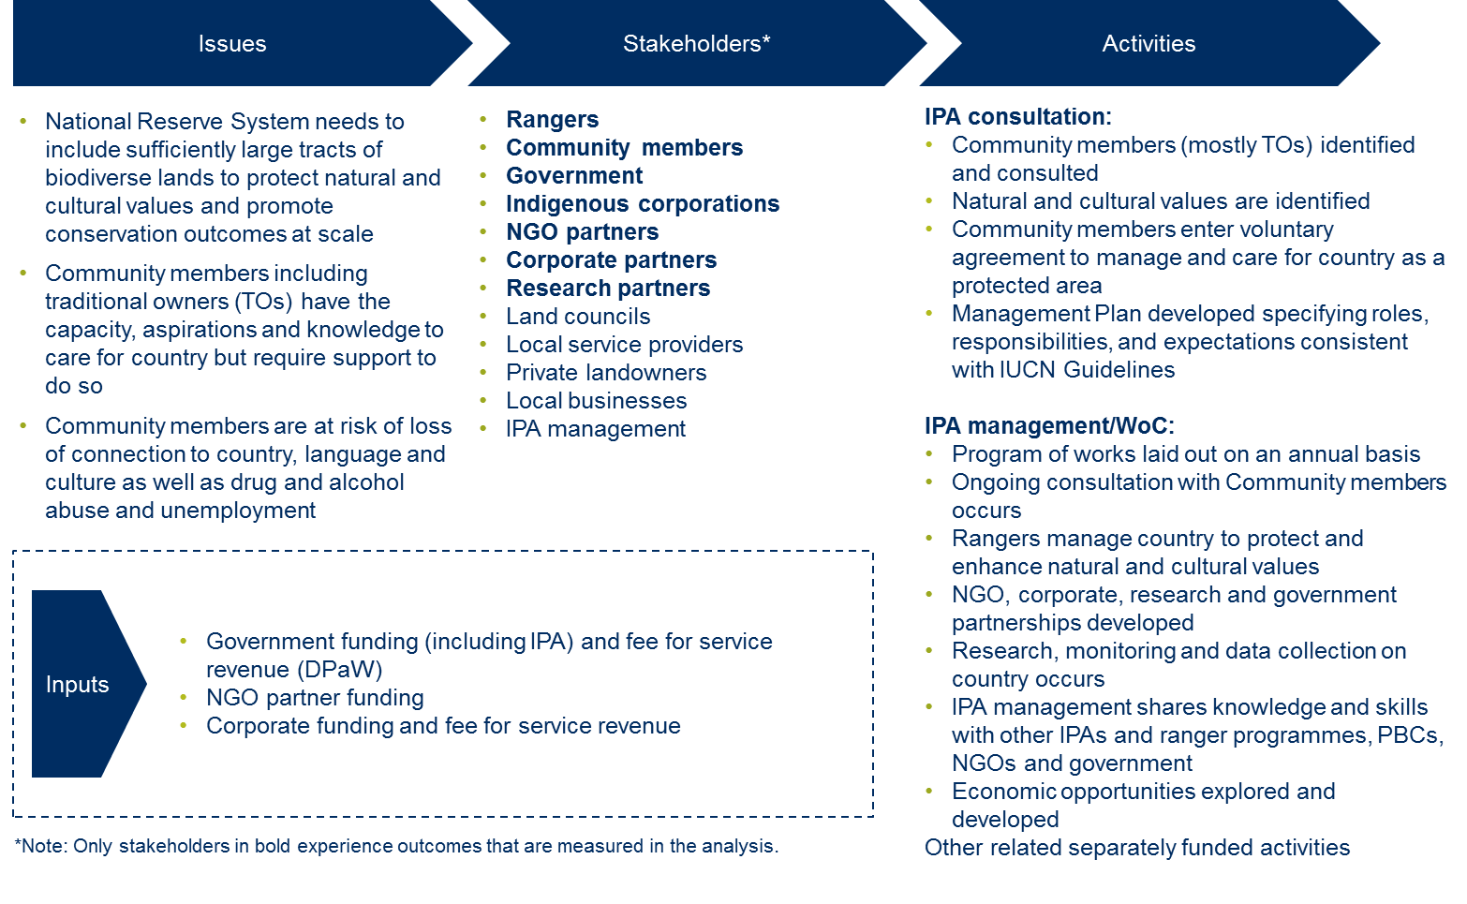
Figure 4.1a –Theory of change for the Birriliburu and MKK IPA projects – Issues, Stakeholders, Activities and Inputs (Investment)
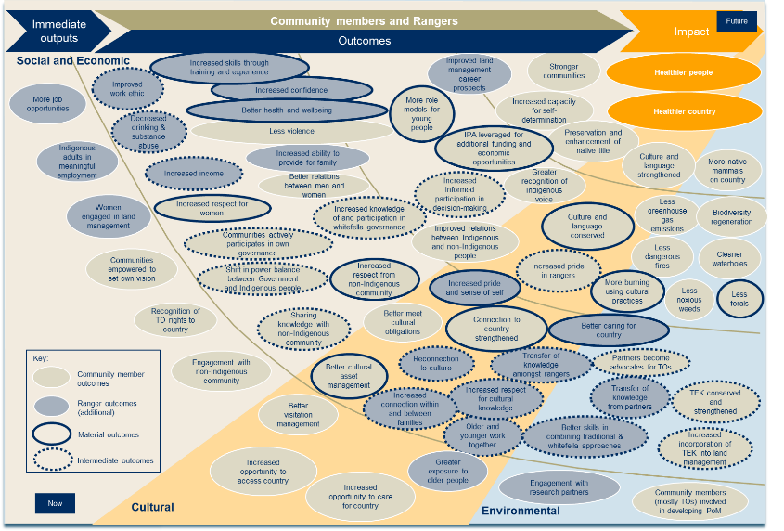
Figure 4.1b –Theory of change for the Birriliburu and MKK IPA projects – Community member and Ranger outcomes
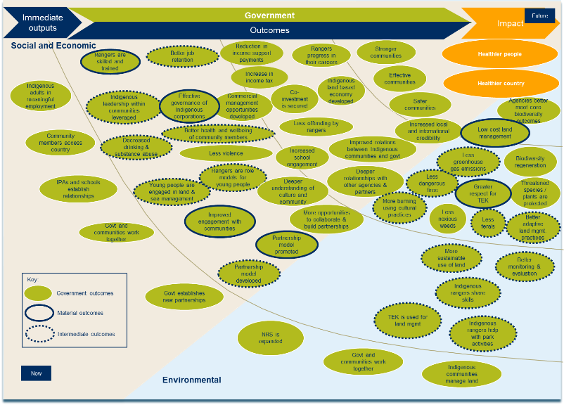
Figure 4.1c –Theory of change for the Birriliburu and MKK IPA projects – Government outcomes
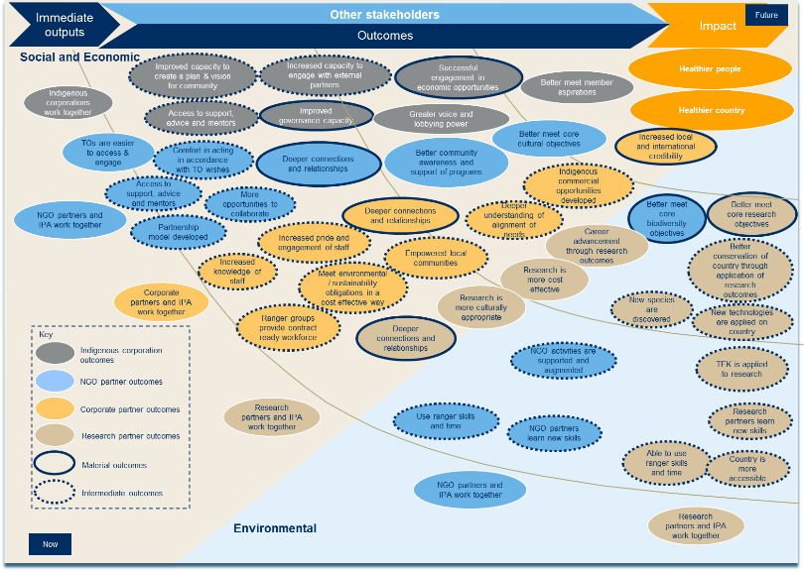
Figure 4.1d –Theory of change for the Birriliburu and MKK IPA projects – Indigenous corporation, NGO partner, Corporate partner and Research partner outcomes

4.2 Stakeholder outcomes
The stakeholder outcomes are represented in the theory of change outlined in section 4.1. This section describes the outcomes experienced by each of the following stakeholders, in more detail:
- Rangers
- Community members, including Indigenous traditional owners
- Government, including the Australian and WA Governments
- Indigenous corporation partners
- NGO partners
- Corporate partners
- Research partners
The outcomes described below are included in the SROI analysis and represent incremental changes for stakeholders that occur as a result of the Birriliburu and MKK IPAs.
- Rangers
Rangers include all those people who work on country within the Birriliburu and MKK IPAs. All Rangers working on country within the two IPAs do so on a casual basis. During the period of investment covered by this analysis, 95 Indigenous people, mostly traditional owners, worked on the Birriliburu and MKK IPAs.
Rangers working on country is the foundation upon which all outcomes are based. Because Rangers work on country, they experience personal benefits including increased skills and confidence, and better health and wellbeing. The work of Rangers on country has also generated positive outcomes for Community Members. Similarly, all Government outcomes are linked to Ranger work on country because of its flow-on effects, including skilled Rangers, greater respect for TEK and more cost-effective land management.
It is likely that a Ranger working on country fits within two stakeholder groups: Rangers and Community Members, which reflects both their job and their role within community. Outcomes achieved by Rangers, captured in Table 4.1 below, are additional to those that are achieved by Community Members.
A summary of the inputs (investment in the programme), outputs (summary of activity) and outcomes (changes) that are experienced by Rangers is included in Table 4.1 below.
Inputs ($) | Outputs | Material outcomes
Nil | - More job opportunities  - Indigenous adults in meaningful employment  - Women engaged in land management  - Greater exposure to older people  - Engagement with research partners | 1.1 Increased skills through training and experience  1.2 Increased confidence  1.3 Better health and wellbeing  1.4 Increased pride and sense of self  1.5 Better caring for country
Table 4.1 – Inputs, Outputs and Outcomes for Rangers
Within Ranger outcomes, there are two threads of outputs and outcomes: social and economic, and cultural.
Social and economic outcomes
The material outcomes that have been generated for Rangers in the social and economic thread are:
- 1.1 Increased skills through training and experience
- 1.2 Increased confidence
- 1.3 Better health and wellbeing
One of the most immediate changes for Rangers working on country is the increase in their technical skills. Technical skills encompass Traditional Ecological Knowledge (TEK) and Western scientific knowledge, each of which is valuable and complementary. Younger rangers working on the MKK IPA, with both older Martu Rangers and DPaW employees, have the opportunity to learn both skills sets.
Most Rangers undertake work across a variety of activities and therefore receive training in relation to fire management, flora and fauna surveys and feral animal and weed management. In some cases, that training is formalised, with both BCA National and Durack Institute of Technology delivering training to Rangers over the period of investment. In March 2015, 6 Rangers were awarded their Certificate III in Conservation and Land Management.
“When I think back to where we started, we’ve learnt a lot..."
Lena Long, Ranger
[Agreeing with Lena] “We’ve come a long way.”
Rita Cutter, Ranger
An outcome occurring for Rangers through the development of ‘increased skills’ is increased confidence. Achievement of this outcome is directly related to time spent on country learning new skills, spending time with the older people and connecting to culture and landscape. Some Rangers compared their lives before and after working on the Birriliburu and MKK IPAs to demonstrate how they had grown and developed over time into a more self-assured person. Many spoke of their experience engaging with partners from the broader community – including Trackcare volunteers and Telstra employees on the Birriliburu IPA – and the difficulty they would have had in speaking for themselves and for country prior to their work as Rangers.
“I didn't used to think whitefellas wanted to listen to me."
Rita Cutter, Ranger
Better health and wellbeing was a consistent theme throughout interviews with Rangers. Improved physical health was seen as the direct benefit of a more active lifestyle and better nutrition when working out on country. Improved mental health was attributed to escaping ‘humbug’ in town, but also to the healing effects of reconnecting with country. Rangers had few positive things to say about their lives in Wiluna, where they would be more likely to drink or get in fights.
“I'm happy when I'm out here. My life is on country. Not in town."
Caroline Long, Ranger
Statements by Rangers that their mental and physical health had improved since they started regular work on country were supported through consultation with the local health service provider, a representative of which highlighted the mental health benefits as being most striking.
“I didn’t used to be able to walk up this hill, now it’s not a problem. I went to see Doctor Toby in town and he's saying, 'you're much healthier than you were.’”
Rita Cutter, Ranger

Cultural outcomes
The material outcomes that have been generated for Rangers in the cultural thread are:
- 1.4 Increased pride and sense of self
- 1.5 Better caring for country
Increased pride and sense of self is a short to medium term outcome that results from increased connection within and between families, and connection (or reconnection) to culture. Rangers described this outcome as linked to the development of their cultural identity, which helped them to better understand themselves, their culture and their place in the world. For those who transfer knowledge onto the younger generations, pride comes from helping others to connect with their culture and continue to keep country healthy.
“I want to teach my son about town stuff and about Martu stuff. I want to teach my wife [who is Noongar] about Martu stuff. We can’t teach Martu stuff unless we’re out on country.”
Zareth Long, Ranger
Better caring for country is a direct result of Ranger work on country and is closely linked with the outcome ‘increased pride and sense of self’. It is a short to medium term outcome that results from older and younger people working together and the transfer of knowledge among Rangers.
The IPAs establish plans of management for country, identifying works that Martu have prioritised through the consultation process. Those works include burning country, managing feral animals, protecting threatened species and managing tourist visitation to important Martu sights. Older people are actively involved in carrying out these works, ensuring that country is better cared for and that TEK is passed on to younger generations.
“We gotta learn ‘em up country, the young ones. We want our young people to learn the traditional ways.”
‘What Martu want for country’, Birriliburu Indigenous Protected Area, Plan for Country, 2012
It is important to understand that, in the absence of WoC funding, CDNTS receives only a small sum of funds for ranger activities each year. For that reason, very few rangers worked for a sufficient period of time in each given year to qualify for basic thresholds used to estimate whether outcomes were likely to have been experienced. Likewise, the number of community members able to access country (considered below), is also limited.
The shortage of funding and opportunities to go out on country, due to vehicle and staffing limitations, was a source of frustration for many Martu during consultation. The impact of limited investment on the valuation of outcomes in this analysis will be explained in further detail in section 4.3 below, when we consider ‘measuring change’.
“Our biggest problem is Martu vehicles. We can't get out to country without Martu cars and we don't have enough of them. We have to wait til Central Desert mob can take us out, but they got their own jobs.”
Lena Long, Ranger
- Community members
Community members represent Indigenous people, mostly Martu, who are connected with the Birriliburu and MKK IPAs, but do not necessarily undertake ranger work on the Birriliburu and MKK IPAs. In that sense, Rangers are a subset of the Community members stakeholder group. Community members usually live in towns or communities proximate to the IPAs, such as Wiluna or Jigalong, but may also be connected through a close relative who is working on the IPAs.
For our visit to Katjarra on the Birriliburu IPA, during the consultation period, we were joined by:
- A group of four Martu Rangers;
- A large group of Birriliburu traditional owners and their children, who live in the Jigalong and Parnngurr communities north of the Birriliburu IPA; and
- A woman, Francene Tressidda, who has a connection to Birriliburu country but is currently living in York, near Perth. Francene was invited on the trip by her aunt, Lena Long, who works as a Ranger.
All of these people are considered Community members.
A summary of the inputs (investment in the programme), outputs (summary of activity) and outcomes (changes) that are experienced by Community members is included in Table 4.2 below.
Inputs ($) | Outputs | Material outcomes
Nil | - Communities empowered to set own vision  - Recognition of TO rights on country  - Engagement with non-Indigenous community  - Better visitation management  - Increased opportunity to access country  - Increased opportunity to care for country  - Community members (mostly traditional owners) involved in developing Plan of Management for Birriliburu and MKK IPA | 2.1 More role models for young people  2.4 IPAs leveraged for additional funding and economic opportunities  2.5 Increased respect for women  2.6 Increased respect from non-Indigenous community  2.7 Better cultural asset management  2.8 Connection to country strengthened  2.9 Culture and language conserved  2.10 More burning using cultural practices  2.12 Less ferals
Table 4.2 – Inputs, Outputs and Outcomes for Community members
Social and economic outcomes
The material outcomes that have been generated for Community members in the social and economic thread are:
- 2.1 More role models for young people
- 2.4 IPA leveraged for additional funding and economic opportunities
- 2.5 Increased respect for women
- 2.6 Increased respect from non-Indigenous community
As a direct result of Rangers working on country and experiencing the outcomes discussed above, Community members benefit on account of the development of Martu role models with increased skills, confidence, pride, knowledge of country and better health and wellbeing. The 2013 survey of Martu found that 25% were engaged in paid work. Many of those employed were working for CDNTS or Northern Star and Newmont (through CDNTS). Separately, given the distances involved and the challenges of finding vehicles and licensed drivers, young Martu would otherwise have limited opportunities to get out onto country and observe their older people fulfilling cultural obligations. The IPA delivers resources to look after country, creating positive, engaged role models in both a cultural and socio-economic sense.
Economic outcomes for Community members
This analysis includes an economic outcome related to Martu’s ability to leverage the IPAs to generate additional funding and economic opportunities, such as work undertaken with Northern Star Resources / Newmont Mining Corporation. This outcome is calculated at an average value of $182,560 per opportunity per year. The total adjusted value associated with this outcome over five years is $2.0 million. See sections 4.3 to 4.5 for more information about the adjusted value of each outcome.

“I want to be a Ranger when I grow up..."
Primary School Student 1, Jigalong
[Pointing to his brother] “I want to be a policeman so I can lock him up.”
Primary School Student 2, Jigalong

Community members experience a direct and significant benefit from the IPA in the form of additional funding and economic opportunities. Unlike other IPAs considered in this broader project, the Birriliburu and MKK IPAs are not complemented with WoC funding. For that reason, it has been critical for CDNTS to seek additional revenue streams to support work on country. The IPA has proved a useful device with which CDNTS have been able to leverage associated economic opportunities for Martu, including the partnerships with Rangelands, DPaW and Northern Star and Newmont.
“We want jobs and money for Martu; people to look after country.”
‘What Martu want for country’, Birriliburu Indigenous Protected Area, Plan for Country, 2012
One outcome identified by IPA management and then supported in consultation with Rangers and Community members was ‘increased respect for women’. Throughout the consultation process, we were surrounded by a group of strong women who were actively participating in decision making and providing leadership for Martu; a traditionally patriarchal people.
“We got a louder voice now, us ladies.”
Rita Cutter, Ranger
“We got a lot of sacred sites. Women's. Men's. We want ranger work for women and men to look after these sites.”
Annette Williams, Ranger
The last material outcome in the social and economic thread to be estimated is increased respect from the non-Indigenous community. Relevant non-Indigenous community members tend to be people living in Wiluna who have regular contact with Rangers working on the Birriliburu and MKK IPAs, such as local business owners and service providers. The value of this outcome is low, in part due to the lack of local awareness and understanding of work that is being done on the IPAs (see sections 4.3 to 4.5 for more information about the adjusted value of each outcome).
To date, CDNTS have found it difficult to engage with local service providers, which tend to operate in silos. Interestingly, CDNTS have experienced no such difficulty when engaging with national NGO and Corporate partners, where deep relationships have been established. Corresponding outcomes are addressed further below in this section with reference to the NGO and Corporate partner stakeholder groups.
Cultural outcomes
The material outcomes that have been generated for Community members in the cultural thread are:
- 2.7 Better cultural asset management
- 2.8 Connection to country strengthened
- 2.9 Culture and language conserved
These three outcomes are closely linked to each other, and the Ranger outcomes (discussed above) related to caring for country. The IPA facilitates better access to country for Rangers and other Community members to look after country. This allows for improved management of fire, feral animals and tourist visitation. Rangers have erected signs and diverted tracks away from important cultural sites, mitigating the risk of rock art vandalism and grindstone theft and ensuring that any visitors know where they are allowed to go and where they are not allowed to go.
"Country is safer now.”
Elizabeth Kadibil, Community member
The very remote location of the IPAs means that – without the resources which flow from the two IPAs – Rangers would not be able to look after cultural sites and Community members would not derive the benefit of accessing and enjoying visitation to those sites. As a result of Rangers carrying out these and other land management activities on behalf of Martu, Community members experience strengthened connection to country and culture and language is conserved. The transfer of knowledge between Rangers creates a benefit for all Martu.
"If this work doesn’t happen, knowledge will be lost. In metropolitan areas – Noongar, Kooris – they're trying to resurrect what they've lost. Their old people died with knowledge. Martu culture has just gone on and on.”
Melvin Farmer, Ranger
Environmental outcomes
The material outcomes that have been generated for Community members in the environmental thread are:
- 2.10 More burning using cultural practices
- 2.12 Less ferals
Better caring for country by Rangers leads to these two outcomes for Community members.
More burning using cultural practices refers to increased early season burning to reduce the risk of wildfires late in the dry season. This is carried out using the knowledge and expertise of traditional owners, with IPA resources. This outcome leads to greater variation in vegetation growth and less dangerous late season fires. In time, Rangers hope to establish a measurable reduction in greenhouse gas emissions.
Improved management of feral animals lead to cleaner waterholes, protection of threatened species and biodiversity regeneration. Cattle and camels are making country sick and their numbers need to be controlled. Cats and foxes hunt threatened species such as bilbies. On the MKK IPA, Rangers are working with DPaW to support the management of ferals and the controlled release of threatened species, with the aid of a predator proof enclosure.
"Nowhere else in Australia have bilbies been reintroduced successfully into the wild. The fact that this project involves land management, adaptive management for fire, feral animal control and reintroductions; includes scientists, Martu, volunteers, government and is now an IPA, gets everyone excited. It ticks all the boxes.”
Ian Kealley, Department of Parks and Wildlife (WA)
- Government
In this analysis the Government stakeholder group includes:
- Australian Government including PM&C and Indigenous Land Corporation (ILC); and
- West Australian Government including DPaW.
Impact for Government is both broad and deep, and stems from a variety of activities including Rangers working on country taking care of the land, Government working more closely with communities and Government establishing new partnerships.
Social and economic outcomes for Government
An intended outcome for Government under the IAS is adults in jobs. This analysis measures a material outcome for Government, ‘Rangers are skilled and trained” which leads to the achievement of this outcome. This outcome is calculated at a value of $9,000 per Ranger per year. The total value associated with this outcome is $594k. See sections 4.3 to 4.5 for more information about the adjusted value of each outcome.
Importantly, there is strong alignment between the impact envisaged and created by the Birriliburu and MKK IPAs and various outcomes targeted through PM&C’s Indigenous Advancement Strategy, including:
- Increased Indigenous employment, business and economic development
- Improved youth transitions to further education and work
- Increased levels of community safety and wellbeing, and less alcohol and substance misuse and associated harm
- Indigenous participation in society and organisational capacity
- Improved engagement in remote Australia and progress in remote employment, education and community safety outcomes.
A summary of the inputs (investment in the programme), outputs (summary of activity) and outcomes (changes) that are experienced by Government is included in Table 4.3 below.
Inputs ($) | Outputs | Material outcomes
$2.8 million | - Indigenous adults in meaningful employment  - Community members access country  - IPAs and schools establish relationships  - Government and communities work together  - Government establishes new partnerships  - NRS is expanded  - Indigenous communities manage land | 3.1 Rangers are skilled and trained  3.4 Effective governance of Indigenous corporations  3.6 Improved engagement with communities  3.7 Partnership model promoted  3.8 Greater respect for TEK  3.9 Low cost land management
Table 4.3 – Inputs, Outputs and Outcomes for Government
Social and economic outcomes
The material outcomes generated for Government in the social and economic thread are:
- 3.1 Rangers are skilled and trained
- 3.4 Effective governance of Indigenous corporations
- 3.6 Improved engagement with communities
- 3.7 Partnership model promoted
An immediate, direct consequence of Indigenous adults engaged in meaningful employment as Rangers is that they are skilled and trained. Government benefits from a more skilled Ranger workforce as it improves job retention. Birriliburu and MKK Rangers may remain as Indigenous Rangers or they may eventually move into other roles. The three work zones (explored in section 2.3 above) support such a transition, in particular through the partnership with Northern Star and Newmont.
For each of the IPAs analysed in this project, we have measured or estimated the economic benefits for Government associated with more Indigenous adults working, specifically a reduction in income support payments and an increase in income tax. Realisation of these outcomes is based on the assumption, tested during stakeholder consultations that, the vast majority of Rangers were on income support prior to their work as Rangers. With a handful of exceptions – including heritage survey work, pastoral station work and a local sandalwood business – Martu living in and around Wiluna are either employed as Rangers or they are unemployed.
However, in light of the limited resources available to fund Ranger work on the Birriliburu and MKK IPAs, each of the 95 Rangers employed during the five year period considered, were employed casually. Martu actively share Ranger opportunities to ensure that they each have the opportunity to go out on country. Those opportunities generally arise for one week each month in each of the three work zones. Payroll date indicates that Birriliburu and MKK Rangers have not earned enough in any given year to impact upon their income support payments or to increase the amount of tax revenue received by Government. Accordingly, these two outcomes have not been deemed material in the case of the Birriliburu and MKK IPAs.
“We need more funding so that we can get more people out on country."
Melvin Farmer, Ranger
Government experiences benefit in the form of effective governance of Indigenous corporations. The Birriliburu and MKK IPA projects engage two Indigenous corporations:
- Mungarlu Ngurrarankatja Rirraunkatja (Aboriginal Corporation) (MNR), as the Prescribed Body Corporate (PBC) for the native title holders of the Birriliburu native title determination; and
- Tarlka Matuwa Piarku (Aboriginal Corporation) (TMP), as the PBC for the native title holders of the Wiluna native title determination.
While responsibility for management of the IPA contracts rests with CDNTS in a formal sense, this function is carried out in close collaboration with the PBCs to ensure that traditional owners are making decisions about country. The IPAs offer the two PBCs a point of focus beyond management of their native title rights, strengthening their governance and management capacity. This is a positive outcome for Government as the work carried out by Indigenous corporations is more effective and Government’s dealings with Indigenous corporations are easier.
The final two social and economic outcomes for Government deal more directly with Government’s role in the Birriliburu and MKK IPAs. Improved engagement with communities is a short-term outcome experienced by Government as a result of Government and communities working closely together. Representatives from PM&C noted that the broader IPA programme is perceived favourably by many Indigenous communities and has resulted in positive Indigenous engagement with a programme funded by government and its representatives. Stakeholder consultation confirmed this to be evident in the case of the Birriliburu and MKK IPAs.
Representatives of the Perth office of the PM&C Regional network have been working closely with CDNTS on development of an intermediate labour market model, leveraging the existing IPA to engage with Martu in an initiative designed to achieve Indigenous Advancement Strategy (IAS) targets.
“There is a plan of management in place which provides a framework within which to work. The IPA provides the funding and the focal point through which to develop and implement that plan of management. IPAs have created the foundations from which we can build; it would be very difficult without them.”
Richard Aspinall, Department of the Prime Minister and Cabinet
Over time, one of the outcomes from the cooperation with the Birriliburu and MKK IPAs is expected to be a deepening understanding within Government of culture and community, improved relations between Indigenous communities and Government, and ultimately, increased local and international credibility of Government programmes.
Both State and Federal Governments have established partnerships through the Birriliburu and MKK IPAs. The most tangible example is the co-management partnership that continues to evolve on the MKK IPA. DPaW has engaged Martu on a fee for service basis for each of the five years under consideration, and with the determination and declaration of native title and IPA respectively, DPaW is now transitioning from the position of landlord to that of tenant, with respect to Martu. The model has now been promoted widely within the Department and has the potential to shift the way in which DPaW engages with IPAs across the state.
“This joint management arrangement has changed the thinking in the Department, understanding that we can operate in this way, even if it doesn't fit the Department's normal conservation reserve tenure model. It is a new paradigm and it is forcing people within the Department to accept that we can work with Aboriginal traditional owners on an IPA with their management plans.”
Ian Kealley, Department of Parks and Wildlife (WA)
Environmental outcomes
The material outcomes that have been generated for Government in the environmental thread are:
- 3.8 Greater respect for TEK
- 3.9 Low cost land management
Effective land management by Martu rangers of the Birriliburu and MKK IPAs achieves a range of outcomes for Government, including:
- More burning using cultural practices
- Less dangerous fires
- Less greenhouse gas emissions
- Less ferals
- Better adaptive land management practices.
The value associated with these intermediate outcomes is accounted for through the measurement or estimation of outcome 3.9, ‘Low cost land management’.
Land management through the Birriliburu and MKK IPA also facilitates the use of TEK in land management which has numerous flow on effects for Government including sharing of skills by Indigenous Rangers, more sustainable use of land and better monitoring and evaluation. Greater respect for TEK from within Government is also a benefit which accrues when Government agencies gain a deeper appreciation of the critical role played by TEK in land management.
"We want to work with the scientists. Even if it's just one or two Martu. Learning from the scientists. And we can teach them Martu names and looking for tracks."
Lena Long, Ranger, Speaking to representatives of DPaW at a meeting of the
MKK Management Committee
"I don't think our staff could ever read the country and track a cat cross country the way Martu can."
Ian Kealley, Department of Parks and Wildlife (WA)
- Indigenous corporations
This stakeholder group consists of Indigenous corporations including PBCs that are involved with land management, engaging with Government and developing economic and other opportunities to improve the wellbeing of their people, for whom native title has been determined. As set out above, the relevant corporations in this instance are MNR and TMP, as the PBCs for the native title holders of the Birriliburu and Wiluna native title determinations respectively.
A summary of the inputs (investment in the programme), outputs (summary of activity) and outcomes (changes) that are experienced by Indigenous corporations is included in Table 4.4 below.
Inputs ($) | Outputs | Material outcomes
Nil | - Indigenous corporations work together | 4.1 Improved governance capacity  4.2 Successful engagement in economic opportunities
Table 4.4 – Inputs, Outputs and Outcomes for Indigenous corporations
Social and economic outcomes
The material outcomes that have been generated for Indigenous corporations in the social and economic thread are:
- 4.1 Improved governance capacity
- 4.2 Successful engagement in economic opportunities
PBCs are required to carry out a wide variety of functions and can operate on limited resources, often carrying out significant unpaid work since negotiated settlements or consent determinations often lack ‘inbuilt’ funding mechanisms. MNR and TMP are relatively new organisations with limited knowledge of western governance principles. The IPAs have given each PBC a point of focus beyond administration of native title business and, through regular engagement with CDNTS and IPA partners, have enabled the development of governance expertise amongst PBC Boards and Committees. During consultation, we had the opportunity to observe a full day workshop with the newly established MKK Management Committee and a meeting between the Committee and representatives of DPaW to discuss future co-management arrangements. As mentioned in the Government outcomes section, improved governance capacity also provides a benefit to Government associated with easier dealings with Indigenous corporations.
The long term ambition of CDNTS and of the PBCs is that the IPA contracts will ultimately be managed by the PBCs. The development of PBC governance and management capacity, which is currently underway, will be crucial to ensure the success of this transition.
"That's what we're working towards [self-management]. We're planning for a time when Central Desert mob won't be here."
Melvin Farmer, Ranger
Related to outcome 4.1, Indigenous corporations are able to successfully engage in economic opportunities. Each IPA has enabled the relevant PBC to develop a plan and vision for Community members and offers a portal through which the PBCs can engage with external partners to develop economic opportunities. Existing partnerships across the corporate, non-profit and government sectors are testament to this.
Confidence in Country: A Case Study of Mungarlu Ngurrarankatja Rirraunkaja (Aboriginal Corporation) (MNR)
Native title holders are often told that the PBC is the body that external parties will come to when they need an exploration tenement, piece of land, or permission to access country. This explanation, while true, is fairly limited and gives native title holders the impression that the work of the PBC simply involves doing other people’s business.
The ‘business’ of getting native title is effectively completed once you have a determination recognising your native title rights, and a PBC to hold and manage those rights. The question which then emerges is: ‘What’s next?’
MNR’s experience has been that having the IPA consultation process occur in parallel with the establishment of the PBC resulted in strong support for MNR’s decision-making structure. While MNR has spent much of its first few years dealing with compliance-based and administrative functions, the IPA consultation project has meant that these functions have not been MNR’s primary focus.
The IPA process has galvanised MNR members around a collective understanding of the benefit of having native title rights to ‘look after country’, and a collective identity as land managers. MNR approaches the external world with strong confidence and determination in its position as the ‘boss for country’.
Herrman and Langford, 2013

- Non-Government Organisation partners
NGO partners of the Birriliburu and MKK IPAs include Bush Heritage Australia (BHA), Pew Charitable Trusts (Pew), Rangelands and Trackcare WA.
A summary of the inputs (investment in the programme), outputs (summary of activity) and outcomes (changes) that are experienced by NGO partners is included in Table 4.5 below.
Inputs ($) | Outputs | Material outcomes
$536k | - NGO partners and IPAs work together | 5.1 Deeper connections and relationships  5.2 Better meet core biodiversity objectives
Table 4.5 – Inputs, Outputs and Outcomes for NGO partners
Social and economic outcomes
NGO partners experience deeper connections and relationships with traditional owners as a result of working with the Birriliburu and MKK IPA projects. These relationships build up slowly over time, and are linked to a number of intermediate outcomes for NGO Partners (not incorporated in this analysis) including:
- Traditional owners are easier to access and engage
- Comfort in acting in accordance with traditional owner wishes
- Access to support, advice and mentors
- Partnership model developed
- More opportunities to collaborate.
Rangelands have been working with CDNTS for the entire five year period under consideration. Support was initially provided in 2007-08 to develop a consistent environmental monitoring methodology with several other Ranger groups. BHA identified the opportunity to support the collection and use of scientific data after attending the Birriliburu IPA declaration in 2013. BHA entered a cost-sharing arrangement with CDNTS for an ecologist to work on the Birriliburu IPA over the last two years, bringing expertise to the IPA that CDNTS would not have been able to secure alone. Following the period under consideration in this analysis, BHA has since agreed to provide additional funding for the Birriliburu IPA and is further considering an investment in the MKK IPA.
Both BHA and Rangelands view the IPA as a catalyst; bringing people together to manage country in accordance with a plan and attracting investment from a range of partner organisations. Without the IPA, neither BHA nor Rangelands would have a point of access to traditional owners and would not have had the opportunity to achieve environmental outcomes on such a large scale estate as the Birriliburu IPA.
Environmental outcomes
Environmental outcomes for NGO partners
Environmental outcomes that occur as a result of land management undertaken on IPAs have been discussed in numerous reports including PM&C’s Working on Country and Indigenous Protected Areas programmes 2013-14 annual report. This analysis considers the value associated with this work for stakeholders other than Community members and Government, such as NGO partners. An outcome for NGO partners related to better meeting their core biodiversity objectives has been calculated at a value of $70,306 per NGO partner per year. The total adjusted value associated with the outcome over five years is approximately $211k. See sections 4.3 to 4.5 for more information about the adjusted value of each outcome.
As a result of working with the Birriliburu and MKK IPA projects, NGO partners experience a significant, long term outcome related to better meeting their core biodiversity objectives. The biodiversity objectives of Birriliburu and MKK’s partners concern three broadly related themes:
- Protect ecologically important land and sea, including different habitats of plants and animals
- Address threats to conservation
- Protect threatened species, and create the right conditions for native species to thrive
The approach taken to achieving these biodiversity objectives by NGO partners involves:
- Working in partnership and collaboration
- Using proven scientific methods
- Being pragmatic and results-focused
NGO partners strongly believe that their deep partnerships with the Birriliburu and MKK IPAs have assisted them to achieve these objectives. As the second largest IPA in the country, Birriliburu offers a relatively unique opportunity to achieve core biodiversity outcomes at significant scale.
- Corporate partners
The Birriliburu and MKK IPA projects’ principal corporate partners are Telstra, Northern Star and Newmont.
Telstra runs a staff reward and recognition program called, ‘Pay it Forward’, through which 20 high performing employees engage in a week-long trip, working on country. For the last two years, Telstra have teamed up with CDNTS and built tank-sheds with Martu on the Birriliburu and Kiwirrkurra IPAs. The success of this initiative has led the parties to explore a formal extension to the partnership for an additional three years. Details of the Northern Star and Newmont partnership are set out in section 2.3 above.
A summary of the inputs (investment in the programme), outputs (summary of activity) and outcomes (changes) that are experienced by Corporate partners is included in Table 4.6 below.
Inputs ($) | Outputs | Material outcomes
$472k | - Corporate partners and IPA work together | 6.1 Deeper connections and relationships  6.2 Increased local and international credibility
Table 4.6 – Inputs, Outputs and Outcomes for Corporate partners
Social and economic
The material outcomes that have been generated for Corporate partners in the social and economic thread are:
- 6.1 Deeper connections and relationships
- 6.2 Increased local and international credibility
As with the NGO partners above, Corporate partners experience deeper connections and relationships with traditional owners as a result of working with the Birriliburu and MKK IPA projects. These relationships build up slowly over time, and are linked to a number of intermediate outcomes (not incorporated in this analysis) including:
- Increased knowledge of staff
- Increased pride and engagement of staff
For Telstra staff the unique ‘Pay It Forward’ experience was more than a building project, it was about cultural connections and learning about caring for country. After several days on country, they came to see through Martu eyes, understanding the abundance and variety of life that is supported. By the end of the trip, deep relationships had been established, and Telstra staff spoke of the privilege of learning how Indigenous Australians have lived on and cultivated the land for thousands of years, about hunting and gathering and eating bush tucker, and about the importance of connection to country for its peoples.
"An Adelaide Telstra employee is still in touch with Lena [Long], two years after the trip to Birriliburu. What's great is that those connections have been maintained."
Lauren Ganley, Telstra
This form of deep engagement can lead to valuable, longer term outcomes for corporate partners such as increased local and international credibility. Several intermediate outcomes (not incorporated in this analysis) precede this outcome, including:
- Ranger group provide contract ready workforce
- Meet environmental / sustainability outcomes in a cost effective way
- Increased pride and engagement of staff
- Empowered local communities
- Deeper understanding of alignment of needs
- Indigenous commercial opportunities developed
This thread of logic is particularly evident in the case of Northern Star and Newmont, through their employment of Martu rangers at Jundee. Newmont identified its incapacity to employ and retain local Indigenous people at the Jundee site. They noticed a hive of activity at the Birriliburu IPA and saw an opportunity to partner with CDNTS. Together, the parties developed a successful model, applying Martu land management skills to environmental compliance work and offering flexible employment, which enables Martu to balance other family and community commitments. The model has continued under Northern Star since it acquired the Jundee site in 2014. Reputational benefits flowing from the initiative have been recognised at several levels:
- in a 2013 attitudinal survey, Martu identified CDNTS and Newmont as the two preferred employers in and around Wiluna;
- the initiative was recognised in a 2013 report co-authored by the Minerals Council of Australia and the UN Global Compact Network Australia; and
- the initiative finished as the runner-up in the Golden Gecko Awards for Environmental Excellence, which recognise leading practice and innovation in environmental management.
- Research partners
Birriliburu and MKK’s Research partners include: Dr Tran Tran from AIATSIS, Dr. Sheree Cairney from Flinders University and Ninti One, and Dr. Bill Kruse from Kimberley Land Council (formerly Banarra). All Research partners have had strong, long-term relationships with the Birriliburu and MKK IPA projects.
A summary of the inputs (investment in the programme), outputs (summary of activity) and outcomes (changes) that are experienced by Research partners is included in Table 4.7 below.
Inputs ($) | Outputs | Material outcomes
Nil | - Research partners and IPA work together | 7.1 Deeper connections and relationships  7.2 Better meet core research objectives
Table 4.7 – Inputs, Outputs and Outcomes for Research partners
As a result of Research partners working with the Birriliburu and MKK IPA projects, deeper connections and relationships are formed over many years. Dr Bill Kruse has been involved with the Birriliburu and Wiluna traditional owners for more than a decade, providing significant input into the current plans of management. More recently, Tran Tran of AIATSIS has worked alongside Martu and CDNTS staff for the last two years to produce a significant body of work in relation to the shared management of MKK. The cooperation of Martu Rangers and Community members in their research has enabled them to achieve their core research objectives.

4.3 Measuring the change
Modelling indicators of change
At the commencement of this project, there had been some data collected on the activities and outputs of the Birriliburu and MKK IPAs, with particular reference to environmental outcomes. However, there had been little data collected over time to indicate the changes experienced by stakeholders and the quantities of stakeholders experiencing those changes. Having identified the material changes experienced by stakeholder groups, we worked with Birriliburu and MKK management and used payroll data to calculate (for the investment period):
- Number of people falling within each stakeholder group
- Number of funding and economic opportunities available since the IPAs declaration
- Number of cultural sites that have been better managed since the IPAs declaration
- Number of organised cultural experiences
- Average number of days carrying out burns using cultural practices in a year
- Number of hectares with less ferals
- Number of Indigenous corporations that the IPAs support
- Number of hectares within the IPAs where land management is more cost-effective
- Average number of economic opportunities for Indigenous corporations that the IPAs support
- Number of NGO partners, Corporate partners and Research partners of the IPA
- Degree of Government, NGO partner, Corporate partner and Research partner outcomes achieved as a result of the IPAs (on a scale of Low to Very High)
As the groups of Rangers and Community Members were large, and their experiences varied, it was not possible to count individuals for whom outcomes had, or had not occurred. Instead we used basic threshold assumptions around the level of engagement required to experience the material outcomes.
The indicators used with respect to Ranger and Community member outcomes are included in Table 4.9 below.
Outcome | Indicator | Quantity
Rangers
1.1 Increased skills through training and experience | # of Rangers who have worked on country for between 3 and 12 weeks in a year (measured in Ranger-years) | 78
1.2 Increased confidence | # of Rangers who have worked on country for more than 12 weeks in a year (measured in Ranger-years) | 10
1.3 Better health and wellbeing | # of Rangers who have worked on country for more than 12 weeks in a year (measured in Ranger-years) | 10
1.4 Increased pride and sense of self | # of Rangers who have worked on country for more than 12 weeks in a year (measured in Ranger-years) | 10
1.5 Better caring for country | # of Rangers who have worked on country for more than 12 weeks in a year (measured in Ranger-years) | 10
Community members
2.1 More role models for young people | # of Rangers who have worked on country for more than 12 weeks in a year (measured in Ranger-years) | 10
2.4 IPA leveraged for additional funding and economic opportunities | # of funding and economic opportunities available since the IPA declarations | 11
2.5 Increased respect for women | Inferred # of community members that have experienced increased respect for women | 38
2.6 Increased respect from non-Indigenous community | Inferred # of non-Indigenous community members that have increased respect for Indigenous community members | 20
2.7 Better cultural asset management | # of cultural sites that have been better managed since the IPA declarations | 300
2.8 Connection to country strengthened | # of community members who engage with country (in addition to Rangers) | 40
2.9 Culture and language conserved | # of organised cultural experiences | 45
2.10 More burning using cultural practices | Average # of days carrying out burns using cultural practices in a year | 25
2.12 Less ferals | # of hectares with feral animals actively managed | 90,000
Table 4.9 – Outcomes, Indicators and Proxies for Ranger and Community member outcomes
Box 4.1 – Modelling indicators of change – Rangers and Community members
An outline of the measurement or estimation approach to a sample of indicators for Rangers and Community members is included below, and corresponds to the indicators outlined in Table 4.9.
- Number of Rangers who have worked on country for between 3 and 12 weeks in a year
The number of Rangers who have worked on country for between 3 and 12 weeks in a year is measured or estimated in Ranger-years, based on the Birriliburu and MKK IPA projects’ payroll data. For example, if a Ranger worked 4 weeks a year over the five year investment period, he or she will be counted once for each year worked.
Indicator | FY11 | FY12 | FY13 | FY14 | FY15 | Total
Number of Rangers who have worked on country for between 3 and 12 weeks in a year | 15 | 15 | 16 | 16 | 16 | 78

- Number of Rangers who have worked on country for more than 12 weeks in a year
An identical process to number one above has been used for modelling the number of Rangers who have worked on country for more than 12 weeks in a year. The Birriliburu and MKK IPA projects’ payroll data was used to model this indicator.
Indicator | FY11 | FY12 | FY13 | FY14 | FY15 | Total
Number of Rangers who have worked on country for more than 12 weeks in a year | 2 | 2 | 2 | 2 | 2 | 10

- Number of Community members who engage with country
For this indicator, the number of Rangers who have worked on country for more than 12 weeks in a year was used as a reference point. The assumption underpinning this indicator was tested with the Birriliburu and MKK IPAs’ management during the project.
Indicator logic steps | Number
Number of Rangers who have worked on country for more than 12 weeks in a year | 10
Assumed number of Community members who engage with country for every Ranger who works on country for more than 12 weeks in a year | 4
Total number of Community members who engage with country | 40
The limited funding received by CDNTS for ranger work makes it difficult for Rangers to cross the minimum thresholds set for achievement of Ranger outcomes. The result will be a substantially lower value for Ranger outcomes (considered in section 4.4 below) than might be the case if WoC funding was attached to the IPAs.
The indicators for Government are formed using four main sources:
- With reference to the number of Rangers who have increased their skills through Ranger work)
- With reference to the number of Indigenous corporate partnerships held by the Birriliburu and MKK IPA projects
- With reference to the inferred level of an outcome achieved by Government (on a scale of Low to Very High)
- With reference to the number of hectares actively managed by the IPA projects.
The indicators used with respect to Government outcomes are included in Table 4.10 below.
Outcome | Indicator | Quantity
Government
3.1 Rangers are skilled and trained | # of Rangers who have increased skills through Ranger work | 88
3.4 Effective governance of Indigenous corporations | # of Indigenous corporation partner employees who engage with the IPAs | 4
3.6 Improved engagement with communities | Inferred degree of engagement with communities as a result of the IPAs (L, M, H, VH) | 3
3.7 Partnership model promoted | Inferred promotion of partnership model (L, M, H, VH) | 5
3.8 Greater respect for TEK | Inferred increase in respect from TEK as result of the IPA (L, M, H, VH) | 4
3.9 Low cost land management | # of hectares actively managed by the IPAs | 360,000
Table 4.10 – Outcomes, Indicators and Proxies for Government outcomes
Box 4.2 – Modelling indicators of change – Government
An example of the approach used to estimate the indicator for Government outcome 3.1 is included below.
Number of Rangers who have increased skills through Ranger work
The number of Rangers who have increased skills through Ranger work is measured or estimated by combining two Ranger indicators: Rangers who have worked on country for between 3 and 12 weeks in a year, and Rangers who have worked on country for more than 12 weeks in a year. The rationale behind this modelling is that all Rangers who have worked on country for more than 3 weeks a year have gained skills.
Indicator | FY11 | FY12 | FY13 | FY14 | FY15 | Total
Number of Rangers who have increased skills through Ranger work | 17 | 17 | 18 | 18 | 18 | 88

The full set of indicators for each material outcome is set out in the Methodological Attachment to this report.
In our recommendations to the Birriliburu and MKK IPA projects’ management team, improvements to the measurement and evaluation of the Birriliburu and MKK IPAs have been suggested to enable more robust analyses in the future.

4.4 Valuing the change
Financial proxies
SROI seeks to value the things that matter. Financial proxies approximate the value of an outcome from the stakeholders’ point of view. In determining appropriate financial proxies, we were initially informed by:
- Interviews with stakeholders
- Discussions with Birriliburu and MKK management.
Before applying a financial proxy, we first needed to understand the relative importance of the outcomes. Once this was ascertained, we could find an appropriate financial proxy, most often using the revealed preference technique. This technique looks at the market price of a similar service, programme or activity that could have achieve a similar outcome for the stakeholder. Other techniques used include potential resource reallocation from changes in demand for service and cash transactions.
Table 4.11 shows the value of the financial proxies for each Government outcome, and the description and rationale for selecting the proxy.
Outcome | Financial proxy (description) | Financial proxy value (per annum) | Financial proxy rationale
Government
3.1 Rangers are skilled and trained | Value placed on achieving work readiness (per person per year) | $9,000.00 | Direct savings to Government as a consequence of skilled IPA Rangers trained on the job and no longer requiring training through a pre-employment program
3.2 Reduction in income support payments | Average income support savings (per person per year) | $228.28 | Direct savings to Government as a consequence of permanent Rangers earning over the threshold for receipt of Newstart and other allowances
3.3 Increase in income tax | Average increase in tax revenue (per person per year) | $5.76 | Increased revenue for Government as a result of increased taxable income
3.4 Effective governance of Indigenous corporations | Value of governance program | $9,065.00 | The improved governance is similar to that which might be achieved through undergoing a governance education program
3.6 Improved engagement with communities | Annual salary of a Community Relations Coordinator for this IPA (and others) | $36,083.00 | Government stakeholders observed that they are more welcome at, and are able to better engage with, communities through the IPA. No on-costs were included.
3.7 Partnership model promoted | Annual salary of a Strategic Partnerships Manager for this IPA (and others) | $49,255.50 | The IPA programs have been promoted internally and externally in recognition of their success. No on-costs were included.
3.8 Greater respect for TEK | Average annual cost of Environmental Scientist salary | $68,625.00 | An alternative for achieving a similar depth of connections and relationships is hiring an environmental scientist. No on-costs were included.
3.9 Low cost land management | Difference in cost between land management on IPAs and national parks | $18.20 | Direct savings to Government as a consequence of voluntary commitment of IPA land
Table 4.11 – Financial proxies used in the SROI analysis
A detailed description of the valuation of each of the outcomes, including the calculations and the source of the financial proxy, is included in the Methodological Attachment to this report.
SROI (Valuation) filters
To present an accurate view of the unique value created through the Birriliburu and MKK IPAs, SROI filters are applied to the financial proxies. This is in accordance with the Social Value principle of not over-claiming. The SROI filters applied to Government outcome 3.1 - ‘Rangers are skilled and trained’ - are included in Table 4.12 below. No displacement was found.
Filter | Assumption | Rationale
Deadweight | 25% | 25% deadweight has been accounted for in the calculations. It is likely that the Rangers would be able to obtain skills or training without the IPA programme or subsequent opportunities that have been catalysed by the IPA programme but only to a limited extent.
Attribution | 0% | No attribution has been accounted for in the calculations. No other programs, initiatives or organisations contribute to achievement of this outcome in a material way.
Duration | 1 | This outcome lasts for the period of the investment (five years). The duration is expressed as ‘1’, to reflect the direct relationship with the period of investment.
Drop-off | 0% | No drop-off is applicable as the outcome is assumed to last for the period of the investment only.
Table 4.12 – SROI filters for Outcome 3.1 ‘Rangers are skilled and trained’

4.5 Calculating the SROI
Once the SROI filters have been applied to each outcome (where applicable), the outcome’s total adjusted value can be determined.
Valuing the outcomes created by the Birriliburu and MKK IPAs
The total adjusted value is the value created for each outcome, which takes into account the following components:
- Quantity
- Financial proxy
- SROI filters: deadweight; attribution; displacement; duration and drop-off.
The application of the SROI filters results in an adjusted value for each financial proxy identified for the analysis. This adjusted value represents the value of the outcome that can be solely attributed to the investment described in this analysis. A worked example of the adjusted value for the Government outcome 3.1 ‘Rangers are skilled and trained’ is set out in Figure 4.1 below.

Quantity
Number of Rangers who have increased skills through Ranger work (calculated by combining two Ranger indicators: Rangers who have worked on country for between 3 and 12 weeks in a year, and Rangers who have worked on country for more than 12 weeks in a year)
Deadweight
It is likely that the Rangers would be able to obtain skills or training without the IPA programme or subsequent opportunities that have been catalysed by the IPA programme but only to a limited extent.
Adjusted
value

88 x $9,000 x (1 - 25%) x (1 - 0%) = $594,000
Financial proxy
Revealed preference – Value placed on achieving work readiness (per person per year) based on a per person commitment made by the Australian Government to deliver Vocational, Training & Employment Centres

Attribution
No one else contributed to the outcome

Figure 4.1 – Worked example for adjusted value of Outcome 3.1
Table 4.13 is a summary of the total adjusted value for all of the outcomes experienced by each stakeholder group.
Outcome | Adjusted $ value for outcome | Value per stakeholder
Rangers
1.1 Increased skills through training and experience | $181,204 | $752,979  (9%)
1.2 Increased confidence | $31,350 | $752,979  (9%)
1.3 Better health and wellbeing | $25,785 | $752,979  (9%)
1.4 Increased pride and sense of self | $142,220 | $752,979  (9%)
1.5 Better caring for country | $372,420 | $752,979  (9%)
Community members
2.1 More role models for young people | $22,500 | $3,216,470  (37%)
2.4 IPA leveraged for additional funding and economic opportunities | $2,008,162 | $3,216,470  (37%)
2.5 Increased respect for women | $93,860 | $3,216,470  (37%)
2.6 Increased respect from non-Indigenous community | $5,400 | $3,216,470  (37%)
2.7 Better cultural asset management | $151,200 | $3,216,470  (37%)
2.8 Connection to country strengthened | $137,800 | $3,216,470  (37%)
2.9 Culture and language conserved | $561,851 | $3,216,470  (37%)
2.10 More burning using cultural practices | $225,000 | $3,216,470  (37%)
2.12 Less ferals | $10,697 | $3,216,470  (37%)
Government
3.1 Rangers are skilled and trained | $594,000 | $3,545,443  (40%)
3.4 Effective governance of Indigenous corporations | $27,195 | $3,545,443  (40%)
3.6 Improved engagement with communities | $90,208 | $3,545,443  (40%)
3.7 Partnership model promoted | $184,708 | $3,545,443  (40%)
3.8 Greater respect for TEK | $193,008 | $3,545,443  (40%)
3.9 Low cost land management | $2,456,325 | $3,545,443  (40%)
Indigenous corporations
4.1 Improved governance capacity | $18,130 | $168,130  (2%)
4.2 Successful engagement in economic opportunities | $150,000 | $168,130  (2%)
NGO partners
5.1 Deeper connections and relationships | $57,164 | $268,081  (3%)
5.2 Better meet core biodiversity objectives | $210,917 | $268,081  (3%)
Corporate partners
6.1 Deeper connections and relationships | $152,438 | $452,438  (5%)
6.2 Increased local and international credibility | $300,000 | $452,438  (5%)
Research partners
7.1 Deeper connections and relationships | $114,328 | $394,962  (5%)
7.2 Better meet core research objectives | $280,634 | $394,962  (5%)
Table 4.13 – Total adjusted value of outcomes
Return on investment
The SROI ratio is generated by comparing the total value of the adjusted outcomes experienced by stakeholders to the investment required to create the value.
The Birriliburu and MKK IPAs have delivered an SROI ratio of 2.3:1 based on the investment across five years between July 2010 and June 2015.
That is, for every $1 invested, approximately $2.3 of social, economic, cultural and environmental value has been created for stakeholders.

That is for every $1 invested, approximately $[ ] of social value is created.

SROI Ratio
2.3:1
Present value of benefits
$8.8 mil
Present value of investment
$3.8 mil
=

Figure 4.1 – SROI ratio for the Birriliburu and MKK IPA projects
There are a number of issues that need to be considered when interpreting the SROI ratio. These include:
- The values for the outcomes created are estimates and provide an indication of the value that was generated through the Birriliburu and MKK IPAs
- The SROI ratio represents the additional value created, based on the Social Value principles. This is the unique value that is created by the Birriliburu and MKK IPAs attributable to the investment for this specific period
- SROI ratios should not be compared between organisations without having a clear understanding of each organisation’s mission, strategy, theory of change, geographic location and stage of development. A judgement about investment decisions can only be made when using comparable data.
Note on discount rates
To calculate the present value, costs and benefits incurred or generated in different time periods need to be aggregated. In many cases, for costs and benefits to be comparable, a process called discounting is required to reflect a preference for present consumption, expected inflation and future uncertainty.
In the case of this analysis, no discounting is required. All investments were treated as cash at the time it was received, and there was no need to adjust its value to present dollars. Benefits also required no discounting as there are no outcomes expected to last beyond the duration of the investment.

Testing assumptions
A series of sensitivity analyses was completed to identify the impact of changes to key assumptions. The outcomes for the sensitivity analyses completed for this SROI are included in Table 4.14 below. These show that the return on investment is very sensitive to key assumptions.
Outcome | Variable | Baseline judgement | Low case | High case
1.3 Better health and wellbeing | Financial proxy: Average cost of engaging in stress-reducing activities | $3,438 | 50% of baseline | $7,995  Note: Average health expenditure per Aboriginal and Torres Strait Islander person in 2010-2011.  Source: AIHW, Expenditure on health for Aboriginal and Torres Strait Islander people 2010-11 (2013). Available at: http://www.aihw.gov.au/publication-detail/?id=60129542787 (accessed 5 Dec 2015)
2.4 IPA leveraged for additional funding and economic opportunities | Attribution | 0% | 0% | 25%
2.7 Better cultural asset management | Financial proxy assumption: Breakdown between diffuse and targeted management | 90% diffuse and  10% targeted management | 95% diffuse and  5% targeted management | 85% diffuse and  15% targeted management
2.10 More burning using cultural practices | Financial proxy: Cost of hiring a contractor to carry out a burn (per day) | $6,000 * remoteness multiplier where appropriate | 50% of baseline | 150% of baseline
2.12 Less ferals | Financial proxy: Cost per hectare of feral animal control | $0.24 | 50% of baseline | 150% of baseline
3.9 Low cost land management | Financial proxy: Difference in cost between land management on IPAs and national parks | $18.20 | $6.17  Note: WA and lowest state estimate in Gilligan (2006) evaluation. Adjusted for inflation. | $49.38  Note: VIC/NSW and highest estimate in Gilligan (2006) evaluation. Adjusted for inflation.
5.2 Better meet core biodiversity objectives | Financial proxy: Estimated value of activities carried out by the IPA that assist with core biodiversity objectives | $210,917 | 50% of baseline | 150% of baseline
6.2 Increased local and international credibility | Financial proxy assumption: % attributable to corporate | 30% | 50% of baseline | 150% of baseline
7.2 Better meet core biodiversity objectives | Financial proxy: Estimated value of activities carried out by the IPA that assist with meeting core research objectives | $467,723 | 50% of baseline | 150% of baseline
SROI ratio |  | 2.3:1 | 1.7:1 | 3.4:1
Table 4.14 – Sensitivity analyses
In the high and low scenarios tested in this sensitivity analysis, the SROI ratio remains in the range of 1.7:1 to 3.4:1 indicating that – even with the most conservative of assumptions – the social value created by the Birriliburu and MKK IPAs is likely to be in excess of the investment.
In the future, it will be important for the Birriliburu and MKK IPA management to collect data related to the most sensitive variables over time to ensure that estimates are robust and that the programs are creating the estimated level of social return on investment. In particular, data needs to be collected on the number of Community members involved with the IPA, other than Rangers.

5 Conclusion
An outline of key findings and insights collected through the SROI analysis is included below.
Creation of value
This analysis demonstrates that the Birriliburu and MKK IPAs have generated significant social, economic, cultural and environmental outcomes for Rangers, Community members, Government and other stakeholders with an interest in Birriliburu and MKK. The achievement of these outcomes is strongly dependent on the engagement of Martu on country. For the Ranger, Community Member and Government outcomes in particular, the more time Martu spend on country, the greater the value created by the Birriliburu and MKK IPAs.
"I'm so proud that my mum has passed all that knowledge to me. We want to take our kids out so that we can tell them all about country. I don't know what other families do but we can't do that in town."
Rita Cutter, Ranger
Value by stakeholder group
Rangers and Community members are the primary beneficiaries of the Birriliburu and MKK IPAs. As a result, a significant amount of value (45% of total value created over five years) accrues to these stakeholder groups consisting of:
- Over $3 million in value for Community members (37% of total value)
- Over $700k in additional value for Rangers (8% of total value).
The accumulation of significant value to these stakeholder groups is logical when their dedication to working on and connecting with country is taken into account. Without Rangers working on country, none of the outcomes measured in this analysis would be achieved.
The most significant outcomes for Rangers relate to better caring for country, increased pride and sense of self, and increased skills through training and experience. Together, these outcomes account for 92% of value created for Rangers ($649k of value across five years). The most significant outcomes for Community members relate to leveraging the IPA for additional funding and economic opportunities, culture and language conserved and more burning using cultural practices. These outcomes amount to approximately 88% of value created for Community members ($2.8 million of value across five years).
Government is also a significant beneficiary of the Birriliburu and MKK IPA projects, accruing 40% of total value created, which amounts to $3.4 million. The most significant driver of value for Government is low cost management of land through the IPA, amounting to 72% of value created for Government ($2.5 million across five years).
Other stakeholders experience benefit from their involvement with the IPA. Indigenous Corporation, NGO, Corporate and Research partners together experience 15% of the value created ($1.3 million over five years).
Value by outcome type
For Rangers and Community members, the split between the value attributed to social and economic, cultural and environmental outcomes is:
- Social and economic outcomes – 59% of value
- Cultural outcomes – 35% of value
- Environmental outcomes – 6% of value.
When considering this information, one must account for the fact that many cultural outcomes (such as ‘better caring for country’ and ‘connection to country strengthened’) can be viewed simultaneously as environmental outcomes and that a high value has been attributed to environmental outcomes realised by Government.
Across all stakeholder groups, the split between the value attributed to social and economic outcomes, cultural and environmental outcomes is:
- Social and economic outcomes – 45% of value
- Cultural outcomes – 16% of value
- Environmental outcomes – 39% of value.
There are two key drivers of variation in the total value of outcomes by category when Rangers and Community members are considered separately, to when all stakeholders are considered together:
- There are no cultural outcomes other than for Rangers and Community members, which diminishes the proportional value of this category of outcome when all stakeholders are considered; and
- The outcome of ‘low cost land management’ for Government, which comes within Environmental outcomes, is a significant driver of value overall.
Value over time
During the analysis, the creation of value over time was tested with stakeholders. Initially it was thought that some value would accrue to stakeholders after the period of investment, with a drop-off in that value over time. However, consultation revealed a strong belief that there would be no continuous change without ongoing investment in the Birriliburu and MKK IPAs. The overwhelming reason for this is that the Birriliburu and MKK IPAs facilitate access to country; without the IPAs, Rangers would not be able to work on country. Although outcomes such as increased skills, connection to country and better health and wellbeing have occurred, these would not continue to be achieved without ongoing investment.
Reasons for success
To understand the reasons for success of the Birriliburu and MKK IPAs, one first needs to understand the crucial ingredient which explains the success of both the IPA and WoC programmes nationwide. That is, the alignment of Indigenous Australian and broader community interests.
- The IPA programme supports Indigenous Australian nations in their pursuit of self-determination, facilitating reconnection with country, culture and language. The desire to access and care for country runs deep within Indigenous Australians across the country. Time spent on country enables the transfer of traditional knowledge from the old people to young people, ensuring that country remains healthy and safe for generations to come.
- Concurrently, Federal and State Governments value the creation of sustainable employment for Indigenous Australians and the achievement of conservation outcomes at scale.
Extraordinary engagement of Indigenous Australians in these programmes has generated a range of positive social, economic, cultural and environmental outcomes, delivering a mutual benefit for all key stakeholders.
In the spotlight: Zareth Long, Ranger
Zareth is one of several young Martu Rangers who are working and learning together and growing in confidence. During the consultation process for this project, Zareth chaired a meeting with representatives from DPaW at the Lorna Glen research station, as Martu and DPaW explored the potential for a deeper co-management relationship in the wake of the recent native title determination and IPA declaration at MKK.
Zareth started working on country because he liked hearing stories from “the old fellas”. He has since found that Ranger work helps him to get away from the stress of living in town, to live a healthier lifestyle and better manage his alcohol consumption.
Zareth hopes to pass on his knowledge to his wife (who is Noongar, from Perth) and his five year old son.
“I want to teach my son about town stuff and about Martu stuff. I want to teach my wife about Martu stuff. We can’t teach Martu stuff unless we’re out on country.”
In the case of the Birriliburu and MKK IPAs, the traditional owners are Martu, whose connection to country, culture and language remains strong. Their engagement with the Birriliburu and MKK IPAs reflects that strength.
And just as Martu are strong, so too is the support received from CDNTS. The work of the CDNTS Land & Community team, led by Rob Thomas, Lindsey Langford and Hamish Morgan, has secured a range of deep and mutually beneficial partnerships which have supplemented IPA funding and enabled more Martu to get out on country. The absence of WoC funding, in this instance, has created greater incentive for CDNTS to tap into other revenue sources. Consequently, Government’s foundational investment of $2.8 million over the five year period has catalysed $8.8m of value for all stakeholders (not just to Government), with an effective return on Government’s investment of over $3 for every $1 invested.
Increased and diversified investment from a range of funding sources would generate additional employment opportunities for Martu and in turn, a more expansive programme of works. With more opportunities for Martu to work on country, almost all of the Ranger and Community member outcomes would increase in value. Several other outcomes which are present in the theory of change, but deemed immaterial in this analysis, might also emerge. For instance, in the corresponding analyses which considered IPA and WoC funded ranger programmes (Girringun and Warddeken), community safety and justice related outcomes, such as ‘less violence’, ‘less offending by rangers’ and ‘safer communities’ were central to the story. In the case of Birriliburu and MKK, there is insufficient work available to keep Rangers engaged on country – away from Wiluna – and engender such change.
At the commencement of the 2016 financial year, BHA agreed to provide additional funding towards the Birriliburu IPA and is further considering support for the MKK IPA. This additional investment will provide further employment opportunities for Martu and is likely to increase the future value created through the IPAs.
The most exciting initiative on the road ahead is the planned transition of IPA management to MNR and TMP, the PBCs managing the Birriliburu and Wiluna native title determinations on which the two IPAs sit. The governance and management capability building work required to prepare the PBCs for their future role will be challenging, but if successful, may ultimately catalyse increased capacity for self-determination amongst Community members.
Recommendations
Recommendations derived from this analysis have been provided to the Birriliburu and MKK management team.
Consolidated Report
A corresponding report has also been developed by SVA Consulting titled, Consolidated report on Indigenous Protected Areas following Social Return on Investment analyses, which includes key insights from this analysis alongside the analyses of three other IPAs. That report is available on the PM&C website.

6 Appendices
All appendices have been published separately in a Methodological Attachment to this report. Those appendices, referenced throughout this report, are as follows:
- Social Value principles
- Project methodology
- Interview guides
- List of interviewees
- Stakeholder groups
- Measurement
- Valuation techniques
- Financial proxies
- SROI filter assumptions
- SROI filters
The Methodological Attachment is available upon request from the Birriliburu and MKK management team. To obtain a copy, please contact:
Rob Thomas
General Manager, Land and Community, Central Desert Native Title Services
T: 08 9425 2057
E: robthomas@centraldesert.org.au

End of Report

Social Value UK, The SROI Guide, 2012: http://socialvalueuk.org/what-is-sroi/the-sroi-guide
Consultation also included IPA management and local service providers for whom material benefits have not been identified in this analysis.
PM&C, Working on Country and Indigenous Protected Areas programmes 2013-14 annual report, 2015: http://www.dpmc.gov.au/pmc-indigenous-affairs/publication/reporting-back-2013-14-working-country-and-indigenous-protected-areas-programmes
PM&C, Indigenous Protected Areas – IPAs: https://www.dpmc.gov.au/indigenous-affairs/about/jobs-land-and-economy-programme/indigenous-environment-branch/indigenous-protected-areas-ipas
Ibid.
https://www.dpmc.gov.au/indigenous-affairs/about/jobs-land-and-economy-programme/indigenous-environment-branch/funding-indigenous-land-and-sea-management-projects.
Birriliburu Indigenous Protected Area Plan for Country, 2012
Matuwa and Murrara Kurrara Indigenous Protected Area Country Management Plan 2015 to 2020, 2015
Birriliburu Indigenous Protected Area Plan for Country, 2012
Ibid
Ibid
Ibid
Matuwa and Murrara Kurrara Indigenous Protected Area Country Management Plan 2015 to 2020, 2015
Central Desert Native Title Services, Matuwa Kurrara Kurrara IPA Dedication Ceremony 3rd July 2015, 2015: http://www.centraldesert.org.au/wp-content/uploads/2015/06/MKK-formatted-final.pdf
Matuwa and Murrara Kurrara Indigenous Protected Area Country Management Plan 2015 to 2020, 2015
Ibid
Ibid
Ibid
Martu Attitudinal Survey, Wiluna Region, WA, 2013, Survey Background and Summary, Muntjiltjarra, Wurrgumu Group
Social Value UK, The SROI Guide, 2012: http://socialvalueuk.org/what-is-sroi/the-sroi-guide
Ibid
A detailed outline of the basis for including and excluding stakeholders is included in the Methodological Attachment to this SROI report
The numbering of outcomes is consistent across the four SROI analyses. Only the outcomes for the Birriliburu and MKK IPAs have been identified here, which explains why numbering is not always sequential. This is the approach taken for Community members and for subsequent stakeholder groups
Martu Attitudinal Survey, Wiluna Region, WA, 2013, Survey Background and Summary, Muntjiltjarra, Wurrgumu Group
Initial research has been conducted in relation to methodologies for central Australia; see ‘Potential for Indigenous fire management in central Australia to reduce greenhouse gas emissions and increase biosequestration’, Neil Burrows, Science and Conservation Division, Western Australian Department of Parks and Wildlife, July 2014
Stakeholder consultation; Martu Attitudinal Survey, Wiluna Region, WA, 2013, Survey Background and Summary, Muntjiltjarra, Wurrgumu Group
Consultation with Ian Kealley, Department of Parks and Wildlife (WA)
Corporations incorporated under the Corporations (Aboriginal and Torres Strait Islander) Act 2006 (CATSI Act)
Native Title Corporations: http://nativetitle.org.au/about.html
Ibid.
Ibid
Note that only the Birriliburu investment has been considered in this analysis.
Martu Attitudinal Survey, Wiluna Region, WA, 2013, Survey Background and Summary, Muntjiltjarra, Wurrgumu Group
The Australian Minerals Industry & Human Rights: Managing Human Rights Risks and Opportunities through the UN Guiding Principles on Business and Human Rights
Stakeholder consultation
Tran and Langford, ‘Negotiating shared management of Matuwa and Kurrara Kurrara’, 2015
A judgement of Low (L = 0.25), Medium (M = 0.5), High (H = 0.75) or Very High (VH = 1.0) for the achievement of each outcome that uses this scale has been made. This judgement has then been multiplied by the period of investment. This judgement is based on stakeholder consultation.
In estimating the extent of change for some outcomes, a judgement of Low (L = 0.25), Medium (M = 0.5), High (H = 0.75) or Very High (VH = 1.0) has been made, informed by stakeholder consultation, for the state of the outcome as at the end of FY15. This value was then multiplied by five (the number of years since consultation) to obtain the resulting quantity of change for the outcome.
Ibid.
Financial proxies do not differ between units based on size and apply average rates where relevant.

