Indigenous Procurement Policy Reporting Solution (IPPRS)

Welcome pack for Commonwealth agencies

IAG Systems Capability Branch & Economic Policy Branch
IAG Business Transformation Office & Community and Economic Development Division

table of Contents

table of Contents 2
Overview 3
Purpose 3
Background 3
System requirements 3
Getting Started 4
Setting up a User ID and Password 4
What you need to login 5
Logging In 6
Basic Navigation 9
The Landing Page/Dashboard 9
Contract Information Screen 10
The Command Bar 11
The Header 11
Process 11
Body 11
Footer 12
Support 12
APPENDIX A Example MMR Reporting obligations email 13

Overview

Purpose
The purpose of this pack is to help you get started with the Indigenous Procurement Policy Reporting Solution (IPPRS)
This document gives you an overview of:
- system requirements
- how to get started
- how to login
- basic navigation
- where to get support
- useful Links.

Background
The IPPRS gives Commonwealth agencies and industry contractors the ability to more efficiently and accurately manage and report their obligations, as mandated by the Indigenous Procurement Policy (IPP).

System requirements
The Indigenous Procurement Policy Reporting Solution (IPPRS) is a Microsoft Dynamics 365 web application and is accessible via a web browser. However, the preferred browser to use is Google Chrome. The application is supported by a recommended set of desktop operating system / web browser combinations. The following table describes the Windows and Internet Explorer or Microsoft Edge versions supported for use with the Microsoft Dynamics 365 web application:
Windows Version | Internet Explorer 10 | Internet Explorer 11 | Microsoft Edge
Windows 10 | Not supported | Supported | Supported
Windows 8.1 | Not supported | Supported | Not supported
Windows 8 | Supported | Not Supported | Not Supported
Windows 7 | Supported | Supported | Not Supported
Table 1: Windows and Internet Explorer or Microsoft Edge supported versions
In addition to the above, Microsoft Dynamics 365 web applications can also operate in any of the following web browsers running on the specified operating systems:
- Mozilla Firefox (latest publicly released version) running on Windows 10, Windows 8.1, Windows 8, or Windows 7
- Google Chrome (latest publicly released version) running on Windows 10, Windows 8.1, Windows 8, Windows 7, or AndroID 10 tablet
- Apple Safari (latest publicly released version) running on Mac OS X 10.8 (Mountain Lion), 10.9 (Mavericks), 10.10 (Yosemite), or Apple iPad
Ensure that your desktop Standard Operating Environment (SOE) operating system / web browser combination meets the above requirements.

Getting Started

Setting up a User ID and Password
The PM&C IPP Business Administrator sets up all nominated users in Office 365. These are the key contacts sent to the PM&C IPP Team by each agency. Once a user is set up, they are automatically sent an email with their user ID and asked to set up a password:
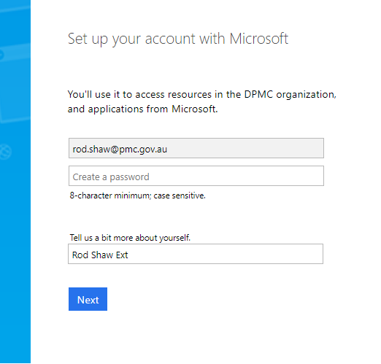
Figure 1: Example Email from Office 365
Follow the prompts to set your account.

When the account is set up with a password, the IPPRS system will generate a Welcome email:
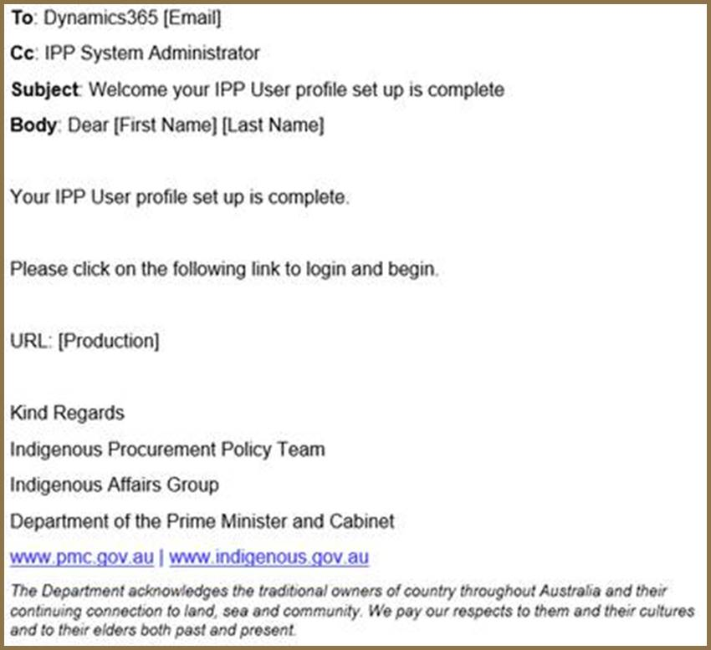
Figure 2: Example Welcome Email from IPPRS

What you need to login
There are three different roles set up for Commonwealth agency users:
- IPP Portfolio Manager
- IPP Agency Manager
- IPP Contractor Manager
- a new role for Defence
NOTE: The landing page, presented on login will vary slightly depending on the user role. The IPP Portfolio Manager is used as an example in this document.
To get started you need to have:
- The URL to take you to the portal
This is included in the welcome email sent by IPPRS.
- User ID
This will be an email from Office 365.
- Password
This is the password setup by the user as prompted by Office 365 to set up their account.

Logging In
When logging in for the first time, please follow these instructions.
Step No. | Action
1 | Enter the URL shown in the Welcome email, into your Web browser. The Microsoft Sign In window is displayed:  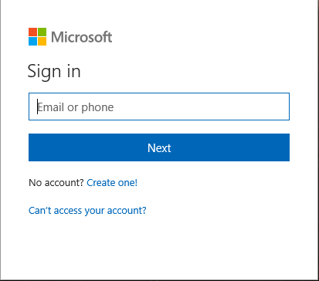  Figure 3: Microsoft Sign in window  Enter your email address (user ID) and click NEXT.
2 | The Microsoft window is displayed, prompting for your password:  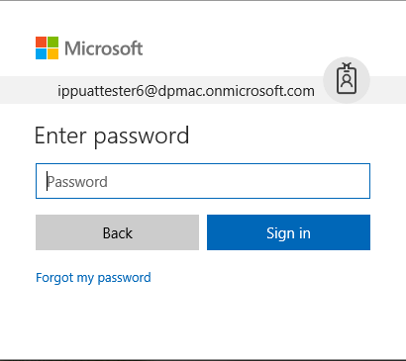  Figure 4: Microsoft Enter password window  Enter your password and click Sign in. The password is the password you entered when you were prompted by the “Set up your account with Microsoft”.
3 | The Microsoft Stay signed in window is displayed:  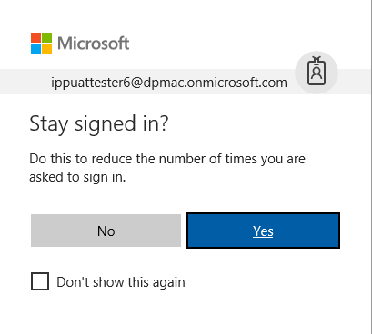  Figure 5: Microsoft Stay signed in window  Click YES. This will prevent you from being timed out during the day.
4 | The Office 365 screen is displayed, showing the applications you have access to:  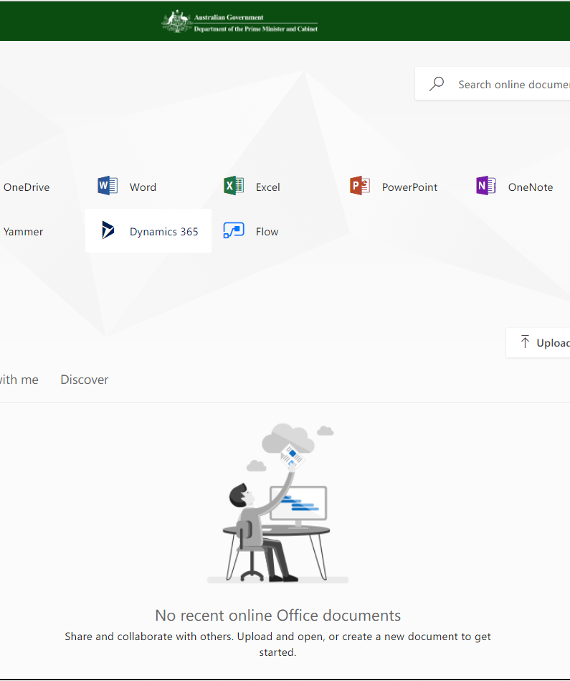  Figure 6: Office 365 Hello Screen  Click on Dynamics 365.
5 | The IPPRS Landing page is displayed:  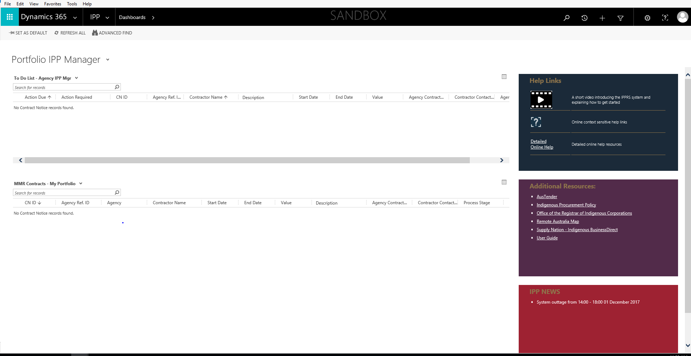  Figure 7: IPPRS Landing Page  You have now logged in.

Basic Navigation
On successful login to IPPRS the landing page or dashboard is displayed:
Figure 8: IPPRS Landing Page

The Landing Page/Dashboard
The Landing Page or Dashboard, consists of the following components:
Navigation Bar
 | This section of the Navigation Bar provides several icons:  In Order:  - Search  - Recently Viewed Items  - + - Not Used  - Advanced Search  - Settings  - Online Help  - User Profile
To Do List
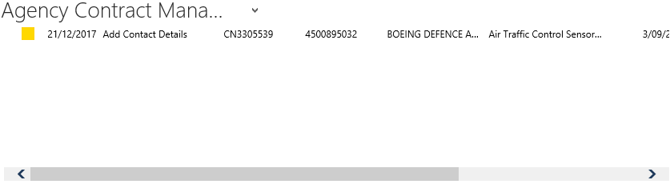 | This list shows you all the items you need to action.
MMR Contracts
 | This list displays all the MMR contracts that belong to your agency.
Resource Panes
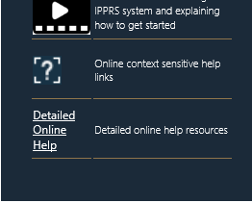 | This pane displays the help links available.  This is where you can access the  online help!
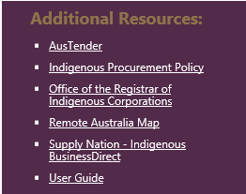 | This pane has several links to useful information.
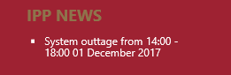 | Any news that you should be aware of is displayed here.

Contract Information Screen

From the Landing Page, double click on a contract to have the Contract Information screen displayed:

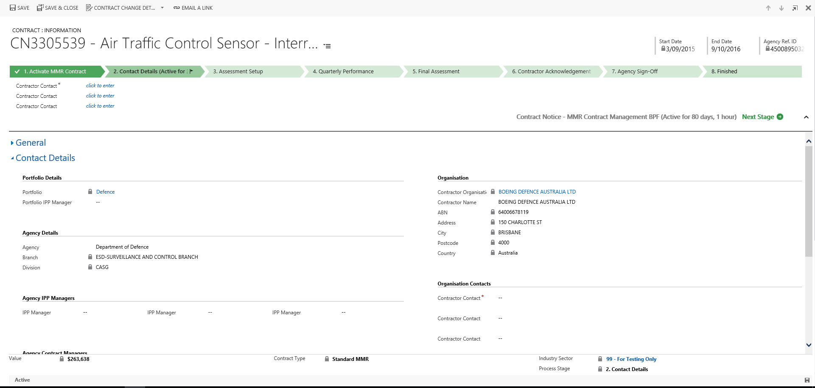

Figure 9: Contract Information

The Contract Information screen consists of five sections:
- The Command Bar
- The Header
- Process
- Body
- Footer.

The Command Bar
The Command Bar allows you to Save and ‘Save and Close’ the contract. You can also change the Contract Change Details and email a link to the contract using Outlook:

Figure 10: The Command Bar

The Header
The Header displays the Contract No, who the contract is with, the Start and End Date and the Agency Reference no. as shown below:

Figure 11: Contract Header

Process
The Process section displays where the contract is in the workflow, shown in Chevrons.

Figure 12: Process Flow
Important to note in this section is the button. Use this to move through the workflow.

Body
The Body section gives you access to several parts of the contract:
- General Information
- Contract Details
- Assessment Setup
- Quarterly Performance Reports
- Final Assessment
- IPP Documents and Emails
- Variations.
- Administration
These sections can be expanded and collapsed by clicking the arrows beside the headings as shown below:

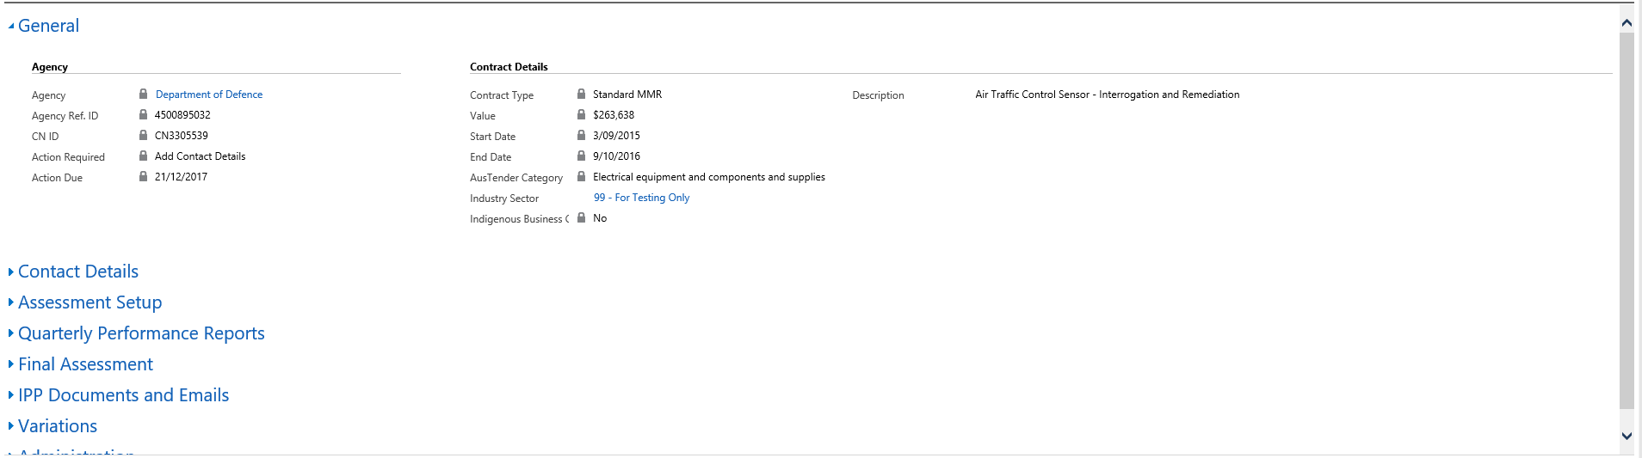
Figure 13: Contract Body

Footer
The footer displays the value of the contract, the contract type, the industry sector of the contract and the process stage the contract is, as shown below:
The Process section shows where the contract is in the workflow.

Figure 14: Contract Footer

Support
The IPPRS contains extensive online help which includes FAQ’s.
In addition, support is available through:
Email: IPPRS@pmc.gov.au
Email requests received prior to noon (12pm) each working day will be answered that working day.
Email requests received after 12pm each day will be answered by 12pm the following working day.
Telephone: 02 6152 3522
8am to 5pm Monday to Friday AEDT

APPENDIX A Example MMR Reporting obligations email
The following is an example email that is automatically generated by IPPRS when an Agency IPP Manager allocates a Contract Manager.
Dear Agency Contract Manager
You have been assigned as the Agency Contract Manager for the following contract with Mandatory Minimum Requirements for Indigenous participation (MMR) -
Contract ID: CN3407587
Agency Ref ID: 4500122916
Contractor: Jones Lang LaSalle VIC Pty Ltd
Description: Property Lease
Duration: 1/03/2017 - 1/03/2022
Value: $18,556,773
Under the MMR, the Contractor is required to report quarterly on information about the Indigenous workforce and/or supply chain outcomes for this contract or for the contractor organisation.
Please use the link below to log in to the IPP Portal. The portal will allow you to enter contract assessment information and nominate the contact within the contractor organisation responsible for providing quarterly performance reporting on the contractor’s Indigenous employment and/or supply chain outcomes.
https://ipptest.crm6.dynamics.com:443/main.aspx?etc=10085&id=8576eb16-2a89-e711-8154-e0071b662bb1&histKey=593598117&newWindow=true&pagetype=entityrecord
Please contact your Agency IPP Managers if you have any queries regarding MMR reporting -

Fiona Shaw fiona.shaw@pmc.gov.au

Figure 15: Example Contract Manager Email

